# Northern Basin Commissioner first year report 2019

© Commonwealth of Australia 2019

**Ownership of intellectual property rights**

Unless otherwise noted, copyright (and any other intellectual property rights) in this publication is owned by the Commonwealth of Australia (referred to as the Commonwealth).

**Creative Commons licence**

All material in this publication is licensed under a [Creative Commons Attribution 4.0 International Licence](https://creativecommons.org/licenses/by/4.0/legalcode) except content supplied by third parties, logos and the Commonwealth Coat of Arms.

Inquiries about the licence and any use of this document should be emailed to [copyright@agriculture.gov.au](mailto:copyright@agriculture.gov.au).

C:\Documents and Settings\west merryn\Local Settings\Temporary Internet Files\Content.Word\by.png

**Cataloguing data**

This publication (and any material sourced from it) should be attributed as: Keelty, M 2019, *Northern Basin Commissioner first year report 2019*, Northern Basin Commissioner, Canberra, December. CC BY 4.0.

ISBN 978-1-76003-242-5

This publication is available at [igmdb.gov.au/reviews](https://www.igmdb.gov.au/reviews).

Northern Basin Commissioner

Department of Agriculture

GPO Box 858 Canberra ACT 2601

Telephone 1800 900 090

Web [agriculture.gov.au](http://agriculture.gov.au/)

The Office of the Northern Basin Commissioner, as an independent Commissioner acting on behalf of the Australian Government through the Department of Agriculture, has exercised due care and skill in preparing and compiling the information and data in this publication. Notwithstanding, the Office of the Northern Basin Commissioner and the Department of Agriculture, its employees and advisers disclaim all liability, including liability for negligence and for any loss, damage, injury, expense or cost incurred by any person as a result of accessing, using or relying on any of the information or data in this publication to the maximum extent permitted by law.

**Acknowledgement**

Photograph of Barwon River, New South Wales courtesy of Murray–Darling Basin Authority.

**Warning: Aboriginal and Torres Strait Islander people should be aware that this report may contain images or names of deceased persons in photographs or printed materials.**

## Foreword

We acknowledge the Traditional Owners of Country throughout Australia and recognise their continuing connection to land, waters and culture. We pay our respects to their elders past, present and emerging.

The opportunity presented by the Minister for Water Resources, Drought, Rural Finance, Natural Disaster and Emergency Management, the Hon. David Littleproud MP, with the support of the former Shadow Minister Tony Burke MP, is a once in a generation window to bring better governance and transparency to the plethora of policies introduced by various governments over many years to manage the Murray–Darling Basin (MDB).

The backing of the Basin state and territory ministers adds to the uniqueness and significance of the current state of compliance in water resource management, particularly in the northern Basin.

At the time of the commencement of the Northern Basin Commissioner (NBC) role there were a number of existential events including:

* Continued criticism of the [Basin Plan 2012](https://www.legislation.gov.au/Details/F2018C00451)
* A Royal Commission in South Australia
* A number of matters involving alleged corruption by a former NSW minister and senior public servants under investigation by the Independent Commission Against Corruption (ICAC)
* A prosecution commenced against a property and water licence holder in Queensland for alleged significant invoice fraud involving funds allocated for water efficiency infrastructure projects.

Since the NBC role commenced there have been further fraud related referrals to the NSW Independent Commission Against Corruption (ICAC) as well as the Queensland Crime and Corruption Commission (CCC) and the Victorian Deputy Ombudsman. The Commonwealth’s purchase of two water titles in Queensland has been referred to the Auditor General and the Australian Competition and Consumer Commission (ACCC) is looking at the water market in the Basin.

During 2017 Mr Ken Matthews AO handed down his report (Matthews 2017) to the NSW government regarding the Department of Primary Industry’s (now Department of Planning, Industry and Environment) compliance activities. Much of this activity followed on from an expose in an ABC 4 Corners program ‘Pumped’ aired in July 2017. A report by the Murray–Darling Basin Authority (MDBA) and an independent panel in late 2017 on water compliance across the Basin resulted in the Council of Australian Governments (COAG) agreement to a Murray–Darling Basin Compliance Compact (Compliance Compact) with a range of actions and public reporting of progress.

The Queensland Department of Natural Resources, Mines and Energy (DNRME) initiated an audit of its policies and compliance regime in March 2018. DNRME is still in the process of implementing the recommendations of that audit and is currently consulting on proposals to strengthen water measurement.

The Productivity Commission handed down a report on the implementation of the Basin Plan in early 2019, and in September the NSW Natural Resources Commission handed down a final report on the Water Sharing Plan for the Barwon–Darling river system.

During the first ten months of operating, over 155 meetings were held with stakeholders during some 25 visits to regional areas specifically focussed on the northern Basin (Table 4). This report is a summary of the matters discovered during interviews that touched upon every aspect of compliance in the northern Basin.

The Matthews report introduced the notion of ‘no meter – no pump’. This doctrine is not universally supported. Some see their water licence as a right to lawfully access their entitlements with little or no regard to the environment and/or Aboriginal Nations.

Others who were interviewed declared that to have publicly available metering data would breach the commercial confidentiality of their business operations and potentially disclose insight in to their operating systems to competitors.

The ‘commercial in confidence’ argument presumes that water licences and entitlements are based on a solid foundation of processes that have integrity and are free of political bias. It remains the case that at least in NSW, the issuing of some historical water licences is still under investigation. Further, this mantra denies the social licence associated with what is a diminishing national asset and a public resource.

In the lead up to the NSW state election (March 2019) the then minister responsible for water received police protection after threats were made in response to water management policies in the Basin. The former minister stood aside from the portfolio after the state election. This was despite the minister’s obvious success in introducing compulsory metering and telemetry legislation, transforming the NSW Department of Primary Industry and winning the respect and support of peers across the public sector and political divides.

It is useful to reflect upon why we lose quality people who act with integrity and commitment over an issue such as the MDB policy.

There was and remains a crisis of confidence in compliance management of the MDB more broadly and the northern Basin in particular.

The Australian government allocated $13 billion to water resource management in the MDB. The balance of those funds must be managed on behalf of all taxpayers with integrity and confidence that good governance is in place.

Lobby groups are very active in shaping government policies around the allocation of funds to projects. Whilst it is difficult, if not impossible, to trace their political influence, stakeholder feedback revealed a level of suspicion that funding is politically influenced. No such link was made during the reporting period.

Transparency is key to ensuring all Australians can be confident the national asset that is the MDB, along with their $13 billion investment, is being managed with integrity.

This report describes progress on a comprehensive work plan and task list, including an indication of the relative achievement against the original terms of reference (see Northern Basin Commissioner terms of reference).

We identify what we believe are some of the major inhibitors to an effective compliance regime that were detected during the first year of examination. The inhibitors are based around the themes of:

* Policy settings
* Communications and coordination
* Governance
* Historical artefacts
* Aboriginal Nations
* Environment.

Our traditional management plan was don’t be greedy, don’t take any more than you need and respect everything around you. That’s the management plan – it’s such a simple management plan, but so hard for people to carry out. — Ngarrindjeri elder, Tom Trevorrow quoted in the Basin Plan 2012.

The role of the NBC and this first report would not have been necessary if all stakeholders adhered to Tom Trevorrow’s management plan.

Stakeholders have all been extraordinarily generous in their engagement with the NBC role. The privilege of being hosted into people’s homes, in groups or as families, to talk through the issues is a highlight of the reporting period. One has to admire the generosity and spirit of these people who are facing the worst conditions since the Millennium Drought and yet remain steadfast to continue the tradition of the generations before them.

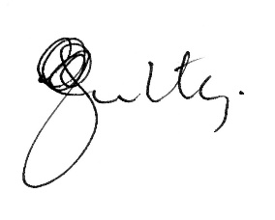

M Keelty AO

Northern Basin Commissioner

December 2019

Contents

Foreword iii

Executive summary x

The Plan x

The report x

Agency engagement xi

Policy and governance xiii

Aboriginal Nations xv

Environment xv

Summary of recommendations xvi

1 Policy settings 1

A contested resource 1

Legislation 1

Policy settings (1) 4

2 Communications and coordination 5

Coordination on compliance 5

Coordination on science and technology 8

Communication issues 9

Complexity of rules for protecting environmental flows 11

Communications and coordination (2) 13

3 Governance 14

Ministerial Council and Basin Officials Committee organisational structure 14

Culture of ‘waiting out’ incumbent ministers 14

Process driven 15

NBC role and terms of reference 19

Governance (3) 19

4 Historical artefacts 20

The legacy of history 20

Culture of mistrust 21

Community expectations 23

Water trading 24

Foreign ownership 25

Historical artefacts (4) 27

5 Aboriginal Nations 29

Water entitlement for Aboriginal Nations 29

Development timeline 30

Bilateral Aboriginal Nation engagement 31

Aboriginal Nations (5) 33

6 Environment 34

COAG agreement to action in northern Basin 34

Decisions based on best scientific advice 34

Environment (6) 40

Miscellaneous 41

Terms of reference 46

Summary of findings and recommendations 52

Policy settings (1) 52

Communications and coordination (2) 52

Governance (3) 53

Findings 53

Historical artefacts (4) 54

Aboriginal Nations (5) 55

Environment (6) 55

Northern Basin Commissioner terms of reference 56

Northern Basin agencies, legislation and intergovernmental agreements 58

Northern Basin legislation and intergovernmental agreements 58

Financial report 60

Glossary 61

References 62

**Tables**

Table 1 Search returns on water entitlements, 4 October 2019 5

Table 2 Discoveries or third-party notifications that led to no further action, Queensland MDB, 2018–19 6

Table 3 Foreign-held water entitlements in the Murray–Darling Basin 26

Table 4 Northern Basin Commissioner’s task list 41

Table 5 Terms of reference—outputs 47

Table 6 Expense summary 60

Table 7 Employee expenses 60

**Figures**

Figure 1 Compliance action undertaken in the Queensland MDB, 2018–19 6

Figure 2 Staff growth and compliance activity undertaken in 12 months, NSW Natural Resources Access Regulator, 2018–19 7

Figure 3 Stakeholder sentiment—communications and coordination 8

Figure 4 Engagement with non-traditional partners 9

Figure 5 Extract from Macquarie River water licence, NSW 12

Figure 6 Governance arrangements for water resource management in the Basin 14

Figure 7 Stakeholder sentiment—governance 18

Figure 8 Timeline of annual volumes of water extracted under ‘A’ class licences in the Barwon–Darling, 1990–91 to 2017–18 22

Figure 9 Annual allocation price scenarios, NSW Murrumbidgee, 2002 to 2020 25

Figure 10 Stakeholder sentiment—legacy of history 27

Figure 11 Bilateral engagement with the Northern Basin Commissioner 32

**Case studies**

Case study 1 Engagement with the Northern Basin Commissioner 2

Case study 2 Cubbie Station 3

Case study 3 Kōmihana Rūwhenua—the Earthquake Commission 3

Case study 4 Menindee mass fish deaths 10

Case study 5 Release from Beardmore Dam 11

Case study 6 Slow delivery of Northern Basin Toolkit measures projects 16

Case study 7 Progress with hydrometric and remote sensing proposal 17

Case study 8 Border Rivers Commission 18

Case study 9 Issuing of water entitlements 21

Case study 10 Queensland moratorium 21

Case study 11 Burning of the *Guide to the Draft Basin Plan* 23

Case study 12 Gayini Nimmie-Caira 32

Case study 13 Active Management of environment water entitlements 35

Case study 14 Gwydir Wetlands Ramsar site 37

**Photographs**

Photograph 1 Northern connectivity event—dry river bed, Gwydir River near Pallamallawa, 15 April 2018 36

Photograph 2 Northern connectivity event—flow working its way along Gwydir River near Pallamallawa, 25 April 2018 36

Photograph 3 Healthy Ramsar wetlands (Goddards Lease), upper Gingham, January 2019 37

Photograph 4 Gwydir section, Old Dromara, summer following provision of planned environmental flows, January 2019 38

Photograph 5 Constrained watercourse channel between two western sections of Ramsar site across agricultural land used for grain cropping, January 2019 38

Photograph 6 Constrained watercourse section leading to western section of Ramsar site, January 2019 39

Photograph 7 Diversity of wetland vegetation contrasted against fallow cropping paddocks at one wetlands boundary, January 2019 39

## Executive summary

### The Plan

In 2012 there was widespread agreement across government that a plan was needed to manage water carefully and protect the Basin for future generations. The Basin Plan 2012 (the Plan) manages the Basin as a whole connected system and seeks to balance the needs of towns, agriculture, industries and the Basin’s rivers, wetlands and floodplains.

For all the criticism of the Plan no one has provided a viable alternative. Nor, in the short term, is any person or group likely to garner the support of every government and stakeholder to quickly devise an alternative to the Plan. This is why it was reassuring to see the August 2019 COAG meeting reaffirm commitment to the Plan.

One has to wonder whether the Plan would be so contentious, had we not been in the grip of the worst drought in our history.

While distractions are created in some quarters about the Plan, the clock is ticking for the environment, Aboriginal Nations, industry, residents and recreational users.

Given the diversity of stakeholder interests, criticism of the Plan is inevitable, however, abandoning it without a viable alternative in place is likely to do even more damage. As with any major project requiring a decade to deliver, there will be alterations and adjustments along the way, but the foundation can remain intact.

Dividing the MDB into jurisdictional pieces of a pie with differing approaches, even to the type and nature of licences granting access to water, has not helped provide a consistent approach to achieving compliance and good governance, to what is essentially a national asset.

Terminology and meanings of related and/or similar issues and policies dealing with water differ in each state, making it difficult to review. Other portfolios such as Transport, Health and Education moved to common operating platforms years ago.

Bipartisan political support has been critical in achieving greater levels of compliance. It has to be said that the extent of the matters brought to the attention of the respective authorities leading to the establishment of the NBC role were not discovered by departmental compliance arrangements. They were discovered by investigative journalism - in particular the work of ABC 4 Corners journalist, Linton Besser in a program titled ‘Pumped’.

### The report

This is the first report of the NBC and it was to be the first instalment of a three-year program by the NBC to address compliance activity in the northern Basin. Following the August 2019 meeting of the Ministerial Council on the MDB, it has been decided to transition the role to that of an Inspector-General with a wider remit across all of the MDB. The terms of reference (ToR) for the NBC have been the subject of ongoing discussion throughout the reporting period. It is arguable whether the original ToR could have ever been achieved by a part-time role with the resources allocated to the NBC position (Commissioner plus one staff member) and many of the ToR are the responsibility of others, such as the Department of Agriculture and the Murray–Darling Basin Authority (MBDA).

The report indicates an alternative and potentially improved model for the NBC position to operate into the future. The idea of a Water Commissioner or Inspector-General of Water Resource Management in the MDB enables a continuous focus on the development of agile and flexible policies. The role should in turn ensure compliance maintains pace with what is a dynamic and stressed operating environment.

As the report indicates, the NBC position had no statutory powers and relied solely upon the cooperation of everyone concerned. This may not be sustainable over the longer-term for an Inspector-General as the operating environment and priorities of governments change.

It is important whatever oversight is in place that it is ‘adding value’ to the existing arrangements rather than adding a further layer of bureaucracy. The first months of the NBC were treated cautiously by some, if not all agencies, many of whom saw the role as an imposition by the Commonwealth. Even the Department of Agriculture struggled to understand how the position would operate.

To be fair, many see the role of the Commonwealth as unclear. The Commonwealth does not own dams or rivers and yet imposes its will through agencies and officials upon those charged with delivering and managing water resources appropriately at the state and territory level. The Commonwealth Environmental Water Office (CEWO), of course, does own and manage water, making the coordination of activities between jurisdictions vitally important.

Coupled with these challenges is an atmosphere of consultation fatigue, where those in authority are said to ‘fly in and fly out’ of regional areas making promises that are not kept or followed through once people return to the relative luxury of their city life. The families, both Indigenous and non-Indigenous, living in the MDB rely upon these authorities to deliver in a timely manner programs that have integrity and that are fair.

The value of water is increasing exponentially in proportion to its scarcity and is now attracting institutional and significant foreign investment.

Case studies are used in the report to strengthen findings.

### Agency engagement

The tensions between competing agencies and the posture by some makes it important not to avoid or ‘wash over’ some difficult issues.

The report praises the speed and agility shown by the NSW government and Department of Industry (DOI) in establishing and resourcing the Natural Resources Access Regulator (NRAR). From the commencement of the NBC role, the NSW DOI (now the Department of Planning, Industry and Environment, or DPIE) and NRAR have been fully engaged, which is a credit to their leadership and change management culture.

Conversely, the report is critical of the Department of Agriculture. The department does not enjoy a good reputation. It appears that over time, the department has become process driven and not action oriented. Stakeholders consider the department not dynamic enough to ‘enable’ projects to obtain approvals and complete with any degree of haste.

The report identifies the Department of Agriculture suffers from a reputation of having too many bureaucratic barriers preventing programs from being funded and completed in a timely fashion. Within the department there is a strong sense of control over taxpayer funds, which is understandable, but the level of control ultimately risks timely delivery of projects.

The large investment by the Australian government of $13 billion of taxpayers’ money, of which about $4.5 billion remains (Productivity Commission 2018) has to be managed diligently and with integrity. However, delivery and implementation should not be impeded through overly bureaucratic processes.

Based on interviews with stakeholders it is considered by some that the priority of projects in the Department of Agriculture is also neither well understood nor adequately communicated. The department is thought to have developed a risk averse culture, which may derive from many years of failed or incomplete project delivery where it has had no control over implementation.

The fact that it is the role of the states to deliver projects does not appear to be fully appreciated by all sections with water responsibilities in the Department of Agriculture. This is not new for Commonwealth departments, it is similar to roles in other portfolios such as Health, Education and Transport.

It was observed the Department of Agriculture is populated by people with expertise and passion, which belies its reputation for being slow to operate and overly bureaucratic.

The answer may lie in the Department of Agriculture adopting a more dynamic posture with an enabling culture that delivers on government and community expectations. This may involve temporarily out-posting officers to the states to get projects happening and/or assisting stakeholders to manoeuvre through the policy barriers.

Further, there is no well-publicised, concise mission statement for the Department of Agriculture when it comes to water. Its value proposition to stakeholders is therefore not universally accepted nor well understood.

For example, is the Department of Agriculture’s role in water to ‘protect the public purse’; or, is it to ‘manage the water resources of the MDB?’ Is its role to ‘protect water resources for the First Nations, environment and legally entitled water licence holders of the MDB?’ or, is Department of Agriculture’s role to ‘deliver the outcomes of the Ministerial Council on the MDB that was established by COAG?’

The lack of a concise mission statement that is universally understood, exacerbates the complex policy environment in which the Department of Agriculture operates. If its key role is in the delivery of infrastructure, then it may be time to consider moving the role from the Department of Agriculture to a department more aligned with delivery of major infrastructure projects.

This suggestion is beyond the remit of the NBC to recommend – it is merely an observation that derives from the lack of an unequivocal value proposition that a concise mission statement would articulate.

The Queensland Department of Natural Resources, Mines and Energy (DNRME) took some time to engage openly and honestly with the NBC role. After much ‘toing and froing’ it was finally acknowledged by DNRME that there are only two ‘compliance officers’ operating in the northern Basin for the reporting period. It does not have an automated system to process its compliance data and it is well behind other agencies in having a reassuring compliance regime when it comes to water resource management in the northern Basin.

The prevarication by DNRME - which at one point included instructions given to staff not to engage with the NBC without senior staff present – markedly improved in the second half of the reporting period. A structural change in the department, coupled with the introduction of metering and telemetry legislation in the Queensland Parliament in May 2019 are positive signs.

There is still some way to go before DNRME can be compared equally with NSW DPIE and NRAR, but positive and constructive engagement has now become the norm.

There has been some outstanding work by DNRME in Aboriginal Nations engagement and it does have particularly good policies governing water resource management.

It is also useful to note the area of the northern Basin in Queensland is disproportionate to other areas of responsibility for DNRME, which needs to be recognised in maintaining a positive and cooperative relationship.

The MDBA is singled out as being the most engaging and professional of all the agencies in this first year of the NBC operations. Their leadership, culture and ability to deliver succinct briefings on complex issues (referred to colloquially as a "Soldiers' Five") is well above the standard of the other agencies.

Publications by the MDBA are of a high standard and assist newcomers in coming to terms with the complex and sometimes technical policies. The MDBA was the target for considerable criticism during the reporting period, which demonstrates a lack of understanding compared to the role of the Department of Agriculture. The MDBA unfairly wore much of the criticism for the well-publicised deaths of fish at Menindee. Many other stakeholders were equally involved in the decision-making around the operations at Menindee, yet they were conspicuous by their absence.

There are a lot of unhappy people in the MDB, especially given the current drought conditions, but this has not deterred the leadership of the MDBA from being front and centre to hear the criticism. More should be done by all responsible agencies to ameliorate stakeholder concerns. A single source of accurate and relevant information relating to water entitlements and availability for the entire MDB is essential, instead of each agency and/or sections of the same agencies having their own websites. This will go a long way to addressing misinformation or the lack of timely information. Manoeuvring through the plethora of websites for stakeholders is slavish and not conducive to achieving high levels of compliance.

### Policy and governance

The number and complexity of overall governing laws and policies surrounding water resource management in the northern Basin are noted in the report, highlighting the compliance risks associated with such a system.

For example, those who have grown up with water trading understand it, but an outsider would rightfully question how upstream carryovers could not possibly adversely affect downstream entitlements.

Nor would anybody unfamiliar with the subject understand how ‘sleeper’ (inactive) licences could be used in a fair and transparent water trading market. To the uninitiated, this would be like having a second deck of cards to ‘trump’ a winning hand at poker. The advent of ‘water brokers’ who, unlike ASX brokers, are unlicensed, does not help to provide a positive view of the governance when comparing the two systems.

While not a term of reference for the NBC, the report makes the observation that it does not make sense to have a Basin Officials Committee (BOC) that excludes the CEWO as a permanent full-time member. Even making the CEWO a permanent observer with non-voting rights would make better sense, given most of the outcomes delivered by the BOC inherently involve the CEWO. These and other issues were identified in the review of BOC by Greg Claydon – whose recommendations do not appear to have yet been fully adopted.

There is mistrust between stakeholders, whether intergovernmental or at the community level. It is not assisted by the absence of a single source of relevant and accurate information relating to water entitlements and availability in the form of a database that everyone, including non-stakeholders, can view. In 2019, this platform should be an application to download on a mobile phone.

There is opposition to data being made publicly available. Claims that telemetry and metering erode competitive advantage in business operations deny the social licence enabling access to this national asset. This issue has been addressed in the compliance reviews by Ken Matthews, the MDBA and its independent panel, and by the Queensland government (Matthews 2017; MDBA 2017; Qld DNRME 2018). However, action to remedy has been very slow.

There has been a ‘crisis of confidence’ in the northern Basin governance arrangements. The situation is exacerbated by allegations surrounding historical decisions to issue water entitlements, coupled with donations to political parties and/or the influence exerted by lobby groups.

It may be the finalisation of the NSW ICAC investigation, following the airing of the ABC 4 Corners program in July 2017, will provide an opportunity to look at improving transparency over the allocation of water entitlements.

A mature and well organised number of water-related lobby groups drive opinions about the virtues, or otherwise, of what governments are doing or need to do. They are described as having a lot of power, but their influence is not immediately transparent, nor easily traced.

Conflicts of interest do not appear to be well understood, nor declared in many instances especially at the local government level. Delays in the publication of political donations feed the mistrust regarding compliance with water laws.

A Water Commissioner/Inspector-General could ensure better coordination between agencies to reduce duplication and ambiguity. It could also help overcome the ‘wait them out’ culture that develops in agencies who are tired of the directions given by what they perceive to be a ‘revolving door’ of ministers, each with their own agendas and priorities.

### Aboriginal Nations

The report identifies the plight of the 22 Aboriginal Nations who are the traditional owners of the northern Basin and yet they are not appropriately represented by the entity created to achieve that representation – the Northern Basin Aboriginal Nations (NBAN). Native title in water remains an unresolved issue that needs addressing.

Engagement with the NBAN was strained during the reporting period, reflecting a succession of dysfunctional events including a vote of ‘no confidence’ in the NBAN Chair and a threat by the NBAN Deputy Chairperson to take legal action against the NBC. The NBAN Executive Officer resigned and was re-instated during the reporting period.

There is much more work to be done to develop NBAN to the level of maturity and effectiveness of its counterpart in the Southern Basin, the Murray Lower Darling Rivers Indigenous Nations (MLDRIN) group.

There are opportunities to continue progress without NBAN, using the Indigenous Land Council or through bilateral engagement with the Commonwealth and state government departments, but the ideal position would be to have NBAN succeed in becoming an authoritative and representative body for the 22 Aboriginal Nations in the northern Basin.

The appointment of an Indigenous person to the Board of the MDBA provides an opportunity to advance First Nations’ interest by having MLDRIN and NBAN report through that board member to the MDBA.

### Environment

The environment needs to remain high in the priorities of those accessing water entitlements. It is required by legislation and is in keeping with the hierarchy of Social Licence – Legal Licence – Water take.

Having the CEWO as a member of the BOC, or indeed a new committee that might be constructed, should a Water Commissioner/Inspector-General position be adopted, is key to ensuring the environment is a priority in whatever policies are implemented.

Excellent work is being done or proposed around fish-ways and reducing the impact of cold-water pollution in the northern Basin. It is a work in progress and more needs to be done. The Northern Basin Project Committee established in the recent northern Basin schedule to the Basin intergovernmental agreement has been slow to get off the ground. A work program should be published as soon as possible, and the committee should consult with the northern Basin community over the proposed work.

## Summary of recommendations

1.1 Map and simplify the Commonwealth and state policy settings with a view to achieving a consistent and easily understood framework for all stakeholders. In particular, water access rules should be designed to be easily understood and to facilitate compliance.

2.1 Adopt a single non-partisan approach to communication and coordination of activities across the northern Basin that provides a single site for relevant and accurate information regarding water entitlements and availability for all stakeholders. This platform should provide a joined-up approach to intelligence, compliance, and science and technology.

3.1 Endorse the appointment of an Inspector-General of Water Resource Management with appropriate powers to oversee governance and program delivery across the entire MDB who can also deal with allegations of corruption or misconduct by referring them to existing integrity oversight bodies.

4.1 Provide a calculation of the total surface and groundwater water pool in the northern Basin on a valley by valley basis including the amount dedicated to water licences (by use), to other forms of entitlement such as stock and domestic use, riparian rights and farm dams, for Aboriginal cultural flow requirements, and for environmental use. Such an analysis would help the community to understand the relative priorities for use and the viability of current licence types.

4.2 Buyback strategies and water trading should give consideration to findings from the current ACCC and Auditor-General inquiries.

Improve the engagement with Aboriginal Nations in the northern Basin, giving consideration to international experience:

5.1 Support further practical examples of integrated land and water management on Country by Aboriginal Nations, including provision of necessary water entitlements.

5.2 Consider further mechanisms by which Aboriginal representatives can have input into the watering priorities of the CEWH in order to meet their cultural flow aspirations.

5.3 Support a three-year pilot ranger program in two or three localities within the northern Basin to demonstrate the potential of a larger program.

5.4 Encourage MLDRIN and NBAN to report to the MDBA through the Indigenous member on the MDBA Board.

5.5 Stronger support for NBAN to become an effective representative organisation.

6.1 Give more compliance attention to environmental outcomes, ensuring stakeholders are putting the social licence of access to water ahead of all other considerations.

6.2 Improve transparency of the basis for water management decisions, including through completing Compliance Compact commitments on improved water information. The BOC should provide a realistic timeline for the completion of the commitments with milestones that are made readily available for the community to judge the performance of government agencies at all levels.

6.3 The Northern Basin Project Group consisting of Commonwealth, NSW and Queensland agencies established to implement improved environment outcomes in the northern Basin should:

* immediately publish its terms of reference and proposed work program.
* embark on a program of stakeholder consultation so that the community understands the work proposed and the opportunities for engagement.
* establish ongoing arrangements for coordination of environmental flows between catchments and jurisdictions in the northern Basin.

## Policy settings

### A contested resource

Irrigation in the northern Basin is mostly for cotton, an industry which is characterised by larger farms, often under corporate ownership, and privately developed on-farm storages able to capture very large volumes of water during periods of flood – which help to maintain production into drier periods.

This style of development is at odds with the perception of the farmer as the lone battler in the outback, or as part of a small, tight knit community, once central to the identity of isolated rural communities in Australia. The shift to highly efficient, automated big business is an expected consequence of development, but what it means for the socio-economic make-up of remote regional areas is being questioned during the first 12 months of engagement with the NBC.

The overlay of the worst drought on record for the northern Basin has exacerbated concerns about the equity with which water is shared – both upstream and downstream.

Headlines in the media sensationalise the difficulties being experienced throughout the MDB. Local issues rise to the forefront as people perceive that someone upstream is taking water inappropriately, and those downstream want more than they could possibly need.

### Legislation

Barely fitting within the northern Basin’s boundaries, the sheer number and excessive complexity of the northern Basin’s agencies and policies contribute to the difficulty of Basin water management being understood, and water laws being complied with.

This complexity is partly due to our federal system of government, and the classic ‘railway gauge’ problem in which different states have historically gone about developing their water resources and associated management rules in a different manner. Much of the complexity is also due to the highly variable nature of the resource, and the desire of water users to be flexible in the way they harvest and use it.

Notwithstanding these issues, the fact that some water users cannot easily understand the rules around which they can access the water they are entitled to, and that some regulatory agencies cannot easily explain these rules, means there is a problem. Simplification is needed over individual access rules, and better communication of the rules is needed. For a list of key decision-makers, legislation and intergovernmental agreements, see Miscellaneous.

Case study 1 Engagement with the Northern Basin Commissioner

|  |
| --- |
| Understandably, given the ambiguity of the ToR provided for the NBC role – many agencies viewed the role with a degree of concern.  Would the role add another layer of bureaucracy? How different is the role to the compliance role of the MDBA? How would the role achieve outcomes when the position was only part time with one staff member to assist?  Despite these questions and more – the NBC role evolved during the reporting period to what is hoped is a value-add role that can be built into the newly announced role of Inspector-General for the entire Basin.  There were two standout agencies who immediately embraced the NBC role, being the Commonwealth MDBA and the NSW NRAR. Both agencies sought immediately to work with the NBC role and offered opportunities to work together with a constructive and partnership ethos. The then NSW Department of Industry (NSW DOI) leadership team was heavily involved in creating the relationship with NRAR and continued to assist the NBC role with frank and sometimes unflattering briefings about shortcomings in previous years of operation.  To the credit of the executive and leadership team in the former NSW DOI and their former minister, an immediate embracement of the NBC role meant the work of NRAR could be supported and promoted by the NBC. Coupled with the introduction of the Water Management Amendment Act 2018 (NSW) in June 2018 that strengthened metering requirements, NSW had responded constructively and quickly to serious allegations of corruption aired in the ABC 4 Corners program of July 2017.  The MDBA embraced the NBC position from the outset. Briefings by the executive and Board in the first days of the NBC commencing meant that an excellent understanding of the situation and history was obtained. MDBA provided excellent and succinct briefings. This is often referred to colloquially as a "Soldiers' Five". That is, what is important to know and how best can you impart the information without being drawn into the complexities and ambiguities of the operating environment.  Queensland DNRME adopted a different position. There was some early resistance to the NBC role as just another ‘layer of Commonwealth bureaucracy’. This is understandable because of the ambiguity of the NBC ToR with other Commonwealth agency roles.  Briefings from DNRME were ambiguous and officers were advised not to engage the NBC without a senior person present.  These early difficulties were overcome as the value of the role became more evident to DNRME. Unfortunately, it took some time to establish that there are only two compliance officers tasked with water compliance activities in the northern Basin. The resourcing of water compliance by DNRME has been poor. The self-reporting of changes to structures on properties affecting water flows, coupled with departmental systems being paper based, fuels concerns from the other states that Queensland is not doing enough to ensure that compliance activity is keeping operators honest.  Queensland has now introduced its metering and telemetry legislation and the way forward is positive and will improve in the short to medium term, which again is a credit to the executive team and their minister. A key watch-point in Queensland will be the extent to which appropriate resourcing is made available to implement these new measures.  In summary, while the approach of agencies has been different - the end of the reporting period has seen very constructive and helpful relations developed, which work well with the new Inspector-General role. |

Case study 2 Cubbie Station

|  |
| --- |
| In accordance with the terms of foreign investment, a resolution for the purchase of 49% of Cubbie Station has been achieved. Navigating Queensland regulation was facilitated by DNRME as part of the complex and lengthy negotiations. The work that DNRME has done on modelling of changes to climatic conditions and the engagement with Aboriginal communities in the north of the state is commendable.  Cubbie Station, the largest irrigation property in the southern hemisphere, is located near Dirranbandi, in south-west Queensland. It is situated on the almost level floodplains of the Culgoa and Balonne rivers. It has a total holding of 93,000 hectares and can store up to 469 gigalitres.  Significantly, the companies say they will voluntarily hand over up to 10 gigalitres of water, back to environmental flows and downstream users, after dry periods.  According to Liz O'Leary, Head of Agriculture and Real Assets at the Macquarie Group, ‘The Cubbie Station deal is an example of the private and public sectors engaging with one another to develop new ways of helping to meet environmental objectives, while enabling productive use of the land at times of high flows’. |

Case study 3 Kōmihana Rūwhenua—the Earthquake Commission

|  |
| --- |
| The Earthquake Commission (EQC) is a New Zealand Crown entity, investing in natural disaster research, education and providing insurance to residential property owners (EQC 2010; Tonkin & Taylor Ltd 2018; Wright & Dally 2018). The Earthquake Commission’s statutory functions are to:   * provide natural disaster insurance for residential property (contents, dwellings and some coverage of land) * administer the Natural Disaster Fund (NDF), including its investments and reinsurance * fund research and education on natural disasters and ways of reducing their impact.   Premiums for the EQC through a compulsory levy added to all home insurance policies. In its first 65 years, the EQC was called on to settle only relatively minor claims and the disaster fund continued to grow, reaching $6.1 billion by 2010.  The EQC mission statement is 'To build resilience to natural disasters such as drought in a similar fashion to how NZ builds resilience to natural disasters in the form of earthquakes'. |

On 4 September 2010, a powerful earthquake struck near Darfield in Canterbury. It began a series of earthquakes and aftershocks lasting till around 2016. The most destructive of these was the 22 February 2011 earthquake, centred close to Christchurch, in which 185 people died. The EQC received over 470,000 claims, more than 15,000 families lost their homes, and repair costs were estimated at over $40 billion.

Is there capacity in the MDB to set up an agency of this nature to provide both financial mitigation against the impacts of changing climatic conditions and invest in scientific research to improve water resource management?

Further, communities would derive greater benefit from a more coordinated whole of government approach to delivery of government funded socio-economic initiatives regarding health, employment, education, Indigenous advancement, water resources, drought relief and natural disasters.

Advantages of having a permanent standing body:

* recognises that the government cannot control the environment
* delivers a message that government can deliver agile and flexible policies
* ensures a level of community resilience for what may lie ahead.

### Policy settings (1)

#### Findings

* 1. The jurisdictional policy setting for the single national resource of the MDB creates divisions.
  2. Policies at Commonwealth and state levels are overly complex.
  3. There is no ‘one stop shop’ for stakeholders.
  4. Policy setting is not conducive to good compliance.
  5. Duplication, ambiguity, complexity, lack of accountability and influential lobbying is creating a risk averse culture in the public service.
  6. The scope of matters leading to the NBC appointment were not identified through departmental processes, they were identified through investigative journalism.

#### Recommendations

1.1 Map and simplify the Commonwealth and state policy settings with a view to achieving a consistent and easily understood framework for all stakeholders. In particular, water access rules should be designed to be easily understood and to facilitate compliance.

#### Closing thoughts

While every endeavour is being made across a variety of agencies to assist in the current drought, from mental health to business subsidies and welfare assistance, there is a view that a more joined up approach could provide a much higher and long term impact for the sustainability of these regional communities into the future.

A complex policy environment is not conducive to compliance. Metering is not a panacea.

We can’t control nature, but we can control policy, implementation and compliance.

## Communications and coordination

Stakeholders report the difficulty and frustration in obtaining clear and concise information relating to water management. Table 1 depicts the myriad of internet search results that are returned when you ask three simple questions from the various northern Basin agency websites.

Table 1 Search returns on water entitlements, 4 October 2019

| Basin agency | What are my water entitlements? | How much water can I take today and from where? | How much water can others take today and from where? |
| --- | --- | --- | --- |
| Basin agency 1 | 2,786 | 182 | 174 |
| Basin agency 2 | 5 | 5 | 5 |
| Basin agency 3 | 20 | 10 | 10 |
| Basin agency 4 | 34,066 | 2,681 | 2,710 |
| Basin agency 5 | 1,372 | 572 | 363 |

Note: Basin agency websites have been de-identified.

The ambiguity and confusion increases if the stakeholder is not clear on which Basin agency to obtain the information from. For example, an open Google search with the question ‘What are my water entitlements?’ brings 1,300,000 results.

Information needs to be communicated in a clear manner, leaving stakeholders with no doubt as to what they are permitted to do, and as importantly what they are not. A single source of accurate and relevant information is essential – certainty is key.

### Coordination on compliance

Consistent reporting is critical to the transparency of compliance frameworks. The NSW NRAR regularly publishes compliance activity reports such as the Natural Resources Access Regulator progress report 2018–19 (NSW NRAR 2019) and the Qld DNRME has recently reported on compliance and enforcement actions taken in the Qld MDB in 2018–19 (Figure 1 and Table 2) (Qld DNRME 2019). There is a notable lack of consistency with regard to the collection and availability of compliance data.

Figure 1 Compliance action undertaken in the Queensland MDB, 2018–19

In total, 1,929 actions were undertaken, including:
• 182 high-priority property audits
• 1,706 self-read audits against entitlements
• 14 advisory letters
• 6 show cause letters
• 12 warning notices
• 5 penalty infringement notices
• 1 compliance notice
• 3 show cause notices.


Source: Department of Natural Resources, Mines and Energy (Qld DNRME 2018)

Table 2 Discoveries or third-party notifications that led to no further action, Queensland MDB, 2018–19

| Preliminary action taken | Number |
| --- | --- |
| Applicable exemption applies | 11 |
| No offence found after further investigation | 43 |
| Insufficient evidence | 1 |
| Limitation period expired | 3 |
| Satisfactory explanation provided and resolved | 6 |
| **Total actions undertaken** | **64** |

Source: Department of Natural Resources, Mines and Energy (Qld DNRME 2018)

Figure 2 Staff growth and compliance activity undertaken in 12 months, NSW Natural Resources Access Regulator, 2018–19

Staff numbers have grown from 69 to 146. The regulator has 107 frontline staff and 40 investigators (up from 12 before the regulator existed—a tripling). More than 60 staff members are involved in compliance.

The regulator has:
• logged 1,285 allegations
• inherited 483 cases of alleged breaches from previous agencies
• received 845 cases for investigation
• received 310 Murray–Darling Basin cases for investigation
• received 182 Northern Rivers cases for investigation
• finalised 809 investigations
• currently 595 active cases
• conducted 324 property inspections
• issued 239 advisory letters
• issued 88 formal warnings
• issued 107 statutory notices
• issued 50 penalty infringement notices
• commenced 9 prosecutions
The regulator received:
• 341 controlled activity applications and completed 312 applications.
• 486 state-significant development/infrastructure referral applications and completed 442.
• 913 integrated development applications and completed 768.

Comparison year-to-year
In 2017–2018, the regulator received 651 cases for investigation compared with 845 in 2018-19.
In 2017–2018, the regulator finalised 538 investigations compared with 809 in 2018–19.
In 2017–2018, the regular received 690 breach allegations compared with 1,285 in 2018–19.

Other
The regulator:
• received more than 5,500 hotline inquiries.
• completed more than 3,200 applications.
• received more than 700 organisational inquiries.
• received more than 1,300 applications for access to water.

Source: Natural Resources Access Regulator (NSW NRAR 2019)

Figure 3 Stakeholder sentiment—communications and coordination

• Natural Resources Access Regulator (NRAR) is effective
• Qld DNRME sit on their hands
• DNRME focus is on vegetation
• Their bosses do not support
• Don’t know who to call
• Commonwealth role is unclear
• Rubber hits road with the State governments
• Unrealistic expectations
• Don’t want another four corners
• Too many departments involved
• Departments do their own thing
• Nothing happens
• People visit then they go away
• They don’t listen
• Have to live in this town
• Not sure who to call
• Lots of meetings/no action
• Good people don’t last
• They keep changing
• They don’t know what they are doing
• Don’t want to go to court
• Don’t make waves
• Listen to the wrong people


Note: The contents of the topic clouds are derived from interviews undertaken by the NBC and do not represent the Commissioner’s views.

### Coordination on science and technology

From the outset of the NBC role it became evident each jurisdiction was pursuing its own science and technology initiatives. Some jurisdictions were using LiDAR (Light Detection and Ranging) to calculate dam capacities taking advantage of the drought period, while others were using a variety of satellite imagery to make similar calculations and observations. It was also noted the Commonwealth has access to unclassified capability in science and technology that might assist.

It was clear that some jurisdictions were unaware of advances in the combination of artificial intelligence, machine learning and biometric recognition capabilities that might be used in the water resource management compliance space.

The MDBA, NSW DPIE and Queensland DNRME have since convened a collaborative working group to oversight the delivery of a program of works to allow use of hydrometric systems, remote sensed data and telemetry to gather information for water resource management and compliance.

This group includes representatives from GeoScience Australia, the Bureau of Meteorology and CSIRO, to ensure the Australian Government, New South Wales and Queensland can develop a value for money system that operates effectively in both jurisdictions. This group will ensure information is shared broadly and the latest technology can be applied across the Basin.

The MDBA has had preliminary discussions with Defence Science and Technology to explore options for collaboration and application of systems to support compliance.

Figure 4 Engagement with non-traditional partners

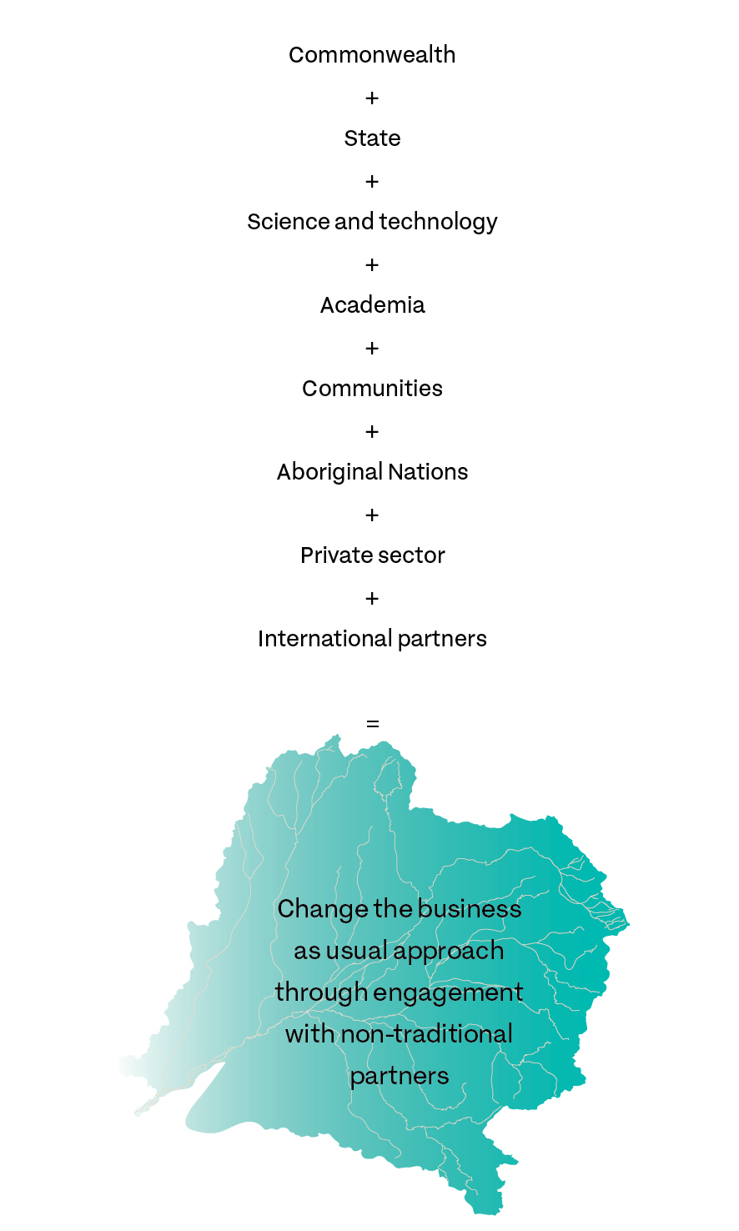

### Communication issues

Communication of the Plan has been characterised by a lack of focused or coordinated effort by the many government agencies involved. It has also been hampered by the complexity of the water management arrangements in each jurisdiction, stakeholder unhappiness with a range of historic decisions by states, and at times a lack of shared commitment to the outcomes being sought. Case study 4 and Case study 5 illustrate some of these problems.

Case study 4 Menindee mass fish deaths

|  |
| --- |
| In the summer of 2019 there were a series of mass fish deaths in the Lower Darling and Menindee Lakes. There was public outcry and extensive media backlash against water resource managers at the state and Commonwealth levels.  The MDBA was the focus of intense negative scrutiny. By coincidence, the timing of the fish deaths coincided with the release of the South Australian Royal Commission report on the management of the MDB, which added fuel to heightened emotions. Misinformation about both the MDBA’s and NSW’s management actions flooded social and news media for much of the first quarter of the year, limiting the capacity of all organisations and communities to come together in a united approach. The situation was exacerbated by the crippling drought.  Although there was a significant amount of community engagement undertaken, the communication strategies of the Commonwealth agencies and departments failed to disseminate the factual information. The then Department of Agriculture and Water Resources (now the Department of Agriculture) did not appear to support the MDBA or provide public leadership to manage the accusations of gross mismanagement by the Commonwealth, despite the fact the department has a lead role in policy.  Social media was not managed well by any agency to counter spurious claims about the causes of the fish deaths, placing significant political pressure on providing answers to what were essentially operational and scientific causes.  Various reviews (Australian Academy of Science 2019; MDBA 2019) found that while there are ongoing management issues that urgently need to be addressed, the primary cause was the record breaking drought. It should be noted that in spite of the damage done to river systems in the Millennium Drought, actions to restore fish numbers must have had significant positive impact prior to this sad event, otherwise the fish would not have been present in such large numbers.  Neither of the subsequent reports said the Plan should be halted. Both found that water recovery and active management to protect environmental flows, already slated for action under the Plan, needed to be progressed as a matter of urgency.  The NBC is in agreement that the protection of environmental flows, through delivery of the toolkit measures in the northern Basin, should be a priority for action by NSW and Queensland. Communication of the facts using a variety of media (especially social media platforms) could have assisted in managing this issue. |

Case study 5 Release from Beardmore Dam

|  |
| --- |
| On 28 April 2019 Sunwater, the company that manages the operation of Beardmore Dam as a contractor to the DNRME, opened the gates to allow the dam to drain. This was done to allow works to address flood damage incurred in 2011.  At the same time the water was released, inflows from a rainfall event in the Maranoa added to the volume of the release. Downstream users put out a call for flows to be released slowly, at 730 M/day as per the regulation for environmental stock and domestic flows in Queensland.  Prioritising the repairs for safety reasons, Sunwater (with the support of DNRME) allowed larger volumes of water to pass down the system, causing the river to back up and spill out onto the floodplain instead of flowing further downstream.  Many stakeholders downstream of Beardmore and into NSW were distressed by the approach taken, given the extremity of the drought and the dire state of the rivers.  Despite authorities having advised the Commonwealth and NSW ministers’ offices of the circumstances surrounding the release, complaints were received by the NBC about the lack of communication from DNRME about what happened and why.  This is a classic example of why a single source of accurate information for what is happening in the northern Basin is so important for all stakeholders to access regardless of jurisdiction.  The MDBA has proposed an inter-governmental northern Basin Forum be formed to support active management and to engage all stakeholders in decision-making processes. The NBC supports the development of such a body, and notes the potential for this function to be taken on by the Northern Basin Project Group created in the new schedule to the COAG agreement on the Plan implementation (Australian Government 2013). |

### Complexity of rules for protecting environmental flows

The NBC received a submission from a landholder in the Macquarie system highlighting their concerns about amendments to the licence conditions permitting take of Commonwealth environmental water.

Further investigation proved this to be true. The success of the Plan depends to a large part on the recovery of water through purchasing of entitlements or Commonwealth investment in more efficient irrigation systems. The recovered water is managed by the Commonwealth Environmental Water Holder (CEWH) to maintain and improve the health of the river system. However, current NSW regulations do not adequately protect the entitlements owned by the Commonwealth from extraction in the northern Basin.

An additional issue raised by this submission was the unintelligibility of the licence itself. Figure 5 is a small extract from an eight-page document.

This licence could only be interpreted by NSW DPIE, demonstrating the lack of consistency across jurisdictions as to what a licence looks like and the lack of universal understanding of what it entitles the licence holder to do. The NBC had to refer the licence to several experts in water management agencies in order to interpret the licence conditions.

The lack of simplified and universally understood licences is a serious barrier to effective water management, as well as a communications issue. This needs to be addressed if a single site for information is implemented as a reference point across the MDB.

Figure 5 Extract from Macquarie River water licence, NSW

The extract shows some of the conditions that the water user must comply with. Two of these conditions have been highlighted:
1) Water must not be taken from flows resulting from releases of sub-allowance 2 from Burrendong Dam.
2) When replenishment flows are released from Burrendong Dam, water from those flows must not be taken.
Both conditions relate to the protection of environmental water under the NSW water sharing plan for the Macquarie River: the Macquarie Bogan Unregulated and Alluvial Water Sources Water Sharing Plan.

### Communications and coordination (2)

#### Findings

* 1. Simplification of rules over water access, and the communication of those rules would make it easier for water users to be compliant, and conversely, it should be easier to detect and ultimately prosecute those who are non-compliant.
  2. It would be useful to establish an ongoing Northern Basin Forum to support active management of water in the north and to engage stakeholders in decision-making processes.
  3. The protection of environmental flows, through delivery of the toolkit measures in the northern Basin, should be a priority for action by NSW and Queensland.
  4. Communication of the facts using a variety of media (especially social media platforms) would be beneficial.
  5. There is a tendency to lay blame for water management decisions at either the Plan or the MDBA when in fact it is often state government decisions – some taken well before the Plan existed - that are the underlying cause. This is partly due to the complexity of the arrangements and widespread lack of understanding of who is responsible for what.
  6. There is mistrust and a lack of confidence amongst stakeholders, generated by the absence of a single source of accurate and relevant information.
  7. The pursuit by jurisdictions of their own communications networks has resulted in duplication and poor coordination of timely information.
  8. The sharing of intelligence, including scientific and technical capability, is poor.
  9. Multiple agencies are consulting widely in the northern Basin resulting in duplication of effort.
  10. Where consultation occurs and action does not follow, it delivers an impression that agencies are not listening, when in fact it is sometimes the case that the agency consulting does not have the remit to deliver the outcome.

#### Recommendations

2.1 Adopt a single non-partisan approach to communication and coordination of activities across the northern Basin that provides a single site for relevant and accurate information regarding water entitlements and availability for all stakeholders. This platform should provide a joined-up approach to intelligence, compliance, and science and technology.

#### Closing thoughts

A single source of accurate and relevant information is essential because certainty is the key.

## Governance

### Ministerial Council and Basin Officials Committee organisational structure

Figure 6 Governance arrangements for water resource management in the Basin

The Commonwealth Water Minister is the decision-maker of the Basin Plan and chairs the Ministerial Council.

The Murray–Darling Basin Authority is responsible for developing, implementing, evaluating and reviewing the Basin Plan. The authority also manages the River Murray system on behalf of joint governments. The authority is made up of the Chair, the Chief executive and 4 part-time members. The authority makes recommendations to the Commonwealth Water Minister, and consults with and provides advice to the Ministerial Council. The authority also consults with the Basin Community Committee on Basin community issues.

The Ministerial Council is made up of the state water ministers from the 5 Basin state and territory governments. The council has a policy and decision-making role on state water shares and the funding of joint programs under the Murray–Darling Basin Agreement. It also provides advice to the Commonwealth Water Minister and delegates to the Basin Officials Committee.

Under the Murray–Darling Basin Agreement, the Basin Officials Committee has a decision-making role on state water shares and the funding of joint programs. The committee comprises officials from the 6 Basin governments.

In addition to the Chair, the Basin Community Committee has 16 members, including one authority member. The committee's role is to provide advice to the authority and the Ministerial Council on Basin community issues. The Chair is an observer at Ministerial Council meetings by invitation.

Source: Courtesy of Murray–Darling Basin Authority (updated 2 October 2018)

#### Core values

1. The decision-maker on the Basin Plan and chairs Ministerial Council.
2. Responsible for developing, implementing, evaluating and reviewing the Basin Plan. Manages the River Murray system on behalf of joint governments.
3. Policy and decision-making roles on state water shares and funding of joint programs as per the MDB Agreement.
4. Has decision-making roles on state water shares and funding of joint programs as per the MDB Agreement.
5. Provides advice to the Murray–Darling Basin Authority and Ministerial Council on Basin community issues.

### Culture of ‘waiting out’ incumbent ministers

During the reporting period there was a common observation made by public servants, water title holders and lobbyists: their complaint was that each time a minister moves into the portfolio the water policy seems to have a different focus. This was particularly cited in Queensland in the changeover to the Newman government from the Bligh government and more recently in NSW with the change from former Minister Blair to Minister Pavey.

The ongoing NSW ICAC investigation has also had an impact, given its focus on former MPs and public servants, as has the recently released report from the NSW Natural Resources Commission in the Barwon–Darling.

A risk averse culture pervades some sections of the public service unwilling to test the limits of the current regime only to see it revert to something else if the minister moves on to another portfolio. This shifting of goal posts has led to a culture of ‘waiting out’ the incumbent to avoid a conflict between legislated drivers and other priorities.

It is hoped the recent commitment to the Plan at the August 2019 COAG meeting will provide certainty in continuing along the same policy lines as in previous years despite the extreme drought conditions experienced in 2018–19.

In just over a decade, the number of ministers and assistant ministers with responsibility for water has included:

* 11 Australian government ministers and 5 Queensland government ministers since 2007
* 6 NSW government ministers since 2008.

Until 2015, water was within the environment ministerial portfolio. In 2015, responsibility for water was made part of the agriculture portfolio while environmental water remained in the environment portfolio.

### Process driven

Within this report, there are a number of examples that highlight a real concern among stakeholders the Department of Agriculture has become process driven rather than action oriented.

It is understandable that proper governance has to accompany the expenditure of public monies, but the culture of the Department of Agriculture does not appear to be one of enabling projects. Holding the purse strings with no role to play in project implementation places the Department of Agriculture in an invidious position.

On the one hand, it is trying to ensure taxpayers’ funding is spent wisely. On the other hand, the Department of Agriculture is not the agency delivering most of the projects for which it allocates funding.

It was discovered during the NBC initial 12 months of operation, the Department of Agriculture does not possess the skills to sit on panels to assess competitive bids, so it outsources or puts to tender, a ‘buy in’ of the skills required to simply consider funding bids without any actual value add to the project to be delivered. Ironically, given the engineering skills embodied within the MDBA, the Department of Agriculture does not appear to routinely seek advice from that source.

The Department of Agriculture does not enjoy a good reputation partly because its role is that of holding the purse strings and those who miss out on funding become disillusioned. The processes are exacerbated by the seemingly ad hoc priority given to projects that only come to light after visits to the region by politicians or senior bureaucrats.

This is not meant to be a criticism of any person in particular. However, the aggregation of poor briefing capability, ad hoc project prioritisation, lack of expert skills and a defensive protection of the public purse gives rise to opinions of inefficiency or ‘roadblocks’ to progress.

The Department of Agriculture needs to be more aware of its own reputation and seek to ameliorate it without losing its ability to adequately account for expenditure on projects. Several ideas have been suggested to improve the operations of the department in water resource management including rotating the chair position of the BOC and out-posting of officers on a temporary basis to assist the jurisdictions to access funding for projects.

The aim of the Department of Agriculture should be to shorten the time between decisions made by governments on projects and their implementation through the development of an ‘enabling culture’. The timeline in Case study 6 demonstrates that there are significant delays in project implementation in the northern Basin.

Case study 6 Slow delivery of Northern Basin Toolkit measures projects

|  |
| --- |
| November 2016  The Northern Basin Review (NBR), undertaken by the MDBA over the past four years, made recommendations that a ‘toolkit’ of measures be implemented by the Commonwealth, NSW and Queensland governments to protect environmental water and improve water delivery and water management across the northern Basin. There are 6 measures in total, 4 of which require funding.  June 2017  MDB ministers make an in-principle commitment to implement the toolkit measures, subject to an amendment to the Basin Plan being made to formalise outcomes of the NBR.  **November 2017**  Basin Plan Amendment Instrument (No. 1) 2018 (to formalise NBR) tabled in the Commonwealth Parliament.  February 2018  Commonwealth announces funding of up to $180 million be made available over the next six years to support Queensland and NSW in implementing the toolkit measures and environmental works.  Basin Plan Amendment disallowed in the Commonwealth Parliament.  May 2018  The Commonwealth agrees to a package of further initiatives to support Basin Plan implementation ensuring the delivery of the outcomes of the NBR (and Sustainable Diversion Limit Adjustment Mechanism) and agreement to the Basin Plan Amendment.  July to August 2018  Basin Plan Amendment re-tabled and made law in Commonwealth Parliament.  December 2018  The Commonwealth, NSW and Queensland agree to:  – a proportion of the funding, for toolkit measures and environmental works, be made available to undertake project feasibility assessments.  – amend the 2013 Intergovernmental Agreement on Implementing Water Reform in the MDB (the IGA) to include implementing the toolkit measures.  August 2019  All Basin governments formalise the agreement to implement toolkit measures in the IGA.  Current  Commonwealth, NSW and Queensland finalising funding arrangements for NSW and Queensland to develop feasibility proposals.  Early 2020  NSW and Queensland feasibility proposals to be assessed and a package of priority projects determined by the Commonwealth. Priority project business cases to be developed by state proponents and are expected to be completed by end 2020 (as required under IGA). |

Case study 7 Progress with hydrometric and remote sensing proposal

|  |
| --- |
| May 2018  The Australian Government committed $20 million to support improved hydrometric networks in the northern Murray–Darling Basin (MDB) and the development of remote sensing and other relevant technologies to enhance monitoring, measurement and compliance across the MDB.  July 2018  The Commonwealth Minister for Water Resources agreed to provide policy approval for funding to improve hydrometric networks in the northern MDB (Hydrometrics and Remote Sensing program).  August 2018  The Department of Agriculture commences consultation with Basin states and the Murray–Darling Basin Authority (MDBA) on the selection criteria for proposals to the Hydrometrics and Remote Sensing program. Guidelines for the Hydrometrics and Remote Sensing program are developed and approved.  November 2018  Hydrometric Networks and Remote Sensing Funding Program guidelines report released.  Application process for the Hydrometrics and Remote Sensing project proposals commences.  November 2018 to February 2019  Application period for the Hydrometrics and Remote Sensing project proposals.  January 2019  Northern Basin Commissioner invited to be part of Hydrometrics and Remote Sensing Project proposals assessment process.  July 2019  Agreement to support joint MDBA, Queensland and New South Wales project - subject to more detailed project plans being developed, and a final assessment process undertaken.  August 2019 to current  NSW, Queensland and MDBA working with consultants to develop more detailed projects for assessment by the department, due December 2019. |

Figure 7 Stakeholder sentiment—governance

• Indecisive
• Absent
• Controlling
• Sitting on hands
• Waxes and wanes
• Role of the Commonwealth is confusing
• Lacks initiative/innovation
• Focussed on process, not outcomes
• Slow to act
• Disorganised/unclear priorities
• Poor communicators
• Inflexible
• Lack agility


Note: The contents of the topic clouds are derived from interviews undertaken by the NBC and do not represent the Commissioner’s views.

Case study 8 Border Rivers Commission

|  |
| --- |
| The Dumaresq–Border Rivers Commission was established in 1946 to implement the agreement made between the governments of Queensland and New South Wales in relation to:   * Sharing the waters of the rivers and streams, which either form or intersect the boundary between the two states and the associated groundwater resources * Investigating, constructing and operating works to conserve and regulate those waters where considered desirable.   According to the 2016–17 and 2017–18 reports, the commission formally met on one occasion each year. Individual commissioners, not acting as the commission, met during the year on several occasions to participate in discussions on several matters.  Anecdotal evidence provided to the NBC indicated the commission is ineffective. This is due to both the changed management environment since the enactment of the Commonwealth Water Act 2007 and the Basin Plan 2012. It is also considered by the relative state departments that it is logistically impossible to gain the signatures of two ministers (premiers of NSW and Queensland) required to approve actions.  The recent agreement at COAG to a new ‘northern Basin’ schedule to the intergovernmental agreement on Basin water reform implementation (COAG 2013) should provide a springboard to establish a new northern Basin forum that, among other things, coordinates environmental flow and allocation issues in the northern Basin. Such a forum could incorporate the historic functions of the Border Rivers Commission. |

### NBC role and terms of reference

The ToR for the NBC role are not compatible with reporting measurable outcomes. They are too broad and address issues currently the responsibility of other agencies (see Northern Basin Commissioner terms of reference).

### Governance (3)

#### Findings

* 1. Benefit would be derived from Commonwealth and states adopting more of a partnership or co-management approach to the implementation of infrastructure projects, rather than the current service provider model. Accountability for delivery of projects to the desired standard and timeframe should be jointly owned by each level of government.
  2. The BOC in its present form is not considered to be value adding to compliance in the northern Basin (e.g. CEWO not a permanent member).
  3. Implementation of governance improvements recommended by Greg Claydon’s review have not been fully implemented. Inclusion of the CEWO and MDBA as BOC members would be advantageous.
  4. There is thought to be a culture of ‘waiting out’ ministerial terms to avoid implementing policy changes.
  5. Agencies and officials are not declaring conflicts of interest in accordance with NSW and Queensland policies.
  6. The Department of Agriculture does not have or communicate a clear mission statement of its role or value proposition in the northern Basin.
  7. The Department of Agriculture is viewed as not providing a leading and enabling capability from which agencies can access funding for programs in the northern Basin.
  8. Bids for resources are competitive rather than collaborative, reducing the potential positive impact of projects on the northern Basin.
  9. There is an unacceptable delay between initiation of projects to improve water resource management and project completion.
  10. The NBC terms of reference were not measurable or accountable in their original form.
  11. The Border Rivers Commission should be reviewed as to its effectiveness.

#### Recommendations

3.1 Endorse the appointment of an Inspector-General of Water Resource Management with appropriate powers to oversee governance and program delivery across the entire MDB who can also deal with allegations of corruption or misconduct by referring them to existing integrity oversight bodies.

## Historical artefacts

### The legacy of history

During the course of the first term of the NBC much has been said about historical artefacts. Examples of the type of issues raised by community stakeholders include:

* a strong feeling in both Queensland and NSW that buybacks are associated with rorts linked to over allocation of water entitlements from previous decades of corrupt or inappropriate practices
* amounts paid for some buybacks appear on the surface to reward 'bad behaviour' as alleged in the ABC 4 Corners program of July 2017
* some entities receiving significant funds for buybacks are linked to political parties
* amounts paid for some buybacks are in excess of market value
* a political divide in the lead up to the 2019 Federal election where Labor promised to repeal previous legislation introduced by the Coalition government putting a cap on water buybacks.

In addition to the aforementioned is the Productivity Commission five year assessment of the Plan and the ongoing investigation by the NSW ICAC. The ANAO has also been asked to investigate purchases of two licences from Eastern Australia Agriculture for about $78.9 million. The NSW Natural Resources Commission has handed down its most recent report on the Barwon–Darling systems recommending the buyback of ‘A’ Class licences as part of the strategies into the future.

The caps and buybacks present an interesting quandary for governments. On the one hand, it is one of the only ways a government can remedy the legacy of past decisions. On the other hand, governments can be seen to be further rewarding certain stakeholders. For the Commonwealth – it remains the only way to control behaviour in the absence of introducing retrospective legislation, which governments are loathe to do.

We will have to await the outcome of the various inquiries before stakeholders, including the general public, can be satisfied about the integrity of Historical Artefacts. Until the situation is clearer, it is probably better to err on the side of caution and not continue buybacks, as it may conflict with the outcomes of the various current investigations or inquiries.

Case study 9 Issuing of water entitlements

|  |
| --- |
| During the ‘development’ phase up to the 1980s (1990s in Queensland), licences providing access to water were available virtually on demand. There were state statutory licensing systems that permitted access and use of water with users simply making an application to the relevant state agency. This approach was met with some concern from parts of the community.  A key concern at this time was that water and land were being accumulated by large corporate entities and that process was not transparent. This fear of water barons or speculators remains to this day in discussions about water markets.  Licences were issued for specified periods, however there was an expectation of automatic renewal, particularly from private diverters. As these licences continued, governments struggled to establish caps that allowed for sustainable levels of extraction within which trading of entitlements could then take place.  The introduction of the Cap on diversions in 1995 was a significant milestone, but this limit was not based on a scientific view of sustainability, adherence by states was voluntary, and it did not apply to groundwater. The Basin Plan made under the Water Act 2007 was the first time in which a legally enforceable limit on both surface and groundwater diversions was possible in the Basin (National Water Commission 2011). |

Case study 10 Queensland moratorium

|  |
| --- |
| When the Queensland Water Act 2000 came into effect, as part of meeting their commitment to the Cap on Diversions, the state government called a halt to development of any new infrastructure for water diversion and storage. Water planning processes were developed and by 2004 landowners had to notify the regulators of any planned works to increase take.  Stakeholders have complained to the NBC that the system relies on self-reporting. Some felt that the true extent of extraction for consumptive use may not have been accurately assessed in this process, and that some landowners may have increased the size of their storages without declaring it.  When accurate metering is fully implemented in Queensland, and remote sensing capability is improved and applied to water resource compliance, any undeclared increase to storage should become very easy to detect.  An increase in the numbers of on-ground staff would increase both compliance and be an effective deterrent. |

### Culture of mistrust

There is a culture of mistrust that permeates the opinions of northern Basin stakeholders and that has been made quite evident during the first year of review. Some of the mistrust emanates from the historical artefacts mentioned in this report. Unresolved investigations such as that undertaken by the NSW ICAC fuel speculation that not all is well in terms of the integrity of the political/stakeholder/policy engagement.

A good example of this is the issue of the ‘A’ Class water licences. The graph illustrated depicts a timeline of extractions of water taken over decades and shows the impact of the rule changes affecting ‘A’ Class licences that were introduced in September 2012.

Feedback to the NBC suggests amendments were made to the Barwon–Darling Water Sharing Plan in response to pressure from lobby groups with political interests.

The culture of mistrust exists among irrigators as well. During one meeting with irrigators in a part of the northern Basin, several of those present alleged that there was no need for compliance activities because everyone only extracted what their licences entitled. By the end of the at times, acrimonious meeting, almost all of those present admitted that they ‘bend the rules’ according to their needs at the time but because ‘everyone’ does it – there is no problem.

It is well known in the northern Basin who is aligned with irrigators and who is not. It is just as well known when irrigators or persons with connections to irrigators are involved in local government decisions around water resource management, either as councillors or as lobbyists. The NSW ICAC and the Queensland Office of the Independent Assessor provide excellent advice and opportunities for persons engaged in activities who have a perceived conflict of interest (NSW ICAC 2019).

The buyback of water licences by governments is seen by some to favour particular water title holders over others. Some of those water licence holders are thought to be heavily involved in donating to political parties or lobbying political parties so the compensation payments are seen as ‘kickbacks’ and not as a way of improving the water resource management of the northern Basin.

An option for the Commonwealth government is to await the outcome of the NSW ICAC investigation before engaging in any further buybacks including ‘A’ Class licences. This is despite the NBC supporting the findings and recommendations of the NSW Natural Resources Commission report on the Barwon–Darling river system released in August 2019.

We all have to work together to rebuild trust and integrity into the policies governing the northern Basin. Confidence and trust work hand in hand, but as Figure 8 clearly illustrates, people will access their entitlements as soon as they become aware of a change in policy, which is why the policy making process has to be based on strong and honest foundations.

Figure 8 Timeline of annual volumes of water extracted under ‘A’ class licences in the Barwon–Darling, 1990–91 to 2017–18

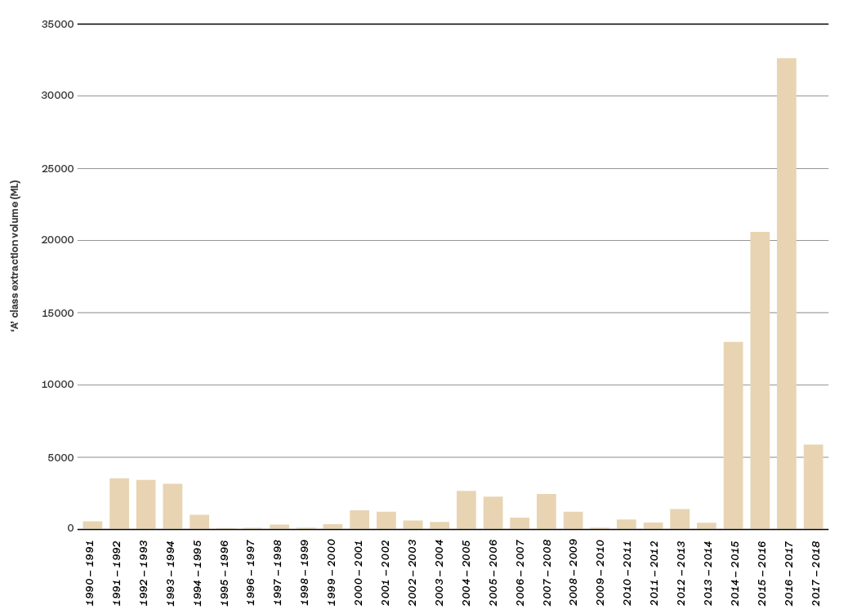

Source: MDBA; NSW Department of Planning, Industry and Environment; NSW Water Register, WaterNSW.

Case study 11 Burning of the Guide to the Draft Basin Plan

|  |
| --- |
| On 13 October 2010, people set fire to the Guide to the Draft Basin Plan at a community information session hosted by the then MDBA. The document was burnt to protest the recovery of water for the environment and the perceived negative impacts to the communities along the river.  The incident was a shining example of how not to conduct public consultation. Firstly, the water recovery targets in the Guide were based on overly simplistic analysis (superseded by new analysis completed for the final Plan). Secondly, the community was left with the impression that any water recovery targets would need to be met through compulsory processes (when this was clearly not intended – all recovery was to be through investment in efficiency projects or through voluntary purchases). The fallout from this experience led to the removal of the then Chair of the MDBA, who was replaced by the Hon. Craig Knowles.  The protest was an indication of the height of emotion that has continued to this day. The furore appears to reflect the feelings of many people who met with the NBC concerned that decisions are being made to favour particular interests.  The emotions of 2010 are as raw today no doubt brought about by the current drought. A considerable number of reviews have been undertaken into the actions of states and the Commonwealth, including a South Australian Royal Commission. The number and timeliness of the reviews reduce the period available to implement their respective recommendations. By the time a response is formulated, there is often a change of government and actions are sidelined in favour of new agendas. Trust in the ability of agencies to rise above local interest and act in favour of the Basin as a whole, is lacking.  While anger is focussed on the Plan, this ongoing negative sentiment continues to cause agitation in the Basin communities. Confidence in the Plan must be restored.  This could be assisted by clearer public support for the work of the MDBA and the CEWO including through ministerial statements, by expediting the appointment of vacant board positions, in particular the Chair, and through the passage of legislation to enhance the MDBA’s compliance powers and to establish the new Inspector-General function.  State governments will also need to play their part in restoring confidence in the arrangements. In the northern Basin, the best test for this would be in expediting the actions contained in the northern Basin work program, including the completion of water resource plans. |

### Community expectations

In another example of the intensity of emotion surrounding this reform, there was public outcry following mass fish deaths in the Lower Darling and Menindee over the summer of 2019. Former NSW Minister for Water, the Hon. Niall Blair, was the subject of threats to himself and his family, as tensions between water users and water managers ran high. The minister required police protection during this period.

The Plan remains an emotive issue for some. More recently, in September 2019, in Victoria a group of angry protesters brandishing a noose attempted to confront the Commonwealth Minister for Water Resources, the Hon. David Littleproud during a tour of the southern Basin. In the same month, angry farmers in New South Wales, threw an effigy of the Commonwealth Minister for Water Resources into the Murray River, calling for the minister to be sacked.

The situation is symptomatic of the tensions that arise when policies implemented by previous governments give rise to unrealistic expectations of unfettered access to water by irrigators without prioritising the needs of the environment, the needs of Aboriginal Nations, and the needs of others in the community - including for stock and domestic use. Political expediency has created an unrealistic sense of entitlement. This coupled with current drought conditions is giving rise to tensions within sectors of the community. Having viewed the devastating impact of the drought first hand during the reporting period, the intensity of emotion is understandable, however, threats of violence against elected members of Parliament is not in keeping with the Australian democratic way of life and should not be tolerated.

Unless the levels of expectation and sense of entitlement can be reset somehow through legislation or through better governance, it is unlikely these historical artefacts will be corrected and we can expect to see more threats of personal violence into the future as individuals fight for what they believe is theirs to keep.

The notion of Social Licence being of a higher order than previous poor policies where more licences were issued than there is available water has to prevail. In northern NSW, removing ‘A’ Class and some ‘B’ Class licences, and inactive or sleeper licences will help to correct previous policies and reduce levels of expectation and entitlement.

To better communicate the state of play with water access it would also be useful, on a valley by valley and aggregated basis, to illustrate how much of the total pool of water is dedicated to the entitlement system and for what purpose (irrigation, mining, town supply, etc.), how much for stock and domestic use or other riparian rights, how much for cultural flows purposes, how much for the environment, and how the relative amounts of use change through a cycle of wet, normal and dry years – so that the community can more easily understand the complete picture of how water is used.

### Water trading

A number of stakeholders have raised concerns regarding the operation of the water market. The ACCC has been commissioned to conduct an inquiry into markets for tradeable water rights in the Basin. The ACCC will consider options to enhance markets for tradeable water rights, including options to enhance their operations, transparency, regulation, competitiveness and efficiency.

Figure 9 Annual allocation price scenarios, NSW Murrumbidgee, 2002 to 2020

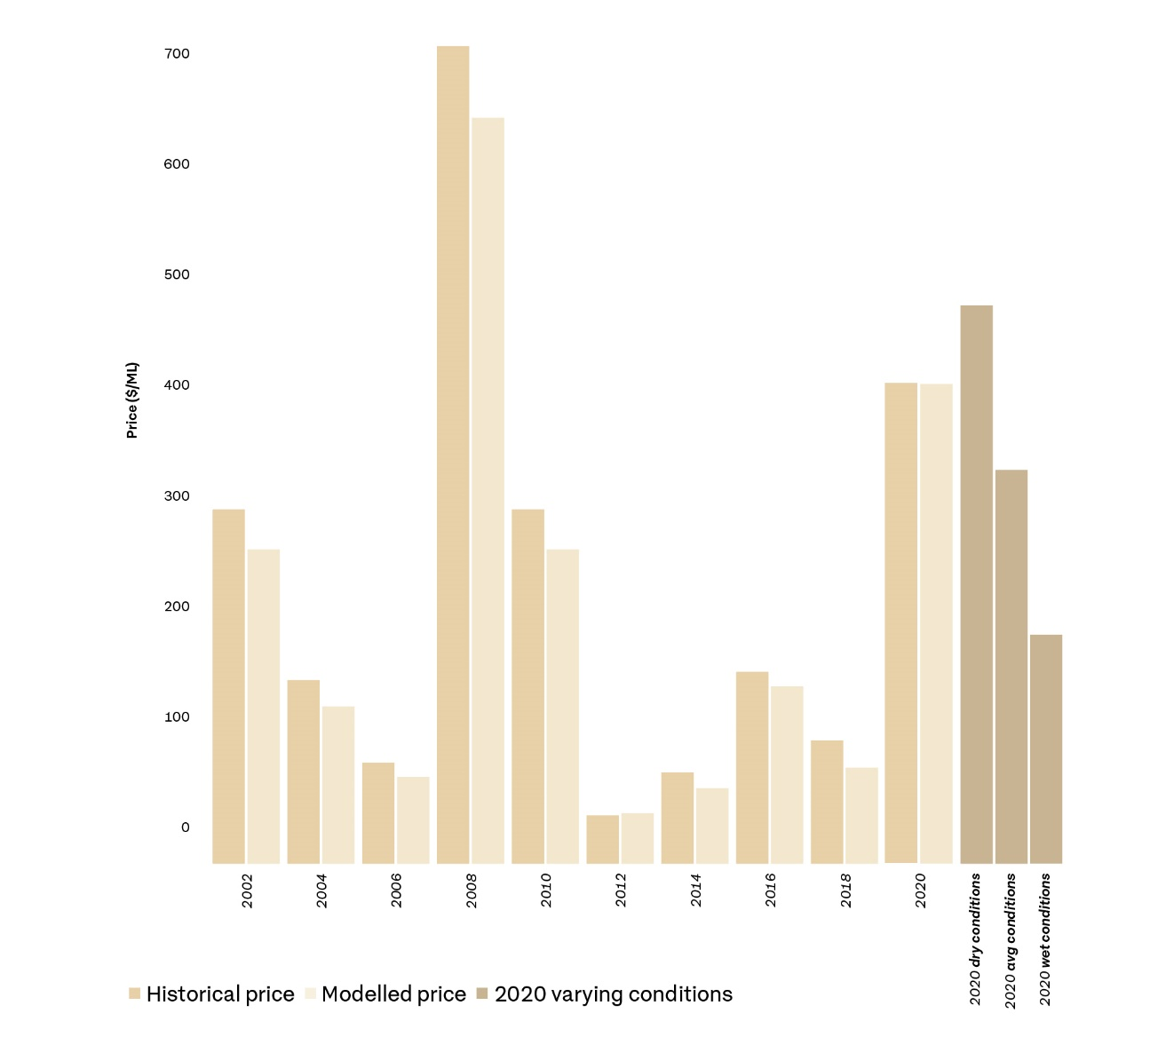

Source: Australian Bureau of Agricultural and Resource Economics and Sciences

### Foreign ownership

The total volume of water entitlements across Australia with a level of foreign ownership (foreign held) is 4,035 GL as at 30 June 2018 (ATO 2019).

Based on comparisons with Bureau of Meteorology (BOM) data, the estimated proportion of water entitlement (which includes groundwater and surface water entitlement) with a level of foreign ownership (foreign held) is 10.4% at 30 June 2018 (ATO 2019).

Key findings on a national basis include:

* Over 1,800 GL of foreign held water entitlement is within the Basin, which is 9.4% of the total water entitlement on issue
* The Basin in turn has just over 51% of the total water entitlement (surface and groundwater) on issue in Australia
* The greatest usages of foreign held water entitlement are for agriculture (66.5%) and mining (26.3%)
* China and the United States are the largest foreign water entitlement holders, each with 1.9% of total water entitlement, followed by the United Kingdom with 1.1%
* Over 81% of foreign held water entitlement is held within Australian incorporated entities
* NSW/ACT have the greatest amount of foreign held interest in water entitlement on issue by volume with 1,306 GL
* Queensland has the next largest portion by volume with 1,219 GL (ATO 2019).

The Australian Tax Office (ATO) is responsible for the registration and reporting on compliance in regard to foreign ownership of water entitlement. The reporting regime by foreign owners is voluntary so the scheme is a self-reporting arrangement. The ATO makes no inquiries into the background of the ownership. For example, the ATO has no records as to whether a foreign owner is an individual or if indeed it is a state entity.

Table 3 Foreign-held water entitlements in the Murray–Darling Basin

| Category | Murray–Darling Basin | Foreign-held water entitlement (GL) | Total water entitlement on issue in the Basin (GL) | Proportion of total water entitlement on issue in the Basin with a level of foreign ownership (%) |
| --- | --- | --- | --- | --- |
| Surface water | Northern Basin | 882 | 4,020 | 21.9 |
| Southern Basin | 738 | 13,354 | 5.5 |
| Groundwater | Northern Basin | 9 | 2,399 | 9.6 |
| Southern Basin | 140 |
| Total | | 1,852 | 19,773 | 9.4 |

**Source**: Australian Tax Office (ATO 2019)

Figure 10 Stakeholder sentiment—legacy of history

• Zero water despair
• Politicians have stayed silent while farmers in the Murray-Darling are robbed of irrigation water in the midst of the drought
• The governance of the Murray-Darling Basin should be national, not divided into potentially warring state interests
• Murray-Darling battle
• Arguments over water can miss the big picture
• Empty words
• Sidestep states for real Murray action
• There are concerns by farmers in the southern Murray-Darling Basin on the system of trading of water
• Worst drought
• The nuts and bolts
• Role of the Commonwealth confusing
• States feeling heat of trade tensions
• Lacks initiative/innovation
• Water trade set to crack
• The current drought in historical perspective
• Spirit got lost in the Murray-Darling Basin PlanNote: The contents of the topic clouds are derived from interviews undertaken by the NBC and do not represent the Commissioner’s views.

### Historical artefacts (4)

#### Findings

* 1. Without statutory powers, the role of the NBC could only be achieved in a collaborative environment.
  2. Historic decisions about the issuing of water licences in the northern Basin have led to strongly-held views about inequity over access to this public resource, and more recent concerns over market power. Current and future policies aimed at redressing the balance of water between its various uses including the environment should be transparent and avoid adding to these perceptions as much as possible. The ACCC inquiry should also assist in addressing these concerns.
  3. Compliance today suffers from a legacy of previous decisions made in a different environment that was pro-development/pro-irrigation. While a stronger culture of compliance has been evident since the 4 Corners program, it will take further effort and resourcing to make this a lasting change.
  4. The Barwon–Darling Water Sharing Plan is an example of how policies can be lobbied for change and subsequently re-lobbied for further change and compensation.
  5. Monitoring the level of foreign ownership in water is a self-reporting, voluntary system subject to no compliance action.
  6. There is a perception that political parties favour certain constituents to the detriment of other water stakeholders including but not restricted to the environment.
  7. Links between donations made to political parties by individuals and groups to decisions made on water policy are not easily identified. Donations by any water stakeholders to political parties should be transparent.
  8. There is a crisis of confidence in the northern Basin affecting stakeholders at all levels; political, departmental, researchers, lobby groups, and end users such as graziers and irrigators.
  9. Governments should be careful not to reinforce perceptions that their decisions are biased towards a particular sector or group of stakeholders. All aspects of water management from the information base, planning, allocation decisions and compliance should be publicly available in a form that can be understood by the community.
  10. A clear and equitable resolution to the Barwon–Darling planning issue is urgently needed to help restore confidence in the process.

#### Recommendations

4.1 Provide a calculation of the total surface and groundwater water pool in the northern Basin on a valley by valley basis including the amount dedicated to water licences (by use), to other forms of entitlement such as stock and domestic use, riparian rights and farm dams, for Aboriginal cultural flow requirements, and for environmental use. Such an analysis would help the community to understand the relative priorities for use and the viability of current licence types.

4.2 Buyback strategies and water trading should give consideration to findings from the current ACCC and Auditor-General inquiries.

#### Closing thoughts

You cannot have a water market that is not properly governed or transparent, particularly given its increasing value.

Some capitalise the gains and some socialise the losses.

## Aboriginal Nations

This is one of Australia’s most magnificent wetlands. When boom times come, the system overflows with water and life. Spectacular colonies of tens of thousands of ibises and spoonbills are very special. — Richard Kingsford, Professor of Environmental Science, University of NSW, Sydney in a quote referring to Gayini Nimmie-Caira

I was so inspired by its ambitious vision, including enhanced Aboriginal cultural heritage, sustainable agriculture, management of environmental water and conservation of waterbird breeding habitat, that I wanted to support it. — John B Fairfax AO, business leader and philanthropist in a quote referring to Gayini Nimmie-Caira

### Water entitlement for Aboriginal Nations

The separation of water title from land title allowed water to be traded. Regulators set out operational rules to manage water more efficiently for agricultural industry and for environmental water holders, who must operate within the same rules as industry. However, the occurrence within 10 years of a drought as significant as the Millennium Drought has played havoc with the intent of the separation. The drought we are in now is described as the worst in our history and has exacerbated the situation.

Aboriginal Peoples are most often not in a financial position to access water (Moggridge 2017). Water title has not been awarded to them, irrespective of whether Native Title has been awarded or there is a recognised connection to an area. (Delfrau 2017) This appears to be a substantial policy gap that governments will need to address nationally.

The CEWH has demonstrated a willingness to include input from Aboriginal Peoples in its watering decisions both in policy (Department of the Environment 2016) and at certain sites (e.g. Toorale National Park is one northern Basin example). Aboriginal Peoples’ representatives have indicated that while they appreciate this, they want to have decision-making powers over their own water.

Various Aboriginal Peoples’ representatives have met with the NBC both in Brisbane and on his visits to the regions. Some of the ideas presented to the NBC on ways to improve Aboriginal engagement in Basin Plan outcomes have included building ‘cultural hubs’ and a network linking them, encouraging people to follow the ‘water highways’ followed by generations of traditional owners.

Many people talking to the NBC voiced their wish for a northern Basin ranger program focussed on building water management expertise for cultural flows, strengthening connections with Country, and educating the wider community.

Indigenous ranger programs draw upon Aboriginal Peoples’ knowledge and connection to Country to protect and manage land and sea country across Australia. There are over 100 separate Aboriginal Ranger groups in Australia (Country Needs People 2019).

Many rangers are Traditional Owners of the land on which they work, although this is more challenging in the northern Basin where relatively little land is under traditional ownership. Some rangers are employed through local Indigenous host organisations with funding provided by the state and Commonwealth governments (Queensland Government 2019). Local communities have widely acknowledged the benefits of Indigenous ranger programs.

### Development timeline

Engagement with Aboriginal Nations in the Murray–Darling Basin has not been moving in tandem when comparing the southern Basin with the northern Basin. Endeavours to achieve a unified voice on behalf of the 22 Nations in the northern Basin that is both authoritative and representative of all Nations’ interests are still progressing.

Given the relative recency of the Northern Basin Aboriginal Nations (NBAN) representative body it has to be kept in mind the maturity of the organisation will not be the same as that in the southern Basin. It is also to be expected that some Nations will be wary of the body until progress is seen and relationships with stakeholders are such that the benefits of becoming an active member of NBAN are self-evident.

The reporting period saw significant dysfunction in NBAN with a vote of ‘no-confidence’ in the Chair and a resignation of the Executive Officer (who since has resumed their position) as well as a number of Nations choosing to establish bilateral relations with the NBC. Some of these bilateral relations have been extremely positive, such as the relationship built with the Barkandji People involved in the Toorale Station near Bourke in NSW and the South West Indigenous Corporation based in St George in Queensland.

It will take time for NBAN to mature and expectations in comparing NBAN to MLDRIN need to be managed. At the same time, should the dysfunction experienced with NBAN during the reporting period continue, then alternatives must be considered so that First Nations in the northern Basin do not miss out on opportunities for their peoples.

#### Engagement with Aboriginal Nations in the Murray–Darling Basin

**1992** Mabo judgement

**1995** Land Fund established; Indigenous Land Corporation (ILC) commences operations

**1996** First National Indigenous Land Strategy

**1998** Formation of MLDRIN, during the Yorta Yorta Native Title Case

**2006** MLDRIN Memorandum of Understanding signed with Murray–Darling Basin Commission

**2009** First meeting of NBAN

**2011** Establishment of National Cultural Flows Research Project Research Committee

**2012** MDBA, MLDRIN and NBAN collaborate to assist over 400 First Nations People to make submissions on the Basin Plan.

Basin Plan enacted, requiring consultation with NBAN and MLDRIN by Basin states in the preparation of water resource plans.

**2016** NBAN Treaty of Unity signed at the Aboriginal Embassy in Canberra

**2017** NBAN completes the first assessment of whether a Basin state has met the requirements of Chapter 10, Part 14 of the Basin Plan.

**2018** Cultural Flows: A Guide for First Nations launched at Old Parliament House.

**2019** MLDRIN and NBAN member Nations now total approximately 20 to 25 ILC remit expanded to include water and renamed Indigenous Land and Sea Corporation.

### Bilateral Aboriginal Nation engagement

The northern Basin Aboriginal Nations are:

* Barkindji (Paakantyi)
* Barunggam
* Bidjara
* Bigambul
* Budjiti
* Euahlayi
* Gamilaroi
* Githabul
* Gunggari
* Gwamu (Kooma)
* Jarowair
* Kambuwal
* Kunja
* Kwiambul
* Maljangapa
* Mandandanji
* Mardigan
* Murrawarri
* Ngemba
* Ngiyampaa
* Wailwan
* Wakka Wakka

Figure 11 Bilateral engagement with the Northern Basin Commissioner

• Bigambul
• Euahlayi
• Gamilaroi
• Gunggari
• Gwamu (Kooma)
• Mandandanji
• Wakka Wakka

Note: The Aboriginal Nations listed have met with the NBC independently of NBAN.

Case study 12 Gayini Nimmie-Caira

|  |
| --- |
| In an example of what good application of Commonwealth funds can achieve, a consortium led by The Nature Conservancy was the successful proponent in a process run by the NSW Government in collaboration with the then Department of Agriculture and Water Resources, to establish the future management of the Nimmie-Caira project area on the lower Murrumbidgee River. In spite of significant delays to the implementation of this project, the outcome has been worth the wait for Aboriginal Peoples in the Maude/Balranald region of the Basin.  Nimmie-Caira (Gayini Nimmie-Caira to the Aboriginal Peoples of the region) is 85,000 hectares of internationally significant Murrumbidgee floodplain in southern NSW. The success of a joint proposal by The Nature Conservancy and the Nari Nari Tribal Council represents a once-in-a-generation opportunity to create a new, sustainably managed and financed conservation property for the benefit of people and nature (The Nature Conservancy 2018).  The development of the project through a unique approach to market allowed the vision of multiple groups to come together under one banner. Since taking over management in May 2018, a consortium led by TNC is managing Gayini Nimmie-Caira for better outcomes for nature and people. Together with its Traditional Owners represented by the Nari Nari Tribal Council, and in partnership with the Murray–Darling Wetlands Working Group and the Centre for Ecosystem Science at the University of NSW, the project aims to achieve (The Nature Conservancy 2019):   * Environmental protection – Proceeds of the commercial activities will be reinvested into environmental works on Nimmie-Caira. Extensive wetlands of Lignum, River Red Gum forests, lakes and floodplains will be enhanced and protected, providing a refuge for a large range of diverse wildlife. * Indigenous engagement and participation – Nari Nari Tribal Council will play a critical role in the management of the property, providing opportunities for Indigenous employment, improved health, education and reconnection to country. * Sustainable development – A diversified range of commercial activities that will boost the local economy and provide ongoing employment in the region around Hay and Balranald, NSW. * These activities will include sustainable, low impact grazing and tourism as well as other potential activities like carbon farming on parts of the property previously used for agriculture. |

### Aboriginal Nations (5)

#### Findings

* 1. Under its present leadership, NBAN is neither authoritative nor representative of the 22 Aboriginal Nations in the northern Basin.
  2. NBAN is still evolving and is not the same value proposition as MLDRIN in which governments can invest at this point in time.
  3. Aboriginal entitlement to water is unresolved compared with Aboriginal title in land.
  4. The Indigenous Land Council remains a viable alternative for investment by governments until NBAN reaches its full potential.
  5. There is strong support for an Aboriginal Ranger program especially if linked to an Aboriginal Water Highway and Cultural Hubs to enhance opportunities.

#### Recommendations

Improve the engagement with Aboriginal Nations in the northern Basin, giving consideration to international experience:

5.1 Support further practical examples of integrated land and water management on Country by Aboriginal Nations, including provision of necessary water entitlements.

5.2 Consider further mechanisms by which Aboriginal representatives can have input into the watering priorities of the CEWH in order to meet their cultural flow aspirations.

5.3 Support a three-year pilot ranger program in two or three localities within the northern Basin to demonstrate the potential of a larger program.

5.4 Encourage MLDRIN and NBAN to report to the MDBA through the Indigenous member on the MDBA Board.

5.5 Stronger support for NBAN to become an effective representative organisation.

#### Closing thoughts

The proper engagement of Aboriginal Nations in water management decisions and the ownership of water by Nations for cultural flow purposes – are both issues requiring greater attention of governments.

## Environment

### COAG agreement to action in northern Basin

In August 2019, the Northern Basin Project Group consisting of Commonwealth, NSW and Queensland agencies was established to implement improved environmental outcomes in the northern Basin, as per Schedule 3 of the revised COAG IGA for Basin water reform implementation (COAG 2013).

This work is to implement the so-called ‘toolkit measures’ recommended by the MDBA in its 2015 Northern Basin Review and the 2018 agreement reached by the Government and Opposition over the passage of related amendments to the Plan (Department of Agriculture 2019; MDBA 2016).

This work is a high priority and if undertaken as recommended will address many of the challenges raised in this report. However, there has been little visible progress with implementation to date and the community has little awareness of what is proposed. Urgent attention should be given to implementing this program and engaging the community (see Case study 6).

### Decisions based on best scientific advice

Water management decisions should be informed by best available science and made transparently so the community can have confidence in the basis of those decisions.

While seemingly outside the remit of the NBC both in the original ToR and the direction of this report, there is a nexus between scientific research, policies adopted by governments and transparency of decision-making.

There are many scientists who are engaged from time to time on the conduct and management of the MDB and in more recent times we have seen scientists engaged by both the Government and the Opposition on the event known as the Menindee Mass Fish Deaths.

The scientific research that is available on all aspects of water resource management in the MDB should enable transparent decision-making at the political level. Indeed, this was why the MDBA – an expertise-based board supported by a professional agency – was established. Their role is to develop a Plan based on best available science and recommend it to the government of the day – as happened with the initial Plan in 2012.

However, interviews conducted by the NBC throughout the reporting period reveal it is not universally accepted that this is how decisions are made and there are many allegations of decisions being made in favour of certain individuals and/or lobbyists.

This lack of confidence in decision-making amongst stakeholders is exacerbated by the lack of transparency in Australia’s electoral donation system. Whether it is true or not, many people engaged by the NBC have linked decisions made by governments over the course of many decades with perceived undue political influence by lobbyists and in some cases, wealthy land owners.

Better transparency around decision-making, especially when it is linked to government grants or compensation, will improve confidence in the integrity of the management of the MDB. This could be achieved through engagement and promotion of the scientific evidence, coupled with transparency around donations to political parties, or the publishing of reasons for enacting policies with seemingly generous compensation to persons of political persuasion.

Achieving this outcome will promote more confidence in government decisions as well as better outcomes for the Basin.

It was noted by some people that following the release of the report into the Menindee mass fish deaths, Minister the Hon. David Littleproud made a commitment of $20 million in funding for research in April 2019. While it was noted that this was in the lead up to the 2019 Federal Election, it was also noted the funding was made available to non-partisan entities, which ensures it will provide objective research and outcomes.

Another aspect of scientific research disclosed during the first year of NBC operations was the lack of linking and coordination between the various government agencies to access the latest in contemporary science and technology advances to monitor the MDB. Each agency seemed to be doing ‘its own thing’ in silos. The problem was identified and is being addressed. The MDBA has had preliminary discussions with Defence Science and Technology to explore options for collaboration and application of systems to support compliance. It is critical the Commonwealth lends its support to this forum, especially in the area of unclassified technology that is being used for other purposes.

Case study 13 Active Management of environment water entitlements

|  |
| --- |
| As discussed in the Release from Beardmore Dam and the Protection of Environmental Flows case studies, there is a problem in the Basin regarding implementation of legislation to both protect and actively manage water entitlements held by NSW and the Commonwealth. Queensland does not hold any environmental water.  NSW has amended legislation to address the protection of held environmental water going through a standard review process, which involves an extended period of public exhibition and consultation.  Following the MDBA Northern Basin Review, the Australian Government, NSW and Queensland agreed to the 70 GL increase to the Sustainable Diversion Limit in the north provided that a series of ‘toolkit measures’ were implemented. One of the measures is to implement regulatory reform to allow active management.  Active management in the toolkit measures involves the states having the legislation in place to allow fast, flexible responses to get the maximum benefit from inflows that could have a significant impact. The Beardmore release is an example of a flow event that could have been managed for multiple outcomes, also demonstrating that active management is not yet in place.  Queensland, the MDBA and the Department of Agriculture are working on a proposal by Queensland to move water purchased by the CEWO into a section of the river that allows easier management of environmental flow within existing regulations, rather than amending the regulations further up river.  The CEWO coordinated the northern connectivity event in 2018, working with NSW to successfully deliver a sustained flow through over 2,000 kilometres of the northern Basin (Photograph 2). NSW achieved this by issuing an embargo on extraction for consumptive use, a Section 324 notification under the Water Management Act 2000 (NSW). One of the drivers for the NSW minister to issue this embargo was to address the social impacts of persistent low or no flows in the system. |

Photograph 1 Northern connectivity event—dry river bed, Gwydir River near Pallamallawa, 15 April 2018

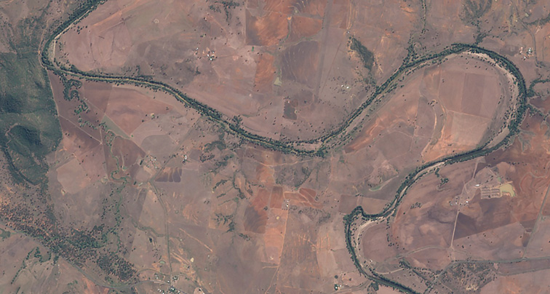

Photograph: Murray–Darling Basin Authority

Photograph 2 Northern connectivity event—flow working its way along Gwydir River near Pallamallawa, 25 April 2018

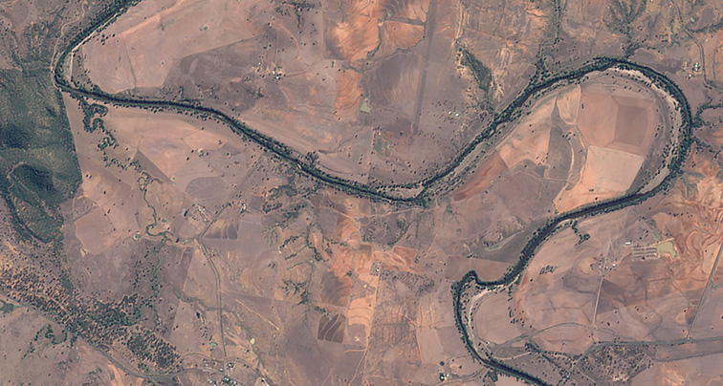

Photograph: Murray–Darling Basin Authority

Case study 14 Gwydir Wetlands Ramsar site

|  |
| --- |
| The Gwydir River terminates on its western floodplain, creating the internationally recognised Gwydir Wetlands. Flows only connect to the Barwon River in the far west in times of large and widespread flooding. They are among the few inland terminal delta wetlands of this kind remaining in the MDB (DPIE 2018).  Listed under the Ramsar Convention (an international agreement to protect important wetlands, particularly for migratory birds) in 1999, these wetlands consist of four separate parcels of land around the Gingham Watercourse and Lower Gwydir (also known as the Big Leather Watercourse). These parcels are called Goddard’s Lease, Crinolyn, Windella and Old Dromana.  In total, the Ramsar site covers 823 hectares. It is part of a wider area of wetlands that was originally a complex wetlands mosaic consisting of more than 100,000 hectares (220,000 acres). In recent times, upstream river regulation drove large scale land-use change across the floodplain. The result has been a substantial reduction in these wetlands to around 15% (15,000 hectares) of their former state.  Environmental flows were provided to the site in 2019, at a time when the majority of the Basin was severely impacted by drought, highlighting the Gwydir Wetlands role as a critical refuge for Basin wildlife. Flows were provided as part of the planned strategy to protect these wetland communities and wider Basin species. The flow regime was interrupted to allow watercourse and adjacent landowners to access their properties for the harvesting of their grain crops. These interruptions along with other constraints in the system, impact the ability of flows to reach the furthest sections of the Gwydir Wetlands.  This type of constraint to achieving environmental outcomes should be addressed if the Gwydir Constraints Project progresses, providing both infrastructure and measures such as easements to allow environmental water managers to retain flows through the system, and landholders to have access to their property.  Today, the Old Dromana and Goddards Lease parcels are owned by the NSW Government and managed by the NSW National Parks and Wildlife service. The previous owners were proud of the environmental values of the wetland on their properties and nominated their wetlands for Ramsar listing to preserve their values for future generations. These properties were subsequently passed to NSW government for conservation.  Another owner has purchased the listed wetland on their property at a time after listing and generally does not support the management of an environmental asset on their agricultural land.  The consequences of these different approaches and the constraints can be seen in Photograph 3 to Photograph 7, taken in January 2019. These sites have prolific vegetation that provides habitat for frogs, birds and many other species of native animals (Department of the Environment and Energy n.d.). |

Photograph 3 Healthy Ramsar wetlands (Goddards Lease), upper Gingham, January 2019

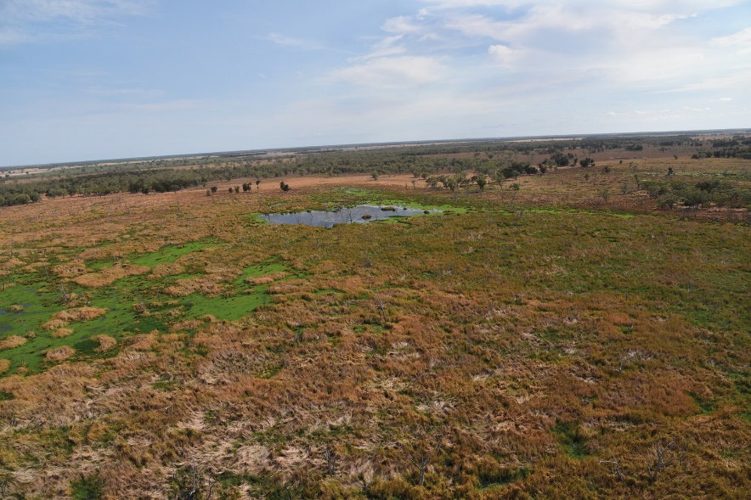

Photograph: NBC

Photograph 4 Gwydir section, Old Dromara, summer following provision of planned environmental flows, January 2019

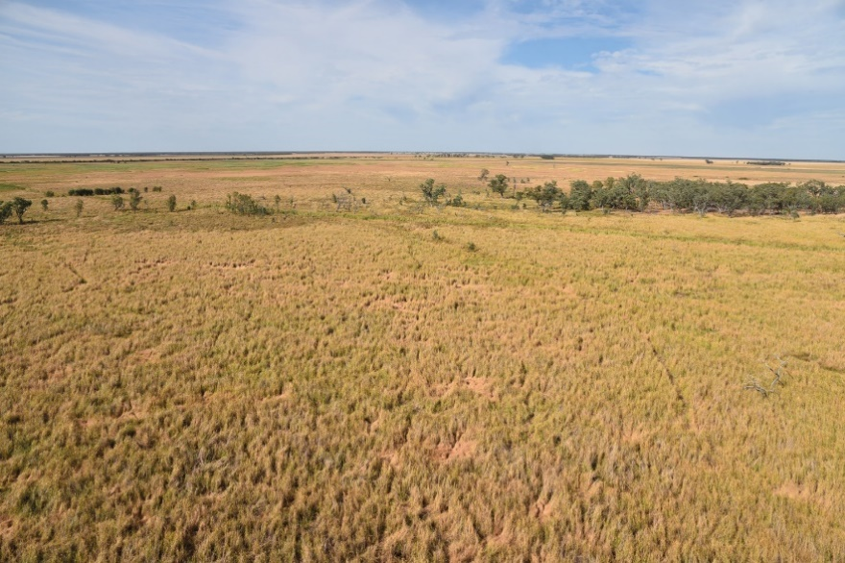

Photograph: NBC

Photograph 5 Constrained watercourse channel between two western sections of Ramsar site across agricultural land used for grain cropping, January 2019

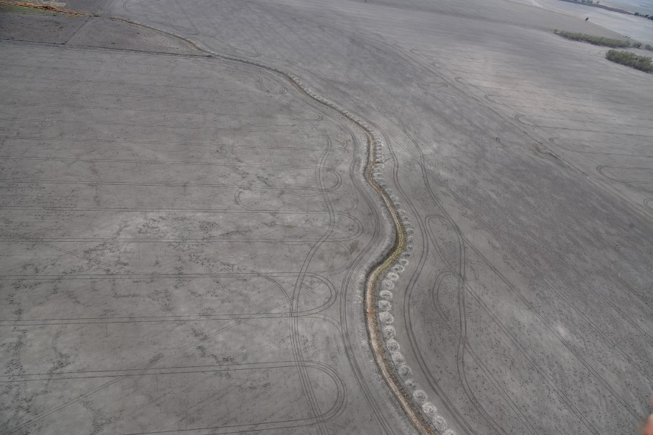

Photograph: NBC

Photograph 6 Constrained watercourse section leading to western section of Ramsar site, January 2019

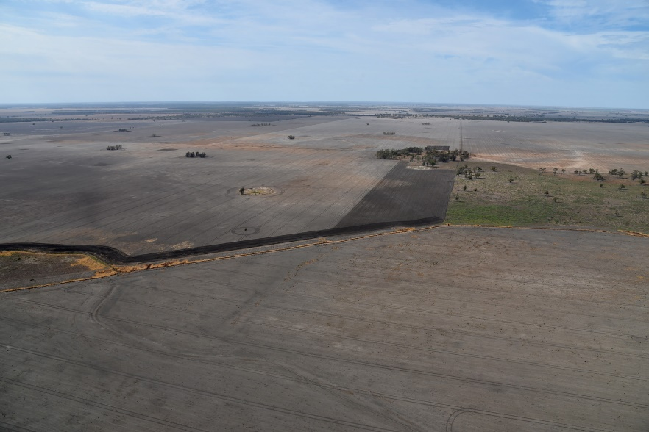

Photograph: NBC

Photograph 7 Diversity of wetland vegetation contrasted against fallow cropping paddocks at one wetlands boundary, January 2019

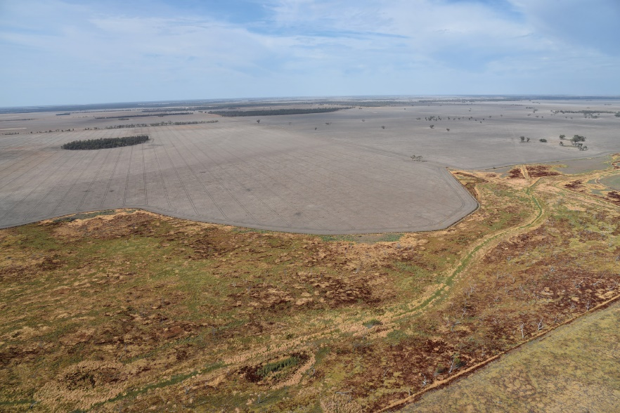

Photograph: NBC

### Environment (6)

#### Findings

* 1. The current 2018–2019 drought is the worst on record.
  2. The absence of water has brought into sharp focus the weaknesses in current policies designed to protect the environment.
  3. The value of water makes it less attractive to put the environment ahead of profit.
  4. The environment suffers from a lack of coordination and lack of protection from low flow events.
  5. There would be benefit in a cohesive program of water management and compliance-related research rather than each agency ‘doing its own thing’.

#### Recommendations

6.1 Give more compliance attention to environmental outcomes, ensuring stakeholders are putting the social licence of access to water ahead of all other considerations.

6.2 Improve transparency of the basis for water management decisions, including through completing Compliance Compact commitments on improved water information. The BOC should provide a realistic timeline for the completion of the commitments with milestones that are made readily available for the community to judge the performance of government agencies at all levels.

6.3 The Northern Basin Project Group consisting of Commonwealth, NSW and Queensland agencies established to implement improved environmental outcomes in the northern Basin should:

* immediately publish its terms of reference and proposed work program
* embark on a program of stakeholder consultation so that the community understands the work proposed and the opportunities for engagement
* establish ongoing arrangements for coordination of environmental flows between catchments and jurisdictions in the northern Basin

#### Closing thoughts

As the contemporary guardians of the environment, it is incumbent upon all of us to deliver a better environment for the generations to follow.

## Miscellaneous

Table 4 Northern Basin Commissioner’s task list

| Task | Purpose |
| --- | --- |
| Correspondence | Implementation of individual daily extraction limits in Queensland – Queensland Department of Natural Resources, Mines and Energy |
| Briefing | Legislated meter accuracy – Queensland Department of Natural Resources, Mines and Energy |
| Meeting | Queensland Crime and Corruption Commission |
| Meeting | Cotton Australia |
| Meeting | Establish regular meeting with Department of Agriculture |
| Briefing | Conflict of interest guidelines – Queensland Crime and Corruption Commission |
| Correspondence | Wrote to NSW Independent Commission Against Corruption |
| Meeting | Queensland Office of the Independent Assessor |
| Meeting | Mayor of Brewarrina |
| Briefing | Implementation of the New South Wales – Queensland Border Rivers Intergovernmental Agreement |
| Briefing | ‘A’ class and sleeper licence purchase – Murray–Darling Basin Authority |
| Briefing | Jurisdictional progress on implementing Murray–Darling Basin Compliance Compact commitments – Murray–Darling Basin Authority |
| Briefing | Toolkit measures – Department of Agriculture |
| Reporting | Present 6 monthly report to the Basin Officials Committee |
| Briefing | Provide update to NSW Environmental Defenders Office on status of efficiency measures program |
| Briefing | Update on current status of Gwydir constraints measure proposal – Department of Agriculture |
| Briefing | NSW Secure Water program and how it intersects with Basin Plan implementation – NSW Department of Industry |
| Briefing | Coordination of NSW metering roll out with Natural Resources Access Regulator actions – NSW Department of Industry, Natural Resources Access Regulator |
| Correspondence | Establish operational targets NSW uses in relation to connecting and low flows |
| Correspondence | Operational rules in the Namoi and protection of low flows |
| Correspondence | Implementation of individual daily extraction limits in relation to protection of low flows in NSW and Queensland |
| Meeting | Legal extraction of environmental water, Macquarie catchment – NSW Department of Industry |
| Correspondence | Legal extraction of environmental water, Macquarie catchment |
| Correspondence | Water Management Act amendment and consideration of drought record |
| Correspondence | Ownership and management of fishways under new rules brought in by NSW Department of Industry Fisheries |
| Correspondence | Wrote to NSW Department of Industry on timeframes for NSW water reforms |
| Correspondence | Wrote to NSW Department of Industry on who is responsible for servicing meters |
| Briefing | Presented at Australian Floodplain Association meeting |
| Meeting | Purchase of ‘A’ class licences |
| Reporting | Desktop review of submissions to the Basin Plan amendments arising from the Northern Basin Review |
| Reporting | Review Register of Foreign Ownership of Water Entitlements |
| Briefing | Method and progress of water recovery in the Condamine-Balonne – Department of Agriculture |
| Briefing | Water recovery in the Condamine-Balonne - Queensland Department of Natural Resources, Mines and Energy |
| Correspondence | Review draft fishways proposal |
| Briefing | Update on allegations – Queensland Department of Natural Resources, Mines and Energy |
| Briefing | Impact of the existing block banks in the Darling River, and the Western Weirs proposal on the sustainable diversion limit and environmental requirements of the Water Act 2007 – NSW Department of Industry, WaterNSW |
| Meeting | Shaw and Partners |
| Briefing | Whether NSW certified officers are paid by landholders to validate meters – Natural Resources Access Regulator |
| Briefing | Establishment of ranger program – Department of Agriculture, NSW Department of Industry, Queensland Department of Natural Resources, Mines and Energy |
| Briefing | Narran Lakes bifurcation issues – Murray–Darling Basin Authority, NSW Department of Industry, Queensland Department of Natural Resources, Mines and Energy |
| Meeting | Natural Resources Commissioner |
| Reporting | Assess response from Queensland Department of Natural Resources and Mines on connected and low flows |
| Briefing | Coordination of environmental watering - Commonwealth Environmental Water Holder |
| Correspondence | Contacts and Aboriginal engagement recommendations requested from NSW Environmental Defenders Office |
| Briefing | Update on Gwydir constraints project – Department of Agriculture |
| Briefing | The Department of Agriculture to provide the toolkit prioritisation framework being developed by the Murray–Darling Basin Authority |
| Briefing | Possibility of purchasing easements allow access to Gwydir Wetlands Ramsar site – NSW Department of Industry |
| Briefing | Purchase of ‘A’ class and sleeper licences - Department of Agriculture |
| Briefing | Number of compliance officers in Queensland – Queensland Department of Natural Resources, Mines and Energy |
| Meeting | Establishment of the equivalent to the NSW Natural Resources Access Regulator in Queensland |
| Briefing | Establish whether new licences are being issued in Queensland and, if so, are NSW consulted on potential downstream impacts – Queensland Department of Natural Resources, Mines and Energy |
| Briefing | Compliance capability – Queensland Department of Natural Resources, Mines and Energy |
| Briefing | Northern Basin gauging stations – Queensland Department of Natural Resources and Mines |
| Briefing | Commence and cease to pump arrangements in Queensland – Queensland Department of Natural Resources and Mines |
| Briefing | Volumetric limits in Queensland – Queensland Department of Natural Resources and Mines |
| Briefing | Funding of metering costs (including maintenance) – Queensland Department of Natural Resources and Mines |
| Briefing | Barriers to prosecution under Queensland legislation – Queensland Department of Natural Resources and Mines |
| Reporting | Report and work plan – Accenture |
| Briefing | Whether NSW has Contaminated Agricultural Runoff dams – NSW Department of Industry |
| Briefing | Who has responsibility for meter servicing – Queensland Department of Natural Resources and Mines |
| Briefing | Managing conflict of interest in local government – Office of the Independent Assessor |
| Meeting | Australian Floodplain Association |
| Meeting | South Australian Royal Commission report |
| Correspondence | Thank you letters |
| Correspondence | Review submissions to Queensland’s water resource plan development process |
| Meeting | NSW Independent Commission Against Corruption |
| Briefing | Aboriginal engagement – Queensland Department of Natural Resources and Mines |
| Meeting | Hon David Littleproud MP, Drought, Rural Finance, Natural Disaster and Emergency Management |
| Correspondence | Referred complaint to the NSW Natural Resources Access Regulator |
| Correspondence | Referred complaint to the NSW Natural Resources Access Regulator |
| Reporting | Provide draft report to designer |
| Briefing | Request that the NSW Natural Resources Access Regulator develops a memorandum of understanding with the NSW Independent Commission Against Corruption |
| Meeting | Queensland Department of Natural Resources and Mines |
| Briefing | Update on the South Western Indigenous Corporation's Lake Munya proposal – Department of Agriculture |
| Meeting | Queensland approach to meeting environmental outcomes – Queensland Department of Natural Resources and Mines |
| Meeting | Pattern approval of meters – Queensland Department of Natural Resources and Mines |
| Meeting | Hon. Melinda Pavey MP |
| Correspondence | Review the Natural Resources Commission Review of the Water Sharing Plan for the Barwon–Darling Unregulated and Alluvial Water Sources 2012 report, that will feed into the development of the water resource plan |
| Briefing | Support for cultural heritage outcomes at Lake Munya – Department of Agriculture |
| Briefing | Carryover rights – Commonwealth Environmental Water Holder |
| Reporting | Draft executive summary and foreword |
| Reporting | Draft case studies |
| Briefing | Queensland irrigator representatives request for clear start-stop pumping signal and gauging station audit |
| Meeting | Management of flows – Commonwealth Environmental Water Office, Queensland Department of Natural Resources, Mines and Energy and SunWater |
| Meeting | Political donations and links to policy decisions – NSW Independent Commission Against Corruption |
| Meeting | Aboriginal Peoples’ engagement – Queensland Department of Natural Resources, Mines and Energy |
| Meeting | Queensland Department of Natural Resources, Mines and Energy |
| Meeting | Hon David Littleproud MP, Drought, Rural Finance, Natural Disaster and Emergency Management |
| Reporting | Update Northern Basin Commissioner’s work plan and job sheet |
| Meeting | Prerequisite policy measures – Queensland Department of Natural Resources, Mines and Energy |
| Meeting | Prerequisite policy measures – NSW Department of Industry |
| Meeting | Discuss development of communication networks to facilitate co-ordinated delivery of environmental water that achieves intended outcomes of the Murray–Darling Basin Water Compliance Compact action 1.3 – NSW Department of Industry |
| Meeting | Discuss development of communication networks to facilitate co-ordinated delivery of environmental water that achieves intended outcomes of the Murray–Darling Basin Water Compliance Compact action 1.3 – Queensland Department of Natural Resources, Mines and Energy |
| Task | Purpose |
| Reporting | Protection of whistleblowers |
| Reporting | Proceeds of crime considerations in water legislation |
| Briefing | Compliance capability of the Commonwealth – Murray–Darling Basin Authority |
| Briefing | Commonwealth environmental flows access – NSW Department of Industry |
| Meeting | NSW Independent Commission Against Corruption |
| Briefing | Establish if state agencies cross reference and compare pump size and capacity relative to allocations |
| Meeting | Brewarrina Council members and stakeholders |
| Meeting | Former president of NSW Farmers Association, former Director of National Farmers Federation, former Chair, Northern Basin Advisory Committee |
| Correspondence | WaterNSW |
| Briefing | WaterNSW – Western Weirs proposal |
| Briefing | Ownership and maintenance responsibility of the NSW Fisheries Fishways project – WaterNSW |
| Reporting | Analyse Queensland Department of Natural Resources, Mines and Energy report for data to support status of compliance issues in Queensland |
| Briefing | Co-ordination between Queensland Department of Natural Resources, Mines and Energy and the Queensland Environmental Protection Agency relating to potential breaches of regulations – Queensland Department of Natural Resources, Mines and Energy |
| Correspondence | Wrote to Basin Officials Committee – co-ordination of agencies for environmental watering actions |
| Meeting | Technology group |
| Meeting | Conflict of interest issues – Local Government Association of Queensland |
| Meeting | Compliance in Queensland – Queensland Department of Natural Resources, Mines and Energy |
| Meeting | NSW Office of Environment and Heritage |
| Meeting | NSW Department of Industry, NSW Drought Coordinator |
| Meeting | Aboriginal Peoples’ engagement advice |
| Briefing | Socio-economic impacts of Basin Plan in the northern Basin |
| Meeting | NSW Fisheries and NSW Department of Industry –Menindee |
| Meeting | WaterNSW |
| Media | The Land – opinion piece |
| Briefing | Healthy Floodplains Project – NSW Department of Industry, Natural Resources Access Regulator |
| Meeting | Hon Lisa Neville MP, Minister for Water, Victoria – inclusion of the Commonwealth Environmental Water Holder on the Basin Officials Committee |
| Meeting | Workshop on hydrometrics and remote sensed data –Murray–Darling Basin Authority |
| Briefing | Concerns raised by Macquarie Marshes Environmental Landholders Association with the NSW floodplain harvesting policy – NSW Department of Industry |
| Briefing | Impacts on water users from the creating of water markets and environmental water – Murray–Darling Basin Authority |
| Meeting | Lower Balonne Floodplain Association |
| Meeting | Narran Lake and Culgoa River Joint Management Committee |
| Meeting | Nimmie-Caira |
| Briefing | Gwydir Constraints proposal – NSW Department of Industry |
| Meeting | River Murray Advisory Committee meeting – update on Northern Basin Commissioner role and work plan |
| Meeting | Site visit Goondiwindi |
| Reporting | Hectare licences in the northern Basin |
| Meeting | Cecil Plans stakeholders |
| Briefing | Mayor of Balonne |
| Reporting | Aboriginal engagement – Queensland Department of Natural Resources, Mines and Energy |
| Briefing | Forms of measurement other than metering – Basin Officials Committee |
| Briefing | Information gathering on the complexity of the Australian Electoral Commission’s policy on political donations |
| Briefing | Active management of environmental water under the toolkit measures – NSW Department of Industry |
| Briefing | Active management of environmental water under the toolkit measures – Queensland Department of Natural Resources, Mines and Energy |
| Briefing | Low flows in Lower Balonne |
| Briefing | Interactions between Murray–Darling Basin Authority and WaterNSW – Murray–Darling Basin Authority |
| Briefing | Interactions between Commonwealth Environmental Water Office and WaterNSW – Commonwealth Environmental Water |
| Briefing | Department of Agriculture response to floodplain harvesting allegations |
| Briefing | Murray–Darling Basin Authority’s response to floodplain harvesting allegations |
| Briefing | Follow up issues and next steps on bifurcation weir |
| Task | Purpose |
| Briefing | Natural Resource Access Regulator |
| Briefing | Briefing with OzFish unlimited |
| Correspondence | Hon Mark Butler MP, Member for Barwon |
| Meeting | Suzanna Sheed MLA, Independent Member for Shepparton |
| Meeting | Susan Close MP, Shadow Environment Minister |
| Meeting | NSW Irrigators Council |
| Reporting | Reviewed Australian Competition and Consumer Commission report on irrigation infrastructure operator complaint |
| Meeting | Northern connectivity event allegations and communication solutions – Commonwealth Environmental Water Office |
| Meeting | Metering reform and funding for trial - NSW Department of Industry |
| Reporting | Assess submission on whole-of-Basin water audit |
| Correspondence | Respond to NSW Department of Industry request – Floodplain Harvesting Program application |
| Meeting | Auscott |
| Meeting | Respond to request to present on Leadership at a Peter Cullen Trust |
| Reporting | Process for finalisation of report |
| Briefing | Environmental watering advisory group in the northern Basin – NSW Department of Planning, Industry and Environment |
| Meeting | Respond to invitation from Murray Darling Association to visit to Menindee and Lower Darling – discuss community concerns |

### Terms of reference

The northern Basin Commissioner (the Commissioner) will oversee the implementation of the Northern Basin Review outcomes, and report on other northern Basin matters including knowledge and information requirements, engagement with Indigenous communities and implementation of water use compliance commitments.

In undertaking these responsibilities the Commissioner will, to the extent practical while maintaining independence:

* 1. Provide a report to the Commonwealth Minister for Water Resources on progress against the outputs (Table 5) by 30 September
  2. Also provide interim and progress reports throughout each year on an as needs basis, including for consideration by Basin Ministerial Council and Basin Officials Committee
  3. Consult with relevant Basin government agencies
  4. Not duplicate existing state and Commonwealth government activities
  5. Be mindful of the risk of community fatigue in water reform engagement
  6. Provide budget and financial information as required to the department on a quarterly basis and at other times as per system requirements.

Table 5 Terms of reference—outputs

| Subject | Basin outcomes | Commissioner’s outputs | Commissioner’s tasks | Timeframe |
| --- | --- | --- | --- | --- |
| 1 Environmental water recovery  Status: Achieved | Environmental water recovery information shared across jurisdictions | Report on the progress and risks to environmental water recovery in the northern Basin. | Meet with key stakeholders and experts to develop understanding of issues and risks.  Meet with Australian Government, NSW and Queensland regulatory agencies and departments acquiring and managing environmental water to assess then monitor current situation and risks to full recovery.  Share information and assist to develop efficient solutions.  Assist development of a cross-jurisdictional remote-sensing data working group. | Introductory meetings:  AG – Complete.  Qld – Complete.  NSW – Complete.  Regular meetings with relevant agencies - Established.  Information gathered from stakeholders on an ongoing basis.  Finalised report submitted to minister on 30 September. |
| 2 Northern Basin Tool Kit measures  Status: Achieved | To ensure effective measures are developed and implemented that protect environmental flows from diversion.  Communication networks to facilitate coordinated delivery of environmental water that achieves intended outcomes as per Compliance Compact 1.3 | Report on progress on the Northern Basin Tool Kit measures.  Report to include:  a) the efficacy of measures to protect environmental flows from diversion.  b) coordinated delivery of planned and held environmental water and achievement of intended environmental outcomes. | Review implementation of measures to protect and manage environmental water including:   * Report on progress of development and implementation of Pre-requisite Policy Measures (PPMs) * Review implementation of measures to protect environmental water (based on register held by MDBA) * Review implementation of measures to monitor environmental water delivery * Review and provide advice to support the assessment of applications received under the Commonwealth’s Hydrometric Networks and Remote Sensing Funding Program. COMPLETE * Review NSW review of the Barwon–Darling water sharing plan/WRP for risks to delivery of environmental water i.e. commence to pump/cease to pump rules. COMPLETE   Liaise with jurisdictional agencies, MDBA and CEWO as required to assess current situation and develop understanding of issues and risks.  Assess current situation.  Monitor events and review outcomes against those planned.  If required, assist in building networks that facilitate b). | Introductory meetings:  AG – Complete.  Qld – Complete.  NSW – Complete.  Quarterly update to BOC.  Reporting by 30 September each year.  Regular meetings with relevant agencies - Established.  Assess delivery/progress through engagement with key stakeholders – As required. |
| 3 Water resource plans (WRPs)  Status: Achieved | Relevant northern Basin WRPs are implemented in a timely manner. | Relevant northern Basin WRPs are implemented in a timely manner.  Report on progress of:  a) finalising water resource plans for assessment and accreditation under the Basin Plan  b) the subsequent implementation of water resource plans. | Liaise with jurisdictions and key stakeholders to monitor and assess progress on implementation of the relevant northern Basin WRPs. Develop understanding of issues and risks.  Share information to assist jurisdictions deliver outputs and create efficiencies where possible.  Consider quarterly reports on WRP accreditation by MDBA.  Provide advice to the minister on any associated risks or issues with the implementation of northern Basin WRPs. | Regular meetings with relevant agencies - Established. |
| 4 Compliance reforms  Status: Achieved | Compliance reforms and Basin Compact compliance commitments are achieved within the required timeframes. | Report on progress with implementation of the compliance reforms including implementation of the Basin Compliance Compact commitments.  A strategy to improve whistleblowing processes where compliance is not followed or effective.  A strategy to enable the proceeds of crime to be integrated into achieving Basin Plan outcomes.  Coordinated cross jurisdictional communication of Basin compliance matters. | Compliance compact 1.2;2.2  Monitor and report on the implementation of compliance reforms, including compliance commitments as set out in both the Basin Compliance Compact and state-specific compliance commitments arising from reviews and audits undertaken by the New South Wales and Queensland governments.  Liaise with jurisdictions and key stakeholders to assess then monitor situation. Develop understanding of issues and risks.  Investigate and develop a strategy to improve whistleblowing for non-compliance in the northern Basin.  Investigate and develop a strategy to enable the proceeds of crime to be integrated into achieving Basin Plan outcomes.  Assess and monitor jurisdictional responses to past audits and reviews.  Share information where possible to assist jurisdictions deliver outputs and create efficiencies.  Liaise with the NSW Natural Access Regulator on Basin compliance matters to ensure a coordinated approach to monitoring and communicating Basin compliance matters.  Consider progress reports on compliance by MDBA. | Regular meetings with relevant agencies - Established.  Finalised report submitted to the minister on 30 September each year of term. |
| 5 Indigenous engagement activities  Status: Achieved | Enhanced Indigenous involvement in the management, planning and delivery of environmental water and Basin Plan outcomes in the northern Basin. | Report on progress with increasing indigenous involvement in the management, planning and delivery of environmental water and Basin Plan outcomes in the northern Basin. | Review the approach to enhancing indigenous engagement in the management, planning and delivery of water resources in the northern Basin.  Work with Basin jurisdictions and the MDBA in developing the Indigenous engagement programs.  Liaise with jurisdictions and key stakeholders to assess then monitor situation. Develop understanding of issues and risks.  Work with indigenous communities to encourage indigenous engagement.  Share information and assist to build networks that assist jurisdictions to deliver outputs and create efficiencies, where possible. | Finalised report submitted to the minister on 30 September each year of term. |
| 6 Science and technology  Status: Achieved | Best practice scientific knowledge and latest technological developments are applied to water resource management in the northern Basin.  Effective networks exist between relevant government and non-government research agencies.  Experts are involved and that they are doing what is required. | Report on:  1 Any new scientific and technical knowledge and information relevant to:  a) Improving understanding of northern Basin environmental needs  b) Improving water resource management, including information on planning assumptions, floodplain harvesting and trade  c) The application of new technologies to improve compliance capabilities especially in remote locations. | Liaise with jurisdictions and key stakeholders to assess then monitor situation. Develop understanding of issues and risks.  Develop understanding of relevant technology, information requirements and improvements.  Network building, liaison, and knowledge sharing to assist jurisdictions deliver outputs and create efficiencies where possible.  Contribute to the cross-jurisdictional remote-sensing data working group.  Support MDBA’s Compliance Community of Practice. | Finalised report submitted to the minister on 30 September each year of term. |
| 7 Environmental water activities  Status: Achieved | Improved community, government and academic understanding of environmental watering actions in northern Basin and their outcomes. | Report on environmental water activities in the northern Basin, including the Narran Lakes, Macquarie Marshes and Gwydir Wetlands, for consistency with environmental watering plans and their intended environmental outcomes. | Liaise with relevant agencies to develop understanding to enable contribution to review as required.  Assess outcomes against stated objectives for watering actions in the northern Basin. | Finalised report submitted to the minister on 30 September each year of term. |
| 8 Commissioner’s role  Status: Achieved | Commissioner’s role is understood in the Basin and by relevant agencies.  Community trust in the Basin Plan process is increased.  Trust in the effectiveness of compliance measures is increased. | Northern Basin Commissioner communication and engagement strategy. | Promote the Basin Plan and Basin governments’ commitment to implementing compliance reforms.  Promote the development and use of water use software applications to improve transparency and provide simplification through mechanisms such as enhancing public accessibility to data from metered take.  Promote importance of transparency and open communications in water resource management in the northern Basin.  Improve communication networks in northern Basin water resource management and use.  Work with the MDBA to provide information to stakeholders, via social media, print media, face to face, meetings, interviews, etc. on Basin Plan issues and developments where appropriate. | Finalised report submitted to the minister on 30 September each year of term.  Discuss with minister – Complete.  Address in reporting.  Finalised communication strategy by December 2019. |

## Summary of findings and recommendations

### Policy settings (1)

#### Findings

* 1. The Jurisdictional policy setting for the single national resource of the MDB creates divisions.
  2. Policies at Commonwealth and state levels are overly complex.
  3. There is no ‘one stop shop’ for stakeholders.
  4. Policy setting is not conducive to good compliance.
  5. Duplication, ambiguity, complexity, lack of accountability and influential lobbying is creating a risk averse culture in the public service.
  6. The scope of matters leading to the NBC appointment were not identified through departmental processes, they were identified through investigative journalism.

#### Recommendations

1.1 Map and simplify the Commonwealth and state policy settings with a view to achieving a consistent and easily understood framework for all stakeholders. In particular, water access rules should be designed to be easily understood and to facilitate compliance.

### Communications and coordination (2)

#### Findings

* 1. Simplification of rules over water access, and the communication of those rules would make it easier for water users to be compliant, and conversely, it should be easier to detect and ultimately prosecute those who are non-compliant.
  2. It would be useful to establish an ongoing Northern Basin Forum to support active management of water in the north and to engage stakeholders in decision-making processes.
  3. The protection of environmental flows, through delivery of the toolkit measures in the northern Basin, should be a priority for action by NSW and Queensland.
  4. Communication of the facts using a variety of media (especially social media platforms) would be beneficial.
  5. There is a tendency to lay blame for water management decisions at either the Plan or the MDBA when in fact it is often state government decisions – some taken well before the Plan existed - that are the underlying cause. This is partly due to the complexity of the arrangements and widespread lack of understanding of who is responsible for what.
  6. There is mistrust and a lack of confidence amongst stakeholders, generated by the absence of a single source of accurate and relevant information.
  7. The pursuit by jurisdictions of their own communications networks has resulted in duplication and poor coordination of timely information.
  8. The sharing of intelligence, including scientific and technical capability, is poor.
  9. Multiple agencies are consulting widely in the northern Basin resulting in duplication of effort.
  10. Where consultation occurs and action does not follow, it delivers an impression that agencies are not listening, when in fact it is sometimes the case that the agency consulting does not have the remit to deliver the outcome.

#### Recommendations

2.1 Adopt a single non-partisan approach to communication and coordination of activities across the northern Basin that provides a single site for relevant and accurate information regarding water entitlements and availability for all stakeholders. This platform should provide a joined-up approach to intelligence, compliance, and science and technology.

### Governance (3)

### Findings

* 1. Benefit would be derived from Commonwealth and states adopting more of a partnership or co-management approach to the implementation of infrastructure projects, rather than the current service provider model. Accountability for delivery of projects to the desired standard and timeframe should be jointly owned by each level of government.
  2. The BOC in its present form is not considered to be value adding to compliance in the northern Basin (e.g. CEWO not a permanent member).
  3. Implementation of governance improvements recommended by Greg Claydon’s review have not been fully implemented. Inclusion of the CEWO and MDBA as BOC members would be advantageous.
  4. There is thought to be a culture of ‘waiting out’ ministerial terms to avoid implementing policy changes.
  5. Agencies and officials are not declaring conflicts of interest in accordance with NSW and Queensland policies.
  6. Department of Agriculture does not have or communicate a clear mission statement of its role or value proposition in the northern Basin.
  7. Department of Agriculture is viewed as not providing a leading and enabling capability from which agencies can access funding for programs in the northern Basin.
  8. Bids for resources are competitive rather than collaborative, reducing the potential positive impact of projects on the northern Basin.
  9. There is an unacceptable delay between initiation of projects to improve water resource management and project completion.
  10. The NBC terms of reference were not measurable or accountable in their original form.
  11. The Border Rivers Commission should be reviewed as to its effectiveness.

#### Recommendations

3.1 Endorse the appointment of an Inspector-General of Water Resource Management with appropriate powers to oversee governance and program delivery across the entire MDB who can also deal with allegations of corruption or misconduct by referring them to existing integrity oversight bodies.

### Historical artefacts (4)

#### Findings

* 1. Without statutory powers, the role of the NBC could only be achieved in a collaborative environment.
  2. Historic decisions about the issuing of water licences in the northern Basin have led to strongly-held views about inequity over access to this public resource, and more recent concerns over market power. Current and future policies aimed at redressing the balance of water between its various uses including the environment should be transparent and avoid adding to these perceptions as much as possible. The ACCC inquiry should also assist in addressing these concerns.
  3. Compliance today suffers from a legacy of previous decisions made in a different environment that was pro-development/pro-irrigation. While a stronger culture of compliance has been evident since the 4 Corners program, it will take further effort and resourcing to make this a lasting change.
  4. The Barwon–Darling Water Sharing Plan is an example of how policies can be lobbied for change and subsequently re-lobbied for further change and compensation.
  5. Monitoring the level of foreign ownership in water is a self-reporting, voluntary system subject to no compliance action.
  6. There is a perception that political parties favour certain constituents to the detriment of other water stakeholders including but not restricted to the environment.
  7. Links between donations made to political parties by individuals and groups to decisions made on water policy are not easily identified. Donations by any water stakeholders to political parties should be transparent.
  8. There is a crisis of confidence in the northern Basin affecting stakeholders at all levels: political, departmental, researchers, lobby groups, and end users such as graziers and irrigators.
  9. Governments should be careful not to reinforce perceptions that their decisions are biased towards a particular sector or group of stakeholders. All aspects of water management from the information base, planning, allocation decisions and compliance should be publicly available in a form that can be understood by the community.
  10. A clear and equitable resolution to the Barwon–Darling planning issue is urgently needed to help restore confidence in the process.

#### Recommendations

4.1 Provide a calculation of the total surface and groundwater water pool in the northern Basin on a valley by valley basis including the amount dedicated to water licences (by use), to other forms of entitlement such as stock and domestic use, riparian rights and farm dams, for Aboriginal cultural flow requirements, and for environmental use. Such an analysis would help the community to understand the relative priorities for use and the viability of current licence types.

4.2 Buyback strategies and water trading should give consideration to findings from the current ACCC and Auditor-General inquiries.

### Aboriginal Nations (5)

#### Findings

* 1. Under its present leadership, NBAN is neither authoritative nor representative of the 22 Aboriginal Nations in the northern Basin.
  2. NBAN is still evolving and is not the same value proposition as MLDRIN in which governments can invest at this point in time.
  3. Aboriginal entitlement to water is unresolved compared with Aboriginal title in land.
  4. The Indigenous Land Council remains a viable alternative for investment by governments until NBAN reaches its full potential.
  5. There is strong support for an Aboriginal Ranger program especially if linked to an Aboriginal Water Highway and Cultural Hubs to enhance opportunities.

#### Recommendations

Improve the engagement with Aboriginal Nations in the northern Basin, giving consideration to international experience:

5.1 Support further practical examples of integrated land and water management on Country by Aboriginal Nations, including provision of necessary water entitlements.

5.2 Consider further mechanisms by which Aboriginal representatives can have input into the watering priorities of the CEWH in order to meet their cultural flow aspirations.

5.3 Support a three-year pilot ranger program in two or three localities within the northern Basin to demonstrate the potential of a larger program.

5.4 Encourage MLDRIN and NBAN to report to the MDBA through the Indigenous member on the MDBA Board.

5.5 Stronger support for NBAN to become an effective representative organisation.

### Environment (6)

#### Findings

* 1. The current 2018–2019 drought is the worst on record.
  2. The absence of water has brought into sharp focus the weaknesses in current policies designed to protect the environment.
  3. The value of water makes it less attractive to put the environment ahead of profit.
  4. The environment suffers from a lack of coordination and lack of protection from low flow events.
  5. There would be benefit in a cohesive program of water management and compliance-related research rather than each agency ‘doing its own thing’.

#### Recommendations

6.1 Give more compliance attention to environmental outcomes, ensuring stakeholders are putting the social licence of access to water ahead of all other considerations.

6.2 Improve transparency of the basis for water management decisions, including through completing Compliance Compact commitments on improved water information. The BOC should provide a realistic timeline for the completion of the commitments with milestones that are made readily available for the community to judge the performance of government agencies at all levels.

6.3 The Northern Basin Project Group consisting of Commonwealth, NSW and Queensland agencies established to implement improved environmental outcomes in the northern Basin should:

* immediately publish its terms of reference and proposed work program
* embark on a program of stakeholder consultation so that the community understands the work proposed and the opportunities for engagement
* establish ongoing arrangements for coordination of environmental flows between catchments and jurisdictions in the northern Basin

### Northern Basin Commissioner terms of reference

#### Purpose

The Australian Government will appoint an independent Northern Basin Commissioner (the Commissioner) to oversee implementation of the Northern Basin Review outcomes, and to audit and report on other northern Basin matters including knowledge and information requirements, engagement with Indigenous communities and implementation of water use compliance commitments.

#### Term

The position is a non-statutory role for a fixed term of three years commencing 1 October 2018.

#### Responsibility

In a role that covers all surface water catchments in the northern Murray–Darling Basin, the Commissioner will be responsible for monitoring, auditing and reporting on the following matters:

1. Progress in environmental water recovery.
2. The development and implementation of ‘toolkit measures’, including
   1. The efficacy of measures to protect environmental flows from diversion
   2. Coordinated delivery of planned and held environmental water and achievement of intended environmental outcomes
   3. Active management of environmental water entitlements
   4. Planning and construction of new fishways and measures to address cold water pollution from water released from storages
   5. Planning and implementation of a new constraints measure in the Gwydir Valley.
3. Progress by New South Wales and Queensland governments in:
   1. Finalising water resource plans for assessment and accreditation under the Basin Plan
   2. The subsequent implementation of water resource plans.
4. The implementation of compliance reforms, including compliance commitments as set out in both the [proposed] Basin Compliance Compact and state-specific compliance commitments arising from reviews and audits undertaken by the New South Wales and Queensland governments.
5. Coordination activities with Aboriginal communities and representatives to enhance their ability to contribute to the management, planning and delivery of water resources.
6. Any new scientific and technical knowledge and information relevant to
   1. Our understanding of northern Basin environmental needs
   2. Improved water resource management, including information on planning assumptions, floodplain harvesting and trade.
7. Environmental water activities in the northern Basin, including the Narran Lakes, Macquarie Marshes and Gwydir Wetlands, for consistency with environmental watering plans and their intended environmental outcomes.

#### Reporting

The Commissioner will report to the Commonwealth Minister for Water Resources (the minister), and will consult with the Minister for Environment and Energy as appropriate.

The Commissioner will be responsible for providing timely annual written reports to the minister.

The minister will table the Commissioner’s reports in the Federal Parliament within 15 sitting days of receipt. The first such report will be due in September 2019. An interim report will be provided to the minister within six months of commencement.

All the Commissioner’s reports will be publicly released on the [Interim Inspector-General of Murray–Darling Water Resources](https://www.igmdb.gov.au/reviews) website.

Once provided to the minister, all reports will be provided to the Murray–Darling Basin Ministerial Council and the Minister for the Environment and Energy.

### Northern Basin agencies, legislation and intergovernmental agreements

#### Multi-jurisdiction

Murray–Darling Basin Ministerial Council (implement MDB Agreement; consulted on Basin Plan)/Basin Officials Committee (advise Council on implementing MDB Agreement; consulted on Basin Plan)/Basin Plan Implementation Committee (implements the Basin Plan Implementation Agreement 2012)/Dumaresq-Barwon Border Rivers Commission (implement water sharing arrangements in the Queensland-NSW border region).

#### Commonwealth

Murray–Darling Basin Authority (develop, enforce and review Basin Plan; River Murray operator)/Department of Agriculture (water policy and water recovery programs)/Commonwealth Environmental Water Office (manage Commonwealth water portfolio)/Australian Bureau of Agricultural and Resource Economics (social and economic assessments of agriculture)/Department of the Environment and Energy (environment policy including Ramsar Convention)/Australian Competition and Consumer Commission (water market)/Productivity Commission (Basin Plan 5 yearly review)/Bureau of Meteorology (water accounts and data storage and sharing)/Geoscience Australia (remote sensed data, surface and groundwater mapping and data collection).

#### NSW

Department of Planning, Industry and Environment (water policy and planning)/WaterNSW (river operator)/Natural Resources Access Regulator (water compliance)/Natural Resources Commission (periodic review of NSW water sharing plans)/Independent Pricing and Regulatory Tribunal (regulation of water pricing and cost recovery)/Audit Office of New South Wales.

#### Queensland

Department of Natural Resources, Mining and Energy (water policy, planning and compliance)/SunWater (river operator).

#### Other committees/representative groups

Basin Community Committee (advise Council and MDBA on community water issues)/Northern Basin Aboriginal Nations (represent Aboriginal Nations in the northern Basin on water management issues)/Advisory Committee on Social, Economic and Environmental Sciences (provides scientific advice to the MDBA)/MDBA Independent Assurance Committee (advise MDBA on its compliance program).

### Northern Basin legislation and intergovernmental agreements

#### Commonwealth/intergovernmental

Water Act 2007 (Cth)/Water Regulations 2008 (Cth)/The Basin Plan 2012 (Cth)/Water Charge Amendment Rules 2019 (Cth)/Water Amendment (Water Resource Plan Accreditation) Regulations 2018 (Cth)/Water Market Rules 2009 (Cth)/Water Charge (Infrastructure) Rules 2010 (Cth)/Water (Indigenous Values and Uses) Direction 2018 (Cth)/Water Act (Northern Basin Review and Other Measures) Direction 2018 (Cth)/Warrego-Paroo-Nebine Water Resource Plan Accreditation Decision 2017 (Cth)/Water Act (Queensland Border Rivers-Moonie Water Resource Plan) Accreditation Decision 2019 (Cth)/Water Act (Condamine-Balonne Water Resource Plan) Accreditation Decision 2019 (Cth)/Register of Foreign Ownership of Water or Agricultural Land Act 2015 (Cth)/Register of Foreign Ownership of Water or Agricultural Land Rules 2017 (Cth)/Register of Foreign Ownership of Agricultural Land (Water Entitlements) Notification 2017 (Cth)/Competition and Consumer Act 2010 (Cth)/Environmental Protection and Biodiversity Conservation Act 1999 (Cth)/Intergovernmental Agreement on Implementing Water Reform in the Murray Darling Basin/Murray–Darling Basin Agreement 2008/Intergovernmental Agreement on a National Water Initiative/Murray–Darling Basin Compliance Compact/New South Wales-Queensland Borders Rivers Intergovernmental Agreement 2008.

#### NSW

Water Management Act 2000 (NSW)/Water Management (General) Regulation 2018 (NSW)/Water (Commonwealth Powers) Act 2008 (NSW)/New South Wales-Queensland Border Rivers Act 1947 (NSW)/Natural Resources Access Regulators Act 2017 (NSW)/Water Industry Competition Act 2006 (NSW)/Water NSW Act 2014 (NSW)/Water NSW Regulation 2013 (NSW)/Water Act 1912 (NSW)/Water (Part 2 General) Regulation 1997 (NSW)/Water (Part 5 Bore Licences) Regulation 1995 (NSW)/Water (Part 5 Drillers’ Licences) Regulation 1995 (NSW)/Water Sharing Plan for the Barwon–Darling Unregulated and Alluvial Water Sources 2012 (NSW)/Water Sharing Plan for the NSW Murray Darling Basin Fractured Rock Groundwater Sources 2011 (NSW)/Water Sharing Plan for the NSW Murray Darling Basin Porous Rock Groundwater Sources 2011 (NSW)/Water Sharing Plan for the Peel Valley Regulated, Unregulated, Alluvium and Fractured Rock Water Sources 2010 (NSW)/Water Sharing Plan for the Upper and Lower Namoi Groundwater Sources 2003 (NSW)/Water Sharing Plan for the Upper Namoi and Lower Namoi Regulated River Water Sources 2016 (NSW)/Water Sharing Plan for the Lower Murray–Darling Unregulated and Alluvial Water Sources 2011 (NSW)/Water Sharing Plan for the Macquarie Bogan Unregulated and Alluvial Water Sources 2012 (NSW)/Water Sharing Plan for the Macquarie and Cudgegong Regulated Rivers Water Source 2016 (NSW)/Water Sharing Plan for the Namoi Unregulated and Alluvial Water Sources 2012 (NSW)/Water Sharing Plan for the NSW Border Rivers Regulated River Water Source 2009 (NSW)/Water Sharing Plan for the NSW Border Rivers Unregulated and Alluvial Water Sources 2012 (NSW)/Water Sharing Plan for the Castlereagh River Unregulated and Alluvial Water Sources 2011 (NSW)/Water Sharing Plan for the Gwydir Regulated River Water Source 2016 (NSW)/Water Sharing Plan for the Gwydir Unregulated and Alluvial Water Sources 2012 (NSW)/Water Sharing Plan for the Intersecting Streams Unregulated and Alluvial Water Sources 2011 (NSW)/Water Sharing Plan for the Lower Gwydir Groundwater Source 2003 (NSW)/Water Sharing Plan for the Lower Macquarie Groundwater Sources 2003 (NSW).

#### Queensland

Water Act 2000 (Qld)/Water Regulation 2016 (Qld)/Water (Commonwealth Powers) Act 2008 (Qld)/Water Plan (Border Rivers and Moonie) 2019 (Qld)/Water Plan (Warrego, Paroo, Bulloo and Nebine) 2016 (Qld)/Water Plan (Condamine, Balonne) 2019 (Qld)/New South Wales-Queensland Border Rivers Act 1947 (Qld)/Environment Protection Act 1994 - Environment Protection Policy (Water) (Qld)/Planning Act 2016 (Qld)/Mineral Resource Act 1989 (Qld)/Petroleum and Gas (Production and Safety) Act 2004 (Qld)/Water Supply (Safety and Reliability) Act 2008 (Qld)/Water Supply (Safety and Reliability) Regulation 2011 (Qld).

#### Sample of audits and reviews

Independent Audit of Queensland non-urban water measurement and compliance/Independent Audit of Queensland non-urban water measurement and compliance – Queensland Government response/Interim Independent investigation into NSW water management and compliance/Final Independent investigation into NSW water management and compliance/The Murray–Darling Basin Water Compliance Review/Integrity of the water market in the Murray–Darling Basin/Register of Foreign Ownership - Water Entitlements/Social and economic benefits from environmental watering/South Australian Royal Commission report/MDBA response to the South Australian Royal Commission/The Northern Basin Review/Murray–Darling Basin Plan: Five-year assessment – Inquiry report/Joint Basin government response to the Productivity Commission inquiry report/Response to fish deaths in the Lower Darling/Multi-Jurisdictional Management and Execution of the Murray–Darling Basin Plan.

### Financial report

Table 6 Expense summary

| Expense | 2018–19 ($) | 2019–20 ($) |
| --- | --- | --- |
| Employees | 101,184 | 48,960 |
| Suppliers | 79,528 | 26,474 |
| Corporate overheads | 7,926 | 3,040 |
| **Total** | **188,638** | **78,473** |

Table 7 Employee expenses

| Expense | Actual 2018–19 ($) | Actual 2019–20 **a** ($) | Revised budget 2018–19 ($) | Approved budget 2019–20**a** ($) |
| --- | --- | --- | --- | --- |
| AC3_Employee Expenses | 101,184 | 48,960 | 24,255 | 44,401 |
| AC3_Operating Expenses | 79,528 | 26,474 | 37,614 | 9,763 |
| AC3_Indirect Costs | 7,920 | 3,040 | 8,669 | 3,221 |
| AC3_Administered Payments | 5 | – | – | – |
| AC3_Expense | 188,638 | 78,473 | 70,537 | 57,385 |

**a** Year to date September.

Source: Department of Agriculture

### Glossary

| Term | Definition |
| --- | --- |
| ACCC | Australian Competition and Consumer Commission |
| ANAO | Australian National Audit Office |
| ATO | Australian Tax Office |
| BOC | Basin Officials Committee |
| BOM | Bureau of Meteorology |
| CEWH | Commonwealth Environmental Water Holder |
| CEWO | Commonwealth Environmental Water Office |
| CSIRO | Commonwealth Scientific and Industrial Research Organisation |
| COAG | Council of Australian Governments |
| CCC | Crime and Corruption Commission (Qld) |
| DOI (now DPIE) | Department of Industry (NSW) |
| DNRME | Department of Natural Resources, Mines and Energy (Qld) |
| DPIE (previously DOI) | Department of Planning, Industry and Environment (NSW) |
| EQC | Earthquake Commission is a New Zealand Crown entity |
| EPBC Act | Environmental Protection and Biodiversity Conservation Act 1999 |
| ICAC | Independent Commission Against Corruption (NSW) |
| ILC | Indigenous Land Corporation |
| IGA | Intergovernmental Agreement |
| MDB | Murray – Darling Basin |
| MDBA | Murray – Darling Basin Authority |
| Compliance Compact | Murray – Darling Basin Compliance Compact |
| MLDRIN | Murray Lower Darling Rivers Indigenous Nations |
| NDF | Natural Disaster Fund |
| NRAR | Natural Resources Access Regulator (NSW) |
| NSW | New South Wales |
| NBAN | Northern Basin Aboriginal Nations |
| NBC | Northern Basin Commissioner |
| NBR | Northern Basin Review |
| Qld | Queensland |
| ToR | Terms of reference |

## References

ATO 2019, [Register of foreign ownership of water entitlements: report of registrations as at 30 June 2018 (pdf 435kb)](https://cdn.tspace.gov.au/uploads/sites/79/2019/02/2018-Register-of-foreign-ownership-Water-entitlements.pdf), Australian Taxation Office, Canberra.

Australian Academy of Science 2019, [Investigation of the causes of mass fish deaths in the Menindee Region NSW over the summer of 2018–2019](https://www.science.org.au/supporting-science/science-policy-and-sector-analysis/reports-and-publications/fish-kills-report), Canberra.

COAG 2013, [Intergovernmental Agreement on Implementing Water Reform in the Murray Darling Basin (pdf 13mb)](https://www.coag.gov.au/sites/default/files/communique/iga-on-implementing-water-reform-in-the-mdb-signed.pdf) (revised March 2017 and August 2019), Council of Australian Governments, Canberra.

Country Needs People 2019 [About Indigenous rangers](https://www.countryneedspeople.org.au/indigenous_rangers), Canberra.

Delfrau, K 2017, [The effects of land and water separation on First Nations Peoples](https://waterpartnership.org.au/the-effects-of-land-and-water-separation-on-aboriginal-people/), Australian Aid, Canberra, 2 March.

Department of Agriculture 2019 [Basin Plan commitments package](https://www.agriculture.gov.au/water/mdb/basin-plan/commitments), Canberra, November.

Department of the Environment 2016, [Engage early—guidance for proponents on best practice Indigenous engagement for environmental assessments under the EPBC Act](https://www.environment.gov.au/epbc/publications/engage-early), Canberra.

Department of the Environment and Energy n.d., [Information sheet on Ramsar Wetlands (RIS) (pdf 175kb)](http://www.environment.gov.au/water/topics/wetlands/database/pubs/50-ris.pdf), Canberra.

DPIE 2018, [Gwydir Wetlands](https://www.environment.nsw.gov.au/topics/water/wetlands/internationally-significant-wetlands/gwydir-wetlands), Department of Planning, Industry and Environment, Sydney, July.

EQC 2010, [Last day to lodge claims with EQC](https://www.eqc.govt.nz/news/last-day-to-lodge-claims-with-eqc), Earthquake Commission, Wellington, New Zealand.

Matthews, K 2017, [Independent investigation into NSW water management and compliance—final report](https://www.industry.nsw.gov.au/water/what-we-do/how-water-is-managed/independent-review-water-management-and-compliance), NSW Department of Industry, Sydney, December.

MDBA 2016, [The Northern Basin review](https://www.mdba.gov.au/publications/mdba-reports/northern-basin-review-report), Murray–Darling Basin Authority, Canberra, November.

——2017, [The Murray–Darling Basin water compliance review](https://www.industry.nsw.gov.au/water/what-we-do/how-water-is-managed/independent-review-water-management-and-compliance), Murray–Darling Basin Authority, Canberra, November.

——2019, [Independent assessment of the 2018–19 fish deaths in the Lower Darling](https://www.mdba.gov.au/publications/mdba-reports/response-fish-deaths-lower-darling), Murray–Darling Basin Authority, Canberra.

Moggridge, B 2017, [Traditional knowledge and scientific knowledge: opportunities and tensions in water management](https://waterpartnership.org.au/brad-moggridge-interview-traditional-knowledge-and-scientific-knowledge-opportunities-and-tensions-in-water-management/), Australian Aid, Canberra, 16 February.

National Water Commission 2011, [Water markets in Australia: a short history (pdf 44mb)](https://apo.org.au/sites/default/files/resource-files/2011/12/apo-nid27438-1224671.pdf), Canberra.

The Nature Conservancy 2018, [Nimmie-Caira: a giant win for nature, the local economy and Indigenous re-connection to Country](https://www.natureaustralia.org.au/explore/newsroom/nimmie-caira--a-giant-win-for-nature--the-local-economy-and-indi/), [media release], Carlton South, Victoria, May.

——2019 [Exploring Gayini Nimmie-Caira](https://www.natureaustraslia.org.au/what-we-do/our-priorities/protect-land-and-water/land-and-water-stories/gayini-nimmie-caira/), Carlton South, Victoria.

NSW ICAC 2019, [Conflicts of interest](https://www.icac.nsw.gov.au/prevention/basic-standards/conflicts-of-interest), NSW Independent Commission Against Corruption, Sydney, May.

NSW NRAR 2019, [Natural Resources Access Regulator progress report 2018–19 (pdf 15mb)](https://www.industry.nsw.gov.au/__data/assets/pdf_file/0007/272689/NRAR-progress-report-2018-19.pdf), Planning, Industry and Environment, Sydney.

Productivity Commission 2018, Murray–Darling Basin Plan: Five-year assessment, final report no. 90, Canberra.

Queensland Government 2019, [Indigenous Land and Sea Ranger Program](https://www.qld.gov.au/environment/plants-animals/conservation/community/land-sea-rangers/about-rangers), Brisbane, August.

Qld DNRME 2018, [Independent audit of Queensland non-urban water measurement and compliance 2018](https://www.dnrme.qld.gov.au/land-water/initiatives/water-measurement-compliance-audit), report by Independent Expert Panel, Department of Natural Resources, Mines and Energy, Brisbane.

——2019, [Queensland Murray–Darling Basin – compliance and enforcement actions report 2018–19 (PDF 535 KB)](https://www.dnrme.qld.gov.au/__data/assets/pdf_file/0010/1458379/qmdb-compliance-enforcement-2018-19.pdf), Department of Natural Resources, Mines and Energy, Brisbane.

Tonkin & Taylor Ltd 2018, [Canterbury earthquake sequence: increased liquefaction vulnerability assessment methodology](https://www.eqc.govt.nz/ILV-engineering-assessment-methodology), report by Tonkin & Taylor Ltd for the Earthquake Commission, Wellington, New Zealand.

Wright M & Dally J 2018, ['Outstanding' EQC boss Ian Simpson quits](https://www.stuff.co.nz/national/84737331/eqc-boss-ian-simpson-quits), Stuff, Wellington, New Zealand, 28 September.