# Annual report 2019–20

**Interim Inspector-General of Murray–Darling Basin Water Resources**

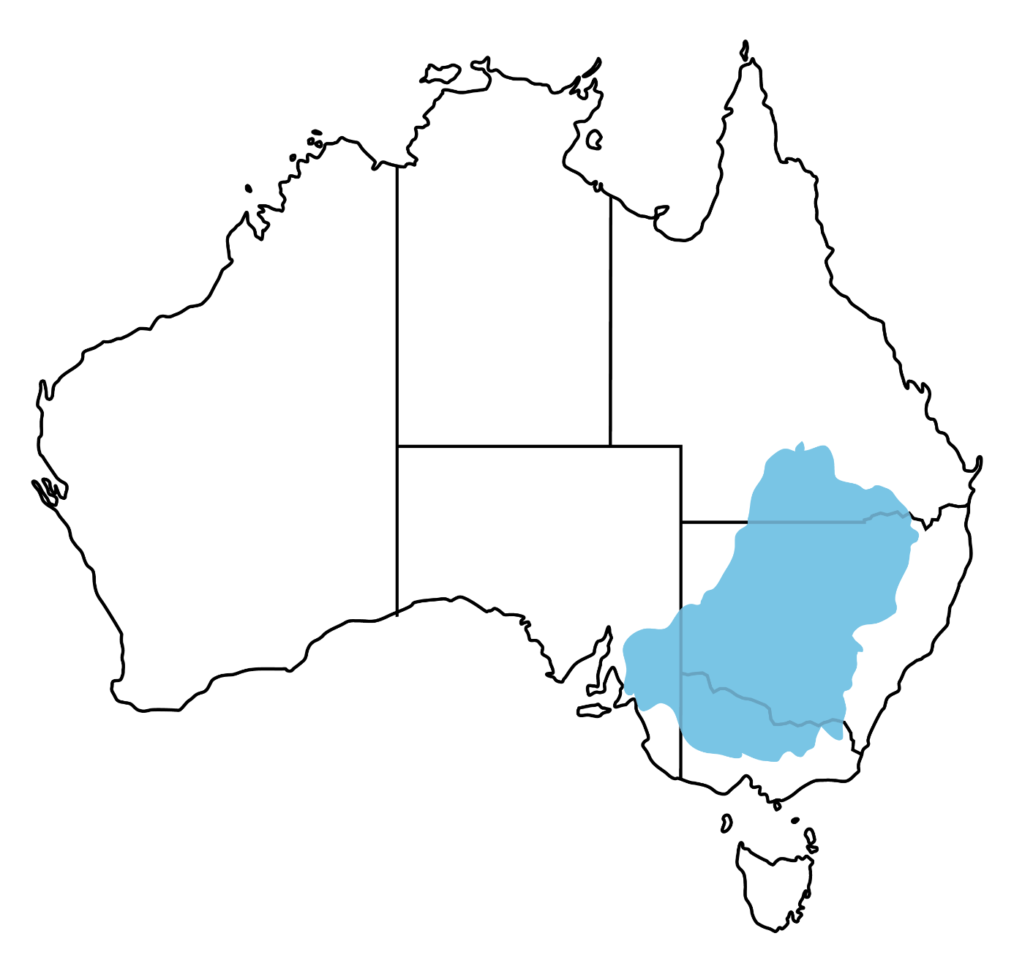

© Commonwealth of Australia 2020

**Ownership of intellectual property rights**

Unless otherwise noted, copyright (and any other intellectual property rights) in this publication is owned by the Commonwealth of Australia (referred to as the Commonwealth).

**Creative Commons licence**

All material in this publication is licensed under a [Creative Commons Attribution 4.0 International Licence](https://creativecommons.org/licenses/by/4.0/legalcode) except content supplied by third parties, logos and the Commonwealth Coat of Arms.

Inquiries about the licence and any use of this document should be emailed to [copyright@agriculture.gov.au](mailto:copyright@agriculture.gov.au).



**Cataloguing data**

This publication (and any material sourced from it) should be attributed as: Interim Inspector-General of Murray–Darling Basin Water Resources , *Annual report 2019–20*, Interim Inspector-General of Murray–Darling Basin Water Resources, Canberra, July. CC BY 4.0.

ISBN 978-1-76003-306-4

This publication is available at [igmdb.gov.au/reviews](http://www.igmdb.gov.au/reviews).

Interim Inspector-General of Murray–Darling Basin Water Resources

Department of Agriculture, Water and the Environment

GPO Box 858 Canberra ACT 2601

Telephone 1800 900 090

Web igmdb.gov.au

The Interim Inspector-General of Murray–Darling Basin Water Resources, acting on behalf of the Australian Government , has exercised due care and skill in preparing and compiling the information and data in this publication. Notwithstanding, the Office of the Inspector-General of Murray–Darling Basin Water Resources, its employees and advisers disclaim all liability, including liability for negligence and for any loss, damage, injury, expense or cost incurred by any person as a result of accessing, using or relying on any of the information or data in this publication to the maximum extent permitted by law.

Contents

Inspector-General of Murray–Darling Basin Water Resources 1

Appointment of Interim Inspector-General 1

Statutory appointment 1

The Office of the Inspector-General 1

Engagement 2

Referrals 3

Inquiries undertaken 4

Interim Inspector-General correspondence 5

**Tables**

Table 1 IIG correspondence 6

**Figures**

Figure 1 Engagement 2

Figure 2 Engagement (excluding water sharing inquiry) 3

Figure 3 Referral categories 3

Figure 4 Referral location 4

Figure 5 Referral outcomes 4

## Inspector-General of Murray–Darling Basin Water Resources

On 1 August 2019 the Australian Government announced the newly created position of Inspector-General of Murray–Darling Basin Water Resources to improve transparency, accountability and community confidence and help deliver the Murray–Darling Basin Plan.

### Appointment of Interim Inspector-General

The government appointed Mick Keelty AO as Interim Inspector-General of Murray–Darling Basin Water Resources (IIG) on 1 October 2019 for a period of 12 months. This was the estimated time to introduce new laws under the *Water Act 2007* to create a permanent statutory position. The appointment of Mr Keelty effectively ended the previous position of Northern Basin Commissioner.

### Statutory appointment

It is expected that amendments to the *Water Act 2007* to create the Inspector-General (IG) role will pass through Parliament in 2021. This was initially planned for 2020. However, the process was delayed due to COVID-19. The government is seeking to ensure the powers of the IG will provide Basin communities with sufficient confidence in water management in the Basin. The department has commenced discussions with the Basin states on drafting the legislation.

Under the interim arrangements, the IIG reports directly to the Minister for Resources, Water and Northern Australia, the Hon. Keith Pitt MP. The IIG also reports to the Murray–Darling Basin Ministerial Council every 6 months.

### The Office of the Inspector-General

A task force was formed in August 2019 to establish the Office of the Inspector-General. In February 2020 the task force was stood down, with the office continuing to support the Interim Inspector-General in his role and functions.

Offices have been established in Brisbane, Goondiwindi, Mildura and Canberra. The location of the offices facilitates public consultation and travel within the entire Murray–Darling Basin and continues the linkages the IIG has established with Basin agencies.

The budget for the office of the IG is drawn from the Department of Agriculture, Water and the Environment. This measure was funded through an offset from the Sustainable Rural Water Use & Infrastructure Program for a period of 4 years.

The office of the IG was funded for 7.5 average staffing level (ASL) equivalent for the 2019–20 financial year, with an increase to 10 ASL equivalent in future years. This ASL figure was based on an estimate of the workload involved in operating the IG function and will be revised commensurate with the introduction of the legislation and the appointment of a permanent IG.

### Engagement

The [IIG website](https://www.igmdb.gov.au/) was established to provide a point of contact for the referral of matters to the IIG, publishing of inquiry reports and to provide information about the public consultation arrangements for specific inquiries undertaken by the IIG.

In the period from December 2019 until March 2020, the IIG undertook extensive public engagement across the Basin to hear directly from the wide range of Basin stakeholders.

Over the reporting period the IIG office has engaged with over 1,700 individuals or groups related to Basin issues. While the vast majority of engagement was undertaken with farmers or community members (Figure 1 and Figure 2) in the course of the water sharing inquiry, the IIG continued to proactively engage with a variety of Basin stakeholders throughout the year.

Figure 1 Engagement

Source: Interim Inspector-General of Murray–Darling Basin Water Resources

Figure 2 Engagement (excluding water sharing inquiry)

Source: Interim Inspector-General of Murray–Darling Basin Water Resources

### Referrals

The IIG received 30 referrals over the reporting period (Figure 3, Figure 4 and Figure 5).

Figure 3 Referral categories

Source: Interim Inspector-General of Murray–Darling Basin Water Resources

Figure 4 Referral location

Source: Interim Inspector-General of Murray–Darling Basin Water Resources

Figure 5 Referral outcomes

Source: Interim Inspector-General of Murray–Darling Basin Water Resources

### Inquiries undertaken

The IIG undertook 4 inquiries during the reporting period.

#### Northern Basin Commissioner’s First Year Report

The Northern Basin Commissioner’s First Year Report was submitted to the (previous) Minister for Water Resources on 1 December 2019 and tabled in Parliament on 5 December 2019. The report is also available on the [IIG website](https://www.igmdb.gov.au/reviews).

The publication of the report was deferred until 1 December 2019 because Mr Keelty was engaged in standing up the new entity of the office of the Inspector-General of Murray–Darling Basin Water Resources.

#### First flush flows report

The IIG conducted an investigation into the circumstances surrounding the premature release of the Murray–Darling Basin Authority’s report titled, ‘Monitoring first flush flows in the Namoi, Macquarie and Warrego Rivers – Remote sensing for compliance and ecohydrology’. The investigation examined:

* the events that led to the premature release of the report
* the Murray–Darling Basin Authority’s response to the premature release of an incorrect version of the report
* the adequacy of Murray–Darling Basin Authority procedures for managing the release of compliance and enforcement related information.

The report was submitted to the (previous) Minister for Water Resources on 30 November 2019. The report is available on the [IIG website](https://www.igmdb.gov.au/reviews).

#### Water sharing inquiry

The IIG undertook an inquiry into the management of Murray–Darling Basin water resources, specifically to consider:

* the impact of the changing distribution of inflows to the southern Basin on state shares under the Murray–Darling Basin Agreement
* any consequential impacts on the state shares resulting from reserves required under the agreement, including how these interact with state allocation policies.

The inquiry heard from many interested and engaged people across the Murray–Darling Basin, including irrigators, community members, subject matter experts and environmental groups.

A report was submitted to the Minister for Resources, Water and Northern Australia on 27 March 2020 and publicly released on 17 April 2020. The report can be found on the [IIG website](https://www.igmdb.gov.au/reviews).

#### Investigation into Lower Murray groundwater entitlements

The IIG has commenced an inquiry into Lower Murray groundwater entitlements, to determine whether flood recharge was considered in the modelling of the Lower Murray sustainable diversion limits when it was set under the Basin Plan.

### Interim Inspector-General correspondence

Table 1 details IIG correspondence between 16 December 2019 and 30 June 2020.

Table 1 IIG correspondence

| Date | Correspondence |
| --- | --- |
| 16 December 2019 | Northern Basin Commissioner First year report provided to The Senate Select Committee on the Multi-Jurisdictional Management and Execution of the Murray–Darling Basin Plan |
| 24 December 2019 | Correspondence to the Minister for Water Resources, Drought, Rural Finance, Natural Disaster and Emergency |
| 20 April 2020 | Submission to The Senate Select Committee on the Multi-Jurisdictional Management and Execution of the Murray–Darling Basin Plan titled Impact of lower inflows on state shares under the Murray–Darling Basin Agreement |
| 13 May 2020 | Provision of responses to Questions on Notice to the Senate Select Committee on the Multi-Jurisdictional Management and Execution of the Murray–Darling Basin Plan following appearance before the Committee on 12 May 2020 |
| 26 May 2020 | Correspondence to Chief Executive, MDBA and Chief Executive Officer, Department of Planning, Industry and Environment (NSW) referring correspondence received from SunRice/Rice Growers Association regarding priority water issues |
| 26 May 2020 | Supplementary submission to The Senate Select Committee on the Multi-Jurisdictional Management and Execution of the Murray–Darling Basin Plan regarding the percentage that the Menindee Lakes scheme delivers to South Australia to meet part of its annual entitlement |
| 10 June 2020 | Correspondence to Chair of Basin Officials Committee seeking advice regarding implications of the withdrawal of MACE Doppler meters from Pattern Approval testing |
| 12 June 2020 | Correspondence to Chief Executive Officer, Department of Planning, Industry and Environment (NSW) regarding oversight of Irrigation Corporations |
| 29 June 2020 | Correspondence to Chief Executive Officer, Department of Planning, Industry and Environment (NSW) on forwarding referral from Senator Ayres regarding changes in policy for the Barwon Darling Water Sharing Plan |
| 30 June 2020 | Correspondence to Chief Executive Officer, Department of Planning, Industry and Environment (NSW) outlining complaints received regarding the consultation process in developing NSW Water Sharing Plans |
| 30 June 2020 | Correspondence to Minister for Resources, Water and Northern Australia |