Compliance and enforcement across the Murray–Darling Basin

Inspector-General of Water Compliance

August 2022

© Commonwealth of Australia 2022

**Ownership of intellectual property rights**

Unless otherwise noted, copyright (and any other intellectual property rights) in this publication is owned by the Commonwealth of Australia (referred to as the Commonwealth).

**Creative Commons licence**

All material in this publication is licensed under a Creative Commons Attribution 4.0 International Licence, except for content supplied by third parties, logos and the Commonwealth Coat of Arms.

Inquiries about the licence and any use of this document should be emailed to [copyright@dcceew.gov.au](mailto:copyright@dcceew.gov.au).



**Cataloguing data**

This publication (and any material sourced from it) should be attributed as: Inspector-General of Water Compliance 2022, *Compliance and enforcement across the Murray-Darling Basin*, the Australian Government, Canberra, August 2022. CC BY 4.0.

This publication is available at <https://www.igwc.gov.au/reviews-reports>

Inspector-General of Water Compliance  
GPO Box 3090 Canberra ACT 2601

**Disclaimer**

The Australian Government represented by the Inspector-General of Water Compliance, has exercised due care and skill in preparing and compiling the information and data in this publication. Notwithstanding, the Inspector-General of Water Compliance, the Australian Government’s employees disclaim all liability, including liability for negligence and for any loss, damage, injury, expense or cost incurred by any person as a result of accessing, using or relying on any of the information or data in this publication to the maximum extent permitted by law.

**Acknowledgement of the Traditional Owners of the Murray–Darling Basin**

The Author pays respect to the Traditional Owners and their Nations of the Murray−Darling Basin. We acknowledge their deep cultural, social, environmental, spiritual and economic connection to their lands and waters.

**Accessibility**

The document and information is available in accessible formats. On some occasions the highly technical nature of the document means that we cannot make some sections fully accessible. If you encounter accessibility problems or the document is in a format that you cannot access, please contact us.

**Acknowledgements**

Mr Des Pearson (AO) assisted the Inspector-General in this review. He received support from IGWC staff.

The Inspector General of Water Compliance would like to thank staff of Basin state water agencies for their cooperation during this review.

# Foreword

The office of the Inspector-General of Water Compliance (Inspector-General) was created to serve as a strong and independent regulator of Australia’s largest water resource – the Murray–Darling Basin. The Inspector-General's role was established to strengthen compliance, increase transparency, and improve trust.  This focus has driven everything my office has done since we were formally established on 5 August 2021.

Living on one of the driest continents on earth has seen the evolution, through necessity, of social licence under which water being such a finite and precious resource, is taken. After all, our nation’s water belongs to all of us. The Basin is a connected, complex, and fragile system.  We should never ever lose sight of the fact that what happens to it in one state inevitably affects another. An effective compliance system is vitally important to maintaining a healthy and sustainable Murray–Darling Basin.

In 1901 the spirit and intent of Federation was to bring the colonies (now states) together and end the complexities and conundrums of each having its own government and laws.  Each state had its own defence force, its own stamps, even its own tariffs (taxes) on goods that crossed its borders. Australia’s early railways were built using different gauges, which complicated the transport of people and goods across the continent. In a relatively short period of time in our federated history, the states came together.  They worked collectively with the federal government to come to a workable, functional, and bipartisan solution on all these matters and more.

Yet 121 years after federation, the management of this finite water resource, that runs through the Basin states, faces ongoing significant challenges. To use the analogy of a railway gauge before Federation to describe water, our water ‘gauges’ – state to state – remain unaligned and disconnected.

We must begin to view water in the Basin as an asset of the Australian people. We must move beyond water being seen through the lens of state ownership. Each Basin state ‘lens’ sees a clear picture of how it runs, manages and abides by its regulatory and compliance obligations. Put together, those varied lenses give a somewhat fuzzy or blurry picture of what the federated view of water should be – a holistic resource consistently managed.

There is a need for adjusting this stereoscopic view (the single perception of a slightly different image from each eye) currently held by the states. The key is to not over or under-adjust the states’ vision, rather fine-tune the individual lens through which water is viewed, so the bigger picture for Australia’s water is crystal clear.

One of my first acts as Inspector-General was to commission a review of Basin state compliance, their enforcement frameworks and practices. This was to establish and understand the state baseline and benchmark for compliance. I engaged the services of Mr Des Pearson (AO) to undertake this review. An esteemed public administrator, Mr Pearson served as Victoria's Auditor-General from 2006 to 2012, and prior to this he served as Western Australia's Auditor-General for 15 years.

He is Australia’s longest serving sitting Auditor-General. In 2014, Mr Pearson was awarded the Ofﬁcer of the Order of Australia for distinguished service to public sector governance in the areas of public accountability and management.  In 2020 Mr Pearson was commissioned by the Victorian Government to conduct an independent review of their water compliance and enforcement frameworks.

The objective of the review I commissioned through Mr Pearson was to report on:

* the adequacy of compliance, enforcement frameworks and governance arrangements
* the robustness of their implementation
* any issues that might inhibit compliance and enforcement management.

Mr Pearson completed his review for the office of Inspector-General Water Compliance in June 2022.  I have been provided with a copy of his report, which I have distributed among all Basin states.

The purpose of this overview is to give the community a sense of Mr Pearson’s independent conclusions. Included in this overview are my observations and a number of pursuits I intend to undertake to address the key issues coming out of Mr Pearson’s review. Mr Pearson’s full report will be published, in full, together with my annual report later this year.

My key focus and takeaway from Mr Pearson’s review was that compliance at the individual water user level is well managed across the Basin. However, there remains a significant amount of water that is unmeasured, and relies on estimation (for example, modelling) to account for water taken across the Basin. Whilst the ability to measure all water used for consumptive purposes in the Basin is still limited and inconsistent, unmeasured water extraction does present an ongoing area of concern.  This presents the potential to undermine community confidence in the effective management of Basin water resources.

It is clear to me that the significance of this unmeasured take potentially impacts data used to determine compliance with the Sustainable Diversion Limits (SDLs), which limit the amount of water that can be taken from the Basin for use by towns, industries and farmers.

Whilst I recognise that responsibility for compliance and enforcement of limits on water use resides at the State level, I see an opportunity for greater collaboration among the Basin states leading to improved outcomes for the Basin. I also see a clear and present opportunity for Basin states to change their view of the federated water plan, and for us all to see our water as an asset of the Australian people.

Hon. Troy Grant

*Inspector-General of Water Compliance*

# Contents

Foreword 3

Contents 5

Background 6

Part 1: Basin state summaries 7

New South Wales 7

Victoria 10

Queensland 12

South Australia 14

Australian Capital Territory 16

Part 2: Key conclusions from the Pearson review 18

Developing more outcome-focused indicators 18

Consistency of enforcement approach 18

Improving transparency 19

Advancing collaboration 19

Part 3: Inspector-General commitments 20

Action Item 1 – Regulatory Leaders Forum 20

Action Item 2 - Water compliance performance reporting 20

Action Item 3 – IGWC Metering Standard 21

Action Item 4 – Review into unmeasured take 21

Action Item 5 – Determining harm from unauthorised take 21

Glossary 24

References 25

# Background

In 2012, the Australian Government in collaboration with the Basin states developed the *Basin Plan 2012* (Cth) (the Basin Plan) to return extractions of water in the Murray–Darling Basin to sustainable levels over the long term to support the health and viability of communities, businesses, and the environment.

Under the Basin Plan, the Basin states develop water resource plans (WRPs) for each water resource plan area in the Basin. WRPs outline how the Basin’s water resources should be managed, including how much water can be taken from the system. They also contain rules to protect water quality, water for the environment and cultural values.

There are 33 WRP areas in the Basin – 14 for surface water, 14 for groundwater, and 5 that cover both. At July 2022, 13 of the 33 WRPs have been accredited by the responsible Australian Government minister and are operational. The remaining 20 are all in New South Wales and are yet to be accredited.

Since 2012 there have been several important reviews of the management of compliance and enforcement in the Basin, namely:

* the *Independent Investigation into NSW Water Management and Compliance* by   
  Ken Matthews AO (2017) (the Ken Matthews report)
* the *Independent audit of Queensland non-urban water measurement and compliance* (2018)
* the *Murray–Darling Basin Water Compliance Review* (Cth) (2017) (the Basin Compliance Review).

Each of these reviews highlighted areas of concern that needed to be addressed to maintain community trust and confidence in the effectiveness of compliance with the Basin Plan.

A particular recommendation of the Basin Compliance Review was for the Australian Government and the Basin states to commit to the [*Murray–Darling Basin Compliance Compact*](https://www.mdba.gov.au/sites/default/files/Basin-Compliance-Compact-180702-D18-31184.pdf)(the Compliance Compact). The Compliance Compact committed all parties to a number of actions under five key themes of compliance and enforcement:

1. Transparency and accountability
2. Compliance and enforcement frameworks
3. Metering and measurement
4. Finalising water resource plans
5. Protecting and managing environmental water

In 2021 the parties reviewed the Compliance Compact to see whether the intended outcomes were being achieved. That review acknowledged that ‘since the Compact’s inception, the Basin has seen water compliance improve in many areas and metering become more widespread and accurate’.[1]

Importantly, however, this review also noted that ‘Notwithstanding these improvements, some water users … identified complex and impenetrable water compliance arrangements as a material impediment to building trust and confidence in water management’.[2]

# Part 1: Basin state summaries

This section gives a brief overview of the compliance and enforcement frameworks and practices in each Basin state, using evidence and data gathered during Mr Pearson’s review, supplemented by existing publicly available information.

Each Basin state summary is divided into five parts:

1. A high-level overview including the governance of Basin water resources in that jurisdiction
2. Metering, measurement, and monitoring
3. Managing non-compliance
4. Public reporting of compliance and enforcement activities
5. An independent observation by the Inspector-General

## New South Wales

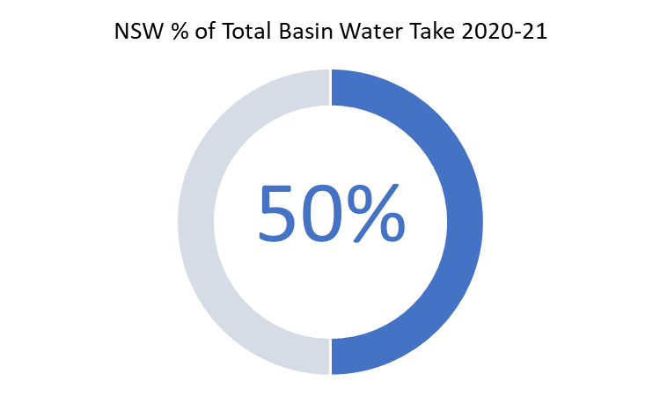

### Overview

New South Wales has the largest area of the Murray–Darling Basin, as well as the largest share of water take (about 50% of the Murray–Darling Basin total). There are over 38,000 water access licences in NSW.

In New South Wales there are three separate agencies overseeing water management and compliance. In broad terms, the Department of Planning and Environment (DPE) is responsible for policy advice and making the rules; WaterNSW is the customer-facing agency responsible for implementing the rules; and the Natural Resources Access Regulator (NRAR) is responsible for enforcing the rules.

NRAR was established in 2018 under the *Natural Resources Access Regulator Act 2017* (NRAR Act) in response to a recommendation from the Ken Matthews report that the compliance functions be transferred from WaterNSW to a new independent regulator.

NRAR acts as an independent authority responsible for all water compliance and enforcement functions, which were previously housed in separate government agencies.

New South Wales faces compliance challenges that are unique among the Basin states, given its geographical size and the fact it contains both regulated and unregulated watercourses.

### Metering, measurement and monitoring

#### Metering and measurement

New South Wales is part-way through implementing a new non-urban metering framework to improve the standard and coverage of non-urban meters. The rollout is being implemented in four tranches. Tranches 1, 2, and 3 cover the Murray–Darling Basin areas of the state. The scale of this project is challenging – with tranche 2 of the rollout containing over 8,000 meters.

As at 1 December 2021, 69% of meters in tranche 1 (pumps bigger than 500mm) were compliant with the new rules.

Under the New South Wales non-urban metering policy, all surface water works greater than 200mm must be fitted with telemetry. Telemetry allows for meter reads to be provided to a central location in near real-time, making it a very effective tool for monitoring water take. New South Wales is running a telemetry rebate program, funded jointly by New South Wales and the Australian Government, to encourage the voluntary uptake of telemetry.

#### Monitoring

Meters that require a manual read (i.e they are not fitted with telemetry) are read by WaterNSW staff. Generally, meters are read quarterly. As well, for licence holders in regulated systems, meter readings are required to be submitted by the licence holder when placing an order for water.

WaterNSW staff monitor individual water accounts for the commercial purposes of billing, account management, and associated reporting. WaterNSW regularly run ‘Negative Balance Reports’ to identify any water accounts that have taken water in excess of their allocation. For these accounts, WaterNSW will contact the licence holder to validate the data prior to issuing bills. Where the account is confirmed to be overdrawn the customer is reminded of their obligation to remain within their allocation and what action is required to correct the negative usage in their account.

From a compliance perspective, NRAR has access to these Negative Account Balance reports.

In late 2021 NRAR implemented a new dashboard which allows staff to monitor individual accounts daily (where the account is updated daily from a telemetered meter reading). This technology is a powerful tool for monitoring water take against allocation. It will become more effective as more meters are fitted with telemetry.

NRAR is an innovator among Basin state agencies regarding its development and utilisation of different technologies to assist with monitoring compliance. Chief among these is the use of satellite imagery in circumstances where water take is difficult to measure, such as floodplain harvesting. As an example of the increasing effectiveness of this technology in the compliance space, in April 2022 NRAR achieved a successful prosecution using evidence gathered by satellite technology, which measured the rise and fall of water in a dam.[3]

The regulation of floodplain harvesting remains a challenge for New South Wales. The New South Wales Legislative Council has disallowed various aspects of floodplain harvesting legislation in recent years. At the time of writing this report, new legislative amendments had commenced on 1 July 2022 that provide a framework to licence and measure the take of water by floodplain harvesting activities. This includes rules about how water take is measured, recorded and reported. Some water sharing plans were amended in July 2022 to enable the implementation of this framework.

### Managing non-compliance

NRAR adopts a risk-based approach to compliance and enforcement, with education at the core of its approach.[4]

When breaches are identified, NRAR will look to employ an educative response if the non-compliance is not severe and the offender is willing and able to rectify the situation. However, NRAR has a range of enforcement tools available, including warning letters, penalty infringement notices, enforceable undertakings and criminal prosecution.

It is important to note the progress made by New South Wales in this area. When the Basin Compliance Review was conducted in 2017, it noted that New South Wales had issued only 44 warning letters, 122 advisory notices and zero prosecutions during the 2016–17 water year.[5] By contrast, in 2020–21 NRAR issued 843 enforcement actions, completed 7 prosecutions and commenced a further 8 prosecutions.[6]

### Public reporting

NSW is notable for its level of transparency when reporting on compliance and enforcement activities and outcomes.

NRAR publishes a quarterly report on its compliance and enforcement activities.[7] It has also produced an interactive dashboard which can be used to display quarterly enforcement actions going back to 2003, categorised by local government area, water sharing plan and enforcement type.[8]

In addition, NRAR has published an annual progress report for the past three years. These reports provide a more complete picture of NRAR’s compliance and enforcement activities.[9]

### Inspector-General observations

The Inspector-General commends New South Wales for its progress since 2017, particularly regarding the resources dedicated to managing compliance; the level of public reporting on compliance and enforcement activities; and the adoption of new technologies to increase monitoring capabilities.

Mr Pearson’s review, whilst noting the achievements of New South Wales, was critical of its ability to effectively monitor licence-holders’ take against allocation. Mr Pearson viewed this as core to an effective compliance framework. In part, he saw this as driven by the separation of the customer-facing agency (WaterNSW) from the enforcement agency (NRAR), as well as by the gaps that remain in metering coverage in certain areas of the state.

Whilst noting these criticisms, the Inspector-General is encouraged by the progress of the current non-urban metering rollout, and the recent development of the dashboard allowing individual licence-holders’ take to be monitored more often. However, there does appear to remain a blurring of the responsibilities for one aspect of the compliance function, with WaterNSW retaining the responsibility for monitoring individual licence holder compliance with take against allocation.

In addition, until the unconstrained taking of floodplain water is regulated, this will remain a shortcoming of the New South Wales water management framework under the Basin Plan. Until it is regulated, floodplain harvesting water take remains directly unmeasured and both state and commonwealth compliance remains inoperative.

The Inspector-General is responsible for ensuring that all forms of water take are within the Sustainable Diversion Limits set by the Basin Plan. How New South Wales propose to achieve compliance with sustainable limits, including the take of floodplain water, is a matter for New South Wales to detail in their submission of Water Resource Plans to the Murray Darling Basin Authority for assessment. Outcomes in this area are well past committed deadlines.

## Victoria

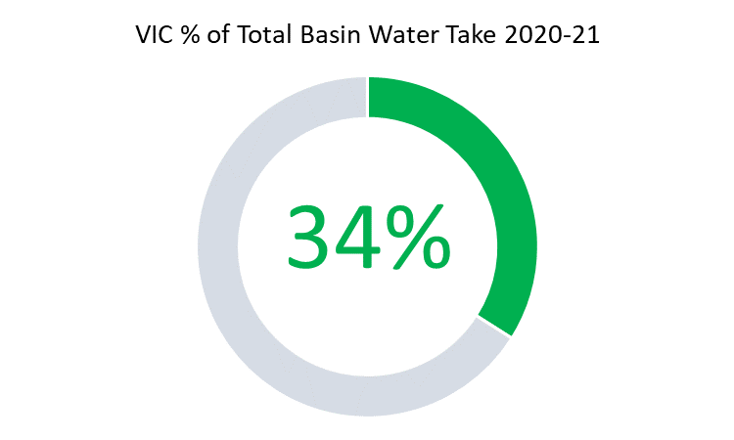

### Overview

Victoria is the second largest user of water in the Basin, accounting for about 34% of annual actual take in 2020–21. About 30,000 licenses, covering about 46,000 service points, are managed in the Murray–Darling Basin area of Victoria.

Four water corporations are responsible for managing service delivery to customers in the Murray–Darling Basin area of Victoria: Goulburn Murray Water, Lower Murray Water, Grampians Wimmera Mallee Water and Coliban Water. These water corporations also have responsibility for the compliance and enforcement function, which is delegated to them by the Victorian Minister for Water.

The Department of Environment, Land, Water and Planning (DELWP) is the government agency with responsibility for water management policy and oversees the performance and appointment of directors to the boards of water corporations.

### Metering, measurement and monitoring

#### Metering and measurement

In 2020–21, 96% of water taken via customer service points in the Murray–Darling Basin area of Victoria was metered. A notable feature of the Victorian meter fleet is the significant level of water taken – approximately 70% of total metered volume taken – where the meter is fitted with telemetry.

#### Monitoring

The frequency of meter reads for non-telemetered meters depends on risk – meters for low volume allocations may only be read once a year, whilst larger allocations will be subject to at least two meter reads per year.

DELWP also oversees unauthorised take through a robust reporting framework linked to data provided by the water corporations on the Victorian Water Register. This is supplemented by quarterly data provided by water corporations. This monitoring data is used to track performance. DELWP also reports to the Minister for Water quarterly on unauthorised take.

Mr Pearson’s review noted the effectiveness of Victoria’s monitoring of water take: unauthorised take in the Murray–Darling Basin area of Victoria represents only 0.1% of all water taken under entitlements recorded in the [Victorian Water Register](https://waterregister.vic.gov.au/).

### Managing non-compliance

Victoria has a publicly stated ‘zero tolerance’ approach to unauthorised water take. However, the water corporations do have a number of tools to address non-compliance assessed as ‘low risk’ without issuing a penalty – for example, where the non-compliance was a first-time offence and assessed as not deliberate. In this scenario, advisory or warning letters can be issued to water users to rectify breaches. Advisory letters represented over 60% of all enforcement actions taken during the 2020–21 water year.[10]

Victoria has set targets for unauthorised take of no more than 1% by total volume, and no more than 3% of accounts having a negative balance. As of 30 June 2021, these benchmarks were being met: unauthorised take represented 0.1% of all water taken, and 2.4% of accounts had a negative balance. [11]

In recent years Victoria has bolstered its enforcement capability through amendments to the *Water Act (VIC) (1989)*. The amendments increased the maximum fine for water theft; gave water corporations the option of issuing penalty infringement notices for water theft; and allowed water to be deducted from those who exceed their allocation. Water corporations commenced issuing penalty infringement notices in 2022.

### Public reporting

Water corporations are required to report on compliance and enforcement actions in their annual reports.

These statistics are then aggregated and reported at a state-wide level on the DELWP website as part of its annual water compliance reports.[12] These statistics include further details on finalised prosecutions, including the location of the offence, the specific breach of the Act, and the outcome of the prosecution.

### Inspector-General observations

One of the outcomes of Mr Pearson’s review, which reflects similar findings in previous reviews, is that Victoria has a clear, robust compliance framework complemented by extensive metering coverage, including a high proportion of meters fitted with telemetry.

The rates of non-compliance for unauthorised take are extremely low. This is a good indication of the effectiveness of the compliance and monitoring framework. There appears to be a strong compliance culture in the water corporations, underpinned by [strong public messaging](https://www.premier.vic.gov.au/zero-tolerance-water-theft-victoria) from the Victorian Government that it takes a ‘zero tolerance’ approach to water theft.

The Basin Compliance Review in 2017 noted Victoria’s lack of a full suite of penalties and sanctions, which at that time offered no enforcement option between low-level warnings and criminal prosecution. It is encouraging to see the strengthening of Victoria’s legislative framework in recent years. The water corporations now have a full range of enforcement options, bringing Victoria in line with other Basin states in this regard. These amendments appear to be having the desired effect: the Pearson review noted that customers are now being more careful to ensure they have positive balances before irrigating and are quickly addressing small negative balances.

## Queensland

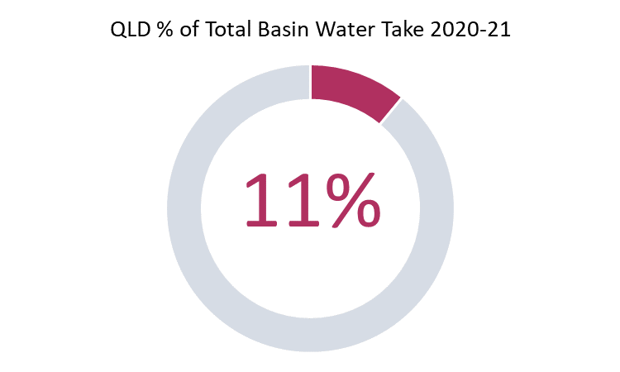

### Overview

Queensland is the third largest user of water in the Basin, accounting for approximately 11% of total annual actual water take in 2020–21. The Murray–Darling Basin area represents about 15% of Queensland.

The Department of Regional Development, Manufacturing and Water (DRDMW) is the responsible agency for managing the Basin water resources in Queensland. This includes the compliance and enforcement function.

### Metering, measurement and monitoring

Like New South Wales, Queensland faces some challenges in monitoring water take, notably the significant volume of water that is unsupplemented (referred to as unregulated in NSW), as well as the vast geographical distances that the Queensland Murray–Darling Basin covers.

#### Metering and measurement

Meter coverage and accuracy in Queensland is not as high as in other Basin states. In the Queensland Murray–Darling Basin area there are 5,945 entitlements, of which 2,730 (representing 74% of total volume) are metered. For the 26% of take that is not metered, a risk-based approach to monitoring is adopted. These entitlements are relatively smaller volume, groundwater entitlements.

Queensland is currently developing a strengthened non-urban water measurement policy, which aims to improve the standard and coverage of non-urban metering.

Licensing of overland flow works has been completed for the Lower Balonne sub-catchment area.[13] As part of the *Rural Water Futures* (RWF) program[14] there is a program of works underway to improve measurement and monitoring of the take of overland flow water. Queensland has also committed to the revalidation of existing measurement in the Lower Balonne; and licensing of the Border Rivers and Moonie floodplains by end of 2022.

#### Monitoring

Meter reading requirements range from annually for some unsupplemented take; during and after flow events for water harvesting; six-monthly for groundwater; and quarterly or monthly for supplemented take.Reconciliation of water use against entitlements is generally undertaken at the end of each water year. Queensland’s water accounting process is largely done manually using spreadsheets.

Overland flow harvesting is read during and after each flow event where licensing and measurement is in place – currently this is limited to the Lower Balonne catchment and 60% of the Border Rivers floodplain.

### Managing non-compliance

The Pearson review noted that in 2020–21, 1,734 audits of meter reads (where meter readings are checked against entitlements) were completed, resulting in a compliance rate of 95%. This shows that where water take is metered, compliance rates for take against allocation are comparable with other Basin states.

Meter readings received are audited against the allocated volumes annually. On a risk basis, some are subject to mid-year checks (usually in March), with exceptions addressed case by case.

DRDMW uses a risk-based and proportionate approach to managing detected non-compliance. Like other Basin states, Queensland has a range of enforcement tools available to use depending on the severity of the offence. There was a noted increase in enforcement activities during [2020-21](https://www.rdmw.qld.gov.au/__data/assets/pdf_file/0005/1581422/qmdb-compliance-enforcement-2021.pdf) compared with preceding years.

### Public reporting

Queensland publishes an annual report on its DRDMW website which gives an overview of compliance and enforcement actions undertaken in the Queensland Murray–Darling Basin, including property audits, warning notices, penalty infringement notices, and prosecutions.

The [2020-21 version](https://www.rdmw.qld.gov.au/__data/assets/pdf_file/0005/1581422/qmdb-compliance-enforcement-2021.pdf) of this report has improved markedly from the [previous version](https://www.rdmw.qld.gov.au/__data/assets/pdf_file/0010/1458379/qmdb-compliance-enforcement.pdf). It now reports on activities by water resource plan area, as well as providing information on the time taken to finalise investigations.

### Inspector-General observations

The Inspector-General commends Queensland for establishing the Rural Water Futures program following the independent audit of non-urban water measurement and compliance in 2018. However, four years on, we note the urgency with which the key outcomes from this program need to be delivered in full.

Mr Pearson’s review noted the willingness of Queensland to work collaboratively with Basin states, particularly New South Wales, to achieve better compliance outcomes for the Basin. A good example of this is the [Hydrometric Networks and Remote Sensing Program](https://www.mdba.gov.au/basin-plan/sustainable-diversion-limits/enhancing-water-monitoring-information). DRDMW has been working closely with the New South Wales NRAR to further develop their remote sensing and satellite imagery analysis capabilities. This sort of cross-jurisdiction collaboration generally leads to improved outcomes for the Basin as a whole – something the Inspector-General would like to see more of, as it can lead to innovation and efficiencies in current processes.

The quality and coverage of metering in Queensland is still an area where improvement is needed to ensure consistency across the Basin. We would hope to see the [current projects](https://www.rdmw.qld.gov.au/water/consultations-initiatives/rural-water-futures/strengthened-water-measurement) underway in this space finalised without further delay, particularly the finalisation of a strengthened non-urban measurement policy.

## South Australia

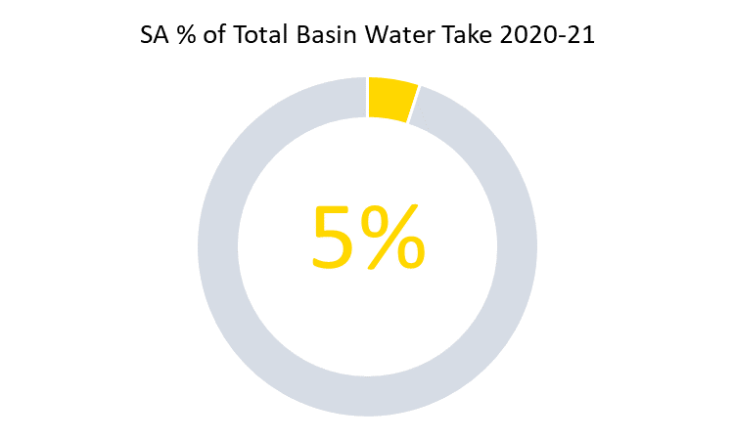

### Overview

The South Australian portion of the Basin extends from the Mount Lofty Ranges to the borders with Victoria and New South Wales. The Murray River is the most significant water resource and supply of water for the state. South Australia is the fourth largest user of water in the Basin, accounting for approximately 5% of annual actual take in 2020–21. There are 14,029 water licenses throughout South Australia. About 5,000 of these licenses are located within the Murray-Darling Basin.[15]

In South Australia the water resources of the Murray–Darling Basin are managed by the Department for Environment and Water (DEW). This agency is responsible for both setting the policy regarding water management and monitoring and enforcing compliance.

### Metering, measurement and monitoring

#### Metering and measurement

Under the [South Australian non-urban metering policy](https://cdn.environment.sa.gov.au/environment/docs/sa-licensed-water-use-metering-policy.pdf), all licensed take must be metered. Exemptions are made only in low-risk scenarios, which account for about 1.2% of take in the South Australian Murray–Darling Basin area. Exemptions to the requirements are defined in meter implementation plans for each water resource area and are published on the department’s website. South Australia is transitioning from government owned meters to privately owned, with all new meters to be replaced at the owner’s expense.

Whilst South Australia does have high metering rates, one area of metering and monitoring where South Australia does lag some other Basin states is telemetry fitted to meters on high-risk extractions. South Australia has maintained a formal public position for several years that a telemetry rollout for high-risk extractions is subject to funding. Importantly, however, South Australia has laid the groundwork for the introduction of telemetry, with a policy that states that all meters must be capable of being fitted with an electronic output device.[16] Funding has also been made available for telemetry trials to be undertaken in the near future.

#### Monitoring

72% of South Australian water licence holders are required to submit a quarterly meter reading (representing 87% of total volume taken). The remaining 28% are subject to annual meter reads. All meter reads are validated by DEW. Complementing this is an annual program of site visits where a minimum of 10% of licensed sites are visited each year. In 2020–21, 21% of water licences in SA received a site visit to conduct a compliance check, which includes taking an authorised meter reading.

### Managing non-compliance

South Australia, like Victoria, has a zero-tolerance approach to unauthorised take and applies mandatory penalties regardless of volume. In July 2019, a quarterly reconciliation process was introduced for licence holders in the South Australian River Murray. Importantly, the penalty regime also shifted from annual to quarterly reconciliation. This means that a mandatory financial penalty is applied to a licence holder who has taken more water than was allocated to them for the quarter. This policy improves deterrence of unauthorised water take. in 2020–21, 72 (about 1.4% of) licensees were subject to this penalty charge.

In addition to mandatory penalties for unauthorised take, South Australia also has a range of other compliance options available, including expiations, directions, licence variation, suspension and cancellation, and prosecution. Like other Basin states, South Australia aims to educate customers about their water licensing obligations, including providing a tool to enable licencees to access information on usage against allocation to facilitate voluntary compliance.

### Public reporting

South Australia has published an annual report on its water compliance activities on its website since 2013–14.[17] South Australia was singled out for praise in the 2017 Murray–Darling Basin Compliance Review for its reporting and transparency. At that time it was the only Basin state to provide publicly available reporting on compliance strategy and compliance activities.

South Australia continues to provide annual reports on its website of compliance and enforcement activities undertaken during the year, with a breakdown showing the type of activity and the location where the non-compliance occurred.

### Inspector-General observations

South Australia has had a strong compliance framework for many years. Mr Pearson’s review concluded that the South Australian compliance framework is operating efficiently and effectively, with clear guidelines and policies that inform water users of their obligations and deter water theft.

The Inspector-General is encouraged by the progress South Australia continues to make towards the implementation of telemetry for high-risk extractions. It is important for South Australia to remain contemporary in this regard, and mandating telemetry for high-risk extractions will align South Australia with best practice metering frameworks in the Basin. This will help ensure that South Australia’s strong record of low non-compliance continues.

## Australian Capital Territory

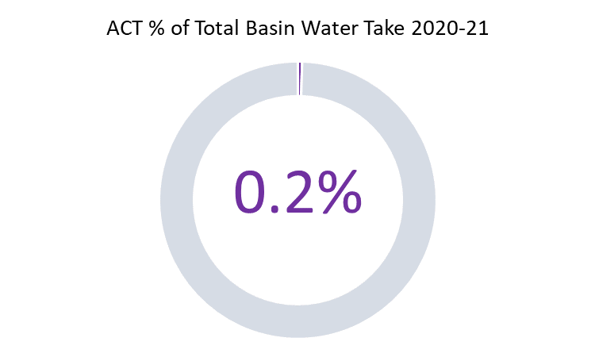

### Overview

The ACT is the smallest jurisdiction in the Basin, both in terms of geographical size and the amount of water it extracts, representing less than 1% of actual take in 2020–21.

Urban water comprises a significant proportion of total use: the ACT has the largest urban area within the Basin and limited agriculture. The ACT contains several major storages used for urban water, such as the Corin, Bendora and Cotter reservoirs.

The *Water Resources Act (ACT) (2007)* is the governing legislation for managing water resources in the ACT. The ACT Environment Protection Authority (EPA) administers the Act, including the function of water compliance and enforcement, whilst the Environment, Planning and Sustainable Development Directorate is the agency responsible for policy development.

### Metering, measurement and monitoring

#### Metering and measurement

All water entitlements in the ACT are required to be metered. In 2020–21, there were 182 active water licences and 316 meters in use.

#### Monitoring

Holders of a licence to take water are typically required to record water meter readings monthly (self-read). There may be reasonable circumstances for less frequent meter reads due to low licence volume (for example, 1 to 5 ML), actual volume of water use, compliance history and the water use activity.

Water use by licensees is analysed annually, and compliance with licence conditions (supply of data, amount of water used) is checked during the accounting process.

Meter reads are complemented with meter inspections by EPA staff. However, only one meter inspection was undertaken during the 2020–21 water year (compared with 43 inspections in 2018–19 and 22 inspections in 2019–20.[18] According the 2020–21 EPA annual report, this low figure was due to ‘COVID-19 restrictions early in the year and staff movements in the water regulation team of the EPA’.

### Managing non-compliance

Given the small scale of non-urban water take in the ACT, enforcement actions are understandably minimal. During 2018–19, two formal warning letters were issued for breaches of licence conditions for no water meter and a faulty water meter.

No enforcement activities were reported for the 2019–20 or 2020–21 water years.

### Public reporting

The ACT reports on its management of non-urban water use as part of the EPA annual report. The report includes brief information on licences, meters and meter inspections, but it does not include information on compliance and enforcement activities of the sort that the other jurisdictions now publish.

### Inspector-General observations

The Pearson review concluded that the ACT compliance and enforcement framework and governance arrangements are effective and fit for purpose in practical terms, given the small scale of non-urban water use.

The overall coverage of meters in the ACT is a strength of the ACT system. Disappointingly, however, a number of issues raised in the Murray–Darling Basin Compliance Compact Assurance Report 2020 have still not been addressed. As that report noted, despite the low risk that the ACT poses at a Basin scale, it is still important that all Basin states are held to the same standard. Otherwise, the perception of fairness and equality across the Basin is weakened.

# Part 2: Key conclusions from the Pearson review

Mr Pearson’s review highlighted a number of issues that need addressing to improve compliance and enforcement at a whole-of-Basin scale and ensure public confidence in the effective management of the Basin’s resources. The following is an overview of these key issues.

## Developing more outcome-focused indicators

Since the Compliance Compact was agreed in 2018, there has been a marked improvement in the availability of compliance information to communities.

However, the improvement has tended to be in the areas of activities and outputs. But simply reporting activities does not necessarily show how effective the activities are in achieving desired outcomes. There is a need to move the focus from activities and outputs to achieving better compliance outcomes. A good example of this is Victoria setting targets for unauthorised water take, then reporting against those targets.

At present there is no established Basin-wide set of key indicators that would allow systematic monitoring of how effective compliance and enforcement activities are in achieving outcomes.

There is a need for a more collaborative approach to establish Basin-wide key indicators and measures showing the effectiveness of compliance activities. A collaborative process to develop these indicators would mean this process is owned by all parties, helping to lower implementation risk.

Outcomes, as opposed to activities, can be assessed in a consistent and comparable way both within and between jurisdictions. The benefit of outcomes-based reporting was also noted in the 2021 Compliance Compact Review, where it was noted that by reporting on outcomes ‘the community will be able to see where further improvement is required and have clear sight of any emerging problems … governments will also be well placed to target existing resources and make new investments in water compliance.’[19]

## Consistency of enforcement approach

Having a transparent and clear escalation pathway for enforcement actions can improve consistency and increase public faith in the process of managing non-compliance.[20]

There is a need to be more consistent about the ‘water theft’ message, and to avoid the perceptions of inequity that can arise when:

* enforcement is not predictable and visible
* tolerance thresholds are applied which have not considered cross-jurisdictional harm and which could be perceived as inconsistent
* enforcement escalation pathways are not clear and consistent.

This situation warrants collaborative Basin-wide attention. Better collaboration would also help jurisdictions as they explore more nuanced options for initiating compliance responses. For example, responses might take into account:

* thresholds of both absolute volume and proportion of allocation/entitlement, when deciding whether breaches are significant
* incidence of breaches within timeframes
* timeliness of water trades so accounts are not overdrawn.

## Improving transparency

As noted above, the level and detail of compliance information available to the Basin community is far greater than it was several years ago. However, there is still progress to be made in this regard. Approaches to compliance reporting vary by jurisdiction. Individually they are at least adequate. However, it would be beneficial if there were greater consistency of structure, coverage and approach, both within and across jurisdictions.

As an example, information on enforcement activities currently ranges from a brief section embedded in an annual report to a fully interactive public register of enforcement actions that allows users to search by location, type of enforcement, and date of the compliance breach.

There would be merit in establishing core criteria, guidance, checklists and reporting formats to facilitate more objective comparisons and analysis across the Basin. This need not impinge on the autonomy of individual jurisdictions.

## Advancing collaboration

Basin-wide improvements in compliance and enforcement will require cultural change and a more objective, outcomes-focused collaborative effort across jurisdictions.

At present there is a lack of agreed standards and benchmarks. Most of the task ahead is to revisit the range of approaches that individual jurisdictions have adopted over time, and to revise those approaches as appropriate in light of today’s standards and circumstances.

It appears that few of the issues inhibiting consistent compliance and enforcement across the Basin relate to legislative provisions. Most of the task ahead is to revisit, from a Basin-wide perspective, the range of approaches that individual jurisdictions have adopted over time, so that similarities and differences are clearly understood and documented; and to reconcile or revise approaches in the context of contemporary standards and circumstances.

A threshold challenge is to commit to providing understandable compliance information. Basin states can provide assurance about compliance standards to the Inspector-General, and the Inspector-General can work to strengthen compliance and improve trust across the Basin.

Across jurisdictions there are many examples of better practice, but all jurisdictions have room for improvement. A collaborative approach offers benefits that will undoubtedly outweigh the investment required.

# Part 3: Inspector-General commitments

This section of the report will detail the actions the Inspector-General will commit to undertake to address the issues raised in Mr Pearson’s review. Some of the issues raised by Mr Pearson are for Basin states to address and are not within the remit of the Inspector-General. However, the following initiatives fit within the Inspector-General’s oversight function, and working in collaboration with the Basin states, implementing these initiatives will lead to a demonstrable improvement in Basin-wide compliance and enforcement.

## Action Item 1 – Regulatory Leaders Forum

### What is it?

A quarterly meeting consisting of the chief water regulatory officers from each Basin state government. This meeting provides the opportunity for the regulatory leaders from each Basin state to discuss current issues, share better practice, and work more collaboratively to achieve better compliance outcomes for the Basin.

Work is progressing on the development of a formal Memorandum of Understanding (MoU) between the Inspector-General and Basin States.

### Who will do it?

The Regulatory Leaders Forum is an initiative of the Inspector-General in collaboration with Basin states.

### When will it be done?

Meetings commenced in October 2021, with subsequent meetings held in March 2022 and June 2022. The intention is for the forum to meet at least 3 times per year.

### What will this achieve?

The Regulatory Leaders Forum is an opportunity for greater collaboration among the Basin states by bringing together the most senior water regulators from all Basin governments in an open forum where matters of importance can be freely discussed. Meetings held to date have already proven beneficial by uplifting individual Basin state water compliance management issues to a whole-of-Basin level.

## Action Item 2 - Water compliance performance reporting

### What is it?

A project to develop and implement improved and consistent Basin-wide public reporting on performance relating to water compliance.

### Who will do it?

It will be led by the Inspector-General of Water Compliance in collaboration with the Basin states via the Regulatory Leaders Forum.

### When will it be done?

By the end of 2022, a set of metrics will be developed that can be reported against by Basin states using their existing systems. In addition, a framework for outcomes based reporting will be developed.

Reporting against this new framework is intended to commence from mid-2023 (for the 2022–23 reporting period) and will progressively expand over the subsequent 3 to 5 years to include other outcomes-focused metrics.

### What will this achieve?

The aim of this project is to address a key finding from Mr Pearson’s review, namely improving the quality and consistency of public reporting on compliance activities, with a focus on the reporting of outcomes, not just activities.

## Action Item 3 – IGWC Metering Standard

### What is it?

The Inspector-General of Water Compliance has the power under the *Water Act* *(2007)* (Cth) to issue standards relating to measuring water taken from the Basin.

### Who will do it?

The Inspector-General of Water Compliance.

### When will it be done?

It is intended to be completed in early 2023.

### What will this achieve?

This project will look to set guidance for minimum standards applying to metering in the Basin.

A Basin-wide metering standard will establish a consistent standard for metering in the Basin, addressing a common concern in the community that water take in the Basin is not being measured consistently and accurately.

## Action Item 4 – Review into unmeasured take

### What is it?

In response to a finding in Mr Pearson’s review regarding the significant volume of unmeasured take that forms part of the Sustainable Diversion Limit (SDL), this project will review the current forms of take that are accounted for using estimates. It will look at any potential issues, the levels of confidence in the modelling, and any concerns about potential for growth in these forms of take.

### Who will do it?

The Inspector-General of Water Compliance.

### When will it be done?

It is intended to be commenced in early 2023 and completed in mid-2023.

### What will this achieve?

This is an internal research project which will look to determine if the current methods used to estimate water take in the Basin that is currently unmeasured are sufficient. Initial research could lay the groundwork for understanding the potential issues involved, including levels of confidence in modelling and any concerns about growth in use of the unmeasured proportion of take.

## Action Item 5 – Determining harm from unauthorised take

### What is it?

This project consists of the development of a guideline for establishing the harm caused from unauthorised take from Basin water resources, which could be used consistently across the Basin for enforcement actions.

### Who will do it?

The Inspector-General of Water Compliance.

### When will it be done?

It is intended to be completed by the end of 2024.

### What will this do?

Guidance on the actual harm caused by unauthorised take of water will assist Basin states when undertaking enforcement of water theft. It aims to create a consistent baseline to quantify the actual harm caused by unauthorised water take, taking into account a number of factors including commercial cost, environmental harm, and the loss of water to First Nations people.

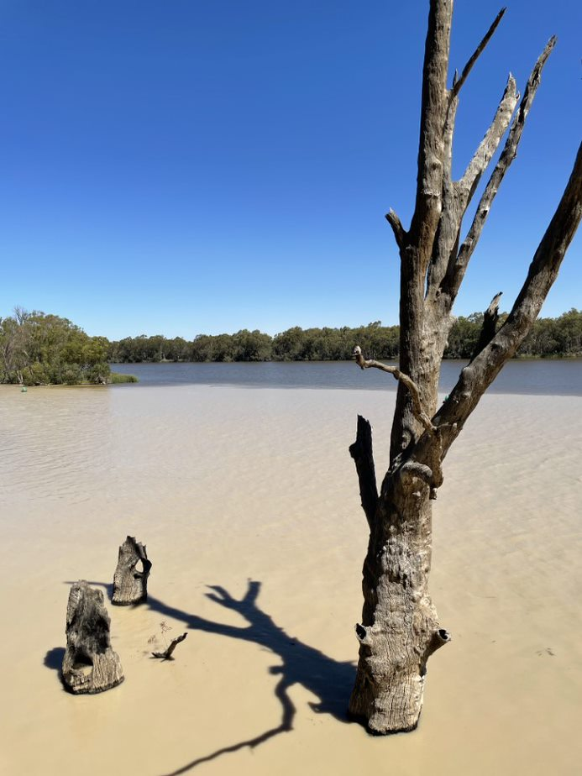

Convergence of the Murray and Darling Rivers at Wentworth, New South Wales.  
Source: Office of the Inspector-General of Water Compliance.

# Glossary

|  |  |
| --- | --- |
| Basin states | Each of New South Wales, Victoria, Queensland, South Australia and the Australian Capital Territory |
| Murray–Darling Basin Compliance Compact | A collaborative, joint commitment by the Australian Government and Basin states that aims to restore public confidence in water resource management in the Murray–Darling Basin by providing transparency and accountability of surface and groundwater management and regulation and a consistent approach to compliance and enforcement practices by governments across the Basin. |
| Basin Plan | The plan made by the responsible Commonwealth minister under section 44 of the *Water Act 2007*. It sets standards for the management of the Murray–Darling Basin’s water resources in a coordinated and sustainable way in collaboration with the community. Officially known as the Basin Plan 2012. |
| Floodplain harvesting | The collection, extraction or impoundment of water flowing across floodplains, including rainfall run-off and overbank flow but excluding the taking of:   * water taken under a water access licence that is not a floodplain harvesting access licence * water under a basic landholder right including water taken under a harvestable right * water under an applicable licence exemption * used irrigation water. |
| Flow event | A rainfall event resulting in a flow of water through a distributory system, resulting in increased storage volumes and announcements for water harvesting. |
| Overland flow | Overland flow refers to water that runs across the land after rainfall, either before it enters a watercourse, after it leaves a watercourse as floodwater, or after it rises to the surface naturally from underground. |
| Regulated system | A system in which water can be stored, or flow levels are controlled, through the use of structures such as dams and weirs. |
| Supplemented water | A term used in Queensland to describe entitlements where reliability is enhanced by infrastructure such as a dam or weir, which is managed under a resource operations licence. |
| Unregulated water | Water that is not controlled or regulated by releases from major storages |
| Unsupplemented water | In Queensland, unsupplemented surface water allocations are water entitlements representing a share of the access to natural run-of-the-river flows or groundwater resource. They may or may not have flow conditions applied. |

# References

ACT Government, *Annual report 2020–21 volume 1: Chief Minister, Treasury and Economic Development Directorate*, 2021.

Department for Environment and Water (South Australia), *Water compliance reporting and planning 2020–2021*.

Department for Environment and Water (South Australia), *South Australian licensed water use metering policy*, June 2019.

Department for Environment and Water (South Australia), *South Australian licensed water use metering specification*, June 2019.

Department of Environment, Land, Water and Planning (Victoria), *Compliance and enforcement report card 2020–21*.

Department of Environment, Land, Water and Planning (Victoria), *Water compliance report 2020–21*.

Department of Regional Development, Manufacturing & Water (Queensland), *Queensland Murray–Darling Basin compliance and enforcement actions 2020–2021*, 2021.

Department of Natural Resources, Mines and Energy (Queensland), *Queensland Murray–Darling Basin compliance and enforcement actions report 2019–2020*, n.d.

Independent Expert Panel, *Independent audit of Queensland non-urban water measurement and compliance final report*, 23 March 2018.

Matthews K, *Independent investigation into NSW water management and compliance*, NSW Department of Industry, 24 November 2017.

Murray–Darling Basin Authority, *Compliance compact review: review by parties for the Murray–Darling Basin Compliance Compact*, May 2021.

Murray–Darling Basin Authority, *Murray–Darling Basin compliance compact*, 12 December 2018.

Murray–Darling Basin Authority, *The Murray–Darling Basin water compliance review,* November 2017.

Murray–Darling Basin Authority, *Murray–Darling Basin compliance compact assurance report 2020*, March 2021.

*Natural Resources Access Regulator Act 2017* (New South Wales).

Natural Resources Access Regulator (NSW), *Progress Report 2020–21*.

New South Wales Department of Industry, *Natural Resources Access Regulator regulatory framework*, January 2019.

New South Wales Department of Planning, Industry and Environment, *NSW floodplain harvesting measurement policy*, July 2020.

*NSW Government response: inquiry into floodplain harvesting*, n.d. [24 May 2022]

Pearson D, *Environmental scan: compliance and enforcement across the Murray–Darling Basin (draft report)*, Office of the Inspector-General of Water Compliance, June 2022.

*Water Act 2007* (Cth).

*Water Act 1989* (Vic).

*Water Resources Act 2007* (ACT).

1. Murray–Darling Basin Authority, [*Compliance compact review*](https://www.mdba.gov.au/sites/default/files/pubs/murray-darling-basin-compliance-compact-2021.pdf), May 2021, p. 3.
2. Murray–Darling Basin Authority, [*Compliance compact review*](https://www.mdba.gov.au/sites/default/files/pubs/murray-darling-basin-compliance-compact-2021.pdf), May 2021, p. 3.
3. [Satellite imagery reveals extent of illegal water take on farm | NSW Dept of Natural Resources Access Regulator](https://www.nrar.nsw.gov.au/news/satellite-imagery-reveals-extent-of-illegal-water-take-on-farm)
4. [Natural Resources Access Regulator Regulatory Framework (nsw.gov.au)](https://www.industry.nsw.gov.au/__data/assets/pdf_file/0018/212517/NRAR-regulatory-framework.pdf)
5. 2017 MDB-Compliance-Review-Final-Report.pdf
6. [Natural Resources Access Regulator - Progress report 2020-21 (nsw.gov.au)](https://www.nrar.nsw.gov.au/__data/assets/pdf_file/0006/477015/NRAR-progress-report-2020-21.pdf)
7. [Quarterly compliance reports | NSW Dept of Natural Resources Access Regulator](https://www.nrar.nsw.gov.au/progress-and-outcomes/qrt-reports)
8. [Public register   | NSW Dept of Natural Resources Access Regulator](https://www.nrar.nsw.gov.au/progress-and-outcomes/public-register)
9. [Progress reports | NSW Dept of Natural Resources Access Regulator](https://www.nrar.nsw.gov.au/progress-and-outcomes/progress-reports)
10. [Water Compliance Report 2020-21](https://www.water.vic.gov.au/water-for-agriculture/taking-and-using-water/compliance-reports/water-compliance-report-2020-21)
11. [Compliance and Enforcement Report Card 2020-21 (water.vic.gov.au)](https://www.water.vic.gov.au/water-for-agriculture/taking-and-using-water/non-urban-water-compliance-and-enforcement-in-victoria/compliance-and-enforcement-report-card)
12. [Water Compliance Report 2020-21](https://www.water.vic.gov.au/water-for-agriculture/taking-and-using-water/compliance-reports/water-compliance-report-2020-21)
13. [Program to improve the measurement of overland flow | Department of Regional Development, Manufacturing and Water (rdmw.qld.gov.au)](https://www.rdmw.qld.gov.au/water/consultations-initiatives/rural-water-futures/projects/measurement-overland-flow)
14. [Rural Water Futures | Department of Regional Development, Manufacturing and Water (rdmw.qld.gov.au)](https://www.rdmw.qld.gov.au/water/consultations-initiatives/rural-water-futures)
15. [annual_compliance_report_-_2020-21.pdf (environment.sa.gov.au)](https://cdn.environment.sa.gov.au/environment/docs/annual_compliance_report_-_2020-21.pdf)
16. [sa-licensed-water-use-meter-specifications-gen.pdf (environment.sa.gov.au)](https://cdn.environment.sa.gov.au/environment/docs/sa-licensed-water-use-meter-specifications-gen.pdf)
17. [Department for Environment and Water - Water compliance reporting](https://www.environment.sa.gov.au/topics/compliance/water-compliance/water-compliance-reporting)
18. [Volume-1-CMTEDD-Annual-Report-2020-21-final.pdf (act.gov.au)](https://www.cmtedd.act.gov.au/__data/assets/pdf_file/0007/1909951/Volume-1-CMTEDD-Annual-Report-2020-21-final.pdf)
19. Murray–Darling Basin Authority, *Compliance compact review*, May 2021, p. 18
20. 2017 MDB-Compliance-Review-Final-Report.pdf, pg. 52