

# Sustainable Diversion Limit compliance statement for 2020–2021

Inspector-General of Water Compliance

August 2022

© Commonwealth of Australia 2022

**Ownership of intellectual property rights**

Unless otherwise noted, copyright (and any other intellectual property rights) in this publication is owned by the Commonwealth of Australia (referred to as the Commonwealth).

**Creative Commons licence**

All material in this publication is licensed under a Creative Commons Attribution 4.0 International Licence, except for content supplied by third parties, logos and the Commonwealth Coat of Arms.

Inquiries about the licence and any use of this document should be emailed to [copyright@dcceew.gov.au](mailto:copyright@dcceew.gov.au).



**Cataloguing data**

This publication (and any material sourced from it) should be attributed as: Inspector-General of Water Compliance 2022, Sustainable Diversion Limit compliance statement for 2020–2021, the Australian Government, Canberra, August 2022. CC BY 4.0.

This publication is available at <https://www.igwc.gov.au/reviews-reports>

Inspector-General of Water Compliance  
GPO Box 3090 Canberra ACT 2601

**Disclaimer**

The Australian Government represented by the Inspector-General of Water Compliance, has exercised due care and skill in preparing and compiling the information and data in this publication. Notwithstanding, the Inspector-General of Water Compliance, the Australian Government’s employees disclaim all liability, including liability for negligence and for any loss, damage, injury, expense or cost incurred by any person as a result of accessing, using or relying on any of the information or data in this publication to the maximum extent permitted by law.

**Acknowledgement of the Traditional Owners of the Murray–Darling Basin**

The Author pays respect to the Traditional Owners and their Nations of the Murray−Darling Basin. We acknowledge their deep cultural, social, environmental, spiritual and economic connection to their lands and waters.

The guidance and support received from the Murray Lower Darling Rivers Indigenous Nations, the Northern Basin Aboriginal Nations and our many Traditional Owner friends and colleagues is very much valued and appreciated.

Aboriginal people should be aware that this publication may contain images, names or quotations of deceased persons.

**Accessibility**

The document and information is available in accessible formats. On some occasions the highly technical nature of the document means that we cannot make some sections fully accessible. If you encounter accessibility problems or the document is in a format that you cannot access, please contact us.

The mission of the Inspector-General of Water Compliance is to provide transparency and accountability against the Basin Plan.

Sustainable Diversion Limits (SDLs) commenced on 1 July 2019. With the legislative amendments to the Water Act 2007 (Cth) and the Basin Plan 2012 (Cth), in August 2021, the Inspector-General of Water Compliance was established and became responsible for responding to Sustainable Diversion Limit compliance.

Sustainable Diversion Limits (SDLs) and compliance with the limits are essential to the implementation and operation of the Basin Plan. Under the Water Act 2007, Sustainable Diversion Limits provide for ‘the establishment and enforcement of environmentally sustainable limits on the volume of surface water and ground water that may be taken from Basin water resources’ (see section 20(b)). In effect, SDLs limit the amount of water that can be taken from rivers and aquifers for towns, industry, and farmers.

Pleasingly, the number of SDL resource units that are subject to SDL compliance under the Basin Plan has expanded since the Murray-Darling Basin Authority’s (MDBA’s) first register of take report and SDL compliance outcomes for 2019–20. The 2019-20 register contained 6 SDL resource units (3 surface water and 3 groundwater) from Queensland, as it was the only Basin state that had some accredited Water Resource Plans on 1 July 2019 for the commencement of that water year. All 6 SDL resource units were assessed as compliant by the MDBA.

I have reviewed the 2020–21 register of take as presented in Tables 4 and 6 of the [MDBA's Sustainable Diversion Limit Registers of Take 2020–21](https://www.mdba.gov.au/sites/default/files/pubs/sustainable-diversion-limit-accounts-registers-of-take-2020-21.pdf) and found all 55 SDL resource units in the register of take to be compliant (see Figures 1 and 2). A positive result for Basin Plan SDL compliance. More detail on this issue can be found at Appendix B: Registers of take 2020–21.

The 55 compliant SDL resource units (19 surface water and 36 groundwater) cover Queensland, South Australia, Victoria and the Australian Capital Territory.

One of the 55 compliant SDL resource units is compliant with an exceedance of the SDL. The Basin Plan sets a surface water non-compliance trigger at a debit amount equal to or greater than 20% of the long-term annual diversion limit. The South Australian (SA) Murray has a 7.87 GL cumulative balance debit. The compliance trigger for the SA Murray SDL resource unit is 108.4 GL (20%). Although there is an SDL exceedance, the compliance trigger has not been exceeded, therefore the SA Murray is compliant and there is no requirement for a reasonable excuse.

I note that the MDBA in developing the 2020–21 register of take has followed the rules set out in the Basin Plan section 6.08(6) for surface water SDL resource units. This requires that following the accreditation of a Water Resource Plan, the opening balance in the register of take for a surface water Sustainable Diversion Limit is set to zero.

Disappointingly, 54 SDL resource units in New South Wales (10 surface water and 44 groundwater) are not currently subject to SDL compliance or enforcement by the Inspector-General, as there are no accredited Water Resource Plans in place. More information on this issue can be found at Appendix A: SDL compliance in NSW.

This statement should be read in conjunction with the [Sustainable Diversion Limit Registers of Take 2020–21](https://www.mdba.gov.au/sites/default/files/pubs/sustainable-diversion-limit-accounts-registers-of-take-2020-21.pdf) report dated May 2022 and published on the MDBA website as well as the Sustainable Diversion Limit Reporting and Compliance Framework dated November 2018 and published on the MDBA website.

I welcome the positive SDL compliance results in the 2020–21 water year and encourage all Basin state Government’s to continue to closely monitor and manage water usage within the Sustainable Diversion Limits.

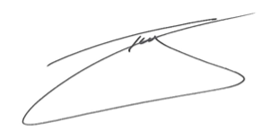

The Hon. Troy Grant  
Inspector-General Water Compliance  
8 August 2022

## Figure 1

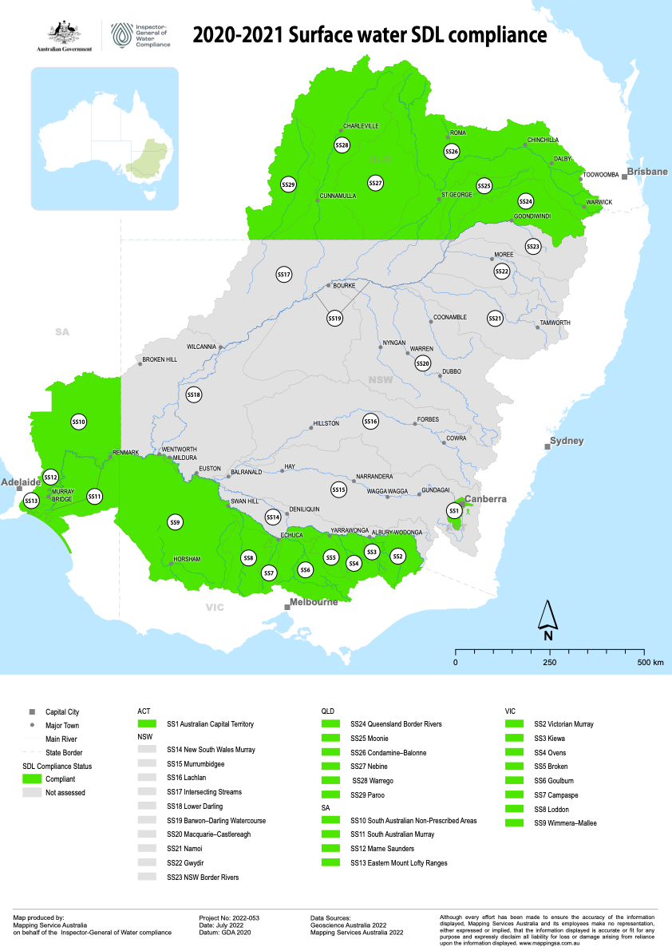

Figure 1 and Figure 2 can be found as separate maps at [www.igwc.gov.au/reviews-reports](http://www.igwc.gov.au/reviews-reports)

## Figure 2

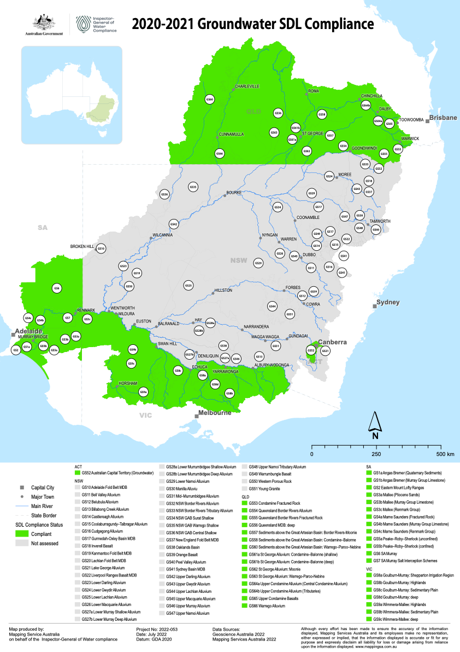

## Appendix A: SDL compliance in NSW

As of end of the 2020–21 period, there were no water resource plans operating in New South Wales (NSW). This is still the case in August 2022. I am seriously concerned that after more than 10 years since the inception of the Basin Plan, no water resource plans are currently accredited and in place in NSW.

Whilst SDLs commenced on 1 July 2019, without water resource plans, SDL compliance provisions in the Basin Plan are not operational. Therefore, I cannot assess any SDL compliance, non‑compliance or claims for reasonable excuse in NSW. Consequently, there is no ability to enforce SDLs in NSW.

The MDBA has recorded NSW’s SDL information on an interim register of take. Although a useful tool for accounting and compliance risk assessment purposes, it is not a legislative tool that can be used to determine or enforce compliance. This constrains my legislative ability to determine both SDL compliance and non-compliance in NSW.

Accounting methods for each SDL resource unit are determined through the WRP accreditation process. For 2020–21 the MDBA has used water accounting methods bilaterally agreed with NSW. The MDBA bilateral agreement and the reports generated from these are administrative arrangements. By undertaking the accounting process under the administrative arrangements, the MDBA does provide an indication of the potential SDL compliance risks in NSW for 2020–21.

Determining compliance with the Basin Plan occurs by considering rules contained inside accredited water resource plans. When a water resource plan is in place, the Inspector-General has a full legal suite of monitoring, risk assessment, and compliance tools such as inquiries, audits, and investigations available to undertake compliance and enforcement.

It is important to note that the Basin Plan requires that once a water resource plan is accredited and operational, the SDL cumulative balance is set to zero. This means that any interim debits or credits in NSW will be reset to zero once water resource plans are in place.

SDL compliance considers the Basin States overall management of take at the whole water resource scale as part of the Basin Plan. SDL take reflects the collective consumptive use (including irrigation, town water supply, run-off dams, commercial plantations, floodplain harvesting, and other consumptive uses whether they are licensed or unlicensed).

It is the responsibility of Basin State governments to use water within the Sustainable Diversion Limit. In this case the NSW Government. The absence of accredited water resource plans in NSW is not a reflection on any individual NSW water users or their level of individual water licence compliance. Nor is it a reflection of the individual water use compliance and enforcement activities of the independent NSW Natural Resources Access Regulator. Throughout the Basin, water access right holders, are lawfully able to take water within the conditions of their water access entitlements.

I continue to strongly encourage the NSW Government to submit water resource plans capable of being accredited to the MDBA as soon as possible. Equally, I encourage the MDBA to assess and respond to submitted plans in a timely manner. An update of status and progress of NSW water resource plans is available on the MDBA website.

I await the formal legal commencement under the Basin Plan of SDL compliance and enforcement within NSW.

## Appendix B: Registers of take 2020–21

The following tables are sourced from the MDBA’s [Sustainable Diversion Limit Registers of Take 2020–21](https://www.mdba.gov.au/sites/default/files/pubs/sustainable-diversion-limit-accounts-registers-of-take-2020-21.pdf). At the time of publication, the data below is true and accurate. This data was used by the Inspector-General of Water Compliance as the basis for the 2020–2021 SDL compliance statement.

Table 4 Surface water registers of take for 2020–21. All numbers are in GL (1 gigalitre = 1 billion litres)

| **State** | **SDL resource unit** | **SDL resource unit code** | **SDL** | **Annual Permitted Take1** | **Annual Actual Take** | **Annual Balance2** | **Cumulative Balance Start of 2020–213** | **Cumulative Balance End of 2020–214** | **HEW Adjustments5** | **Adjusted Cumulative Balance End of 2020–216** | **Compliance Trigger (-20% of SDL)7** | **Was the trigger compliance exceeded? (Yes/No)** |
| --- | --- | --- | --- | --- | --- | --- | --- | --- | --- | --- | --- | --- |
| QLD | Queensland Border Rivers | SS24 | 363.6 | 508.2 | 452.4 | 55.8 | 0.00 | 55.8 | 0.00 | 55.8 | -72.7 | No |
| QLD | Moonie | SS25 | 89.9 | 114.3 | 58.8 | 55.5 | 0.00 | 55.5 | 0.00 | 55.5 | -18.0 | No |
| QLD | Condamine-Balonne | SS26 | 919.0 | 853.9 | 848.4 | 5.52 | 0.00 | 5.52 | 0.00 | 5.52 | -183.8 | No |
| QLD | Nebine | SS27 | 17.1 | 16.9 | 11.1 | 5.78 | 4.92 | 10.7 | 0.00 | 10.7 | -3.41 | No |
| QLD | Warrego | SS28 | 55.5 | 38.1 | 21.8 | 16.3 | 24.4 | 40.8 | 0.00 | 40.8 | -11.1 | No |
| QLD | Paroo | SS29 | 11.8 | 10.9 | 10.85 | 0.08 | 0.08 | 0.15 | 0.00 | 0.15 | -2.36 | No |
| ACT | Australian Capital Territory | SS1 | 53.4 | 35.1 | 19.8 | 15.3 | 0.00 | 15.3 | 0.00 | 15.3 | -10.7 | No |
| VIC | Victorian Murray8 | SS2 | 1319.8 | 1266.8 | 1137.7 | 129.1 | 0.00 | 129.1 | 0.00 | 129.1 | -264.0 | No |
| VIC | Kiewa8 | SS3 | 27.7 | 28.4 | 20.9 | 7.49 | 0.00 | 7.49 | 0.00 | 7.49 | -5.54 | No |
| VIC | Ovens8 | SS4 | 85.8 | 91.2 | 75.2 | 15.9 | 0.00 | 15.9 | -0.04 | 15.9 | -17.2 | No |
| VIC | Broken8 | SS5 | 49.0 | 44.6 | 42.2 | 2.42 | 0.00 | 2.42 | 0.00 | 2.42 | -9.80 | No |
| VIC | Goulburn8 | SS6 | 1278.0 | 1149.1 | 797.0 | 352.1 | 0.00 | 352.1 | 0.00 | 352.1 | -255.6 | No |
| VIC | Campaspe8 | SS7 | 111.7 | 80.5 | 68.1 | 12.4 | 0.00 | 12.4 | 0.00 | 12.4 | -22.3 | No |
| VIC | Loddon8 | SS8 | 127.7 | 81.9 | 73.2 | 8.77 | 0.00 | 8.77 | 0.00 | 8.77 | -25.5 | No |
| VIC | Wimmera-Mallee (surface water)8 | SS9 | 76.1 | 72.3 | 48.2 | 24.1 | 0.00 | 24.1 | 0.00 | 24.1 | -15.2 | No |
| SA | South Australian Murray9 | SS11 | 542.2 | 635.4 | 629.6 | 5.72 | 0.00 | 5.72 | -13.6 | -7.87 | -108.4 | No |
| SA | South Australian Non-Prescribed Areas9 | SS10 | 55.2 | 55.2 | 23.3 | 31.9 | 0.00 | 31.9 | 0.00 | 31.9 | -11.0 | No |
| SA | Marne-Saunders9 | SS12 | 3.00 | 1.94 | 1.44 | 0.50 | 0.00 | 0.50 | 0.00 | 0.50 | -0.60 | No |
| SA | Eastern Mount Lofty Ranges9 | SS13 | 28.3 | 27.2 | 18.1 | 9.13 | 0.00 | 9.13 | 0.00 | 9.13 | -5.66 | No |
| VIC | Goulburn-Broken-Campaspe-Loddon8,10 |  | 1566.4 | 1356.1 | 980.5 | 375.6 | 0.00 | 375.6 | 0.00 | 375.6 | -313.3 | No |
| VIC | Victorian Murray-Kiewa-Ovens8,10 |  | 1433.3 | 1386.4 | 1233.8 | 152.6 | 0.00 | 152.6 | -0.04 | 152.5 | -286.7 | No |

Notes: The reader will need to refer to the MDBA [Sustainable Diversion Limit Registers of Take 2020–21](https://www.mdba.gov.au/sites/default/files/pubs/sustainable-diversion-limit-accounts-registers-of-take-2020-21.pdf) for information on footnotes.

Table 6 Groundwater registers of take for 2020–21 under accredited Water Resource Plans (WRPs). All numbers are in GL (gigalitre = 1 billion litres)

| **State** | **SDL resource unit code** | **SDL resource unit** | **SDL** | **Cumulative Permitted Take from previous year** | **Cumulative Actual Take from previous year** | **Annual Permitted Take1** | **Annual Actual Take2** | **20% of SDL** | **Cumulative Permitted Take** | **Cumulative Actual Take** | **Compliance Trigger3** | **Was the trigger exceeded? (Yes/No)** |
| --- | --- | --- | --- | --- | --- | --- | --- | --- | --- | --- | --- | --- |
| QLD | GS54 | Queensland Border Rivers Alluvium | 14.0 | 14.0 | 13.5 | 14.0 | 11.1 | 2.80 | 28.0 | 24.6 | 30.8 | No |
| QLD | GS55 | Queensland Border Rivers Fractured Rock | 10.5 | 10.5 | 8.95 | 10.5 | 8.84 | 2.10 | 21.0 | 17.8 | 23.1 | No |
| QLD | GS57 | Sediments above the Great Artesian Basin: Border Rivers- Moonie | 46.9 | 46.9 | 0.51 | 46.9 | 0.51 | 9.38 | 93.8 | 1.03 | 103.2 | No |
| QLD | GS62 | St George Alluvium: Moonie | 0.69 | 0.69 | 0.02 | 0.69 | 0.02 | 0.14 | 1.38 | 0.04 | 1.52 | No |
| QLD | GS53 | Condamine Fractured Rock | 1.48 | 1.48 | 0.69 | 1.48 | 0.63 | 0.30 | 2.96 | 1.33 | 3.26 | No |
| QLD | GS56 | Queensland MDB: deep | 100.0 | 100.0 | 0.00 | 100.0 | 0.00 | 20.0 | 200.0 | 0.00 | 220.0 | No |
| QLD | GS58 | Sediments above the Great Artesian Basin: Condamine– Balonne | 18.1 | 18.1 | 0.44 | 18.1 | 0.44 | 3.62 | 36.2 | 0.89 | 39.8 | No |
| QLD | GS61a | St George Alluvium: Condamine–Balonne (shallow) | 27.7 | 27.7 | 0.54 | 27.7 | 0.34 | 5.54 | 55.4 | 0.88 | 60.9 | No |
| QLD | GS61b | St George Alluvium: Condamine–Balonne (deep) | 12.6 | 12.6 | 11.5 | 12.6 | 11.7 | 2.52 | 25.2 | 23.2 | 27.7 | No |
| QLD | GS64a | Upper Condamine Alluvium (Central Condamine Alluvium) | 46.0 | 46.0 | 43.5 | 46.0 | 42.9 | 9.20 | 92.0 | 86.4 | 101.2 | No |
| QLD | GS64b | Upper Condamine Alluvium (Tributaries) | 40.5 | 40.5 | 29.3 | 40.5 | 25.9 | 8.10 | 81.0 | 55.2 | 89.1 | No |
| QLD | GS65 | Upper Condamine Basalts | 79.0 | 79.0 | 51.5 | 79.0 | 48.1 | 15.8 | 158.0 | 99.6 | 173.8 | No |
| QLD | GS60 | Sediments above the Great Artesian Basin: Warrego–Paroo– Nebine | 99.2 | 0.74 | 0.74 | 0.74 | 0.74 | 19.8 | 1.47 | 1.48 | 21.3 | No |
| QLD | GS63 | St George Alluvium: Warrego–Paroo–Nebine | 24.6 | 0.08 | 0.08 | 0.08 | 0.08 | 4.92 | 0.16 | 0.16 | 5.08 | No |
| QLD | GS66 | Warrego Alluvium | 10.2 | 0.77 | 0.77 | 0.77 | 0.77 | 2.04 | 1.53 | 1.54 | 3.57 | No |
| ACT | GS52 | Australian Capital Territory (groundwater) | 3.16 | 3.16 | 0.34 | 3.16 | 0.63 | 0.63 | 6.32 | 0.97 | 6.95 | No |
| VIC | GS8a | Goulburn-Murray: Shepparton Irrigation Region | 244.1 | 244.1 | 109.2 | 244.1 | 94.1 | 48.8 | 488.2 | 203.3 | 537.0 | No |
| VIC | GS8b | Goulburn-Murray: Highlands | 68.7 | 68.7 | 14.6 | 68.7 | 14.0 | 13.7 | 137.4 | 28.7 | 151.1 | No |
| VIC | GS8c | Goulburn-Murray: Sedimentary Plain | 223.0 | 223.0 | 129.4 | 223.0 | 99.1 | 44.6 | 446.0 | 228.4 | 490.6 | No |
| VIC | GS8d | Goulburn-Murray: deep | 20.0 | 20.0 | 1.10 | 20.0 | 1.17 | 4.00 | 40.0 | 2.28 | 44.0 | No |
| VIC | GS9a | Wimmera-Mallee: Highlands | 2.75 | 2.75 | 1.09 | 2.75 | 0.96 | 0.55 | 5.50 | 2.05 | 6.05 | No |
| VIC | GS9b | Wimmera-Mallee: Sedimentary Plain | 186.9 | 186.9 | 7.20 | 186.9 | 7.24 | 37.4 | 373.8 | 14.4 | 411.2 | No |
| VIC | GS9c | Wimmera-Mallee: deep | 20.0 | 20.0 | 0.06 | 20.0 | 0.07 | 4.00 | 40.0 | 0.13 | 44.0 | No |
| SA | GS3a | Mallee (Pliocene Sands) | 41.4 | 41.4 | 0.00 | 41.4 | 0.00 | 8.28 | 82.8 | 0.00 | 91.1 | No |
| SA | GS3b | Mallee (Murray Group Limestone) | 63.6 | 63.6 | 35.7 | 63.6 | 36.6 | 12.7 | 127.2 | 72.2 | 139.9 | No |
| SA | GS3c | Mallee (Renmark Group) | 2.00 | 2.00 | 0.00 | 2.00 | 0.00 | 0.40 | 4.00 | 0.00 | 4.40 | No |
| SA | GS5a | Peake–Roby–Sherlock (unconfined) | 3.41 | 3.41 | 0.19 | 3.41 | 0.19 | 0.68 | 6.82 | 0.38 | 7.50 | No |
| SA | GS5b | Peake–Roby–Sherlock (confined) | 2.58 | 2.58 | 1.10 | 2.58 | 0.89 | 0.52 | 5.16 | 1.99 | 5.68 | No |
| SA | GS6 | SA Murray | 64.8 | 64.8 | 1.80 | 64.8 | 1.80 | 13.0 | 129.6 | 3.60 | 142.6 | No |
| SA | GS7 | SA Murray Salt Interception Schemes | 28.6 | 28.6 | 12.7 | 28.6 | 12.4 | 5.72 | 57.2 | 25.1 | 62.9 | No |
| SA | GS1a | Angas Bremer (Quaternary Sediments) | 1.09 | 0.25 | 0.00 | 0.25 | 0.00 | 0.22 | 0.50 | 0.00 | 0.72 | No |
| SA | GS1b | Angas Bremer (Murray Group Limestone) | 6.57 | 6.57 | 1.57 | 6.57 | 0.99 | 1.31 | 13.1 | 2.56 | 14.5 | No |
| SA | GS2 | Eastern Mount Lofty Ranges | 38.5 | 38.5 | 10.2 | 38.5 | 10.2 | 7.70 | 77.0 | 20.4 | 84.7 | No |
| SA | GS4a | Marne Saunders (Fractured Rock) | 2.09 | 2.09 | 0.54 | 2.09 | 0.54 | 0.42 | 4.18 | 1.07 | 4.60 | No |
| SA | GS4b | Marne Saunders (Murray Group Limestone) | 2.38 | 2.34 | 1.37 | 2.34 | 1.14 | 0.48 | 4.68 | 2.51 | 5.16 | No |
| SA | GS4c | Marne Saunders (Renmark Group) | 0.50 | 0.50 | 0.00 | 0.50 | 0.00 | 0.10 | 1.00 | 0.00 | 1.10 | No |

Notes: The reader will need to refer to the MDBA [Sustainable Diversion Limit Registers of Take 2020–21](https://www.mdba.gov.au/sites/default/files/pubs/sustainable-diversion-limit-accounts-registers-of-take-2020-21.pdf) for information on footnotes.