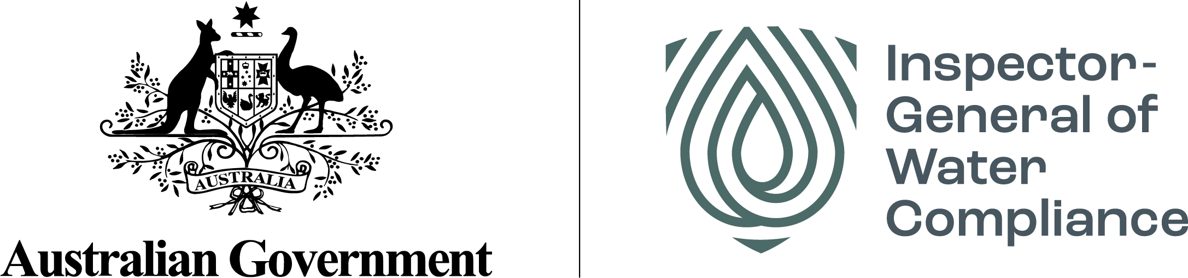

# Sustainable Diversion Limit Compliance Frequently Asked Questions

## Why is New South Wales (NSW) not subject to SDL compliance, like the other Basin States?

One requirement of an accredited water resource plan is to describe the water accounting methods that enable Sustainable Diversion Limit (SDL) accounting and the creation of the ‘*Register of take’*for an SDL resource unit.

For SDL compliance to be assessed under the Basin Plan, an accredited water resource plan must exist. The Inspector-General uses information from the Registers of take, established and maintained by the Murray-Darling Basin Authority (MDBA), to inform SDL compliance.

As NSW currently do not have any accredited water resource plans, there is no legally agreed method that can be used to calculate their SDL compliance under the law of the Basin Plan.

All other Basin States had accredited and operating water resource plans on 1 July 2020 for the 2020–21 water year and were able to provide information for the Registers of take, as required by the Basin Plan, and were subject to SDL compliance.

## How is NSW managing the water if they do not have water resource plans?

NSW has water sharing plans, which set the rules under NSW legislation to manage NSW water resources, including how water is allocated based on water availability. Water sharing plans are enforced by NSW. This includes individual water user compliance as well as compliance with the NSW long term average annual extraction limits.

Unlike accredited water resource plans, NSW water sharing plans do not include all the requirements to meet the objectives of the Basin Plan. Water resource plans go through an accreditation process, to verify that Basin Plan requirements and objectives are met. Water resource plans are accredited by the Federal Minister, on recommendation by the MDBA and are enforced by the Inspector-General.

Under the Murray-Darling Basin Agreement, NSW also reports annually to the MDBA on compliance with the Murray-Darling Basin Cap on diversions.

## Is the Inspector-General suggesting NSW water users are doing something wrong as they have not been assessed for SDL compliance?

No, SDLs are not about assessing individual water users’ compliance. Rather, SDL compliance considers the overall management of take from both surface and groundwater at a SDL resource unit level. SDLs reflect the collective consumptive water use, including irrigation, town water supply, run-off dams and commercial plantations.

Water access right holders are lawfully able to take water within the conditions of their water access entitlements. Once a water resource plan is accredited, it is the responsibility of Basin States to manage water use within the SDL.

## What is a reasonable excuse and how is it assessed?

When an SDL compliance trigger has been reached or exceeded, a Basin State may choose to provide a ‘reasonable excuse’ report explaining the reasons for the SDL exceedance to remain compliant. Basin States must provide this report to the MDBA and the Inspector-General.

The reasonable excuse report must include ‘make good’ actions that will address the reason for the SDL exceedance in a timely manner.

The Inspector-General assesses reasonable excuse reports from Basin States. Reasonable excuses may vary due to the difference in water management rules between water resource plan areas, Basin States, specific water resources (surface water or groundwater) and the models or methods used to calculate and manage water use. It might also occur for circumstances beyond a Basin States control.

More detail is available in the [Sustainable Diversion Limit Reporting and Compliance Framework](https://www.mdba.gov.au/sites/default/files/pubs/SDL-Reporting-Compliance-Framework-Nov-18.PDF) dated November 2018 and published on the MDBA website. To note, the MDBA’s framework will be updated to reflect the separation of the SDL compliance role, since the establishment of the Inspector-General. The Inspector-General intends to develop a separate SDL compliance framework to reflect the compliance role.

NSW provided a [reasonable excuse report](https://www.industry.nsw.gov.au/__data/assets/pdf_file/0003/509565/reasonable-excuse-report-for-bd-sdl-compliance-2020-21.pdf) to the Inspector-General of Water compliance relating to the Barwon-Darling for the 2020–21 water year. The Inspector-General was unable to legally consider or respond to the report. The report was published by NSW Department of Planning & Environment in June 2022.

## Where does the water accounts data come from, and can it be trusted?

Water account data is submitted by the Basin States as required under section 71 of the Commonwealth Water Act 2007. This information is due four months after the end of the water accounting year i.e., 30 June, which means submission is due on 31 October annually. Although Basin States can seek an extension from the MDBA.

Basin States source the Section 71 data from several different resources including water licensing systems, water resource monitoring gauging stations, hydrological models, and other methods as necessary.

When submitting the Section 71 data, Basin States provide a declaration of accuracy of the data. The MDBA then undertakes a quality assurance check on the data and collates the information onto the Registers of take.

## What does it mean when a register of take is set to zero?

The SDL cumulative balance is required to be set at zero in surface water SDL resource units at the commencement of the first year of operation of an accredited water resource plan. The SDL cumulative balance is an indicator of SDL compliance.

For the period between 1 July 2019 until a water resource plan commences, the MDBA records section 71 information on *interim registers of take*. Although a useful tool for accounting and compliance risk assessment purposes, it is not a legislative tool that can be used to determine or enforce SDL compliance.

For surface water SDL resource units, the cumulative balances on the *interim registers of take*, will be set to zero once the water resource plan is accredited and operational.

## If South Australia has a “cumulative balance debt”, how can they be compliant?

In 2020-2021, the South Australian Murray (surface water SDL resource unit SS11) register of take showed a small cumulative balance debit of -7.87 GL. Under the Basin Plan non-compliance only occurs once the cumulative balance debit amount is equal to or greater than 20% of the SDL (the SDL compliance trigger). For the SA Murray SDL resource unit, 20% of the SDL is -108.4GL.

Consequently, the compliance trigger was not exceeded, therefore the SA Murray SDL resource unit is compliant and there is no requirement for a reasonable excuse.

## Why was Queensland the only Basin State with registers of take in 2019-2020?

The Queensland, Warrego-Paroo-Nebine water resource plan was accredited in 2016. It was the first and only water resource plan to be accredited and operating from 1 July 2019, when SDL accounting and compliance commenced. Registers of take for three surface water and three groundwater SDL resource units were published by the MDBA for the 2019-20 water year.

During the 2019-2020 water year several other water resource plans commenced operation across the Basin. The water resource plan needs to be operating for a complete water accounting year for it to be included in the official registers of take.

## Where do I find out more?

The Inspector-General’s 2020–21 SDL compliance statement should be read in conjunction with the [Sustainable Diversion Limit Registers of Take 2020–21](https://www.mdba.gov.au/sites/default/files/pubs/sustainable-diversion-limit-accounts-registers-of-take-2020-21.pdf) dated May 2022 and published on the MDBA website as well as the [Sustainable Diversion Limit Reporting and Compliance Framework](https://www.mdba.gov.au/sites/default/files/pubs/SDL-Reporting-Compliance-Framework-Nov-18.PDF) dated November 2018 and published on the MDBA website.

Further information is available on:

* the [MDBA website](https://www.mdba.gov.au/basin-plan/sustainable-diversion-limits)
* the [NSW Department of Planning & Environment website](https://www.industry.nsw.gov.au/water/allocations-availability/tracking-surface-water)
* the [Inspector-General of Water Compliance website](https://www.igwc.gov.au/)