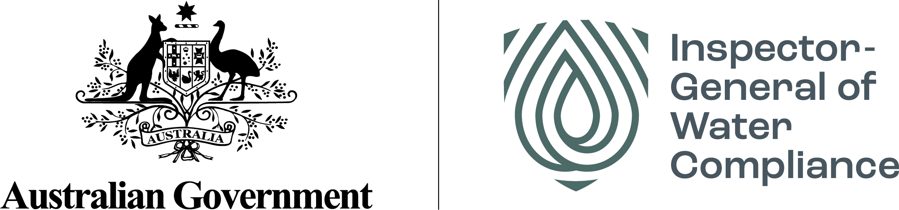

# *‘Steady as it flows’*

An assessment of River Murray operations and environmental water management

Inspector-General of Water Compliance   
September 2022

Commonwealth of Australia 2022

**Ownership of intellectual property rights**

Unless otherwise noted, copyright (and any other intellectual property rights) in this publication is owned by the Commonwealth of Australia (referred to as the Commonwealth).

**Creative Commons licence**

All material in this publication is licensed under a Creative Commons Attribution 4.0 International Licence, except for content supplied by third parties, logos and the Commonwealth Coat of Arms.

Inquiries about the licence and any use of this document should be emailed to [copyright@dcceew.gov.au](mailto:copyright@dcceew.gov.au).



**Cataloguing data**

This publication (and any material sourced from it) should be attributed as: Inspector-General of Water Compliance 2022, ‘Steady as it flows’ – An assessment of River Murray operations and environmental water management, the Australian Government, Canberra, September 2022. CC BY 4.0.

This publication is available at <https://www.igwc.gov.au/reviews-reports>

Inspector-General of Water Compliance  
GPO Box 3090 Canberra ACT 2601

**Disclaimer**

The Australian Government represented by the Inspector-General of Water Compliance, has exercised due care and skill in preparing and compiling the information and data in this publication. Notwithstanding, the Inspector-General of Water Compliance and the Australian Government’s employees disclaim all liability, including liability for negligence and for any loss, damage, injury, expense or cost incurred by any person as a result of accessing, using or relying on any of the information or data in this publication to the maximum extent permitted by law.

**Acknowledgement of the Traditional Owners of the Murray–Darling Basin**

The Author pays respect to the Traditional Owners and their Nations of the Murray−Darling Basin. We acknowledge their deep cultural, social, environmental, spiritual and economic connection to their lands and waters.

**Accessibility**

The document and information are available in accessible formats. On some occasions the highly technical nature of the document means that we cannot make some sections fully accessible. If you encounter accessibility problems or the document is in a format that you cannot access, please contact us.

**Acknowledgements**

The Inspector-General of Water Compliance would like to thank staff in Basin government agencies and other stakeholders for their cooperation during the development of this report.

## Contents

Foreword 1

1. Trust and confidence 2

2. Basin water management remains a contested space 2

3. Complexity and poor communication undermine confidence 2

Overall conclusions 3

Introduction 5

Role of the Inspector-General of Water Compliance 5

Why this assessment was undertaken 5

How this assessment was conducted 5

Part 1: Murray-Darling Basin Authority River operations 6

What are river operations? 6

What did this assessment look at? 7

What we found 8

Conclusions 10

Part 2: The Commonwealth Environmental Water Holder 11

What is the Commonwealth Environmental Water Holder? 11

What did this assessment look at? 12

What we found 12

Conclusions 16

Glossary 18

Appendix A 20

## Foreword

My role as Inspector-General of Water Compliance is to provide independent oversight; to ask critical questions about how government agencies are performing their roles; to gather and assess the data and evidence before me; and to hold agencies to account against legislative and Basin Plan obligations.

Immediately after assuming the role of Inspector-General of Water Compliance, I made it a priority to travel across the Murray-Darling Basin to listen, to hear and to understand people’s concerns. I wanted to hear from those who live and work in Australia’s food bowl, which is kept alive by the country’s most complex, fragile, critical, precious and heavily regulated waterways.

In the main, what I heard was raw, honest, passionate, and clear. To those who opened their communities and homes to me and took the time to prosecute their case as to why I should investigate matters further, I thank you. What you told me was your truth.

Along the rivers of the Murray-Darling Basin I heard first-hand from people concerned about how the Murray-Darling Basin Authority (MDBA) was managing the River Murray. I listened as people told me what they believed the Commonwealth Environmental Water Holder (CEWH) was doing with its water - water that they believed was being poorly used or lost in the system.

My role is to provide independent oversight and to hold government agencies to account against the legislative and Basin Plan obligations and objectives. Duty-bound, I commissioned work to review the details, investigate further, and have a good look at the how the MDBA is running the river, and how the CEWH is managing environmental water.

Overall, within the scope of this assessment, I found the two organisations are performing professionally and in accordance with their obligations. Of course, as you would expect with any organisation undertaking important and complex roles, I see opportunities and scope for improvement. I outline some of those opportunities and scope in this report and I will pass these on to the respective organisations for their consideration and action. But I did not find any major issues. No wrongdoing. No maladministration.

I know this is not what many were expecting to hear, but as Inspector-General, I can assure you, based on the evidence put before me, it is what I found.

Others before me have noted – water management is inherently complex – complexities amplified tenfold once multiple jurisdictions are involved. This is exacerbated by the sheer number of federal, state, local and independent agencies involved – making it difficult for the average person to know where to go and find accurate, reliable information… a clear picture of the matter.

For example, I observed over 20 organisations and websites all showing different information about the Basin’s water resources. Each Basin government holds vital information about their own water rules, entitlements, allocations and environmental water. Missing is a single, consolidated voice for the Basin – a single, trusted source that provides the clarity and transparency many are seeking.

This siloed, individual, and narrow cast lens that Australia’s most precious water resource is seen through is an artefact of federation and can easily be a convenience to the partners of the Basin Plan at a political and stakeholder level. It is a by-product and reality of joint state and federal management via both the Murray‑Darling Basin Agreement (the Agreement) and the Murray‑Darling Basin Plan. Communities will rightly continue to feel confused and shut out unless this issue is addressed; water in the Basin must be seen as an Australian resource and not an asset of an individual state or industry.

As I have previously stated, my findings in the following report may not be what many were expecting to hear. Some may disagree. Some may not like what I have found – or feel I have not found. Some may view this as a wasted exercise. I beg to differ. In reading and sharing my findings, I ask you to take the following into the context of how I landed on the position before you:

### 1. Trust and confidence

If you raise legitimate concerns with me as Inspector-General of Water Compliance, I will – to the maximum range of my powers, obligations, and the law – investigate those concerns. My job is to uncover the evidence and call it as I see it; to provide trust and confidence to the community.

It must be accepted that this is a two-way street. You need to trust the process – the procedural fairness, trust the rule of law, and respect what I find. Just as I will call out bad actors, actions, and practices if I find them, in equal measure, I will acknowledge the good being done.

I am about being unbiased, a fully independent voice. My job is to call it as I see it. This means people, industry, peak bodies, all branches and levels of government, may not always like or agree with what I have to say. That’s ok, many great sacrifices have been made over many generations for us all to enjoy the free and open democracy of today.

### 2. Basin water management remains a contested space

I am concerned that much of the noise generated about agencies ‘doing bad’ or ‘not doing enough’ is being driven by tensions between the use of water for the environment and water for irrigation. There is room in the system for both, but more work is needed to answer questions about how we prioritise the different uses of water in a system increasingly under pressure from changes in usage patterns and climate.

With strong demand on the river system, concerns about water being wasted through poor management are heightened. While I have not found mismanagement, I do see opportunities to respond to some community concerns.

One area that remains unresolved is the tension between the Murray-Darling Basin Agreement, with its focus on sharing water between the southern states and irrigation, and the Basin Plan, with its focus on delivering water for the environment. Neither of these instruments set out a clear or transparent prioritisation pathway for river operators should they face competing demands. This leaves the community wary about how decisions around prioritisation will be made if the situation arises. While my remit does not extend to oversight of the Agreement, I do see this as an area for further focus, if community concerns about management of the River Murray system are to be addressed.

### 3. Complexity and poor communication undermine confidence

Water, particularly water in Australia, is a complex space to live and work in. It is complex for a reason; water management – particularly when it is such a finite, precious and contentious resource – is difficult at best. The management environment is notoriously difficult, unpredictable and changeable. Add a federated system of government to manage a resource that by its very nature does not respect borders, and it becomes a whole lot more complex. Add 20 plus channels all showing information about the Basin’s water resources which, due to the lack of agreed standards, appears inconsistent, and the white noise not only becomes disorientating, but can also result in deafness to the facts of the matter.

My role is to seek and present the facts and this is what I have done in this report.

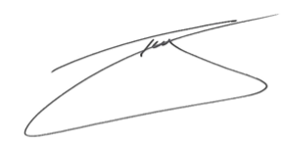

The Hon. Troy Grant  
Inspector-General of Water Compliance

## Overall conclusions

A key role of the Inspector-General of Water Compliance (Inspector-General) is to provide independent oversight of the performance of government agencies in managing the Murray‑Darling Basin’s water resources and implementing the Basin Pan.

This assessment examined how the Murray-Darling Basin Authority (MDBA) performs its role in running the River Murray system and how the Commonwealth Environmental Water Holder (CEWH) manages its portfolio of water entitlements to improve river health and deliver better environmental outcomes across the Basin. This involved assessing whether each agency worked to specific rules and had appropriate management and decision-making processes in place.

Overall, this assessment found the two organisations performing professionally and in accordance with the obligations considered by this review. Of course, as is to be expected of any organisation with complex roles and activities, there are opportunities for improvement. Some of these are outlined in this report and have been passed on to the respective organisations.

However, none of the opportunities identified for improvement would fundamentally change how the river is operated or how environmental water is planned and managed. They generally involve incremental changes that would be expected as technology, science and management improve over time.

The assessment found that the measurement and modelling of water that underpins the MDBA’s river operations function is fit for purpose to deliver the requirements of the Murray-Darling Basin Agreement (the Agreement). However, it was noted that ongoing improvements will be necessary to adapt to the challenges presented by changes in demand patterns and climate. It is clear that water in the River Murray system is in high demand, and the changing nature of where water needs to be delivered, together with forecasted reduced average inflows as a result of climate change, are increasing the challenges faced by river operators.

In addition, this assessment noted the unresolved conflict that exists between the Basin Plan, with its focus on environmental requirements, and the Agreement, which focuses on water delivery for the southern states and irrigation. This conflict is exemplified by the lack of clear and transparent processes for prioritising needs when there are competing demands for water delivery.

Similarly, the assessment found that the CEWH discharges its functions appropriately in relation to its responsibility to plan and manage water to achieve positive environmental outcomes across the Basin. Potential improvements identified include opportunities for better local consultation, engagement, evaluation and reporting of benefits.

A key overarching theme that goes to the heart of some of the concerns that prompted this assessment relates to the complexity of water management and the legislative and governance framework. This makes communication and engagement difficult and often confusing. Many of the concerns raised by stakeholders are not solely the responsibility of the MDBA or the CEWH. Some lie with other state or federal government agencies or committees, and others are shared responsibilities.

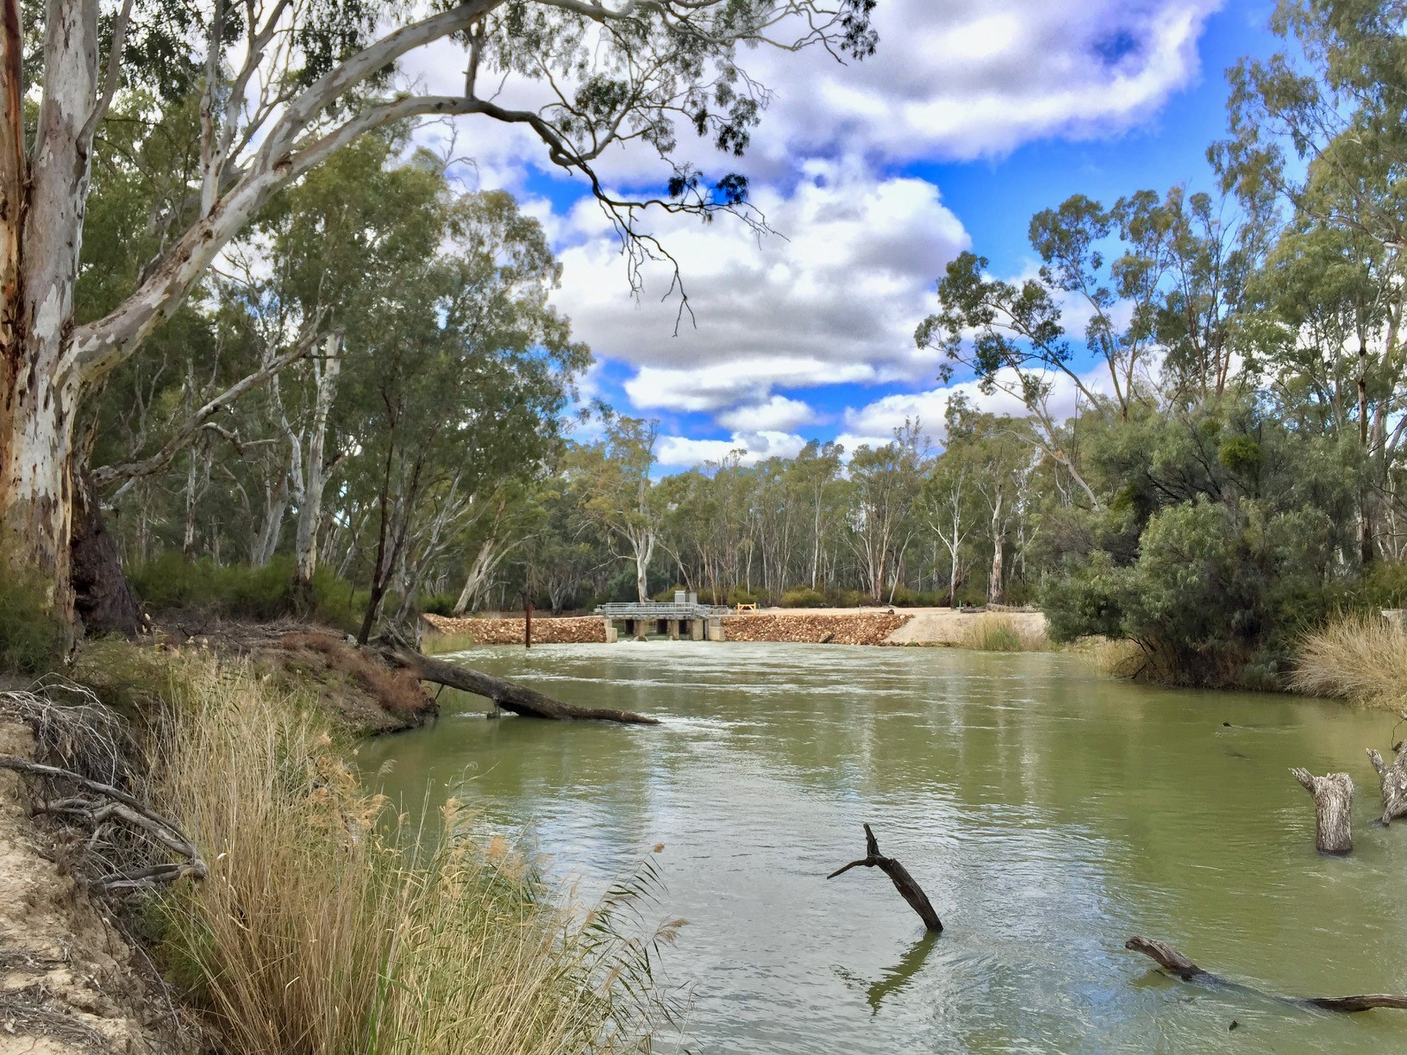

Photo: Lindsay Island on the River Murray, Victoria. Source: Inspector-General of Water Compliance

Both the MDBA and the CEWH make considerable volumes of information on river activities and environmental watering available. However, these functions are inherently technical and complex and can be difficult for a non-expert to digest. For example, there are over 20 websites for consumers to obtain information on river operations and water volumes. The inherent complexity in the system, together with inconsistencies in how information is collated and presented, can act as a barrier to reaching the community. It also makes it difficult for the majority of individuals to navigate. This is likely leading to a trust deficit from some stakeholders.

There are many opportunities to improve trust and confidence by increasing consistency, developing agreed data standards and improving accessibility and clarity of information. Without a single, trusted entity providing a Basin-wide information source, it is difficult for Basin communities to find the information they need to address their concerns. The Inspector-General has commissioned further research to better understand community perceptions across the Basin. The Inspector-General intends to use this to inform ongoing tracking of trust and confidence in water compliance and management and identify areas for improvement.

## Introduction

### Role of the Inspector-General of Water Compliance

The Inspector-General of Water Compliance was established by the Australian Parliament on 5 August 2021 to provide the public with transparency about how water is managed and ensure compliance with the Basin Plan’s water rules. The Inspector-General’s independence and focus on community engagement aims to ensure that water management and compliance is fair and equitable.

The Inspector-General has powers to scrutinise, provide oversight of and monitor compliance with the Basin Plan 2012, Water Resource Plans, intergovernmental agreements, Government agencies and arrangements relating to water resource management in the Basin.

### Why this assessment was undertaken

The MDBA and the CEWH are two key Australian Government agencies responsible for water management in the Murray-Darling Basin. Since the time an Interim Inspector-General of Murray‑Darling Basin Water Resources was appointed in 2019, a common sentiment has been concern about how the MDBA is operating the River Murray system and how the CEWH is managing its environmental water portfolio. In [his report](https://www.igwc.gov.au/sites/default/files/2020-09/iig_final_report.pdf) into the impact of lower inflows on state shares under the Murray-Darling Basin Agreement, former Interim Inspector-General of Murray-Darling Basin Water Resources, Mick Keelty AO, noted a concern frequently raised by stakeholders was that river operators are not running the system efficiently, and “face little to no accountability for minimising losses, and that there is no transparency in how they manage the river”.[1]

The Inspector-General therefore decided to undertake further work to assess how the MDBA is performing its role in running the River Murray system and how the CEWH is managing its portfolio of water entitlements to improve river health and deliver better environmental outcomes across the Basin.

### How this assessment was conducted

The Inspector-General undertook this process as a consultative assessment, working cooperatively to seek relevant information from the MDBA, the CEWH and other relevant stakeholders.

The Inspector-General also commissioned independent research to assess particular aspects of the CEWH and the MDBA’s operations. For each agency, the first stage involved assessing internal operational documents, tools and processes. Both these agencies have been subject to high levels of public scrutiny and have been the subject of numerous previous public reviews into various aspects of their operations. The process also therefore included analysing previous reviews, including by the Productivity Commission, the Australian National Audit Office, the Independent River Operations Review Group and the Interim Inspector-General of Murray-Darling Basin Water Resources (see full list of previous reports at Appendix A).

The second stage involved targeted interviews with the MDBA, CEWH and a number of State delivery partners and stakeholders that are directly involved in river operations and the planning and management of environmental water. Knowledge and insights developed during the desktop assessment were independently examined during interviews.

## Part 1: Murray-Darling Basin Authority River operations

### What are river operations?

Regulated river systems have storages (for example dams or weirs) which enable the controlled release of water for delivery to irrigators, communities, and the environment. Water delivery happens by releasing water from a dam, or by adjusting infrastructure in the river like weir pools, to ensure there is enough water in the system when it is needed.

River operators are responsible for delivering water to users at the right times and in the right volumes. This is challenging and requires an understanding of many moving parts, including; the weather, competing demands of different water users, variable water transit times from storage locations to delivery sites, and accounting for how much water will be ’lost’ to evaporation or seepage.

The Murray-Darling Basin Authority (MDBA) is responsible for managing and operating the River Murray system on behalf of the New South Wales, Victorian and South Australian governments, up to the point it reaches the South Australian border.

The MDBA coordinates the operation of the River Murray system to provide water to New South Wales, Victoria and South Australia in accordance with the Water Act 2007 (Cth) (the Water Act) and the Murray-Darling Basin Agreement (the Agreement).

**The Murray-Darling Basin Agreement**

The first version of the water sharing agreement was signed in 1914 when New South Wales, South Australia and Victoria came together to make sure water in the River Murray was managed in an agreed way, and to leave South Australia with enough water.

Basin State governments and the Australian Government have all signed the Agreement, and each state contributes funding for managing the River Murray based on its level of water use.

The Agreement has been updated and amended from time to time by the Ministerial Council, ensuring it meets current needs. An example of this is when updates were made to address problems identified during the Millennium Drought. In 2008, the Agreement was incorporated into the Water Act (2007).

The Agreement sets out the MDBA’s responsibilities for managing the river system and provides the operating rules for the MDBA to follow. It is important to note that once each Basin State’s share of water is determined in accordance with the Agreement, it is the Basin States, not the MDBA, who are responsible for deciding the amount of water allocated to individual water users.

River operations involves managing water storages and delivering water to water users and communities. The MDBA determines the volume of water that will be released from the River Murray system to meet demands, but it does not own or control the water. The MDBA can only release water from storage to meet state orders or River Murray system demands.

It is the MDBA’s responsibility to manage the structures used to control flows and supply and manage stored water along the River Murray. These structures include:

* Dartmouth Dam, Hume Dam, and Lake Victoria
* 14 weirs and 13 locks, including Yarrawonga Weir

These structures, together with structures operated by state authorities, are depicted in Figure 1.

**Figure 1. Overview of River Murray system and tributaries. Source: MDBA**

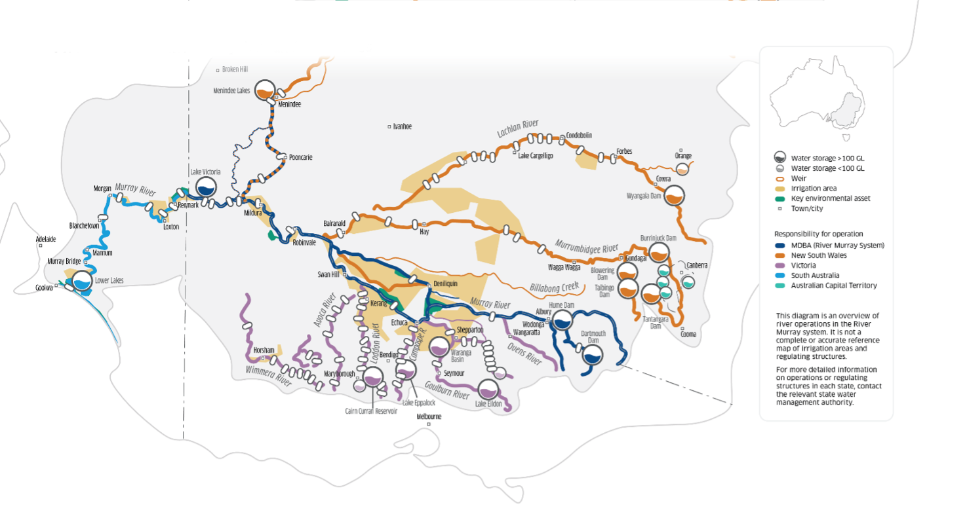

### What did this assessment look at?

The scope of this assessment covered two aspects central to the MDBA’s river operations function:

* Whether the measurement of water in the River Murray system is adequate to ensure that the river can be run efficiently and effectively. This involved looking at the coverage and quality of hydrometric data. (See page 9 for “What is hydrometric data?”)
* 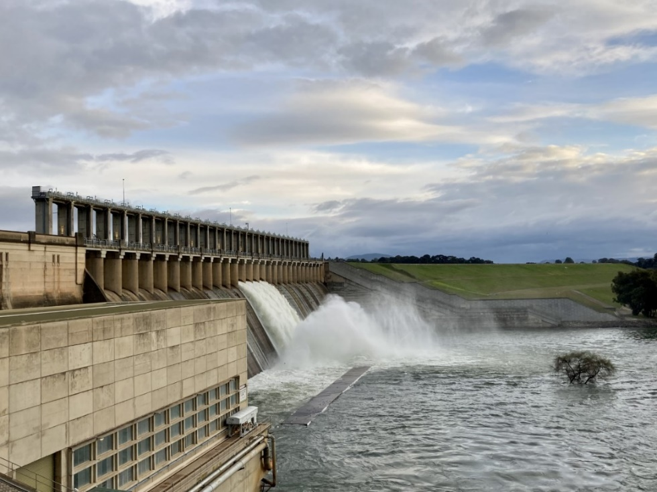Whether the data analysis and modelling processes on which river operators rely are sound and fit for purpose.

Photo: Hume Dam located at Albury, NSW. Source: Inspector-General of Water Compliance

### What we found

Water measurement data coverage and quality

* Overall, the measurement data that underpins river operations is adequate and fit for purpose.
* The lack of an agreed data standard has the potential to impact the efficiency of river operations, as well as lead to confusion and reduced community confidence.
* Changing water demand patterns driven by climate change and the rise in horticultural plantings are driving a need for improvements in aspects of water measurement.

This assessment reviewed the data quality and coverage of the hydrometric network in the River Murray. This included looking at the adequacy of key measurement points in the river, and the methods and technologies used to measure water volumes and flows.

Overall, the assessment found the current level of data quality and measurement points (i.e. flow gauges) is adequate and provides the MDBA with sufficient information to operate the river effectively. However, the assessment identified two issues concerning hydrometric data that may require further investigation.

Firstly, while the coverage of water measurement points was assessed as adequate for current river operations, the impacts of climate change, combined with ongoing changes in demand patterns, is leading to a less predictable operating environment. Significant changes to historical demand patterns are occurring for a number of reasons, including an expansion of permanent plantings in the lower Murray, as well as the introduction of environmental watering. These changes are driving an increasing need for improvements in measurement, such as additional gauging points in some areas and supplemental data sources (such as satellite imagery) to better equip river operations to respond to new and differing scenarios.

**What is hydrometric data?**

Hydrometric data includes information collection by hydrometric stations (commonly called river gauges) situated at various points along a river. These gauges collect information such as river height, water flow and water quality.

This provides river operators with important information about how much water is in the system at different times and locations: fundamental to making sound river operations decisions.

The MDBA largely relies on the Basin States to provide the hydrometric data that underpins river operation decisions.

In the northern Basin, additional gauging points would be useful for understanding the increasingly variable flows and their flow-on impacts. Pleasingly, in December 2020, the Australian and NSW Governments announced the location of 20 new and upgraded gauging stations across the Darling, Macquarie, Culgoa, Gwydir, Border Rivers and Namoi catchments in New South Wales.

In the southern Basin, additional gauging points on some of the tributaries that flow into the system, as well as an increase in the availability of telemetered measurement data, would potentially benefit MDBA river operators. It should also be noted however, that there is additional work underway to further refine and improve the accuracy of the volumetric measurement of environmental water, including returns flows (see Part 2 of this Report).

The second issue identified relates to the lack of uniform and agreed data standards to ensure the consistency of water data that is collected by the Basin States and provided to the MDBA. This includes standardising elements of data collection such as the timing for recording readings from gauging points. The absence of data standards has the potential to adversely impact data collection and data analytics, which can make processing and analysing data more difficult than it need be.

This issue was also recognised by the Independent River Operations Review Group (IRORG) in its 2020–21 report, which acknowledged the “lack of formal assurance from all jurisdictions around methods and data quality providing hydrometric monitoring services to the MDBA”. The lack of a data standard often results in the need for manual activities to be performed to enable data to be ready for ingestion by the MDBA systems. Agreed standards would improve the MDBA’s internal efficiencies and improve transparency and accountability.

Inconsistent data can also be confusing, particularly to the community. For example, gauge read timings that vary between state agencies and other entities providing data across the Basin can lead to apparent inconsistences in reported river flows. This can leave the decisions of the river operations function unnecessarily open to question.

Data analysis processes undertaken by the MDBA and Basin states

* Existing data analysis processes are fit for operating the river in accordance with the Murray-Darling Basin Agreement.
* The scheduled river modelling platform upgrade is important to enhancing the MDBA’s river operations planning.

The assessment also looked at data analysis processes and modelling used by the MDBA to inform river operations decisions, including the robustness of the models being used.

**What is a river model?**

Data analysis and computer modelling are core inputs to making river operations decisions. Models are essentially computer‑based representations of the river system.

They can be used to test different scenarios to see how different weather conditions, water sharing rules and water management decisions might affect the river system, including predicting effects on water flows and water quality.

Overall, the assessment found that the current modelling and data analysis that supports the river operations functions is fit for purpose. However, similar to the water measurement findings above, changing climate and demand patterns are making the river operating environment less predictable. This is driving an increased need for more accurate modelling and accounting for issues such as system losses (water that is naturally “lost” through evaporation and seepage), overbank flows and return flows.

The MDBA uses a modelling platform called ‘Source’ to inform its river operations function. Source can be used to test different river management scenarios and help develop river managements policies. It can also be used in real time to inform operational decisions.

The Source modelling platform is currently undergoing further development as part of a $66 million modelling uplift program. The upgrade to the platform should provide more advanced tools and capabilities to enable more rapid assessment of future water demands, apply improved streamflow forecasting techniques and compare alternative operating plans. It will also enable better integration of state modelling and reduce much of the manual intervention that is currently required. It may also enable better understanding of flow peaks, and overbank and return flows associated with environmental watering.

### Conclusions

The assessment found that the MDBA is performing its river operations function competently, and that the water measurement and modelling information it relies on to conduct this function is fit for purpose. As would be expected in any technically complex area, there are ongoing opportunities for improvement. In the area of water measurement and modelling these range from additional gauging stations to exploring new technologies that enable river operators to better respond to future challenges. Pursuing these opportunities will require increased investment by Basin governments.

As already noted, the MDBA does not manage the river as a sole operator. Much of what it must do is dictated by requirements in the Agreement and is managed jointly with the responsible Basin states. The complexity of governance arrangements, as well as the technical complexity inherent in river operations, are key drivers in determining not only how decisions are made but also how they are understood.

While the key focus of this assessment was on various technical aspects of how water is measured and modelled, it quickly became evident that the disparate sources of information on river operations, as well as the quality of data presented to the public, are key issues influencing community understanding and confidence around river operations. The complexity inherent in the system makes it difficult for a non-expert reader to navigate multiple information sources, and this is further exacerbated by different sources presenting information with apparent inconsistencies. This issue is most likely contributing to a trust deficit among some stakeholders.

Furthermore, the quality of the data presented is potentially weakened by the absence of formal standards governing the collection and transfer of water measurement data. This was an issue that was recognised by the Australian Competition and Consumer Commission, albeit relating to a different aspect of water management (water trade), in its [2021 water markets inquiry.](https://www.accc.gov.au/system/files/Murray-Darling%20Basin%20-%20water%20markets%20inquiry%20-%20Final%20report_0.pdf)

It is also clear that there are multiple websites providing water information to users, and while public access to information is important, the historic lack of a single trusted source of river operations data has been a concern. Recent efforts by the Bureau of Meteorology (BoM) to establish the [Water Information Portal](https://mdbwip.bom.gov.au/999/#4.6/-31.5/147) are addressing this matter.

A further issue identified by this assessment – while not directly in the scope of this assessment it is nonetheless an area of some concern among stakeholders – is the inherent conflict that exists between the Basin Plan and the Agreement. The Agreement sets out how water in the River Murray system is shared between Victoria, NSW and South Australia, but does not incorporate the management of water for the environment, which was only formally recognised with the introduction of the Water Act and the Basin Plan. This conflict is exemplified by the lack of clear and transparent processes for prioritising needs when there are competing demands for water delivery.

This is not a new issue, having previously been identified by the Independent River Operations Review Group, an advisory committee established under the Water Act to review the MDBA’s performance in river operations and water sharing activities. In their 2021 Review of Performance, the IRORG noted that a formal process for mitigating this risk is yet to be developed.

## Part 2: The Commonwealth Environmental Water Holder

### What is the Commonwealth Environmental Water Holder?

The Commonwealth Environmental Water Holder (CEWH) is an independent statutory position established under the Water Act. The CEWH is responsible for managing the Australian Government’s environmental water entitlements in the Murray-Darling Basin. This water, often referred to as water for the environment, is used to keep the rivers and wetlands of Murray‑Darling Basin healthy.

It is the Murray-Darling Basin Authority’s (MDBA) responsibility to set annual environmental watering priorities for the Basin each year and the CEWH’s responsibility to plan and manage water to meet these priorities where possible. This can range from directing water into wetlands, improving flows in-stream and flushing salt out of the river system.

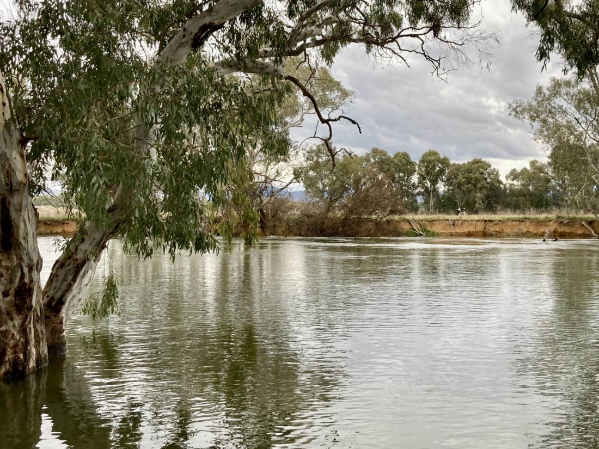Each year the CEWH works with state government environmental water holders, local landholders, and First Nations to plan, manage and monitor the use of water for the environment. As a statutory office established by the Water Act, the functions of the CEWH are closely tied to delivering the outcomes of the Basin Plan.

Photo: River Murray downstream of Hume Dam, Albury, NSW. Source: Inspector-General of Water Compliance

### What did this assessment look at?

One of the Inspector-General’s responsibilities under Part 9A of the Water Act is to monitor and provide independent oversight of the performance of the CEWH under the Water Act and the Basin Plan.

The scope of this assessment focussed on several aspects that are critical to the CEWH’s operations, including:

* How effective is the CEWH’s approach to planning and managing water for the environment?
* How adequate is the volumetric measurement of environmental water?
* How adequate is the CEWH’s program for monitoring, evaluating and reporting (MER) on environmental watering outcomes?
* How effective is the CEWH’s communication and engagement?
* Has the CEWH improved its operations over time?

### What we found

Planning and management of water

* The CEWH’s water planning processes are consistent with Basin Plan.
* This includes following the Environmental Watering Principles such as: coordinating with other water managers, working with local communities and maximising environmental benefits.

Water planning and management appears to be an area of strength for the CEWH. Environmental watering is a complex process, and the CEWH rarely operates in isolation. It relies strongly on productive working relationships with Basin State delivery partners, who are usually responsible for on ground management. This can, however, be confusing and can lead to community uncertainty as to who is responsible for what.

The complexity of roles and activities is illustrated in Figure 2 below. This shows that the CEWH operates with guidance from other parties, including the MDBA, which is responsible for providing the five-yearly Basin-wide environmental watering strategy along with more detailed annual watering priorities.

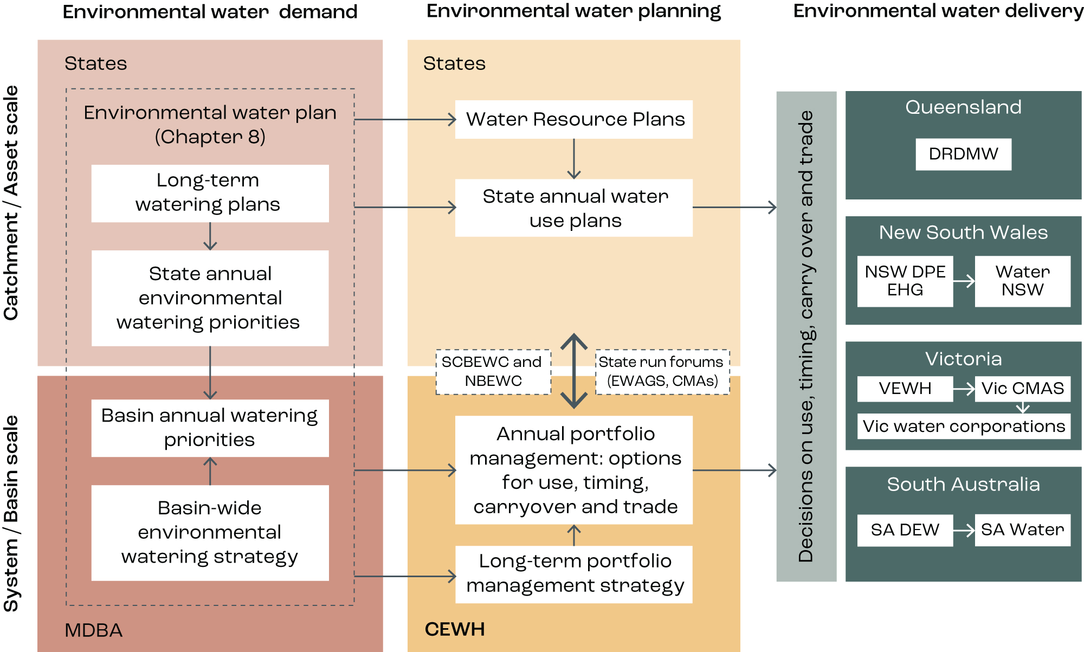**Figure 2. Plans and processes involved in Basin-scale and catchment-scale planning and delivery of environmental water**

The CEWH also faces a range of constraints it must consider when planning how it will use its water. For example, the CEWH is just one of many entitlement holders that rely on a shared river channel for their water delivery. Issues such as channel capacity constraints and limitations to delivering water over the top of riverbanks to reach wetlands and floodplain areas given impacts to private property, can influence the CEWH’s water planning decisions. Responsibility for these challenges does not lie solely with the CEWH, rather they are challenges experienced by many water holders, together with river operators, and require shared responses.

Some stakeholders have expressed concern about how the CEWH manages carryover. Carryover is unused water that the water entitlement holder can save for the next water year. This assessment found that the CEWH uses carryover effectively to manage risk and enhance future watering options, particularly, for example, to enable timely watering actions early in the next water year when environmental water is often most beneficial. Like other water holders, the CEWH uses carryover to maximise the benefits created by its water entitlement. The CEWH provides information on carryover volumes in a catchment-by-catchment manner via its annual Water Management Plan.

Providing more accessible information on core issues around water planning may help the community understand how the CEWH is using its water and develop more confidence in the process. This could include publishing more detailed information on how a range of climate scenarios are planned for and how decisions are made to use water, and subsequent acquittals.

Volumetric measurement of water

* The CEWH adheres to State requirements for measuring its water.
* Measuring and monitoring environmental water can be complex, and improved modelling and mapping tools could make watering events more efficient.

Water use is measured in different ways and for different purposes in different parts of the river system. A fundamental purpose is for water accounting, to make sure a water user is taking the right amount water at the right time and is operating in accordance with their licence conditions.

The CEWH’s water is accounted for in the same way as other users, such as irrigators. The CEWH’s water is released from storages or delivered to offtake points in the river where it can flow or be pumped into environmental sites such as wetlands. When the CEWH orders water, it is debited from CEWH water allocation accounts which are maintained by State water management agencies.

As for other water users, Basin State legislation mandates the tools or methodologies for how the CEWH’s water volumes are measured. For example, where the CEWH uses pumps to deliver water, it is metered under the same requirements as other water users. The assessment found that the CEWH actively contributes to investigate options to measure environmental water flows, by working with State water managers, river operators and delivery partners.

Frequently, the major factor affecting measurement accuracy is the physical locations where environmental watering occurs. Wetland delivery and return flows (where water flows through a wetland and returns back into the river) often occur in highly complex, variable and unique locations. Flows out on to floodplains or returning from wetlands back to the river can be widely dispersed and with multiple flow paths that are difficult to gauge using standard techniques. The majority of the Basin’s current gauge network is concentrated in river channels, dams or storages and provides limited information during, for example, very low flow events and their hydraulic outcomes on floodplains.

In these instances, water usage is often determined using techniques and technologies such as digital elevation modelling, hydraulic modelling and inundation mapping. To ensure other water users are not impacted, a conservative measurement approach is generally applied where there are uncertainties. As with other elements of water management, the CEWH collaborates with the state agencies who use these techniques to determine the volumes delivered, with support from the MDBA, Geoscience Australia and the Commonwealth Scientific and Industrial Research Organisation (CSIRO).

Considerable work is being undertaken to further refine and improve the accuracy of environmental water volumetric measurement in circumstances where these techniques and methodologies are applied. These improvements will be particularly important if constraints (a technical term for anything that reduces the ability to deliver water for the environment) are relaxed, which would see larger water volumes inundating larger areas.

Continued improvements measuring flows to floodplains and water returning from wetlands back into the main river channel will improve the accuracy of assumed use volumes and provide more accurate information into the CEWH’s monitoring and evaluation programs. For example, getting more rapid water usage data after a watering event could improve the CEWH’s ability to undertake subsequent watering actions in a downstream wetland in a timely manner.

Monitoring, evaluation and reporting

* The CEWH’s monitoring, evaluation and reporting of environmental water use meets its adaptive management and reporting obligations.
* More work in identifying and communicating the wider social, cultural and economic benefits of environmental watering could build community confidence.

Monitoring, evaluation and reporting on watering events is important to understand how much water is being used, when and where it is being used, and what results it is getting. This is important for accountability and for adaptive management purposes, so that lessons can be learnt and acted upon in future waterings.

There is good evidence that the CEWH’s monitoring, evaluation and reporting of environmental flows both meets its reporting obligations and provides useful information to feed into future water planning. This includes meeting several specific reporting obligations under Schedule 12 of the Basin Plan.

The CEWH is just one partner in a complex network of agencies undertaking environmental monitoring and evaluation in the Basin. Other agencies include the MDBA, state water agencies, catchment management authorities and other state environmental water holders such as the Victorian Environmental Water Holder. As with most Basin water management, this means that a lot of coordination and cooperation is required, which presents some shared challenges.

These challenges include implementing collaborative monitoring programs with limited resources and coordinating multiple ‘masters’ all seeking information for their own purposes. There are also competing demands between effectively monitoring and reporting on the outcomes of individual watering events at specific locations and longer-term Basin-wide monitoring that is required to build a long-term picture of how the whole system is responding and whether overall Basin Plan outcomes are being achieved.

There is also evidence that while scientific monitoring of environmental outcomes is well established, monitoring, evaluating and reporting on the wider social, cultural and economic benefits of environmental watering is not. Conveying information about environmental outcomes and community benefits is not easy and previous research shows low levels of community awareness around the use and benefits of environmental water. More work in this area would help in demonstrating and communicating the benefits arising from the significant public investment in the Basin Plan.

Communications and community outreach

* The CEWH has put considerable effort into communication, however the results of this effort are unclear.
* Investment in Local Engagement Officers has created positive on-ground relationships; extending this model would have benefits.

There are many organisations involved in delivering held environmental water and no one party has exclusive responsibility for reporting on watering events and outcomes. The CEWH is a relatively new concept for many Basin communities. Recent research indicated that out of 15 water management organisations and agencies operating in the Basin, the CEWH was the least well known.

The complex water management framework also makes for a disjointed information system. It is difficult for the community to get information on the reason for a specific flow event, including what the objectives and expected benefits of the flow are. This contributes to misconceptions of the value of environmental water, how it is used for the strategic health of the Basin and how this could benefit the community.

Investment and effort in local, quality outreach programs has resulted in positive on-ground relationships and engagement. The CEWH’s Local Engagement Officers (LEOs) are part of their water delivery team. LEOs strengthen the CEWH’s connections to on-ground knowledge, actions, concerns and aspirations – important principles for environmental watering under the Basin Plan (Chapter 8). LEOs have real impacts in their communities. Extending the LEO model would have benefits if resourcing is available.

The CEWH is a relatively new organisation, responsible for managing a new asset in the water management framework. The CEWH is working with new objectives within a river management framework that was originally designed for consumptive users.

It is not surprising then that the CEWH has been the subject of multiple published inquiries and reviews since 2013. In responding to these, the CEWH has shown a strong culture of improvement and a willingness to learn and change as required.

A culture of continuous organisational improvement is key to effective partnering and collaboration. It is the foundation for long-term success. This assessment found that the CEWH is open to feedback and innovation and is seen as taking reviews and recommendations for change seriously. Current work to develop a corporate plan is seen as an important initiative to guide clear strategic intent.

### Conclusions

Overall, this assessment found that the CEWH has a robust and effective approach to planning and managing water for the environment. While the assessment identified some possible improvements to operations, there was no evidence that the CEWH is not performing its functions competently and in accordance with Basin Plan environmental objectives.

It is clear the CEWH has been subject to numerous public reviews and receives a high level of public scrutiny (many of these previous reviews are listed in Appendix A). The CEWH has a strong record of heeding the recommendations of these reviews and acting upon them in order to improve its operations. This indicates a positive culture of continuous improvement.

One area for potential improvement involves the measurement of environmental water. While current approaches to measuring environmental water use are appropriate and adequate, ongoing improvement would allow the CEWH to refine how it uses its water to achieve better environmental outcomes.

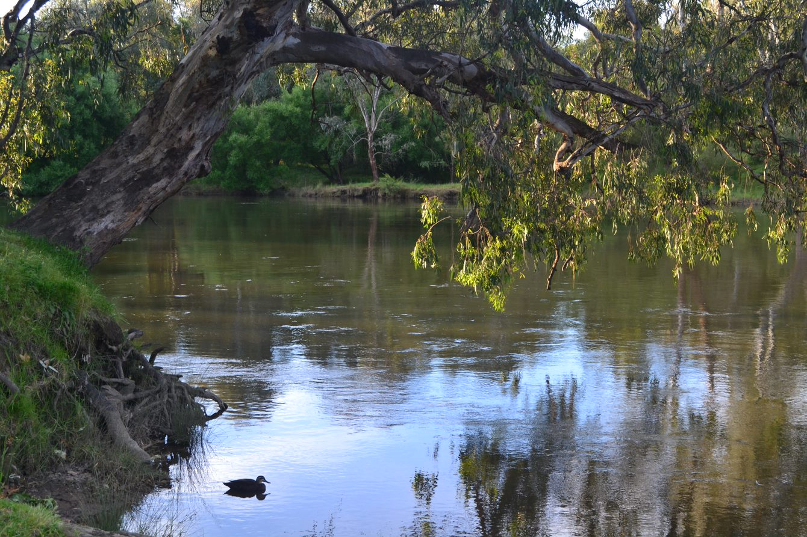Similarly, improvements in communication and engagement would help build community understanding of what the CEWH is trying to achieve and how they do their work. The CEWH has the significant challenge of communicating complex science and decision-making. While the CEWH has a commendable outreach program, particularly through its on-ground Local Engagement Officer network, this could be expanded to ensure more communities have the chance to connect, collaborate and ask questions of an informed local staff member in ‘their patch’ of the Basin.

Photo: River Murray at Albury, NSW. Source: Inspector-General of Water Compliance

## Glossary

| **Term** | **Definition** |
| --- | --- |
| Allocation | The amount of water a water entitlement holder receives in a given year. |
| Adaptive Management | Adaptive management allows governments and communities to adjust their approach in response to climatic conditions, new information and local knowledge when planning for the future. Monitoring and evaluation provide important input for implementing adaptive management. |
| Basin Plan | The plan made by the responsible Commonwealth minister under section 44 of the Water Act 2007. It sets standards for the management of the Murray–Darling Basin’s water resources in a coordinated and sustainable way in collaboration with the community. Officially known as the Basin Plan 2012. |
| Carryover | The part of an allocation which remains unused at the end of the water year and which, under certain circumstances and subject to conditions, may be taken in the following water year. |
| Constraints | A ‘constraint’ is a technical term for anything that reduces the ability to deliver water for the environment. |
| Data standards | Documented agreements that govern how data is managed, used, represented, formatted, defined and stored. |
| Environmental water | Water used to achieve environmental outcomes, including benefits to ecosystem functions, biodiversity, water quality and water resource health. |
| Held environmental water | Water available under a water right, for achieving environmental outcomes. |
| Independent River Operations Review Group | The IRORG is an advisory committee established under the Water Act (Cth) (2007) to review the MDBA’s performance in river operations and water sharing activities. |
| Losses | The volume of water which is lost due to evaporation or seepage into the ground as part of normal river operations. Losses vary from year to year, depending on seasonal conditions. |
| Murray-Darling Basin Agreement | A long-standing arrangement that aims to share water in the southern Basin and outlines the rules for the way the River Murray is managed and operated. The Agreement replaced the original River Murray Waters Agreement in 1987. |
| Overbank flow | Natural diversion of water based on an open water channel filling above 100%. |
| Return flows | Water that returns to the river from floodplain areas and wetlands. |
| Source | A hydrological modelling platform that assess information about the River Murray and Lower Darling systems on a daily timestep. Source has functionality to assist river management and river operations. |
| Victorian Environmental Water Holder | The VEWH is an independent statutory body responsible for holding and managing Victoria’s environmental water entitlements. |
| Water entitlement | The ongoing right to a share of the available water in the river system up to a maximum amount. Also known as a water right or water license. |
| Water Act | The Water Act 2007 (Cth) provides the legislative framework for ensuring that the Murray-Darling Basin is managed in the national interest. |

## Appendix A

Relevant reviews that have previously considered the activities and performance of the Murray‑Darling Basin Authority and the Commonwealth Environmental Water Holder are listed below.

| **Report** | **Author** |
| --- | --- |
| [Senate Select Committee on the multi-jurisdictional management and execution of the Murray-Darling Basin Plan](https://parlinfo.aph.gov.au/parlInfo/download/committees/reportsen/024609/toc_pdf/FinalreportandreportonConstitutionAlteration(WaterResources)2019.pdf;fileType=application%2Fpdf) | Senate Select Committee 2021 |
| [Review of the Southern Spring Flow Event 2019](https://www.mdba.gov.au/sites/default/files/pubs/review-of-the-southern-spring-flow-event-2019.pdf) | Murray-Darling Basin Authority 2021 |
| [Murray-Darling Basin water markets inquiry](https://www.accc.gov.au/system/files/Murray-Darling%20Basin%20-%20water%20markets%20inquiry%20-%20Final%20report_0.pdf) | Australian Competition and Consumer Commission 2021 |
| [Review of Performance Against Objectives and Outcomes – 2020-21](https://www.mdba.gov.au/sites/default/files/pubs/review-of-performance-against-objectivies-and-outcome-2020-21.pdf) | Independent River Operations Review Group 2021 |
| [Final Report: Independent assessment of social and economic conditions in the Murray–Darling Basin](https://www.awe.gov.au/sites/default/files/documents/panel-report.pdf) | Sefton et al. 2020 |
| [Impact of lower inflows on state shares under the Murray–Darling Basin Agreement](https://www.igwc.gov.au/sites/default/files/2020-09/iig_final_report.pdf) | Interim Inspector-General of Murray–Darling Basin Water Resources 2020 |
| [Socio-economic outcomes of environmental watering in northern Victoria](https://vewh.vic.gov.au/__data/assets/pdf_file/0005/538214/P919023_SocioeconomicOutcomesEnvWaterNorthVic_FINAL-Mar-2020.pdf) | Natural Capital Economics 2020 |
| [Murray–Darling Basin Plan: Five-year assessment, Productivity Commission Inquiry Report](https://www.pc.gov.au/inquiries/completed/basin-plan/report/basin-plan.pdf) | Productivity Commission 2018 |
| [Review of the Commonwealth Environmental Water Holder’s operations and business processes](https://www.awe.gov.au/sites/default/files/documents/cewh-review-final-report.pdf) | Natural Capital Economics 2017 |
| [Commonwealth environmental watering activities, Performance Audit](https://www.anao.gov.au/sites/default/files/201213%20Audit%20Report%20No%2036.pdf) | Australian National Audit Office 2013 |

1. Interim Inspector-General of Murray-Darling Basin Water Resources 2020, [Impact of lower inflows on state shares under the Murray–Darling Basin Agreement (igwc.gov.au)](https://www.igwc.gov.au/sites/default/files/2020-09/iig_final_report.pdf), p. 27