# Annual Report 2021–22

© Commonwealth of Australia 2022

Ownership of intellectual property rights

Unless otherwise noted, copyright (and any other intellectual property rights) in this publication is owned by the Commonwealth of Australia (referred to as the Commonwealth).

Creative Commons licence

All material in this publication is licensed under a Creative Commons Attribution 4.0 International Licence, except for content supplied by third parties, logos and the Commonwealth Coat of Arms.

Inquiries about the licence and any use of this document should be emailed to [copyright@ agriculture.gov.au](mailto:copyright@%20agriculture.gov.au).



Cataloguing data

This publication (and any material sourced from it) should be attributed as: Inspector-General of Water Compliance (IGWC) 2022, Annual Report, Australian Government, Canberra, November. CC BY 4.0.

This publication is available at [www.igwc.gov.au/reviews-reports](http://www.igwc.gov.au/reviews-reports).

Inspector-General of Water Compliance  
GPO Box 3090 Canberra ACT 2601  
Web [www.igwc.gov.au](http://www.igwc.gov.au/)

Disclaimer

The Australian Government represented by the Inspector-General of Water Compliance, has exercised due care and skill in preparing and compiling the information and data in this publication. Notwithstanding, the Inspector-General of Water Compliance, the Australian Government’s employees and advisers disclaim all liability, including liability for negligence and for any loss, damage, injury, expense or cost incurred by any person as a result of accessing, using or relying on any of the information or data in this publication to the maximum extent permitted by law.

**Acknowledgement of all Traditional Owners**

We pay our respect to the Traditional Owners and their Nations of the Murray−Darling Basin. We acknowledge their deep cultural, social, environmental, spiritual and economic connection to their lands and waters.

Aboriginal people should be aware that this publication may contain images, names or quotations of deceased persons.

# Foreword by the Inspector-General

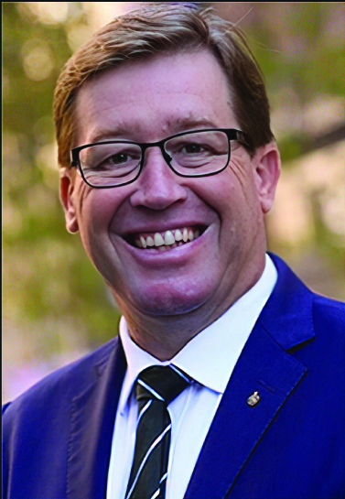

When the role of the Inspector-General of Water Compliance (IGWC) was established, I made it a priority to get out to communities across the Murray–Darling Basin, and I’ve heard the community’s concerns loud and clear. The concerns raised reflect the reasons this office was established, and this inaugural Annual Report will highlight some of the work I have started to address those concerns.

With increasing public scrutiny and interest in water management across the Basin, this office was established on 5 August 2021 to provide oversight, compliance, and enforcement functions. We have been empowered as an independent regulator with inquiry, audit, and investigative powers. I was initially appointed to the role of Interim Inspector-General in December 2020, before being appointed as Inspector-General for a four-year term commencing on 5 August 2021.

As the Inspector-General, I now have oversight of the performance of state and Commonwealth agencies operating under the Basin Plan, and I intend to bring about transparency and accountability, to ensure there is trust and confidence in the management of the Murray–Darling Basin and its water resources.

I’ve hit the ground running, visiting countless Basin communities. The feedback from the community tells me that people from government do lots of listening, but they rarely hear what people actually say. However, I not only listen, and hear what the community have to say – I act on it. Since starting, we have expanded our footprint with eyes and ears across the Basin with a Field Officer network. These Field Officers are speaking face-to-face with communities that live and work along the rivers. I’ve joined them in speaking to First Nations peoples, farmers, landholders and businesses whose livelihoods and culture rely on an effectively and lawfully managed Basin.

My office is using evidence to make decisions. In this Annual Report, you’ll learn about the ‘Steady As It Flows’ report, looking at how the Murray–Darling Basin Authority (MDBA) operates the River Murray system, and how the Commonwealth Environmental Water Holder (CEWH) manages its portfolio of water for the environment. This report is an example of acting on community concerns. The community told me that they were concerned about how these government agencies were managing the river, so we looked into it. While we didn’t find any clear indication that things weren’t being done properly, I can confidently say we’ve reviewed it. There are areas that could be improved, and I’ve spoken to the relevant agencies about those improvements.

You’ll also read about the Sustainable Diversion Limit statement of compliance, metering and measurement, and an audit of Goulburn-Murray Water. All of these reports and assessments aim to improve trust and confidence in water management. As the Inspector-General I am independent, accountable and transparent, and I operate with the highest degree of integrity, so the community can be assured I am acting on the information provided to me.

In my first year as Inspector-General I’ve observed both challenges and opportunities for the Basin. I am optimistic that most people support the Basin Plan and recognise its success is critical. And I understand that the Basin Plan is a massive and ambitious generational body of work – technically, physically and legislatively. This water resource is not an open tab on the bar.

**As Basin-wide custodians of such a precious, finite, and contested resource, nobody gets to choose what part of the law does or does not apply to them. And nobody gets to flout the rules without consequence – including the agencies responsible for managing that resource.**



The Hon. Troy Grant  
Inspector-General of Water Compliance

# About the Inspector-General

Each year, the Inspector-General of Water Compliance must report on the activities undertaken in the previous financial year by preparing an annual report (section 215Y, Water Act 2007). This report not only fulfils that legislative obligation, it also ensures the Inspector-General operates in a transparent manner by sharing findings, reporting on commitments and communicating with the public. It should be noted that the Inspector‑General’s annual report is not typical of an annual report prepared by an Australian Government agency. The Inspector‑General is supported by the Australian Government Department of Climate Change, the Environment, Energy and Water (DCCEEW) which publishes an annual report containing information such as financial statements and other information to meet statutory requirements under the Public Governance, Performance and Accountability Act 2013.

## Who is the Inspector-General of Water Compliance?

The Hon. Troy Grant: Inspector-General of Water Compliance

Troy has a 32-year career of public service in government, law enforcement, emergency service, social justice, community and charity. He was an elected member of the New South Wales Parliament from 2011 to 2019. Troy has lived and worked in the northern and southern Murray–Darling Basin for over 40 years. He maintains a sound understanding and connection to the communities in the Basin.

As the Inspector-General of Water Compliance, he holds a suite of delegations under the Water Act relevant to that role. For example, the Inspector-General makes decisions relating to the commencement of audits or inquiries and enforcement actions. Troy also fulfils the role as the main conduit for public engagements and acts as Chair of the Regulatory Leaders Forum.

Daniel Blacker: Deputy Inspector-General of Water Compliance – Regulation

Daniel joined as the Deputy Inspector-General of Water Compliance at the commencement of the independent Inspector-General on 5 August 2021. Daniel is responsible for the Water Regulation Group, which undertakes compliance monitoring, investigations and audits within the Murray–Darling Basin. In his role overseeing the regulation function, Daniel maintains areas where subject matter expertise is required into technical and complex water management functions, including annual sustainable diversion limits compliance statements, water trade matters, legislative obligations, regulatory reform and case management.

Bridgett Leopold: Deputy-Inspector-General of Water Compliance – Capability

Bridgett started in her role as interim Deputy Inspector-General of Water Compliance in July 2021. In her role overseeing the capability function of the office, Bridgett is responsible for intergovernmental relations, governance, communications, field operations and inquiries. The capability function brings together various elements of engagement with both the public, water stakeholders and other government agencies. It also includes powers to undertake inquiries and set standards and guidelines for effective water regulation and performance reporting.

### Organisation chart

# Contents

Foreword by the Inspector-General 3

About the Inspector-General 5

Who is the Inspector-General of Water Compliance? 5

01 Introduction 8

What is the Murray–Darling Basin and why is it important? 8

Water sharing in the Murray–Darling Basin has a long history 9

The Inspector-General of Water Compliance is established 11

Functions and powers of the Inspector-General 11

The roles and responsibilities of other agencies 12

Water resource plans set limits on water use 13

The Inspector-General is an independent statutory office holder 13

The independence of the Inspector-General is crucial 14

What does a field officer do? 14

Connection to community – field operations 15

Community sentiment and understanding 16

Office contact information and locations 17

02 Compliance and performance 18

Basin state compliance and enforcement 18

Metering and measurement 23

State of play – metering across the Basin 27

Compliance with sustainable diversion limits 29

Audit of Goulburn-Murray Water 32

Investigations 33

03 Oversight and trust 34

Trust and confidence 34

Review of River Murray operations 35

Review of the Commonwealth Environmental Water Holder 35

Looking forward 37

# 01 Introduction

## What is the Murray–Darling Basin and why is it important?

The Murray–Darling Basin is significant for its environmental, social and economic contribution to the nation. It is the country’s largest river system – more than 2 million people rely on the rivers of the Basin for their drinking water. The Basin is made up of more than 20 major rivers and extends over 1 million square kilometres, covering three-quarters of New South Wales, more than half of Victoria, significant portions of Queensland and South Australia, and all of the Australian Capital Territory. It is known as ‘the food bowl of Australia’.

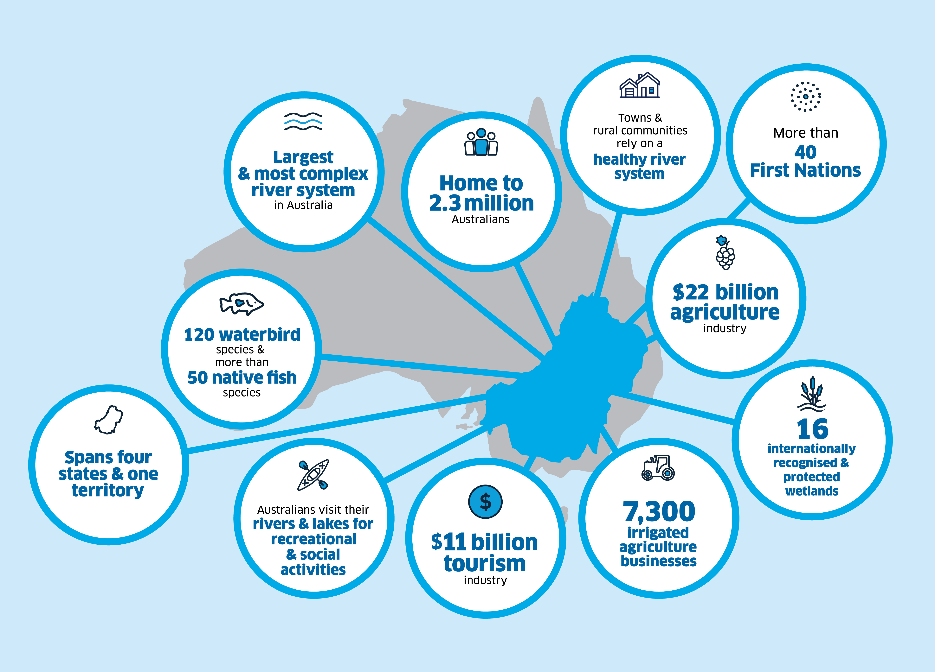The Basin includes more than 77,000 kilometres of rivers, creeks and watercourses, and an estimated 30,000 wetlands. It also contains Australia’s three longest rivers: the Darling, the Murray and the Murrumbidgee.

Source: [A plan for the Murray–Darling Basin | Murray–Darling Basin Authority (mdba.gov.au)](https://www.mdba.gov.au/basin-plan/plan-murray-darling-basin)

## Water sharing in the Murray–Darling Basin has a long history

For thousands of years before European settlement First Nations peoples practiced a balance between resource use and sustainability across Australia, including in the area we now know as the Murray–Darling Basin. Following the arrival of British settlers in 1788, the colonies of New South Wales, Victoria, Queensland, South Australia, Western Australia and Tasmania developed their own governments and laws. By the 1880s, differences between the colonies caused inefficiencies and frustration, creating support for federation.

On 1 January 1901 the Commonwealth of Australia was born, unifying the colonies under the Australian Constitution. 120 years after Federation the effects of that history are still evident. The Constitution considered the management of water resources. Section 100 states:

The Commonwealth shall not, by any law or regulation of trade or commerce, abridge the right of a State or of the residents therein to the reasonable use of the waters of rivers for conservation or irrigation.

Section 100 of the Constitution ensures that states retain a level of control over the regulation of water use, but it does not provide clarity on how shared water resources should be divided among the states. Historically this has been managed through intergovernmental agreements, in particular the River Murray Waters Agreement (now known as the Murray–Darling Basin Agreement), which was established in 1914 to formalise water-sharing arrangements between South Australia, New South Wales and Victoria in the River Murray.

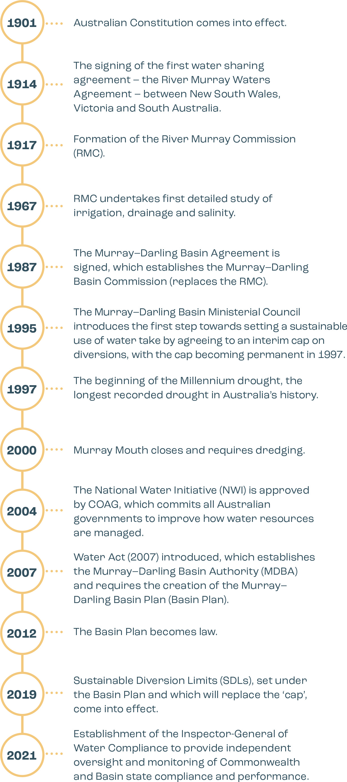

### Worst drought in history creates impetus for change

During the Millennium Drought (1997 to 2010) inflows to the rivers of the Basin fell to the lowest on record at that time in 2007. Public pressure regarding slow progress on attempts to improve environmental outcomes created an opportunity to pursue national legislation to co‑ordinate decision-making to manage the Basin as a single whole resource.

Commonwealth legislation, the Water Act 2007, was enacted as a framework for managing the Murray–Darling Basin as a national asset requiring cooperation and alignment on objectives greater than those at an individual state level. While not overriding State legislation, the Water Act established the Murray–Darling Basin Authority (MDBA) and required the MDBA to develop the Basin Plan. At its core, the Basin Plan sets the sustainable levels of water that can be taken across the Basin in order to keep the system healthy and viable into the future.

This approach, with both Commonwealth and state laws operating in the same area with similar objectives, creates a complicated web of laws for managing the Basin’s water resources. This means that the division of roles and responsibilities between the Commonwealth and State governments is not always clear. This can cause confusion and misunderstanding among Basin communities, and makes accountability difficult.

When communities cannot find straightforward answers to questions about the roles and responsibilities of the various authorities, it can impact trust and confidence in the management of one of Australia’s most precious resources, water in the Murray–Darling Basin.

## The Inspector-General of Water Compliance is established

As a result of public dissatisfaction in the integrity and transparency of water management and compliance, the Commonwealth amended the Water Act to create an overarching, basin-level, independent position to address these concerns. The statutory position of the Inspector-General of Water Compliance (the Inspector-General) was established on 5 August 2021. This has been a significant reform in holding Basin agencies (including the Australian Government) to account in meeting their obligations under the Basin Plan. It is an example of a law changing in response to a moral or ethical change in public perception, priority or value. This is a cornerstone of the way our democracy works.

## Functions and powers of the Inspector-General

The Inspector-General of Water Compliance has both oversight powers and specific compliance powers relating to areas of water management.

The Inspector-General’s oversight powers include the ability to undertake inquiries into how Commonwealth or Basin state agencies are performing their functions under the Water Act and the Basin Plan.

As well, the Inspector-General oversights eleven intergovernmental agreements which implement various elements of the Basin Plan.

The water compliance functions and powers allow the Inspector-General to investigate unauthorised water take and contraventions of Basin Plan water trading rules and take enforcement action as appropriate. Some of these powers were previously held by the MDBA, and upon transfer to the Inspector‑General were strengthened to include new offences relating to water trade and water theft.

This ensures the Inspector-General has the powers that are needed to investigate and prosecute non-compliance, while also deterring water theft and contraventions of Basin Plan water trading rules through criminal and civil penalties.

Specific compliance powers include powers to:

* conduct audits to assess compliance with the Basin Plan and Water Resource Plans
* appoint authorised officers to investigate allegations of non-compliance
* set standards and guidelines
* investigate and prosecute water theft offences and Basin Plan water trade obligations.

The Inspector-General may use these powers to address:

* contraventions of the water management arrangements in parts of the Water Act, the Basin Plan, or Water Resource Plans
* failure to comply with enforcement notices
* obstruction of authorised officers or authorised compliance officers
* failure to provide information where required.

## The roles and responsibilities of other agencies

The Inspector-General’s powers emphasise the importance of compliance with water laws as one of the keys to maintaining the integrity of water management by all Basin governments.

The following table shows some of the different roles of the Inspector-General, the Murray–Darling Basin Authority and Basin state agencies in managing the Basin’s water resources:

The Inspector-General is responsible for overseeing and monitoring state and Australian Government agencies with respect to their obligations under the Water Act and the Basin Plan. Basin states are responsible for monitoring compliance with their water laws in their states and for determining the allocations between different types of water use licences.

Other Australian Government agencies also have responsibilities relating to Basin Plan implementation. They include the Murray–Darling Basin Authority, the Department of Climate Change, Energy, the Environment and Water, and the Commonwealth Environmental Water Holder. The Inspector-General can hold these agencies to account by monitoring and inquiring into their performance to ensure these responsibilities are being carried out.

## Water resource plans set limits on water use

To ensure the sustainability of the Basin’s water resources, a limit needed to be set on the amount of water that can be extracted for consumptive use. As such, a key mechanism of the Basin Plan is the setting of formal limits on water extraction, otherwise known as sustainable diversion limits (SDLs).

In order to show how this level of extraction will not be exceeded, water resource plans (WRPs) are developed for each ‘water resource’ area. A WRP sets out the rules for how, and how much, water is used at the local or catchment level. The Basin is divided into 33 WRP areas accounting for both groundwater and surface water. The WRPs not only provide a framework to ensure that SDLs within that WRP area will not be exceeded; they also outline how environmental water is managed and how water quality standards will be met.

States are responsible for monitoring and managing water take throughout the year to ensure that water resources in the Murray–Darling Basin are managed sustainably. The role of the Inspector-General is to assess compliance with Basin-wide water take at the end of each water year. If there are any identified exceedances of the SDL, the Inspector-General has a range of compliance powers available to help ensure that extraction returns to sustainable levels in future years.

When looked at collectively, WRPs provide a Basin-wide plan for sustainable water use. They are accordingly critical to the successful implementation of the Basin Plan. It should be noted, however, that at the time of publication New South Wales is the only state to not have all of its WRPs accredited and operational.

## The Inspector-General is an independent statutory office holder

The Inspector-General was established as a statutory office-holder by the Water Legislation Amendment (Inspector-General of Water Compliance and Other Measures) Act 2021.

This means that:

* the functions of the Inspector-General are set out in the legislation
* the Inspector-General is appointed by the Governor-General
* the Inspector-General is appointed for a set term (4 years) and cannot be terminated before the term expires (except for misbehaviour, physical or mental incapacity or similar reasons)

The Inspector-General is supported by staff employed by the Department of Climate Change, Energy, the Environment and Water (DCCEEW). Interactions between staff and the broader department need to be managed in a way that enables the department and staff to comply with their legal obligations while respecting and supporting the integrity and independence of the Inspector-General.

## The independence of the Inspector-General is crucial

A critical factor to the way the Inspector-General works is that the role is independent.

Historically, compliance functions have wrestled for attention, approval, funding, time and people within an agency or department. Thus, by establishing a stand-alone water regulator, the necessary prioritisation has been given to meeting the community expectation that this role has the powers and resources it needs to effectively undertake its duties.

In the case of the Inspector-General, independence comes from:

* Self-determination: there are very limited circumstances in which the Inspector-General can be directed by others
* Security of tenure: there are statutory provisions regarding things such as the appointment and dismissal of the Inspector‑General
* Access to resources: the Inspector-General has a dedicated budget and staffing
* Lines of accountability: as the Inspector-General is a statutory officer, oversight of the performance of the IGWC comes ultimately from the Parliament, not from a Departmental secretary.

This means that when making decisions, the Inspector-General is not interested or involved in politics. A demonstration of this independence is the Inspector-General’s requirement to set an annual work plan which is not subject to ministerial direction. Each year, the annual work plan is published on the Inspector-General’s website ([Governance | Inspector-General of Water Compliance (igwc.gov.au)](https://www.igwc.gov.au/governance))

With independence comes a greater need to be transparent and accountable. This is achieved by:

* engaging transparently with the community
* public reporting
* accountability of the Inspector-General to the Parliament.

The end goal is that the rules are clear, the playing field is even and people know that when the rules are broken there are appropriate consequences.

## What does a field officer do?

### Engage

Engaging with key stakeholders and communities

### Gather

Gathering stakeholder feedback for future work plan priorities

### Ensure

Ensuring complaints and allegations are recorded and communicated to the appropriate agencies

### Provide

Providing support to the Inspector-General of Water Compliance

### Liaise

Liaising across Commonwealth and State agencies to provide feedback to specialist IGWC teams

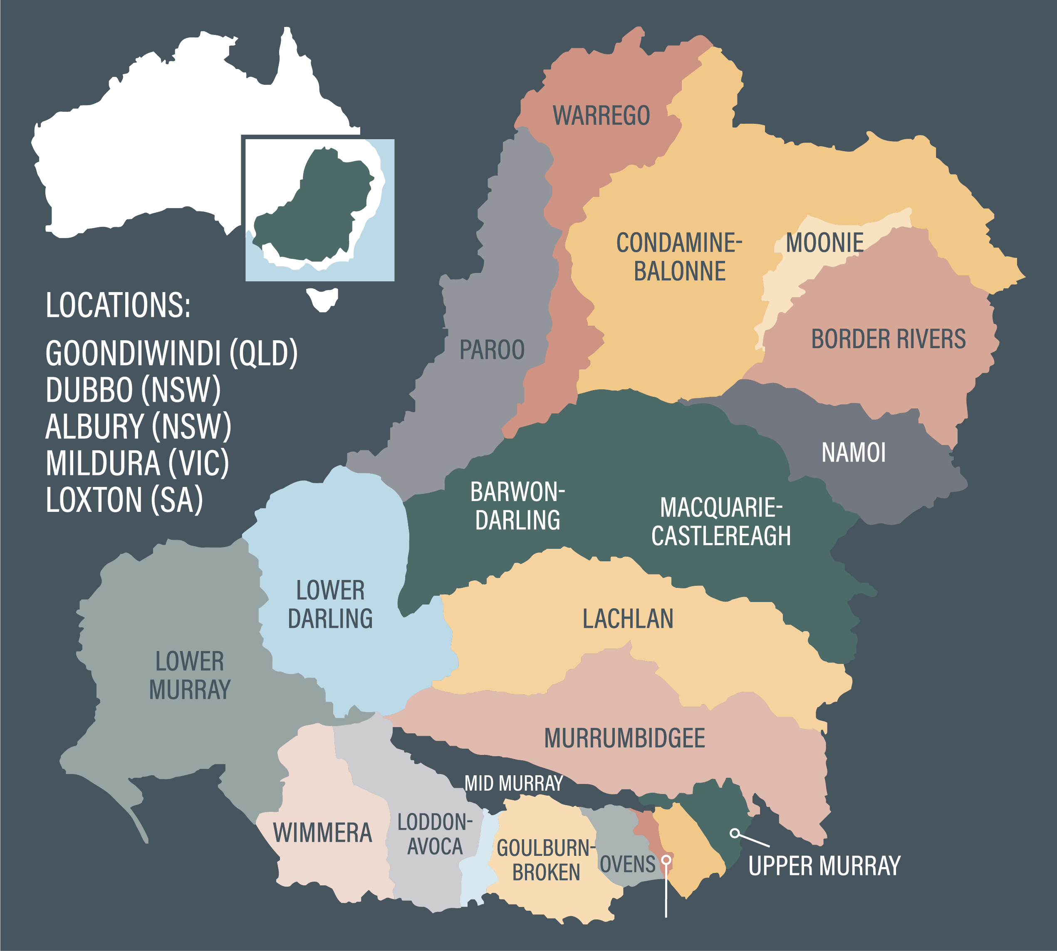

## Connection to community – field operations

The Inspector-General maintains a team of five Field Officers who live and work in the Basin.

* Field Officers act as a conduit between the Basin community and the Inspector-General
* Field Officers’ responsibilities include, but are not limited to, the following areas:
* providing support to the Inspector-General during engagement activities
* assessing stakeholder concerns and directing them to the relevant agency
* gathering ‘on-ground’ intelligence to inform the Inspector-General of concerns relating to trust and confidence
* assisting stakeholders in navigating complex water information
* working with and liaising across Australian Government and state agencies on matters relating to the Inspector-General.
* Key stakeholders include:
* communities
* First Nations Peoples
* peak bodies (including environmental)
* irrigators and farmers
* industry representatives
* Australian Government, state and local government agencies and representatives
* infrastructure and river operators.

## Community sentiment and understanding

Henty Field Days 2022

This year the IGWC Field Operations team set up a site at the Henty Field Days, which is regarded as southern Australia’s biggest agricultural event. This year’s event saw more than 70,000 visitors attend over the 3 days.

The IGWC Henty site attracted a number of interested community members. Each visitor was asked to participate in a short interactive survey where they were asked to identify the Basin issue that matters most to them. Overwhelmingly, attendees identified the examination and reform of the water market as the most important issue for them.

Water management is complex due to the shared responsibilities of Australian Government and state government agencies as well as the multiple purposes that water serves to Basin communities. Satisfying stakeholders with different environmental, social, economic and cultural needs will always require a balancing act.

At times when water availability is low, community attention relating to water management may be heightened. The complexity of water management arrangements and uncertainty about where to go to get information can create frustration.

Research indicates there are a number of drivers for perceptions of water management, which include:

* feeling informed / having a good understanding of the topic
* being aware of positive outcomes
* having access to trusted sources of information
* decision making processes meeting expectations.

The Inspector-General has spent time in Basin communities to better understand the drivers behind community mistrust in relation to water management. One of the more commonly held concerns was the notion that there is a lack of transparency in decisions relating to water management. Subsequently, communities cannot see where their individual community needs have been considered or met. The role of the Inspector-General includes providing transparency into matters of concern relating to agency performance under the Basin Plan where evidence, community sentiment or risk demonstrates a need.

All agencies involved in Basin water management have a role in communicating decisions and providing transparency regarding the information used to inform decision-making. However, there is no single agency responsible for telling the whole story.

Community members tend to rely on word‑of-mouth as their most trusted way of getting information, with government sources only being considered by few or infrequently. The Inspector-General intends to undertake an annual survey of Basin communities and use it to help inform future priority areas.

## Office contact information and locations

Our offices are located throughout the Basin. In addition to an office in Canberra, there are 5 regional offices in the Basin: Goondiwindi, Dubbo, Albury, Mildura and Loxton. To contact the office, please visit the website: [Contact us | Inspector-General of Water Compliance (igwc.gov.au)](https://www.igwc.gov.au/contact)

# 02 Compliance and performance

Laws are generally only effective when there is someone ensuring they are being complied with. The establishment of a Commonwealth independent body to oversee Basin Plan water laws and regulations is an important step in ensuring accountability of those who carry water management responsibilities in the Basin.

The role of state governments is to represent the interests of their area. They should legitimately act out of self-interest for their residents whilst balancing other state needs and priorities. However, there is an important and additional balance to be found when considering matters that cross-borders; it’s a difficult balance to get right.

It is clear that in the Murray–Darling Basin some states continue to heavily focus on their jurisdiction’s needs without a balancing collective national view. It is one of the reasons why an independent Inspector‑General is so important. When a jurisdiction acts in contradiction with Basin-wide outcomes, then the Inspector-General has a role to call out embedded cultures of self-interest which conflict with the broader interest of sustainability under the Basin Plan.

RESEARCH – compliance: perceptions, attitudes and behaviours

There are strong emotions associated with water compliance in the Murray–Darling Basin – with most community members and water licence holders reporting they get angry with those who do not follow the rules. There is also a perception (rightly or wrongly) among many that people often take more water than they are allowed to. And while many feel the rules are easy to comply with, there is still a significant group who disagreed with this statement highlighting the complexity of complying with water management rules.

## Basin state compliance and enforcement

There are challenges in comparing compliance systems across jurisdictions. There are significant variations between the Basin states in the degree to which there is an embedded culture of compliance, the levels of transparency, the comprehensiveness and clarity of the policy framework, and the administrative framework for managing compliance.

Notwithstanding this challenge, the Inspector-General has the legislated function of monitoring the performance of Basin states in managing Basin water resources. When the Inspector-General’s role was established, there was a critical need to conduct a wholesale review of Basin states’ compliance and enforcement frameworks and practices.

To help with this review, the Inspector-General engaged Mr Des Pearson AO, an esteemed public administrator who served as a state auditor-general (in both Victoria and Western Australia) for over 20 years.

In order to put some context around the Basin states’ management of water take, it is first important to understand how much of the Basin’s water take each state is responsible for. The graphic below illustrates the percentage of total water take (surface water and groundwater) taken by each Basin state in the most recent water year.

Figures based on 2020–21 take data reported to the MDBA.

Surface water figures includes interceptions - eg. take from runoff dams or commercial plantations.

Who is Des Pearson?

Des Pearson AO has spent half of his 40-year career working on program delivery and regulatory roles, and over 20 years as a state auditor-general in Western Australia and Victoria. Des is currently the Chair of the Audit and Risk Management Committee at Federation University. He was awarded the Order of Australia for distinguished service to public sector governance in the areas of public accountability and management, and for the development of innovative financial sustainability measures. The Inspector-General identified Des as an ideal person to review compliance and enforcement across the Basin.

Des noted that despite all the Basin states trying to do the same thing – which is to distribute a limited resource fairly – they all had varying ways of doing so. However, in his recommendations, Des noted that it is important for Basin states to continue collaborating and cooperating, because it will be a long journey to ensure everyone is on the same page.

### Review of compliance and enforcement across the Murray–Darling Basin

Before looking at the key findings and outcomes of this review, the following is a brief outline of the compliance and enforcement operating environment in each Basin state.

#### New South Wales

The current regulatory framework and governance arrangements in New South Wales arose through the implementation of the Securing our water policy published in 2017. Under this policy:

* the Department of Planning and Environment is responsible for policy advice and maintaining the State’s water rules
* WaterNSW is responsible for implementing the rules
* the Natural Resources Access Regulator (NRAR) is responsible for enforcing the rules.

There has been a significant investment in water compliance and enforcement in New South Wales, with NRAR’s level of resourcing and the adoption of sophisticated approaches, intelligence gathering and analysis. Reporting on compliance and enforcement in New South Wales is ongoing via dashboards and web pages, and efforts are being made to provide clearer insights into core compliance rates of take within allocations/entitlements, in terms of both volume and numbers of water users.

#### Victoria

Monitoring compliance with Victorian water laws is split between the Department of Environment, Land, Water and Planning (DELWP) and water corporations. Relevantly, the Department is responsible for policy advising, facilitation and co-ordination and monitoring, while the four water corporations (Goulburn-Murray Water; Lower Murray Water; Grampians Wimmera-Mallee Water; and Coliban Water) are responsible for the operational management and the enforcement of compliance with Victorian water laws in their respective regulated water systems.

A state-wide approach to compliance has been adopted through the implementation of the [Non-Urban Water Compliance and Enforcement Guidelines for Water Corporations](https://www.google.com/url?sa=t&rct=j&q=&esrc=s&source=web&cd=&cad=rja&uact=8&ved=2ahUKEwjwuYLIxfD6AhWZiGMGHV3bA7QQFnoECBIQAQ&url=https%3A%2F%2Fwww.water.vic.gov.au%2F__data%2Fassets%2Fpdf_file%2F0020%2F443081%2FComplianceEnforcementGuidelines-Final.pdf&usg=AOvVaw0aRi8iJOX2OnCToLzournF). This allows the water corporations to assess and harmonise their respective interpretations of the ‘zero tolerance’ policy, approaches to, and timeliness of, compliance management, criteria for escalation and entering into rectification arrangements, and to achieve more consistency in the management of and reporting on unauthorised take.

#### Queensland

The Department of Regional Development, Manufacturing and Water (DRDMW) enforces Queensland’s water laws (for example, in relation to construction of works to take or interfere with water consistent with entitlements and water plan rules). The Queensland Government’s efforts are focused on promoting voluntary compliance through a range of educational activities, however maintains a range of tools to respond to non-compliance. DRDMW adopts a risk-based approach to plan and respond to potential non-compliance.

A significant challenge for Queensland is the need to establish arrangements to accurately account for water diverted from overland flows. Measuring interception of overland flows is challenging because of the size of catchments, geography and the complexity of managing Queensland’s mostly unregulated flows compared with the more regulated catchments of other states, where infrastructure manages how much and when water is released.

#### South Australia

The South Australian Department for Environment and Water (DEW) is responsible for managing the state’s water resources through a water licensing and permit system and compliance framework.

Water take in the South Australian Murray–Darling Basin is primarily self-reported through quarterly meter reads (for 72 percent of licences; the balance is through annual reads). These reads are reported in a water register maintained by DEW, which is then validated and used to undertake compliance action against all users who take in excess of allocation, and also help inform targeted compliance and related activities.

#### Australian Capital Territory

Responsibility for water management in the Australian Capital Territory is shared between the Environment Protection Authority (EPA), which is responsible for administering the Territory’s water laws, and the Environment, Planning and Sustainable Development Directorate, which is responsible for water policy and planning.

The EPA adopts an annual billing cycle that builds on periodic self-reporting of meter readings (typically monthly). Water use by licensees is analysed annually via the accounting process and compliance with licence conditions (supply of data, amount of water used) is checked during the accounting process.



WATER’S EDGE PODCAST: ‘The Pearson Report’ to hear from Des Pearson and Inspector-General Troy Grant scan this QR code, or go to https://apple.co/3Dt9dJX

Des and Troy are honest and forthcoming with their views about the report and provide an insight into how water can be better managed across the Basin; with a more consistent approach to water terminologies and water accounting.

### What did this review find?

Key findings of this review include:

#### Public reporting should focus on outcomes – not activities

There has been significant improvement in the availability of compliance information in the last few years.

However, the review noted that Basin states still focus too much of their public reporting effort on compliance activities conducted, rather than what outcomes have been achieved by those activities. The community is more interested in knowing the rate of unauthorised water take in the Basin rather than how many audits or site inspections have been conducted in a given period.

#### Enforcement pathways should be clearer and more consistent

A key driver of trust in compliance and enforcement activities is knowing that when water theft is identified, those responsible will be held to account and face an appropriate penalty. The Basin community have told us that they don’t believe that water theft is penalised consistently across the Basin.

This review noted a lack of consistency in how Basin states apply penalties (for example, warning letters, fines etc) when their compliance activities have identified unauthorised take of water.

#### Basin States need to work together, not in isolation

This review noted that many differences among the Basin states in their approaches to compliance and enforcement are not driven by differences in legislation; rather, they simply reflect different historical practices (‘this is how we’ve always done it’) combined with a reluctance to recognise that other states may have a better way of doing things, and thus an opportunity to share better practice is being lost.

IGWC research relating to compliance perceptions, attitudes and behaviours showed that the elements of water management highlighted in the text below promoted positive community perceptions.

This aligns with the findings of the review of compliance and enforcement frameworks across the Murray–Darling Basin undertaken by Mr Pearson.

Research found that:

Cooperation and collaboration between governments and agencies, with Federal oversight is needed to support consistency of management across the Basin, leading to positive sentiment among water licence holders.

Consistency in the rules and their application across States/Territory and between different water licence holders was important to increase perceived fairness of water management.

Strong compliance and enforcement of water rules and regulations is needed to ensure that all water users were following the same rules.

### What will this lead to?

The Inspector-General has committed to undertaking 5 key actions to address the findings of this review:

1. Establish and chair a quarterly meeting of all Basin state government chief regulatory officers
2. Develop and implement an improved framework for Basin states to report on compliance performance
3. Develop a standard to inform the minimum standards for metering in the Basin
4. Conduct a review into unmeasured water take
5. Develop a guideline to help Basin states with establishing the harm caused by unauthorised water take

For more detail of the findings and outcomes from this review, please see the Inspector-General’s report [Compliance and enforcement across the Murray–Darling Basin (igwc.gov.au)](https://www.igwc.gov.au/sites/default/files/2022-08/compliance-enforcement-across-murray-darling-basin.pdf)

## Metering and measurement

Regulatory Leaders’ Forum – what is it?

As noted above, one of the key takeaways from Des Pearson was that State compliance agencies have traditionally focused on barriers to collaboration rather than ways to work together to achieve Basin wide outcomes.

To address this concern, the Inspector-General has convened a quarterly forum of Senior Executives responsible for compliance and enforcement in each Basin jurisdiction. This forum, known as the Regulatory Leaders Forum (RLF), will meet quarterly to achieve the following outcomes:

* discuss matters of priority and identify opportunities for collaboration in resources, technology, and intelligence.
* actively pursue consistency and consider the potential for harmonisation (of terminology, for example); and
* focus on building community trust and confidence in water compliance.

In addition, members of the RLF are close to finalising a single, multi-lateral Memorandum of Understanding (MoU) to support compliance.

A growing culture of shared improvement and collegiality is essential in order to deliver on Basin wide outcomes relating to transparency and consistency of compliance and enforcement activities.

### Why metering matters

Measuring water take is fundamental to trust in water accounting and compliance. Water meters measure licence holder water take so there can be confidence that water use in the Basin remains within sustainable diversion limits. Metering across the Basin needs to be consistent to make sure water take is fair for everyone. If it isn’t metered, how would we know at an individual, or state, or even national level how much water is being taken? That’s why metering is so critical – because if you can’t measure it, you can’t manage it.

As depicted in the graphic above, there is a direct link between water taken by individual licence holders and water taken annually at the Basin scale. For the purposes of Basin Plan water accounting, individual water take, together with other categories of water take, are aggregated to show how much water has been taken in that area for that year.

This volume of water take for that area is accounted for annually by the relevant Basin state to determine if the total volume of water taken has remained within the sustainable limit set under the Basin Plan (more on page 21).

### Metering reform in the Murray–Darling Basin

For the past 15 years there has been broad-based support for metering reform in the Basin. The Metering Reform Timeline below illustrates the numerous attempts by Governments to achieve consistent and accurate metering in the Basin.

Progress towards mutually agreed goals has been frustratingly slow and inconsistent across jurisdictions. When governments keep missing deadlines and failing to deliver on the promise of metering water take it ultimately reduces community trust and confidence in water management. The delay also has a much more systemic impact on compliance. Due to continual policy changes and deadlines being treated like ‘guidelines’, some water users have now adopted a ‘wait and see’ approach to buying meters in some regions. This is impacting on the achievement of deadlines.

It is worth acknowledging the challenges that can inhibit the timely progress of metering reform - delivering compliant meters on a Basin scale involves a complex supply chain, infrastructure delivery and coordination, and more recently, widespread flooding. An additional challenge is the limited availability of certified meter installers in some locations to install or supervise the installation of new meters.

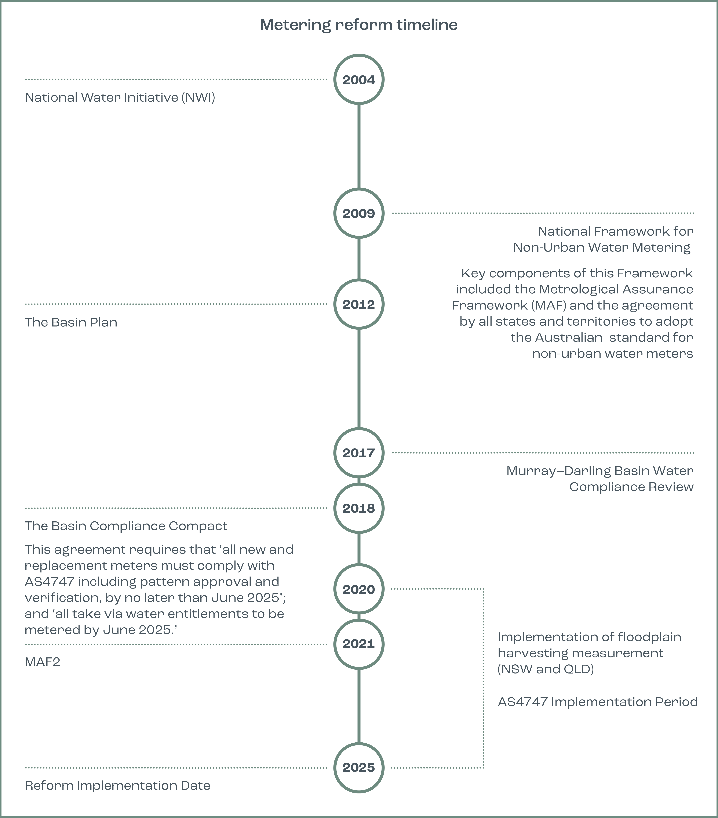

Case Study

NSW non-urban metering rollout

New South Wales takes over half of all the water taken in the Basin. This means that getting metering right in New South Wales is important for water management in the whole Basin.

As part of the Basin Compliance Compact, New South Wales committed to progressively improve the standard (that is the accuracy) and coverage of non-urban water meters across the state.

To facilitate this state-wide reform, New South Wales broke down the reform into four tranches. The first tranche required large water users with pumps sized 500 millimetres and above to be compliant with the New South Wales policy by 1 December 2020.

As part of the 2021–22 work program, the Inspector-General monitored the rollout of the first tranche. The IGWC made a number of observations relating to different aspects of the rollout.

Meter availability: There was no unreasonable delay in the supply of AS4747 compliant meters in the lead-up to the Tranche 1 deadline. For large format meters (above 1000mm diameter) there were some supply delays. However, these were not attributable to market failure; rather they were generally caused by last minute ordering.

Duly qualified persons (DQPs): The availability of DQPs (otherwise known as ‘certified meter installers’) was stretched in some areas of NSW during Tranche 1, however more came online during 2021 after the deadline which helped addressed this. With the higher number of meters requiring installation and validation in Tranches 2-4, this may cause some delays to meeting compliance deadlines in some catchments.

Compliance: Compliance levels were low immediately following the Tranche 1 deadline. Twelve months later around three-quarters of this group were compliant. A takeaway message is that that major reform may take longer than expected, particularly as individuals respond to change differently.

Industry buy-in: Some felt the feedback they provided through public consultations on the metering framework in 2018 had not been taken on board.

During 2021, NSW agencies made a more targeted effort to engage with industry and water groups. This resulted in a more constructive relationship, which has helped push out information on metering requirements to members and encourage compliance.

## State of play – metering across the Basin

There are three elements to fit for purpose metering of water take – coverage, accuracy, and timeliness:

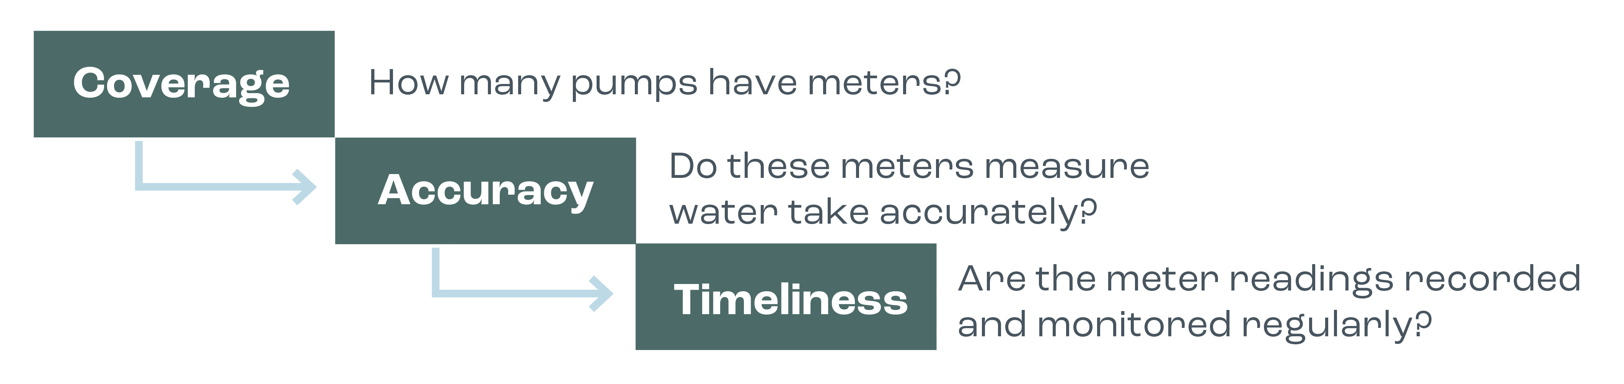

Meter coverage is the foundation of effective water measurement. While each Basin state has generally taken a risk-based approach to ‘when’ a meter is required, the basis on which risk is assessed does vary in each jurisdiction.

The graphic below demonstrates the different levels of coverage across the Basin states. These numbers are based on ‘meterable take’ from the 2020–21 water year.

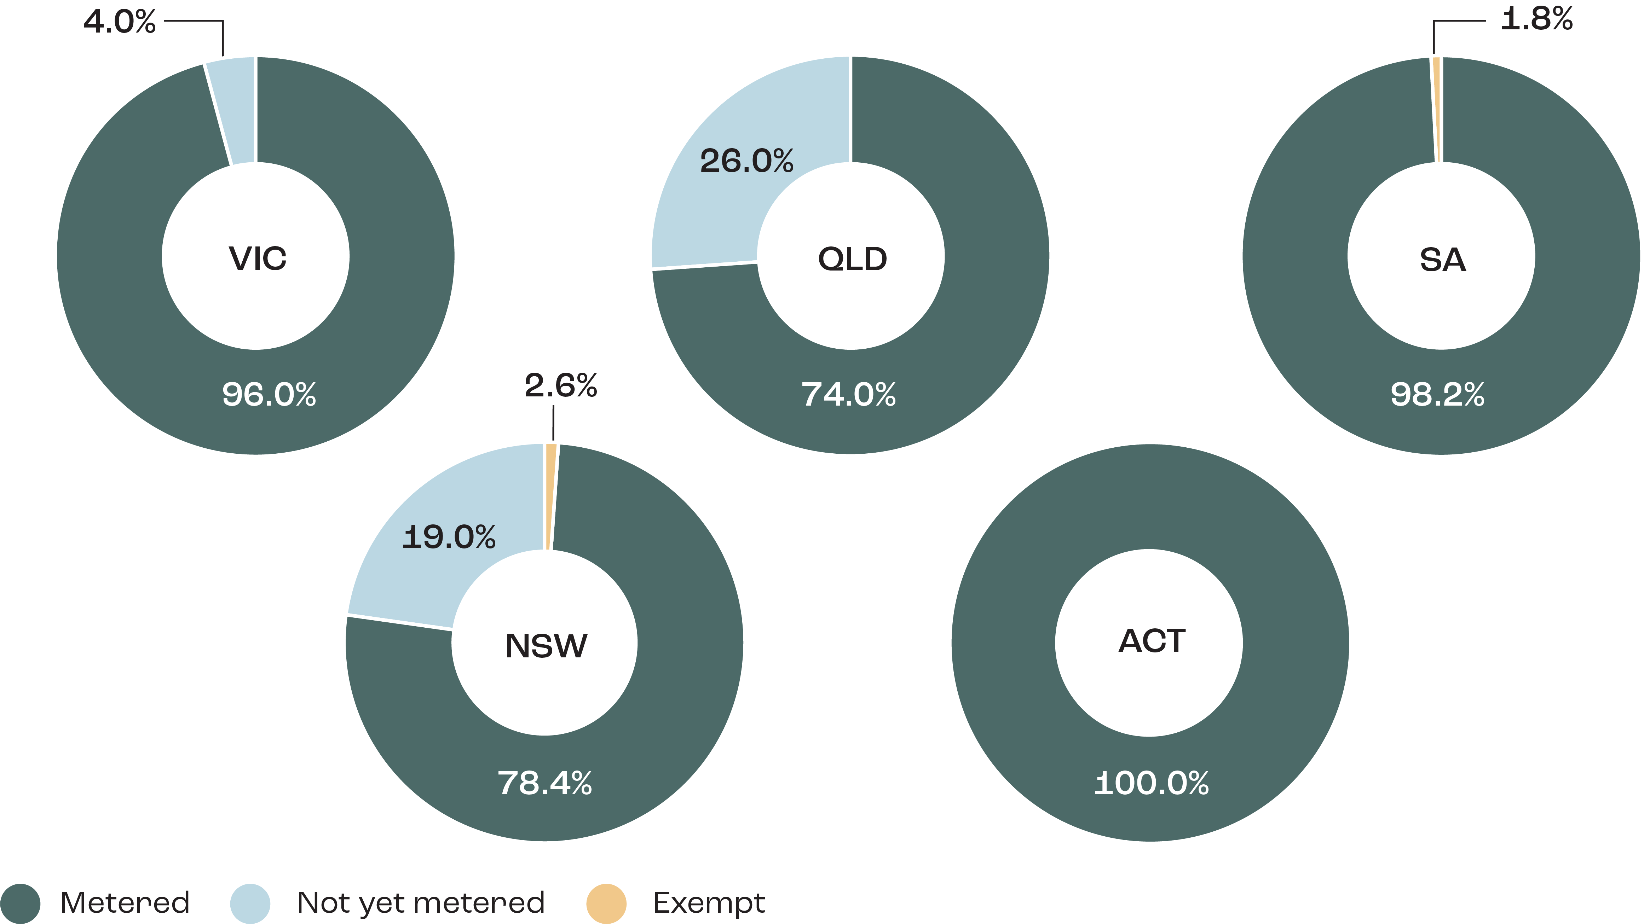

Notes

1. These figures are based on licenced water take from the 2020–21 water year.
2. This data has been provided directly by the Basin states – no assurance check has been undertaken by the IGWC to attest to the validity of these figures.
3. In NSW and SA there are some categories of water take which are exempt from the requirement to be metered.
4. QLD could not supply a metering figure based on water take; instead this figure represents the total volume of entitlements that are metered.
5. The IGWC is currently working with the Basin states to develop a more comprehensive metering report card. This work is expected to be finalised in 2023.

### Accuracy and Timeliness

Just having a meter does not ensure precise measurement of water take. Meters must also operate within a certain accuracy range to ensure there is a level playing field of water measurement across the Basin. Importantly, through the Compliance Compact, all Basin states have committed to a policy position that all new and replacement meters will meet the Australian standard 4747 (AS4747) by 2025 (with any exemptions to this to be published on the relevant agency’s website).

The third element of fit for purpose measurement of water take is having the data which is recorded by a meter automatically transmitted to a regulator. This is enabled through a process called telemetry (i.e timeliness). The benefit of telemetry is that it enables the transmission of water take by the meter directly to the regulator, rather than requiring the meter to be read in-person.

In the coming year, the Inspector-General will produce and publish an ongoing annual snapshot of Basin state progress towards their metering commitments agreed to under the Compliance Compact. The intention of this report is to give the public confidence that metering reforms are progressing, and by making this progress transparent, to help ensure that the 2025 deadline for metering reform is achieved.

## Compliance with sustainable diversion limits

### Background

The Inspector-General of Water Compliance is responsible for monitoring Basin states’ compliance with the sustainable diversion limits (SDLs). This year the Inspector-General released the first [sustainable diversion limit compliance statement.](https://www.igwc.gov.au/sites/default/files/2022-08/igwc-2020-21-sdl-compliance-statement_0.pdf)

Sustainable diversion limits are a key element of the Basin Plan. Under section 20(b) of the Water Act, the Basin Plan is to provide for ‘the establishment and enforcement of environmentally sustainable limits on the quantities of surface water and ground water that may be taken from Basin water resources’. In effect, SDLs limit the amount of water that can be taken from rivers and aquifers for towns, industry and farmers.

Under the Basin Plan, sustainable diversion limits are set for 29 surface water areas and 80 groundwater areas across the Basin (these areas are referred to as SDL resource units). SDLs cover all forms of water take defined in the Basin Plan – including take from watercourses and regulated rivers, groundwater, floodplain harvesting, runoff dams, commercial plantations, and take under basic rights.

The Water Act requires Basin state governments to provide an annual report to the MDBA on the volumes of water take for each SDL resource unit. Upon receiving the water take data from the Basin states, the MDBA performs a quality assurance check on the data before passing the data on to the Inspector-General as the Register of Take for the purposes of determining SDL compliance.

### Sustainable diversion limit compliance in 2020–21

Pleasingly, the Inspector-General reported this year that in the 55 SDL resource units where water take figures were officially reported to the MDBA in the register of take, all 55 were found to be compliant with SDLs. These 55 resource units (combining both surface water and groundwater) cover Victoria, Queensland, South Australia and the Australian Capital Territory.

On a more disappointing note, the 54 SDL resource units in New South Wales (10 surface water and 44 groundwater) were not subject to SDL compliance or enforcement by the Inspector-General, as there were no accredited water resource plans in place in NSW for the 2020–21 water year, as shown in the images below.

Determining compliance with SDLs can only occur where accredited water resource plans exist for the relevant SDL resource units. It is only when a water resource plan is operational that the Inspector-General has a full legal suite of monitoring, risk assessment and compliance tools, such as inquiries, audits and investigations.

Once again, this highlights the absolutely critical importance of having accredited water resource plans in place. Their absence only adds to community mistrust in the effective operation of the Basin Plan.

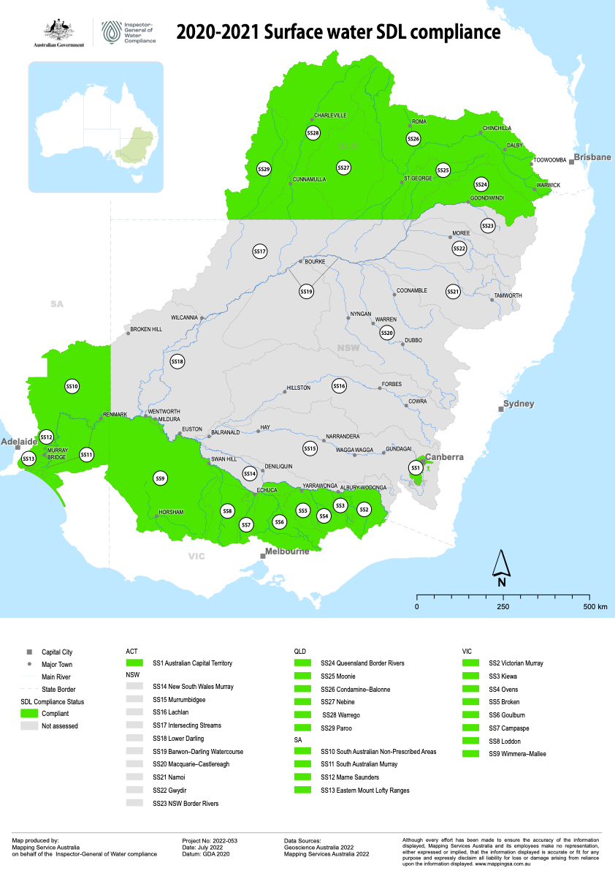

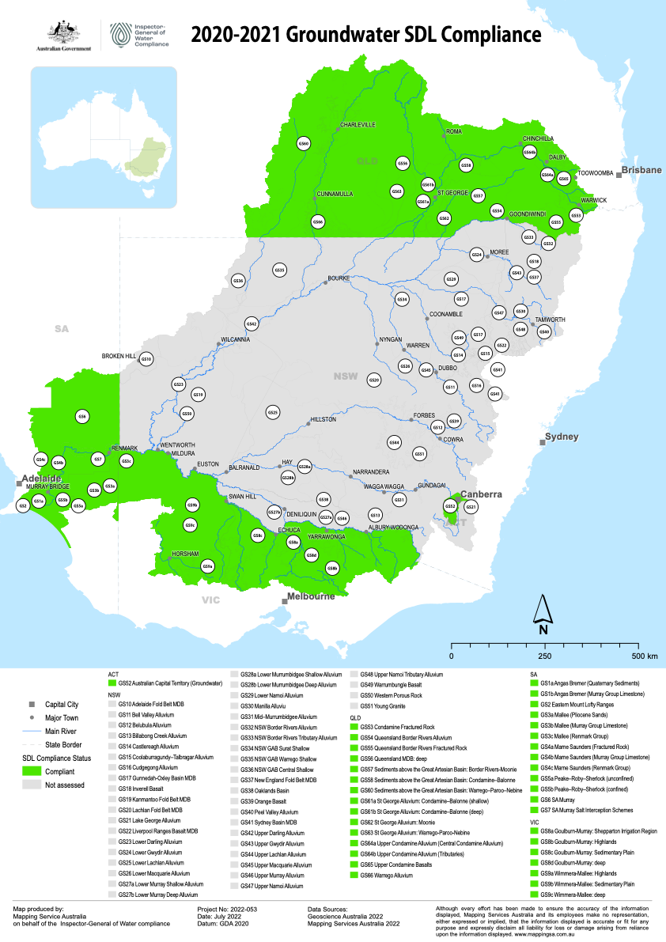

## Audit of Goulburn-Murray Water

One of the compliance functions transferred from the MDBA to the Inspector-General in 2021 was the power to conduct audits to assess compliance with the Basin Plan.

In 2022, the Inspector-General [audited Goulburn-Murray Water (GMW)](https://www.igwc.gov.au/sites/default/files/2022-07/igwc-audit-of-gmw-disclosure-obligations-ff.pdf) to assess whether it was meeting its obligations as an approval authority under the Basin Plan regarding the disclosure of certain information relating to water trades.

Under the Basin Plan an approval authority has obligations to disclose its interest in a trade before it occurs and then publish certain information on its website after the trade has been approved. An approval authority’s disclosure obligations are an important function designed to help avoid actual, potential or perceived conflicts of interest where the approval authority, or a related party, is conducting and approving trades where it has a commercial, equitable or legal interest.

### Why we did this audit

We audited GMW:

* to determine the adequacy of GMW’s arrangements for identifying the legal, equitable or commercial interests that exist
* to determine the adequacy of arrangements for ensuring that the nature of any legal, equitable or commercial interest that GMW or a related party has is disclosed to the other party before a trade is approved
* to determine the adequacy of arrangements for ensuring that GMW publishes all the information required after a trade has been approved.

### Key facts

* GMW is the largest approval authority in Victoria and Australia’s largest irrigation infrastructure operator, with over 20,000 customers across northern Victoria.
* GMW is one of the major approval authorities in the Basin and holds water access rights that are traded.
* GMW selects from a panel of 5 water brokers for its own water trading activities.
* A related party includes any entity in which an approval authority has a controlling interest, or any natural person acting on behalf of an approval authority for a commission or fee.

### What we found

* The volume of water traded by GMW is not likely to have had any material impact on the water market.
* GMW does not have formal arrangements for identifying all the legal, equitable and commercial interests that it or a related party may have in water access rights that are traded.
* There was a lack of physical evidence to ensure that parties to a trade were notified when GMW or a related party had a legal or equitable interest in the water access right or a commercial interest in the activities of the water market intermediary who submitted the trade for approval.
* GMW does not have documents to evidence instructions for all trades provided to brokers.

### What we recommended

* GMW should have arrangements that properly consider the extent to which it or a related party has legal or equitable interests in a water access right or a commercial interest in the activities of a water market intermediary.
* Agreements with brokers need to confirm the process for notifying other parties where GMW or a related party has a legal or equitable interest in the water access right.
* GMW should maintain records that allow it to reconcile applications submitted for approval with trades published.

Goulburn-Murray Water accepted all of the recommendations and have notified the IGWC that it has completed implementation of the actions in response.

## Investigations

Investigations are conducted in relation to matters for which the Inspector-General is the appropriate enforcement agency under section 137(a) of the Water Act, which provides scope around the matters which the Inspector‑General can investigate. Part 10AA sets out the investigative powers and tools open to appropriately authorised staff on behalf of the Inspector-General.

These powers include:

* entering premises to monitor compliance (s.223)
* securing evidence of a contravention (s.223A)
* asking questions and seeking production of documents (s.223B)
* entering premises to search for evidential material (s.224)
* monitoring warrants (s.225)
* investigation warrants (s.226)
* use of equipment at a premises (s.231).

Many of these powers are obtained through an application to a magistrate (for example, warrants). To date the Inspector-General has not used these powers to progress an investigation. Investigations currently undertaken by the Inspector-General are dominated by allegations relating to alleged inconsistencies with Chapter 12 (Water Trading Rules) of the Basin Plan.

Over the past year the Inspector-General has commenced 19 investigations. Nine of these have been closed, and ten remain open. Of the closed investigations, all but one were closed due to no non-compliance having been detected. The remaining matter fell within the remit of a Basin state and was subsequently referred for further investigation.

# 03 Oversight and trust

## Trust and confidence

Community perceptions of water management tends to be more negative than positive. Agencies working in this space are starting from a negative base in relation to community sentiment overall.

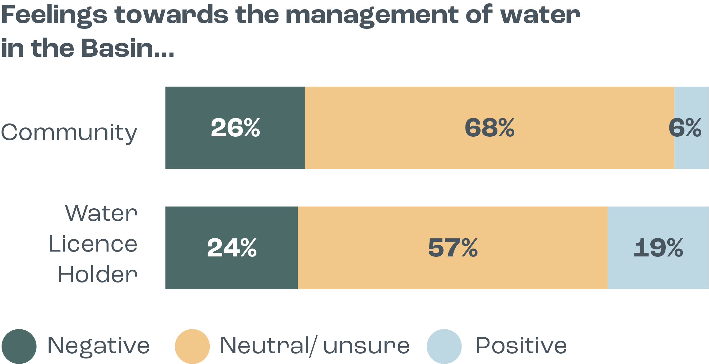

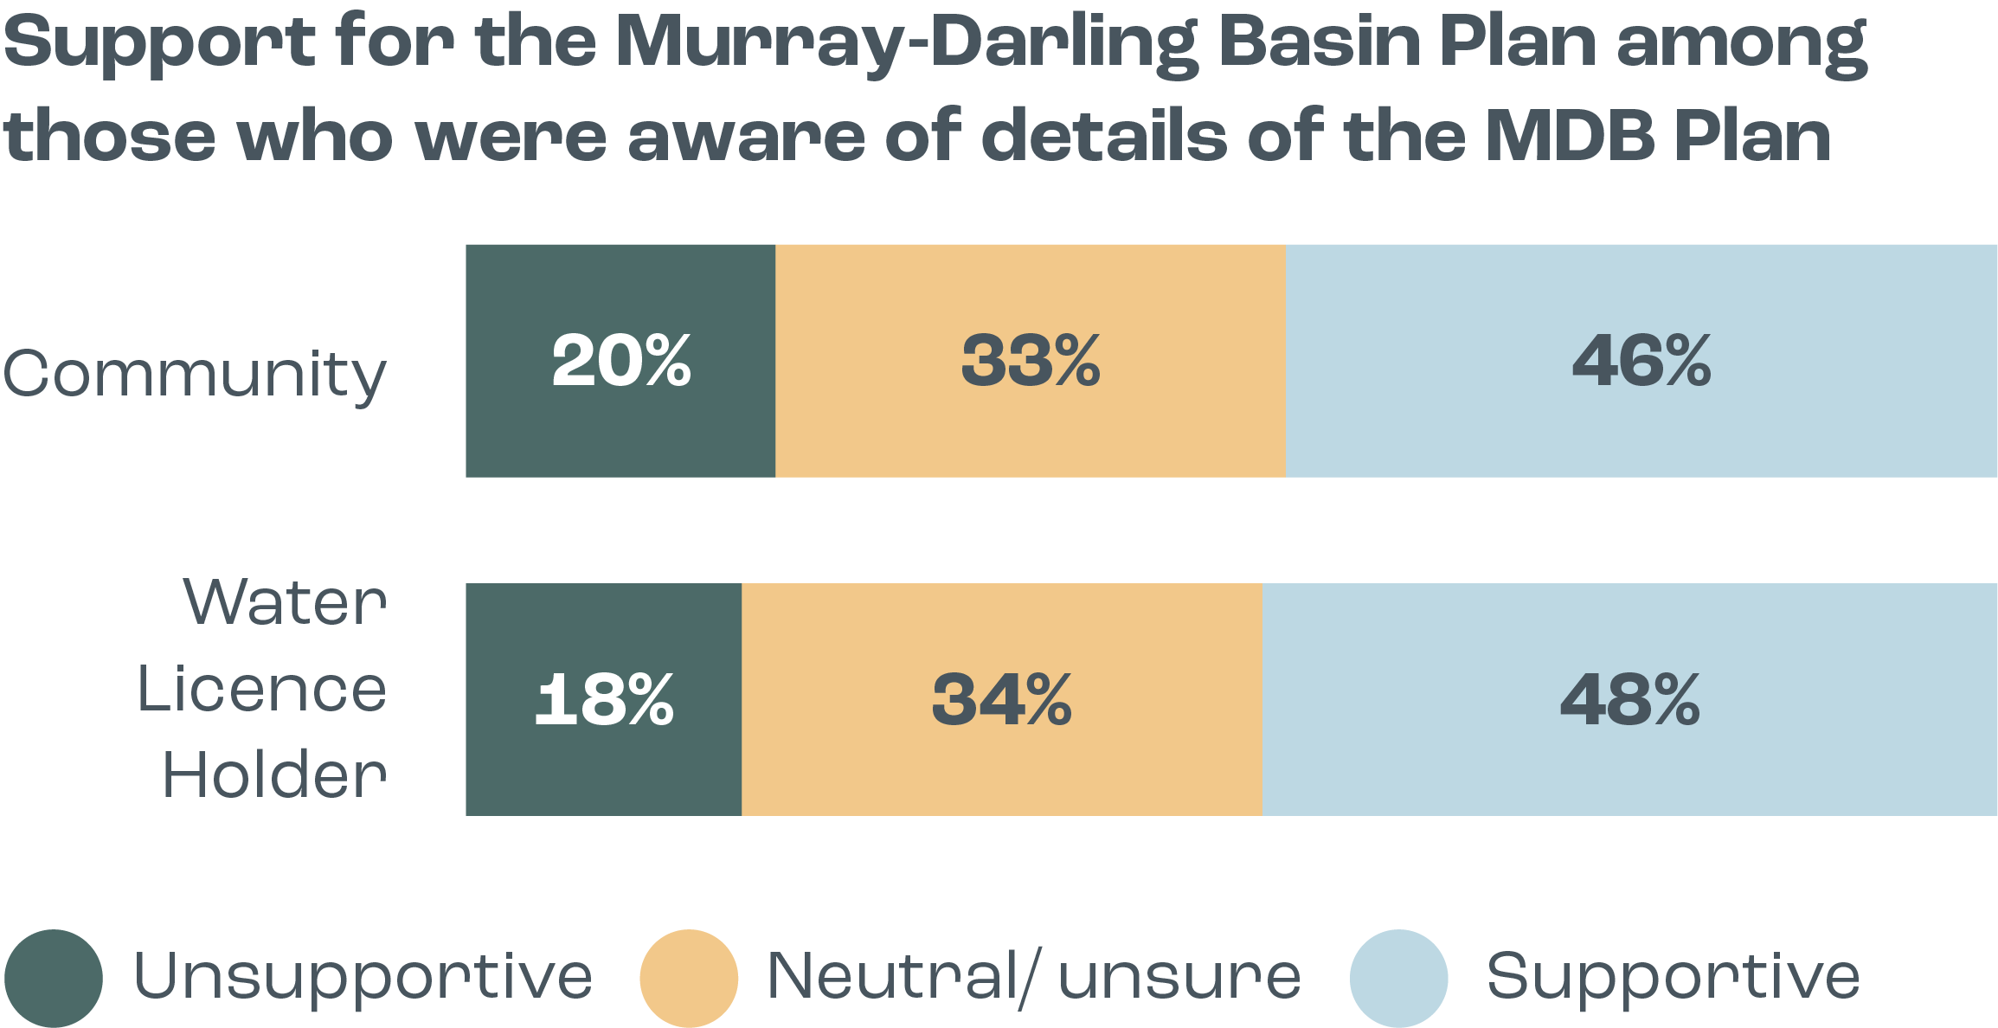Community support for the Basin Plan was surprisingly high, with almost half of the Basin community (who were aware of the details of the Basin Plan) supportive of the Plan.

This evidence challenges the perception that the Basin Plan is not supported by the majority of the community or water licence holders.

The research also found that trust and confidence are strongly linked and build on one another. Enhancing knowledge, demonstrating actions and outcomes and sustained performance were found to be critical to enhancing both trust and confidence.

Part of the role of the Inspector-General of Water Compliance includes an oversight function. This connection between trust and confidence and the role of the Inspector‑General was a driver in undertaking significant reviews into two key aspects of water management in the Basin completed this year – River Murray operations and the management of environmental water by the Commonwealth Environmental Water Holder (CEWH). Both of these matters were brought to the attention of the Inspector-General by community members during engagement activities in 2021. The outcomes of these reviews are outlined below.

## Review of River Murray operations

### How is a river ‘operated’ and who does it?

Regulated river systems such as the River Murray have storages (for example dams or weirs) which enable the controlled release of water for delivery to irrigators, communities and the environment.

Water delivery happens by releasing water from a dam, or by adjusting infrastructure in the river like weir pools, to ensure there is enough water in the system when it is needed.

The MDBA is responsible for operating the River Murray on behalf of New South Wales, Victoria and South Australia, up to the South Australian border.

### What did this review look at?

This review looked into two aspects central to the MDBA’s river operations function:

1. whether the measurement of water in the River Murray system is adequate to ensure that the river can be run efficiently and effectively; and
2. whether the data analysis and modelling processes on which river operators rely are sound and fit for purpose.

### What did the review find?

The review found that overall the measurement data that underpins river operations is adequate and fit for purpose. Likewise, the data analysis processes undertaken by the MDBA river operations team are fit for operating the river in accordance with the Murray–Darling Basin agreement.

The review did, however, identify some areas for improvement:

1. The lack of an agreed data standard may impact the efficiency of river operations. This could lead to confusion and reduced community confidence.
2. Changing water demand patterns driven by climate change and the rise in horticultural plantings are driving a need for improvements in aspects of water measurement.
3. This changing operating environment will also require more accurate modelling and accounting for issues such as system losses (water that is naturally lost through evaporation and seepage), overbank flows and return flows.

The review also noted that there is an inherent conflict between the Basin Plan and the Murray–Darling Basin Agreement. The agreement sets out how water in the River Murray system is shared between Victoria, NSW and South Australia; but it does not incorporate the management of water for the environment, which was only formally recognised with the Water Act and the Basin Plan. This conflict is exemplified by the lack of clear and transparent processes for prioritising needs when there are competing demands for water.

## Review of the Commonwealth Environmental Water Holder

### What is the Commonwealth Environmental Water Holder?

The Commonwealth Environmental Water Holder (CEWH) is an independent statutory position established under the Water Act. The CEWH manages the Australian Government’s environmental water entitlements in the Murray–Darling Basin. This water, often referred to as water for the environment, is used to keep the rivers and wetlands of Murray–Darling Basin healthy.

### What did this review look at?

This review looked into the following aspects of the CEWH’s operations:

1. How effective is the CEWH’s approach to planning and managing water for the environment?
2. How adequate is the volumetric measurement of environmental water?
3. How adequate is the CEWH’s program for monitoring, evaluating and reporting on environmental watering outcomes?
4. How effective is the CEWH’s communication and engagement?
5. Has the CEWH improved its operations over time?

### What did the review find?

Overall, this review found that the CEWH has a robust and effective approach to planning and managing water for the environment. While the review identified some possible improvements to operations, there was no evidence that the CEWH is not performing its functions competently and in accordance with Basin Plan’s environmental objectives.

Some specific findings of note include:

* Water planning and management appears to be an area of strength for the CEWH. Environmental watering is a complex process, and the CEWH rarely operates in isolation.
* The CEWH’s water is accounted for in the same way as other water, such as water used by irrigators. The CEWH’s water is released from storages or delivered to offtake points in the river where it can flow or be pumped into environmental sites such as wetlands. When the CEWH orders water, it is debited from CEWH water allocation accounts which are maintained by state water management agencies.
* There is good evidence that the CEWH’s monitoring, evaluation and reporting of environmental flows meets its reporting obligations and provides useful information to feed into future water planning.
* Investment and effort in local, quality outreach programs has resulted in positive on-ground relationships and engagement. Extending this model would have benefits.

More information on the review of River Murray operations and the review of the CEWH can be found in the Inspector-General’s ‘Steady As It Flows’ report published in September, located at: [Reviews and reports | Inspector-General of Water Compliance (igwc.gov.au)](https://www.igwc.gov.au/reviews-reports)

The conclusions of these two reviews are consistent with research relating to the community’s desired characteristics of water management:

Evidence-based decisions – i.e. water management decisions driven by science, data, technology, monitoring and informed by local context, in order to increase trust and ‘buy-in’.

Transparency and accountability – it was important for water management processes and decisions to be transparent (i.e. communicated to the public), and for authorities to be accountable for their decisions (i.e. having clarity around who was responsible for what, and agencies “owning” their decisions).

Open and proactive engagement and communications – including to raise awareness of, and educate about, the system, the Basin Plan, current water management activities and positive stories/outcomes in the Basin.

Forward planning for weather events (.e.g droughts, floods) – to ensure that adequate water supply and quality was available at these times.

# Looking forward

The role of the Inspector-General of Water Compliance was created to provide independent oversight; to gather and assess data and evidence; and to hold agencies to account against legislative and Basin Plan obligations.

Naturally, given the role of the independent Inspector-General is a new statutory position, the priority in the first year has been to gather intelligence and evidence in order to inform decision-making and future priority areas. This process included speaking to stakeholders, completing a stocktake of various Basin-related issues, and undertaking specific reviews to look into common areas of concern. As an evidence-based regulator and oversight body, a thorough and systematic assessment of issues and risks that fall within the legislative remit of the Inspector-General was a key initial phase of this first year.

The 2021–22 work plan priorities included both areas that will have an enduring focus year on year, as well as some specific singular projects based on community concerns.

The Inspector-General’s 2022–23 work plan will align with matters which are urgent, relate to risk or demonstrate an evidence-based need. This includes a greater focus on water resource plan compliance, trade compliance, and further building trust and confidence in water management across the Basin.

Water trade remains an area of concern and interest to many Basin stakeholders. The operation of the water trade market is currently subject to significant reform, likely to span from 2022 onwards. This process is separate to the Inspector-General, but there are potential outcomes that are likely to form part of future work plan priorities for water trade compliance.

The Inspector-General will continue to seek the views of the community to understand the drivers of the lack of trust and confidence in water management. This information will be used to target priority projects or use powers to look into matters lacking transparency.

In other areas of focus, the Inspector-General will also be subject to review following the first year of operation, with a focus on ensuring the statutory position has the powers and functionality to deliver on the intent of the role.