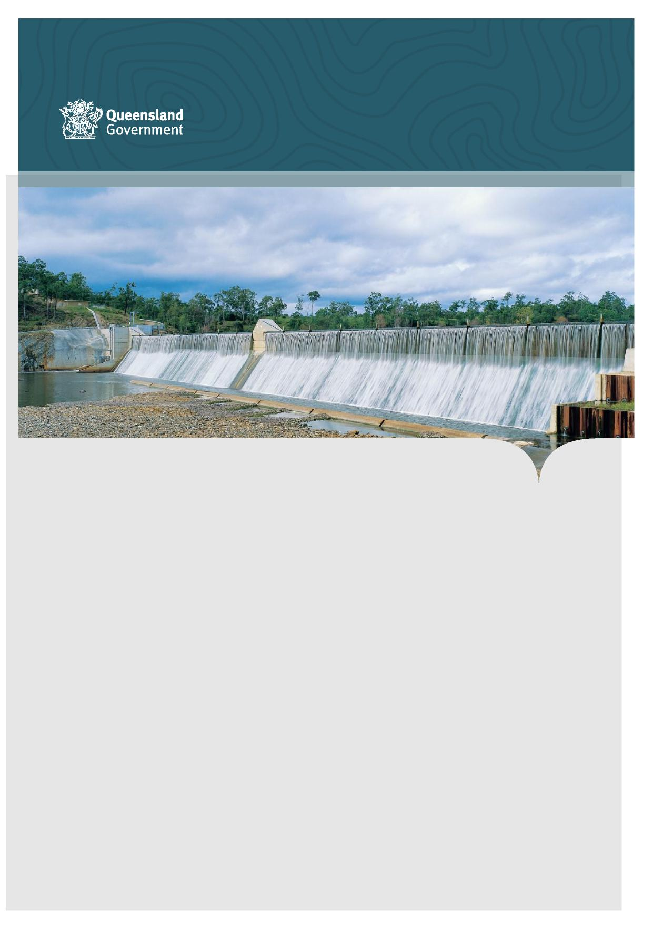

**Department of Regional Development, Manufacturing and Water (DRDMW) - Management Response to Audit Recommendations**

**Inspector-General of Water Compliance Audit management of overland flow harvesting in the Lower Balonne**

[**rdmw.qld.gov.au**](https://www.rdmw.qld.gov.au/)

**Recommendation 1 – Develop documented guidance around key compliance activities**

DRDMW should develop documented guidance for:

* 1. remote monitoring of storage conditions pre-, mid-, and post-flow
  2. verification of measured take data, including routine approaches and guidance for applying additional scrutiny where necessary;
  3. use of accounting spreadsheets; and
  4. use of flow event management spreadsheets.

Having guidance in place for these key compliance activities would help to reduce the risk of loss of capacity or corporate knowledge due to staff turnover, inconsistent application of rules and gaps in implementation. Documentation of the monitoring, frequency and findings in line with guidance (developed in relation to a and b) would provide greater consistency, quality assurance, and auditability. Guidance (developed in relation to c and d) would also mitigate risks of inconsistent application of spreadsheets between officers or missing requirements during handover to different offices.

The guidance for use of the flow event management spreadsheet (developed in relation to d) should include a method for tracking the period elapsed between flow events to support implementation of trigger-based flow event management rules within Chapter 9 of the Water Management Protocol.

**Management Response to Recommendation 1   
The recommendation is accepted.**

Investment in future work practices and workflow will be delivered through an initiative of the Rural Water Futures program (RWFP) to improve the measurement of overland flow.

The overland flow measurement program has been established to develop consistent ways of determining overland flow take and drive legislative change. The program will support the development of new and enhanced measurement and monitoring tools and supporting systems.

Through this project, current state and future state work practices and supporting systems requirements will be documented.

Transparent water information is another initiative of the RWFP and includes a project to develop and implement a future water accounting framework that improves systems and processes to enable automated reconciliation of actual and authorised take. This project is seeking to systematise consistent water accounting across the MDB.

2

**Recommendation 2 –** **Commit to a minimum number of on-site audits for pre and post flow events**

DRDMW should:

1. commit to undertaking pre-flow event and post-flow event on-site audits at a minimum

Undertaking sufficient on-site audits will address the risk that issues are not detected, including nonoperational meters, changes to storages, and noncompliance with licence conditions.

**Management Response to Recommendation 2   
The recommendation is accepted in part.**

Currently, the Department of Regional Development, Manufacturing and Water (DRDMW) prioritises on-site audits in the Lower Balonne in Spring (pre-flow), during flows and post flow events. The ability to undertake audits on-site is impacted by weather and access conditions at the time and was particularly impacted during the audit period. Access to monitoring sites is limited by a number of factors:

* flood waters cutting vehicular access to properties.
* main unsealed road networks closed to all traffic; and
* local rainfall making farm tracks non-trafficable.

The Strengthened water measurement initiative of the RWFP is progressively investigating the use of technology to strengthen measurements on-site.

To strengthen on-site monitoring, technology trials are being undertaken to support overall timely measurement of water take. Some of these initiatives include:

* telemetry,
* a Water User App that captures and submits meter readings through automated recognition tools, and
* Remote sensing using satellite imagery proof of concepts including analytics of imagery to detect the presence of water in offstream storages.

On-site audits will continue to be a part of the overall compliance framework but will be complemented by other strategies. The numbers of audits of overland flow storages undertaken in each year will continue to be assessed according to risk and prioritised in the DRDMW Annual Compliance Plan.

3

**Recommendation 3 – Implement alternative audit strategies to combat limitations to onsite audits due to weather conditions**

DRDMW should:

1. ensure post-flow audits occur with minimal delay
2. investigate alternate types of evidence (to on-site meter reads) to verify take immediately post event and develop a methodology.

Where on-site audits are not feasible or are delayed, remote monitoring approaches should be taken to ensure there is timely oversight during and following flow events. Monitoring and audit of measurement data is most critical immediately post event and when remote sensing would be of most value to verify the actual volume taken by licence holders during the event is compliant with the licence held.

Alternative audit strategies to investigate should include cloud-penetrating remote sensing, satellite imagery, aerial imagery for pre- and immediately post-event (whether by plane, drones, or helicopter flyovers).

**Management Response to Recommendation 3 The recommendation is accepted.**

Alternative strategies are being investigated as part of:

* the RWFP as described in the response to Recommendation 2.
* the Commonwealth funded Hydrometric Network and Remote Sensing Program, and
* collaboration across New South Wales, Bureau of Meteorology, Geosciences Australia and the Murray Darling Basin Authority.

The alternative strategies are focused on methods that are cost effective and repeatable at short notice.

4

**Recommendation 4 – Ensure that the requirement to report measured take within a specified period is consistent and enforceable**

DRDMW should:

1. reconcile the current approach in the Management Protocol, which requires reporting 5 business days at the end of an announced period, with Division 4 of the Water Regulation 2016 which suggests from compliance perspective the threshold is 30 days from receiving a notice from the chief executive.
2. revise the approach to include a time threshold, beyond which a notice requiring a meter reading within 30 days is sent. This would address the risk of extended delays in receiving data that may prevent DRDMW from checking compliance with conditions and publishing flow event reports. This would also enable a compliance response to be taken if appropriate.

**Management Response to Recommendation 4   
The recommendation is accepted.**

The technical standard for on-farm water level stations (which commenced in 2021) already sets the requirement for collection, data security and logging time requirements. Under the standard, collection and recording of water level data is a continuous requirement at hourly intervals. Data collection in relation to overland flow entitlements will be consistent with this standard once the current process to revalidate all water level stations in the Lower Balonne area is complete.

As described in the RWFP, the current approach (5 business days mentioned in the Management Protocol) will be replaced with a requirement to transfer data in accordance with new measurement requirements as the second phase of the overland flow measurement framework (measurement plans) is implemented. This will ensure that information about water taken is transferred to DRDMW in accordance with its compliance needs.

Changes to the Water Act 2000 which provides the foundation for the future approach [are currently being progressed](https://documents.parliament.qld.gov.au/bills/2022/3111/Water-Legislation-Amendment-Bill-2022-d529.pdf).

**Recommendation 5 – Verify self-reported measured take**

DRDMW should:

1. verify licence holder reported take (links to Recommendation 1b)
2. develop a method to reduce the risk that meter read data is tampered with (meter read data is manually collected by licence holders and transferred to DRDMW)

Methods to investigate for recommendation 5b include a chain of custody method such as telemetry, or by requesting date-stamped photo evidence of the meter reads and storages in addition to supplying the meter read sheet.

This recommendation may align with initiatives to strengthen water measurement under the Queensland Rural Water Futures program.

**Management Response to Recommendation 5   
The recommendation is accepted.**

Alternative strategies are being investigated as part of the RWFP as described in the response to Recommendation 2.

These strategies include investment in data analytics that compare volumes taken with previous patterns of water use.

**Recommendation 6 – Provide entitlement holders with clear written instructions for notification of changes to storages**

DRDMW should:

1. review the level of information provided to educate entitlement holders on compliance requirements; and
2. ensure entitlement holders are provided with clear written instructions on their requirement to notify on completion of a new water storage, or the alteration of an existing storage used to store water under the authority of a water allocation.

The information could be included in a variety of written communications, such as in a Water Licence, direct mailout and/or on the DRDMW website.

**Management Response to Recommendation 6   
The recommendation is accepted in part.**

DRDMW believes there is a high level of knowledge in the Lower Balonne of the requirements for notification and/or development approval for changes to water infrastructure including storages.

In accordance with **DRDMW’s** current [Regulatory Strategy 2022-2024](https://www.rdmw.qld.gov.au/__data/assets/pdf_file/0011/1630784/regulatory-strategy-wrm-2022-24.pdf#:~:text=This%20strategy%20sets%20out%20our%20approach%20for%20the,we%20utilise%20and%20our%20compliance%20and%20enforcement%20pathways.), DRDMW will continue to provide information and guidance to all entitlement holders to ensure awareness of their requirements.

This includes the development of targeted and routine communications with entitlement holders in the Lower Balonne and the wider Queensland Murray Darling Basin.

Targeted communications are currently planned under the current [Annual Compliance Plan 2022-2023](https://www.rdmw.qld.gov.au/__data/assets/pdf_file/0007/1634182/compliance-plan-2022-23.pdf).