Modern Regulator Improvement Tool

DRAFT Summary of process and outcomes

July 2024

# Summary of process and outcomes

The Inspector-General of Water Compliance was established on 5 August 2021.

An immediate observation of the Inspector-General was the absence of a collaborative forum for sharing good water regulation practice at the senior executive leader level in the Murray-Darling Basin. Consequently, the first Regulatory Leaders Forum (RLF) was held on 18 October 2021. The purpose of the forum was largely to drive improvements in regulatory maturity across the Murray-Darling Basin; specifically, to:

* share lessons (noting specific opportunities in resources, technology, intelligence and behaviour)
* pursue consistency and consider harmonisation
* focus on building community trust and confidence in water compliance.

A review of compliance and enforcement across the Murray–Darling Basin prepared by Mr. Des Pearson AO in June 2022 for the Inspector-General recommended:

*“That the Inspector-General of Water Compliance (IGWC), in consultation with the Regulatory Leaders Forum, work to improve collegiality of water compliance regulators by leveraging off existing opportunities to drive cultural shift and to recognise that this would deliver benefits to all regulators.”*

There is a broad recognition among governments, water users and academics about need for strengthened water governance arrangements for the effective management of Basin water resources. The importance of adequate accountability in effective governance has also been emphasised, particularly as key principles of integrity, accountability and transparency are crucial to promote confidence in regulatory frameworks.

In early 2023, the RLF considered the benefits of undertaking self-assessment of regulatory maturity using the Modern Regulator Improvement Tool (MRIT) developed by the Australasian Environmental Law Enforcement and Regulators neTwork (AELERT). The MRIT is a qualitative self-assessment tool which requires and relies upon significant judgment in application. Whilst the tool is not able to be benchmarked between regulators, it does provide a way of self-assessing internal governance arrangements to provide a limited level of assurance regarding good regulatory practice in support of continuous improvement.

Further, in June 2023 the Inspector-General formed a strategic partnership with AELERT with a focus to customise the MRIT to make it fit-for-purpose for water regulators. The MRIT is quite generic and therefore not as accurate or helpful for water regulators as a bespoke MRIT would be. The updated tool was completed in May 2024.

The tool does not provide a full or complete assessment of organisational maturity. When interpreting results of the self-assessment, it is important to recognise that the tool reflects criteria which are focused on the activities and outcomes of front-line regulatory agencies, which in a number of instances is not relevant to the Inspector-General as a ‘second line’ regulator. Further, the oversight function of the Inspector-General is more aligned to an integrity agency as opposed to a traditional regulator, and consequently this part of the Inspector-General’s functions is not articulated in the MRIT, and hence is not assessed.

The MRIT six-point maturity assessment scale

Leading

Well-established

Maturing

Developing

Emerging

Absent

### Baseline self-assessment results

This assessment provides a baseline for internal self-assessment of regulatory maturity which will be replicated annually to measure regulatory maturity over time.

Count of ratings (total 12):

Leading = 0

Well-established = 2

Maturing = 4

Developing = 3

Emerging = 3

Absent = 0

The results of this first self-assessment by the Inspector-General largely reflect a developing and maturing new organisation as expected, noting this assessment was conducted two years after establishment of the Inspector-General.

**Well established**

Stakeholder and Community Engagement and Learning with others are assessed as well established. The early strategic investment in collaboration with Basin regulators is recognised in a rating of ‘well-established’. Equally, early investment by the Inspector-General in stakeholder engagement in support of a statutory function to engage with the Australian community is also recognised with a rating of ‘well-established’.

**Maturing**

Leadership, culture, governance, corporate planning and regulatory approach are all assessed as maturing relative strengths. However, whilst the Inspector-General has adopted a risk-based problem-focused approach, the elements of a robust risk assessment process are still emerging in a variety of projects and implementation.

**Developing**

Performance reporting, activity and visibility are assessed as developing; however these areas have strong foundations already in place which will allow current implementation efforts to provide evidence of further maturity during the next assessment period.

**Emerging**

Training and procedures was assessed as emerging. However this aggregation masks the varying status of maturity of these two elements within the IGWC. Procedures are well developed and currently under implementation. Training has not been a priority for the IGWC as its capability strategy was built on attraction of skills and subject matter expertise as well as commissioning during its capacity building phase. Training will become a greater need and focus for the IGWC over time. Building water knowledge amongst staff is a long-term investment and activity.

Quality assurance and review functions are assessed as emerging largely due to the absence of relevant criteria in the first two years for the Inspector-General.

**Key theme from January 2024 self-assessment**

A key theme identified through the self-assessment is that management artefacts are often recently developed but implementation is in its infancy for many of those artefacts. This dampens the maturity rating for this baseline assessment and provides a platform from which the maturity assessment should grow next assessment period.

# Rating

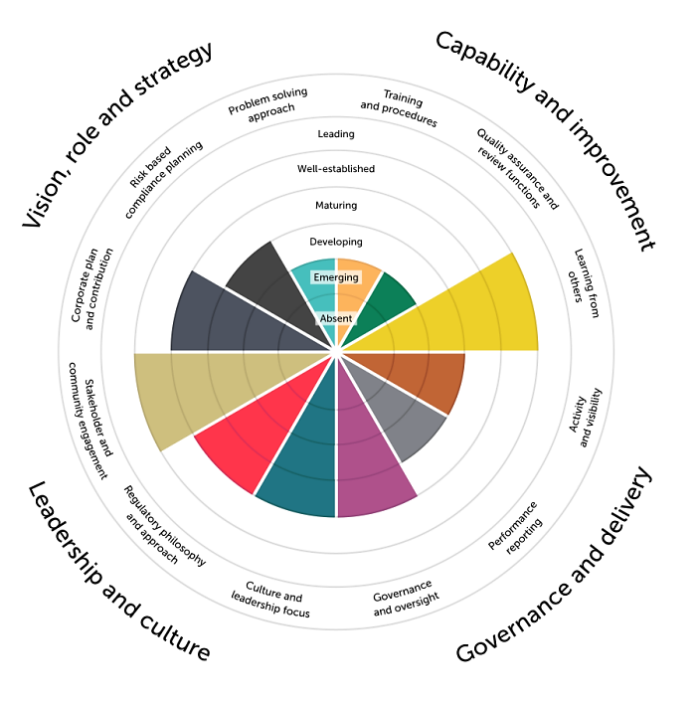

Vision, role and strategy

* Corporate plan and contribution: Maturing
* Risk-based compliance planning: Developing
* Problem-solving approach: Emerging

Capability and improvement

* Training and procedures: Emerging
* Quality assurance and review: Emerging
* Learning with others: Well-established

Governance and delivery

* Activity and visibility: Developing
* Performance reporting: Developing
* Governance and oversight: Maturing

Leadership and culture

* Culture and leadership focus: Maturing
* Regulatory philosophy and  
  approach: Maturing
* Stakeholder and Engagement: Well-established