Modern Regulator Improvement Tool

Summary of process and outcomes

March 2025

# Summary of process and outcomes

The Inspector-General of Water Compliance was established on 5 August 2021.

An immediate observation of the Inspector-General was the absence of a collaborative forum for sharing good water regulation practice at the senior executive leader level in the Murray-Darling Basin. Consequently, the first Regulatory Leaders Forum (RLF) was held on 18 October 2021. The purpose of the forum was largely to drive improvements in regulatory maturity across the Murray-Darling Basin; specifically, to:

* share lessons (noting specific opportunities in resources, technology, intelligence and behaviour)
* pursue consistency and consider harmonisation
* focus on building community trust and confidence in water compliance.

A review of compliance and enforcement across the Murray–Darling Basin prepared by Mr Des Pearson AO in June 2022 for the Inspector-General recommended:

*“That the Inspector-General of Water Compliance (IGWC), in consultation with the Regulatory Leaders Forum, work to improve collegiality of water compliance regulators by leveraging off existing opportunities to drive cultural shift and to recognise that this would deliver benefits to all regulators.”*

There is a broad recognition among governments, water users and academics about the need for strengthened water governance arrangements for the effective management of Basin water resources. The importance of adequate accountability in effective governance has also been emphasised, particularly as key principles of integrity, accountability and transparency are crucial to promote confidence in regulatory frameworks.

In early 2023, the RLF considered the benefits of undertaking self-assessment of regulatory maturity using the Modern Regulator Improvement Tool (MRIT) developed by the Australasian Environmental Law Enforcement and Regulators neTwork (AELERT). The MRIT is a qualitative self-assessment tool which requires and relies upon significant judgment in application. Whilst the tool is not able to be benchmarked between regulators, it does provide a way of self-assessing internal governance arrangements to provide a limited level of assurance regarding good regulatory practice in support of continuous improvement.

Further, in June 2023 the Inspector-General formed a strategic partnership with AELERT with a focus to customise the MRIT to make it fit-for-purpose for water regulators. The original MRIT is quite generic and therefore not as accurate or helpful for water regulators as a bespoke MRIT would be. The updated tool was completed in May 2024 and resulted in significant changes to the criteria within the *risk-based compliance planning* and *performance reporting in water regulation* attributes. The 2025 rating for these 2 attributes is therefore considered a new baseline rating. There were additional minor amendments to the criteria within the *water regulator’s* *capability function* (formerly *training and procedures)* and *culture and leadership* sections, as well as *learning with others*.

In late 2024, AELERT was working on a refresh of the generic MRIT, the results of which will inform the next self-assessment. We have employed the *MRIT – Customised for Water Regulatory Agencies (Version 5.0.1)* to complete this self-assessment. As such, several attribute headings are different from the original MRIT. These are identified in the visual outcomes on page 4.

The tool does not provide a full or complete assessment of organisational maturity. When interpreting results of the self-assessment, it is important to recognise that the tool reflects criteria which are focused on the activities and outcomes of front-line regulatory agencies, which in a number of instances is not relevant to the Inspector-General as a regulator with predominantly oversight powers. The MRIT, therefore, provides a guide to the Inspector-General regarding areas for, and a pathway to, improvement, rather than a complete maturity description of the organisation.

The MRIT six-point maturity assessment scale

Leading

Well-established

Maturing

Developing

Emerging

Absent

### This self-assessment measured against baseline results

Since the initial self-assessment finalised in January 2024, 4 criteria (*Culture and Leadership focus*, *Activity and visibility*, *Problem-solving approach* and, *Training and procedures*) have increased in maturity rating. All 4 increased a point higher within the six-point scale and are explored in more detail below.

This outcome reflects increases in organisational maturity and the strong continuous improvement culture embedded within all aspects of the Inspector-General’s management policies and structures.

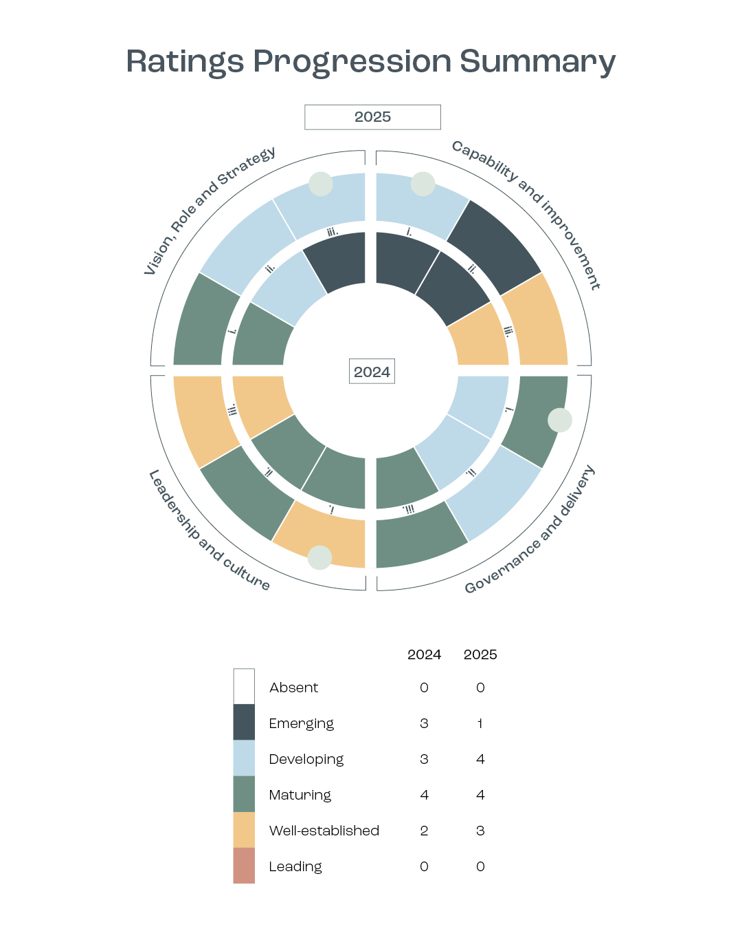

|  |  |  |
| --- | --- | --- |
| **Category** | **2024 Rating** | **2025 Rating** |
| **Vision, Role and Strategy** | | |
| i. Corporate plan and contribution | Maturing | Maturing |
| ii. Risk-based regulatory approach for the water sector[1] | (Developing) | Developing |
| iii. Problem-solving approach | Emerging | Developing |
| **Capability and improvement** | | |
| i. Water regulator’s capability function[2] | Emerging | Developing |
| ii. Quality assurance and review | Emerging | Emerging |
| iii. Learning with others | Well-established | Well-established |
| **Governance and delivery** | | |
| i. Activity and visibility | Developing | Maturing |
| ii. Performance reporting in water regulation[3] | (Developing) | Developing |
| iii. Governance and oversight | Maturing | Maturing |
| **Leadership and culture** | | |
| i. Culture and leadership focus | Maturing | Well-established |
| ii. Regulatory philosophy and approach | Maturing | Maturing |
| iii. Stakeholder and community engagement | Well-established | Well-established |

### Areas of Improvement in 2024-25

**Culture and leadership focus**

This attribute has been assessed as *well-established*, up one level from an assessed baseline rating of *maturing* in 2023-24. All criteria against this maturity rating are now observed, including clear articulation of the Inspector-General’s vision and values, opportunities for leadership development, open and transparent mechanisms for decision-making and clear processes for the discussion of staff performance and career progression. In an independent review of the Inspector-General completed in early 2024 by Mr Harris AO, it was observed that employing a single SES officer is inadequate for an organisation with the width and responsibilities such as the Inspector-General and noted this inadequate structure as a serious risk. In response to this observation, as well as others within the review, the Inspector-General successfully bid for additional funding and resources to establish a fit-for-purpose senior executive structure. This structure was successfully implemented as part of a broader growth and maturity project, which commenced July 2024.

**Activity and visibility**

An assessment rating of *maturing* is an increase of one level from the baseline rating of *developing* against this attribute. Visibility of the Inspector-General’s actions continues with the publication of regulatory outcomes and open dialogue with key stakeholders, in line with the value of transparency. An additional outcome of the increased funding and resourcing for the Inspector-General in 2024-25 was the establishment of a dedicated Inquiry team, and the launch of the Inspector-General’s first inquiry in October 2024. The Inspector-General now has the ability to utilise all functions and powers available under the *Water Act 2007 (Cth)* (the Water Act), an important milestone in this activity and visibility attribute.

**Problem solving approach**

The Inspector-General’s maturity rating in this area has progressed from *emerging* to *developing* as the team continues its iterative annual process of identifying annual and longer-term priorities. The evidence base from previous work is increasing, allowing for a more mature approach year-on-year.

**Training and procedures**

The IGWC maturity against this attribute has been raised from *emerging* to *developing* largely as a result of work done to formalise internal staff capability offerings, particularly in the regulatory space, and improvements to onboarding and induction training.

**Next Steps**

The Inspector-General will continue to utilise the MRIT to guide its approach to continuous improvement as a regulator, and across its broader functions. The next self-assessment, scheduled for 2025-26, will consider any additional amendments made to the *MRIT – Customised for Water Regulatory Agencies.* The Inspector-General remains committed to supporting regulatory uplift across the Murray-Darling Basin and supports other RLF members to continue their own regulatory maturity efforts.

# Rating

Vision, role and strategy

* Corporate plan and contribution: Maturing
* Risk-based compliance planning[4]: Developing
* Problem-solving approach: **Developing**

Capability and improvement

* Training and procedures[5]: **Developing**
* Quality assurance and review: Emerging
* Learning with others: Well-established

Governance and delivery

* Activity and visibility: **Maturing**
* Performance reporting[6]: Developing
* Governance and oversight: Maturing

Leadership and culture

* Culture and leadership focus: **Well-established**
* Regulatory philosophy and approach: Maturing
* Stakeholder and Community Engagement: Well-established

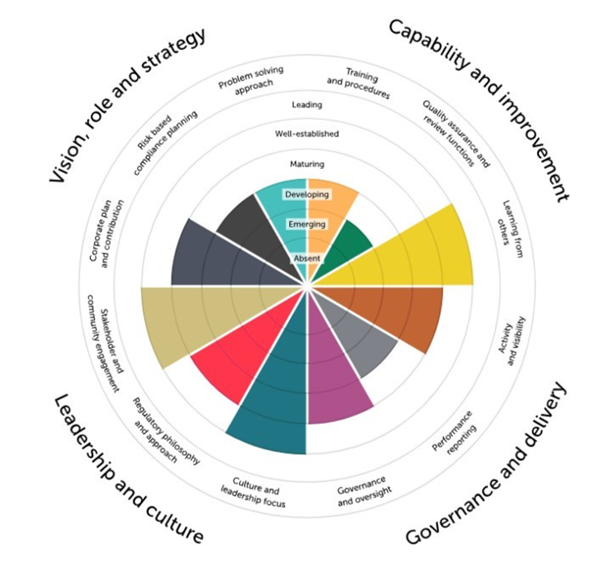

1. Formerly Risk-based compliance planning
2. Formerly Training and procedures
3. Formerly Performance reporting
4. *Risk-based regulatory approach for the water sector* in the MRIT for water
5. *Water regulator’s capability function* in the MRIT for water
6. *Performance reporting fin water regulation* in the MRIT for water