Annual Work Plan

2025-26

© Commonwealth of Australia 2025

**Ownership of intellectual property rights**

Unless otherwise noted, copyright (and any other intellectual property rights) in this publication is owned by the Commonwealth of Australia (referred to as the Commonwealth).

**Creative Commons licence**

All material in this publication is licensed under a Creative Commons Attribution 4.0 International Licence, except for content supplied by third parties, logos and the Commonwealth Coat of Arms.

Inquiries about the licence and any use of this document should be emailed to [copyright@dcceew.gov.au](mailto:copyright@dcceew.gov.au).



**Cataloguing data**

This publication (and any material sourced from it) should be attributed as: Inspector–General of Water Compliance 2025, Inspector–General of Water Compliance, Annual Work Plan 2025-26*,* the Australian Government, Canberra, August 2025. CC BY 4.0.

This publication is available at <https://www.igwc.gov.au/what-we-do/reviews-and-reports>

Inspector-General of Water Compliance  
GPO Box 3090 Canberra ACT 2601

**Disclaimer**

The Australian Government represented by the Inspector–General of Water Compliance, has exercised due care and skill in preparing and compiling the information and data in this publication. Notwithstanding, the Inspector–General of Water Compliance, the Australian Government’s employees disclaim all liability, including liability for negligence and for any loss, damage, injury, expense or cost incurred by any person as a result of accessing, using or relying on any of the information or data in this publication to the maximum extent permitted by law.

**Acknowledgement of the Traditional Owners of the Murray–Darling Basin**

We pay our respects to the Traditional Owners and their Nations of the Murray-Darling Basin. We acknowledge their deep cultural, social, environmental, spiritual and economic connection to their lands and waters.

Aboriginal people should be aware that this publication may contain images, names or quotations of deceased persons.

**Accessibility**

The document and information is available in accessible formats. On some occasions the highly technical nature of the document means that we cannot make some sections fully accessible. If you encounter accessibility problems or the document is in a format that you cannot access, please contact us at [contact@igwc.gov.au](mailto:contact@igwc.gov.au).

# Foreword by the Inspector–General

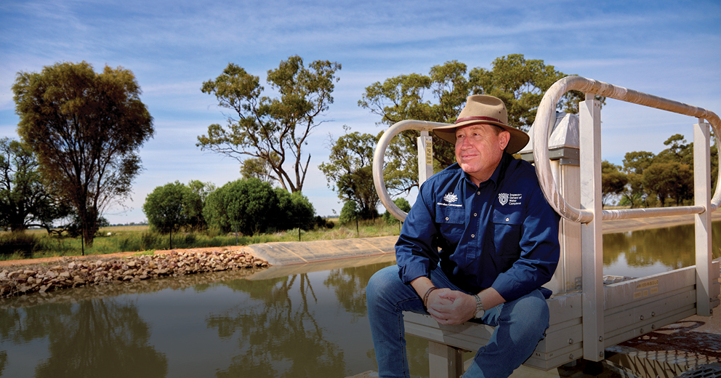

I’m delighted, and very proud, to present the 2025-26 Annual Work Plan for the Inspector–General of Water Compliance. Delighted, because it again shows year-on-year growth in the capability, scope, reach and influence of our work and the office supporting me – boosted by a significant investment in the Inspector–General of Water Compliance by the Australian Government in the 2024-25 Budget. Proud, because I’m delivering this work plan at the start of my second tenure (two terms being the maximum allowed) serving as the Inspector–General of Water Compliance having been reappointed in March 2025 until 4 August 2029. I am immensely honoured to again serve the Australian public in the role, and immensely proud to lead a highly skilled, capable, and committed team of professionals in the office supporting me.

This work plan is being released against the backdrop of two stark contrasts across the Murray-Darling Basin (Basin). Record flooding in April 2025 across the far North West of the Basin, and the onset of drought in its South West, affecting large parts of Victoria and South Australia. Those dry conditions are forecast to be less than favourable during the initial period of this 2025-26 work plan, influenced by unpredictable dry weather patterns affecting large parts of the nation overall.

This work plan is also being delivered during some critically important junctures for non-urban metering across the Basin. This includes the June 2025 deadline for AS4747 meter compliance within the Murray-Darling Compliance Compact.

Water take, and the accurate and consistent measurement and reporting across different forms of take, is never more critical (and top-of-mind across communities) than in times of drought. As conditions worsen and water becomes scarcer, those communities in direct threat inevitably ask, “where did all the water go?”

The availability of water is a fundamental challenge to life and prosperity not only across the Basin, it also affects the nation – exacerbating community and environmental stressors amid drought. Managing water resources, and the public interest in them, becomes acute during drought. The integrity of measurement of take and accurate water accounting comes into question more so in prolonged dry periods - driving the need for high levels of accountability across the Basin.

Drought intensifies the already complex and detailed work of water operators and regulators as their work becomes critical in maintaining the trust and confidence of community and governments. The need to oversee the regulators to ensure transparent and firm compliance with allocation comes into sharper focus in order to maintain community confidence during drought. Community expectation is heightened that those who do the wrong thing are held to account by the relevant regulators to ensure deterrence for offenders and fairness to those that remain compliant.

It should not take drought to intensify the focus of transparency and accountability to ensure trust and confidence in how water is being managed. Our work and focus aren’t seasonal, nor is it driven by current affairs and headlines. It is driven by an expectation and commitment that the work of the Inspector–General of Water Compliance:

* Ensure it’s lawful.
* Ensure it’s visible.
* Do it better.
* Make it better.

Among our outcomes and work from the previous financial year, we’ve continued to plan for and deliver increased, improved and effective capacity and capability for the Inspector–General of Water Compliance by the end of my first tenure. This has allowed me to better prepare to exercise the full suite of tools and powers afforded to the role of the Inspector–General, including inquiry, audit, enforcement, and investigation. This will ensure we meet the 2025-26 annual work plan and will assist us in supporting the successful delivery of a Basin Plan.



**The Hon. Troy Grant**

Inspector–General of Water Compliance

# The Work Plan

In conformity with section 215E of the *Water Act 2007* (Cth) (Water Act), the Inspector–General must prepare a work plan for each financial year. The Inspector–General must publish the work plan for a financial year on the Inspector–General’s website as soon as practicable after it is finalised.

## The role of the Inspector–General

The Inspector–General of Water Compliance’s statutory functions are set out in the Water Act. The independent Inspector–General broadly has the roles of:

* Monitoring and overseeing the performance of functions and exercise of powers by agencies of the Commonwealth.
* Monitoring and overseeing relevant Commonwealth, and Basin State and territory government agencies’ performance in the management of Basin water resources.
* Enforcing compliance with Commonwealth laws that regulate the management of Basin water resources and the provision of water markets information.
* Engaging with the Australian community on the management of Basin water resources.

## Developing the 2025-26 Work Plan

The work plan responds to current expectations and emerging risks and opportunities for improved water management in the Murray-Darling Basin (the Basin). A range of factors are considered to set the work program, including:

* the statutory role of the Inspector–General
* the Minister’s Statement of Expectations
* the Inspector–General’s Strategic Plan 2023-26
* what community groups and stakeholders have told the Inspector–General and their office
* analysis of the performance of functions and exercise of powers by Commonwealth agencies in relation to the Water Act and the Basin Plan, and analysis of Basin State performance against obligations under *the Basin Plan 2012* (the Basin Plan), Water Resource Plans (WRPs), and intergovernmental agreements
* review of strategic risks to Basin Plan implementation
* analysis of data and information demonstrating the level of compliance withthe Basin Plan and water management arrangements in each state and territory
* previous monitoring and oversight findings of governments’ commitments to Basin Plan implementation
* projects and activities currently underway within the Inspector–General, as well as other agencies responsible for the delivery of the Basin Plan
* the current state of the Basin Plan, including the 2026 Basin Plan Review, and potential future risks and opportunities arising from such activities.

## The anticipated operating context in 2025-26

The Inspector–General acknowledges that climate, changing demographics, new technologies and changing social values all have an impact on outcomes in the Basin. This broad range of influences increases the complexity of the operating environment for those involved in water management in the Basin.

Agility and flexibility remain crucial to address emerging priorities under this changing operating context of water management in the Basin. Key contextual factors for the development of the 2025-26 Work Plan of the Inspector–General of Water Compliance are:

* The Inspector–General identified 2 priorities in the 2024-25 Annual Work Plan, Environmental Outcomes, and the Inquiry into the Northern Basin Toolkit, and some of this work will continue into 2025-26.
* The Murray-Darling Basin Authority (MDBA) conducts a Basin Plan Evaluation every 5 years. The 2025 Basin Plan Evaluation was published in July 2025 and will inform the 10-yearly review of the Basin Plan in 2026. This 10-yearly review is a requirement under the Water Act and will focus on 4 key themes:
  1. Climate change
  2. First Nations
  3. Sustainable water limits
  4. Regulatory design[1]

The Inspector–General’s work in 2025-26, and in previous years, will provide key input into these evaluation and review processes.

* There will be a third independent Water for the Environment Special Account (WESA) review in 2025 that will consider funding and progress to the recovery of the 450GL of additional environmental water. The review process will cover several important areas:
  1. evaluate progress toward environmental recovery, informing recommendations on the requirement of additional action to meet environmental objectives
  2. assess whether WESA funding is sufficient to achieving its goals
  3. inform future policies and programs related to the Basin
  4. contribute to greater transparency and accountability in water management by publicly reporting on progress and challenges.

The WESA review will provide important evidence to inform the work of the Inspector–General during the year.

* A review of the role of the Inspector–General will occur in 2025-26 under section 215Z of the Water Act. The Inspector–General is looking forward to engaging with the review.
* The 2024-25 Budget allocated $28.6 million to the Inspector–General over 4 years. In 2024-25, the Inspector–General used this funding to build dedicated inquiry and legal teams and launch their first inquiry. The Inspector–General will continue to build internal capability and continue their important work under the oversight function.

## Review of the Work Plan

Section 215F of the Water Act requires the Inspector–General to undertake a review of the work plan at least once during the financial year.

Following a review of the work plan, the Inspector–General may amend the work plan to respond to emerging areas of risk. Where the work plan is amended, it will be published on the website at www.igwc.gov.au.

A body of water in a field at sunset with the base of a windmill.


## Snapshot

### Values

* Integrity
* Accountability
* Transparency

### Strategic Plan Outcomes

1. Ensure it’s lawful
2. Ensure it’s visible
3. Do it better
4. Make it better

### Work Plan Priority

* Holding responsible Commonwealth agencies and Basin States accountable on Basin Plan implementation

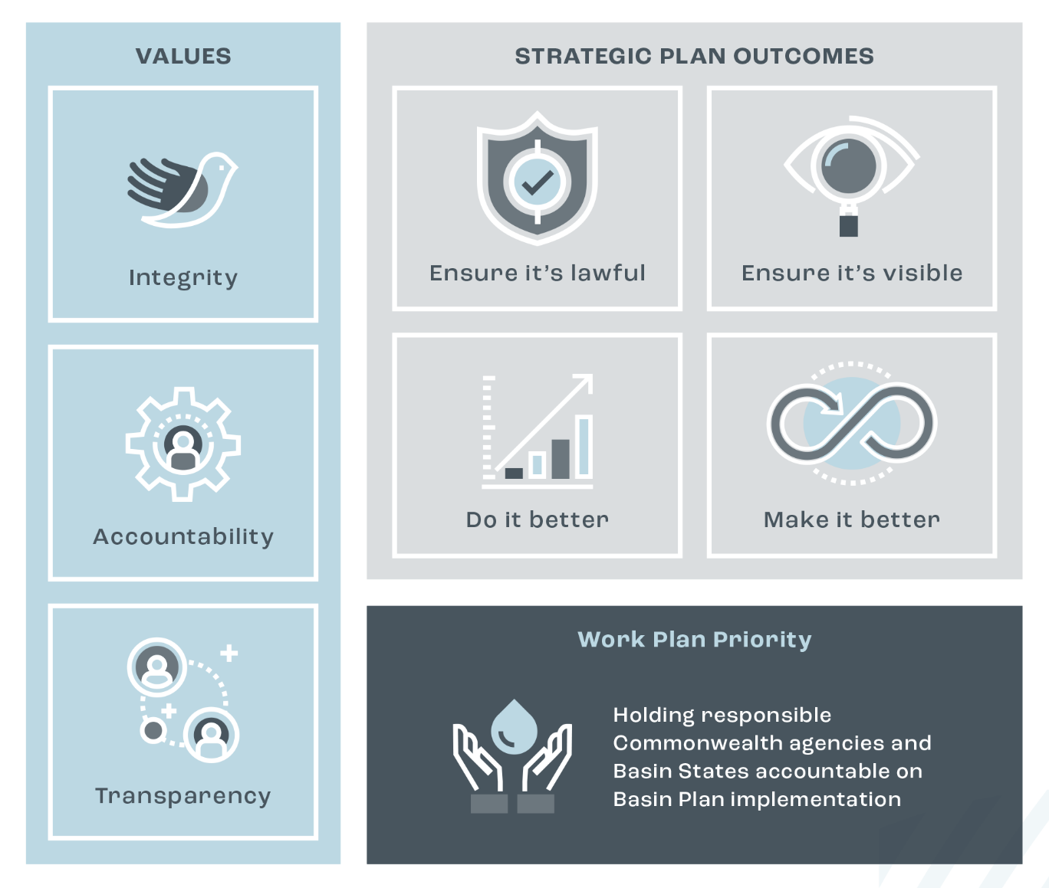

## A tree next to a body of water.

## 2025-26 Priority

**Holding responsible Commonwealth agencies and Basin States accountable on Basin Plan implementation**

### Why it’s a priority

The deadline for the implementation of multiple components of the Basin Plan was extended to the end of 2026 via the *Water Amendment (Restoring Our Rivers) Act 2023* (Restoring Our Rivers Act). With this new deadline approaching, the effective implementation of activities by responsible agencies is crucial to delivering the Basin Plan’s intended outcomes.

### The role of the Inspector–General

The Inspector–General is responsible for overseeing Commonwealth and Basin State water management agencies' performance in relation to the Basin Plan under section 215C of the Water Act*.* This includes the oversight of the implementation of commitments in intergovernmental agreements that support the effective operation of the Water Act and delivery of the Basin Plan, as well as Water Resource Plans (WRPs).

### Strategic Plan Outcomes

2. Ensure it's visible

3. Do it better

## What the Inspector–General will do

|  |  |
| --- | --- |
| Activity | Details |
| Inquiry – Northern Basin Toolkit | Deliver a report on the Inquiry into the Northern Basin Toolkit. The terms of reference for the inquiry, commenced in October 2024, allow for a comprehensive review of all aspects of the Toolkit program, including implementation, design, governance, expenditure, effectiveness and outcomes. |
| Audit – sustainable use and management of groundwater resources in NSW | Deliver an audit report into the sustainable use and management of groundwater resources in the Macquarie-Castlereagh water resource plan area. The audit will focus on the rules and commitments made in water resource plan addressing sections 10.18, 10.19 and 10.20 of the Basin Plan. The audit report will determine whether rules are being implemented to ensure the integrity of groundwater systems is protected and that environmental watering requirements are not being compromised. |
| Audit – Planning for environmental watering | Deliver an audit report into the implementation of rules and commitments made in the NSW Intersecting Streams and Victorian Murray water resource plans when planning for environmental watering. The audit focusses on sections 10.26, 10.27 and 10.28 of the Basin Plan and aims to provide visibility on how environmental watering is planned for in water resource plan areas that contain significant wetlands. |
| Compliance Compact review | Complete a stocktake of the status of implementation of commitments under the *Murray-Darling Basin Plan Compliance Compact* (Compliance Compact), producing an evidence base on Compliance Compact implementation and allowing for consideration of further compliance priorities to support Basin Plan outcomes once the Compact concludes at the end of 2025. |
| Compliance performance reporting | Establish foundations for consistent annual reporting on water compliance performance and outcomes by Basin States, addressing a current gap in visibility from a Basin-wide perspective. Publish an annual compliance performance and outcomes report to provide transparency on Basin State compliance performance and outcomes to support Basin Plan implementation. |

1. [Roadmap to the 2026 Basin Plan Review | Murray–Darling Basin Authority](https://www.mdba.gov.au/publications-and-data/publications/roadmap-2026-basin-plan-review-0)