Sustainable Diversion Limit Compliance Report

for 2023-2024

Inspector–General of Water Compliance

**August 2025**

© Commonwealth of Australia 2025

**Ownership of intellectual property rights**

Unless otherwise noted, copyright (and any other intellectual property rights) in this publication is owned by the Commonwealth of Australia (referred to as the Commonwealth).

**Creative Commons licence**

All material in this publication is licensed under a Creative Commons Attribution 4.0 International Licence, except for content supplied by third parties, logos and the Commonwealth Coat of Arms.

Inquiries about the licence and any use of this document should be emailed to [copyright@dcceew.gov.au](mailto:copyright@dcceew.gov.au).



**Cataloguing data**

This publication (and any material sourced from it) should be attributed as: Inspector–General of Water Compliance 2025, Sustainable Diversion Limit Compliance Statement 2023-2024, the Australian Government, Canberra, August 2025. CC BY 4.0.

This publication is available at <https://www.igwc.gov.au/reviews-reports>

Inspector–General of Water Compliance  
GPO Box 3090 Canberra ACT 2601

**Disclaimer**

The Australian Government represented by the Inspector–General of Water Compliance, has exercised due care and skill in preparing and compiling the information and data in this publication. Notwithstanding, the Inspector–General of Water Compliance, the Australian Government’s employees disclaim all liability, including liability for negligence and for any loss, damage, injury, expense or cost incurred by any person as a result of accessing, using or relying on any of the information or data in this publication to the maximum extent permitted by law.

**Acknowledgement of the Traditional Owners of the Murray–Darling Basin**

We pay our respects to the Traditional Owners and their Nations of the Murray–Darling Basin. We acknowledge their deep cultural, social, environmental, spiritual and economic connection to their lands and waters.

Aboriginal people should be aware that this publication may contain images, names or quotations of deceased persons.

**Accessibility**

The document and information is available in accessible formats. On some occasions the highly technical nature of the document means that we cannot make some sections fully accessible. If you encounter accessibility problems or the document is in a format that you cannot access, please contact us at [contact@igwc.gov.au](mailto:contact@igwc.gov.au).

# Table of Contents

Table of Contents 3

Introduction 4

Purpose of the Compliance Statement 4

Legislative and Regulatory Framework 4

Scope of the Compliance Statement 4

Assessment Findings 5

Areas assessed for SDL Compliance in 2023-2024 5

Uncertainty in Modelled Actual Take 11

Trends in SDL Compliance 12

Climatic context 12

SDL Trends since implementation 12

Water Use across the Basin 19

Understanding SDL Compliance 22

Sustainable Diversion Limits 22

Water Resource Plans 22

IGWC’s role in SDL Compliance 23

The SDL Compliance Advisory Panel 23

Calculation of the Cumulative Balance for SDL Compliance 24

One-off adjustment 24

Baseline Diversion Limits and changes to SDL over time 25

Sustainable Diversion Limits and the 2026 Basin Plan Review 25

Assessment Process 26

Sources of compliance data 26

Timely provision of SDL data 26

What is meant by compliant or non-compliant? 27

Actions that can be taken when non-compliance is found 28

Reasonable Excuse 28

Potential impact of delays in buybacks on SDL compliance 29

Accounts 30

Surface Water Accounts 30

Groundwater Accounts 32

Glossary 39

# Introduction

### Purpose of the Compliance Statement

The Sustainable Diversion Limit (SDL) Compliance Statement (Statement) and Compliance Report (Report) have been prepared by the Inspector–General of Water Compliance (IGWC) to assess and report on whether Basin States have been compliant with SDLs as required under the *Basin Plan 2012* (the Plan) for the 2023–2024 water year.

The IGWC is an independent statutory position established in 2021 under the *Water Act 2007* (the Act), with powers to monitor, investigate, and enforce SDL compliance across the Murray–Darling Basin. A key role of the IGWC is to establish and publicly report on annual SDL compliance, providing a transparent and evidence-based account of whether water take has remained within the limits designed to protect the Basin’s rivers, wetlands, communities, and ecosystems. The IGWC is responsible for issuing an annual compliance statement and determining appropriate regulatory responses where non-compliance is identified.

The Statement and Report draw on verified data and consistent assessment methods to promote transparency, accountability, and public confidence in the management of the Basin’s shared water resources.

### Legislative and Regulatory Framework

SDL compliance is underpinned by the Act and in Chapter 6 of the Plan. These provisions define how SDLs are applied to surface water and groundwater resource units across the Basin and establish how compliance is measured.

The IGWC’s compliance determinations are also guided by the [*Sustainable Diversion Limit Compliance Framework*](https://www.igwc.gov.au/sites/default/files/2023-10/sdl-compliance-framework.pdf)published by the IGWC in October 2023. This non-statutory framework sets out principles and processes that ensures assessments are conducted transparently, consistently and fairly across jurisdictions.

### Scope of the Compliance Statement

The Statement and Report covers the 2023–2024 water year, from 1 July 2023 to 30 June 2024, and applies to all SDL resource units where an accredited water resource plan was in place for the entire water year.

As of the start of the 2023–2024 water year, seven NSW surface water WRPs have been accredited; however, none are yet subject to SDL compliance assessment for this period. Additionally, although 23 groundwater SDL resource units across 5 water resource plans in NSW are assessable, 19 SDL resource units across 6 NSW water resource plans are excluded from compliance assessment in 2023–2024. The compliance status is based on SDL accounting data prepared by the Basin States and reconciled by the Murray–Darling Basin Authority (MDBA/the Authority) as outlined under section 71 of the Act.

# Assessment Findings

**Compliance with Sustainable Diversion Limits**

**All 78 SDL resource units assessed for the 2023–2024 water accounting year were found to be compliant.**

This SDL compliance assessment includes 19 surface water and 59 groundwater SDL resource units listed on the Registers of Take. These are managed under 18 water resource plans across all Basin States, as shown in Table 1 (2023-24 assessable units). All assessed units were fully compliant, with no SDL excess recorded in any jurisdiction.

As there were no SDL resource units in excess of the SDL compliance threshold, there were no claims of a reasonable excuse or action plans provided by Basin States to the IGWC. This outcome of IGWC’s SDL compliance assessment confirm the Basin States’ self-assessments, as required under section 71(1)(g) of the *Water Act* (2007).

Three groundwater SDL resource units were found to have cumulative total takes equal to the cumulative permitted take since 2019: Warrumbungle (NSW), Sediments above the Great Artesian Basin: Warrego-Paroo-Nebine (QLD) and Warrego Alluvium (QLD). These are relatively small volume, unmetered regions, where the water use is predominantly for stock and domestic use.

### Areas assessed for SDL Compliance in 2023-2024

In total there are 109 SDL resource units (29 surface water and 80 groundwater), managed within 33 water resource plan areas (14 surface water, 14 groundwater and 5 shared) across the Basin States. These resource units are shown in Figures 1 and 2.

For the 2023-2024 water accounting year, there were 18 accredited water resource plans for the full water year (5 surface water, 8 groundwater and 5 shared) that encompassed 19 surface water and 59 groundwater SDL Resource Units that could be assessed for SDL compliance. The IGWC welcomes the recent accreditation of several water resource plans from NSW (Figure 3). A total of 23 new groundwater SDL Resource Units from NSW are being assessed for the first time in the 2023-2024 Compliance Statement (owing to the accreditation of the Darling Alluvium, Macquarie-Castlereagh Alluvium, NSW Border Rivers Alluvium, NSW MDB Fractured Rock and NSW MDB Porous Rock water resource plans).

As noted previously, SDL compliance can only be assessed for those surface water and groundwater resource units which have had an accredited WRP for the entire water accounting year.

Compared to the 2022-2023 Compliance Statement, the 2023-2024 water accounting year has no new surface water SDL Resource Units available for compliance assessment, meaning NSW still has no surface water areas assessed, six years after the original due date for water resource plan accreditation and full SDL compliance was meant to be in place.

A total of 7 new surface water and 4 new groundwater water resource plans were accredited during the 2023-2024 water year and will become available for compliance assessment for the 2024-2025 period. A total of 4 water resource plans, all from NSW, are still not accredited (Gwydir Alluvium and Namoi Alluvium groundwater water resource plans and Gwydir and Namoi surface water resource plans).

A total of 31 resource units, all in NSW, could not be assessed due to water resource plans not being accredited for the entire water accounting period.

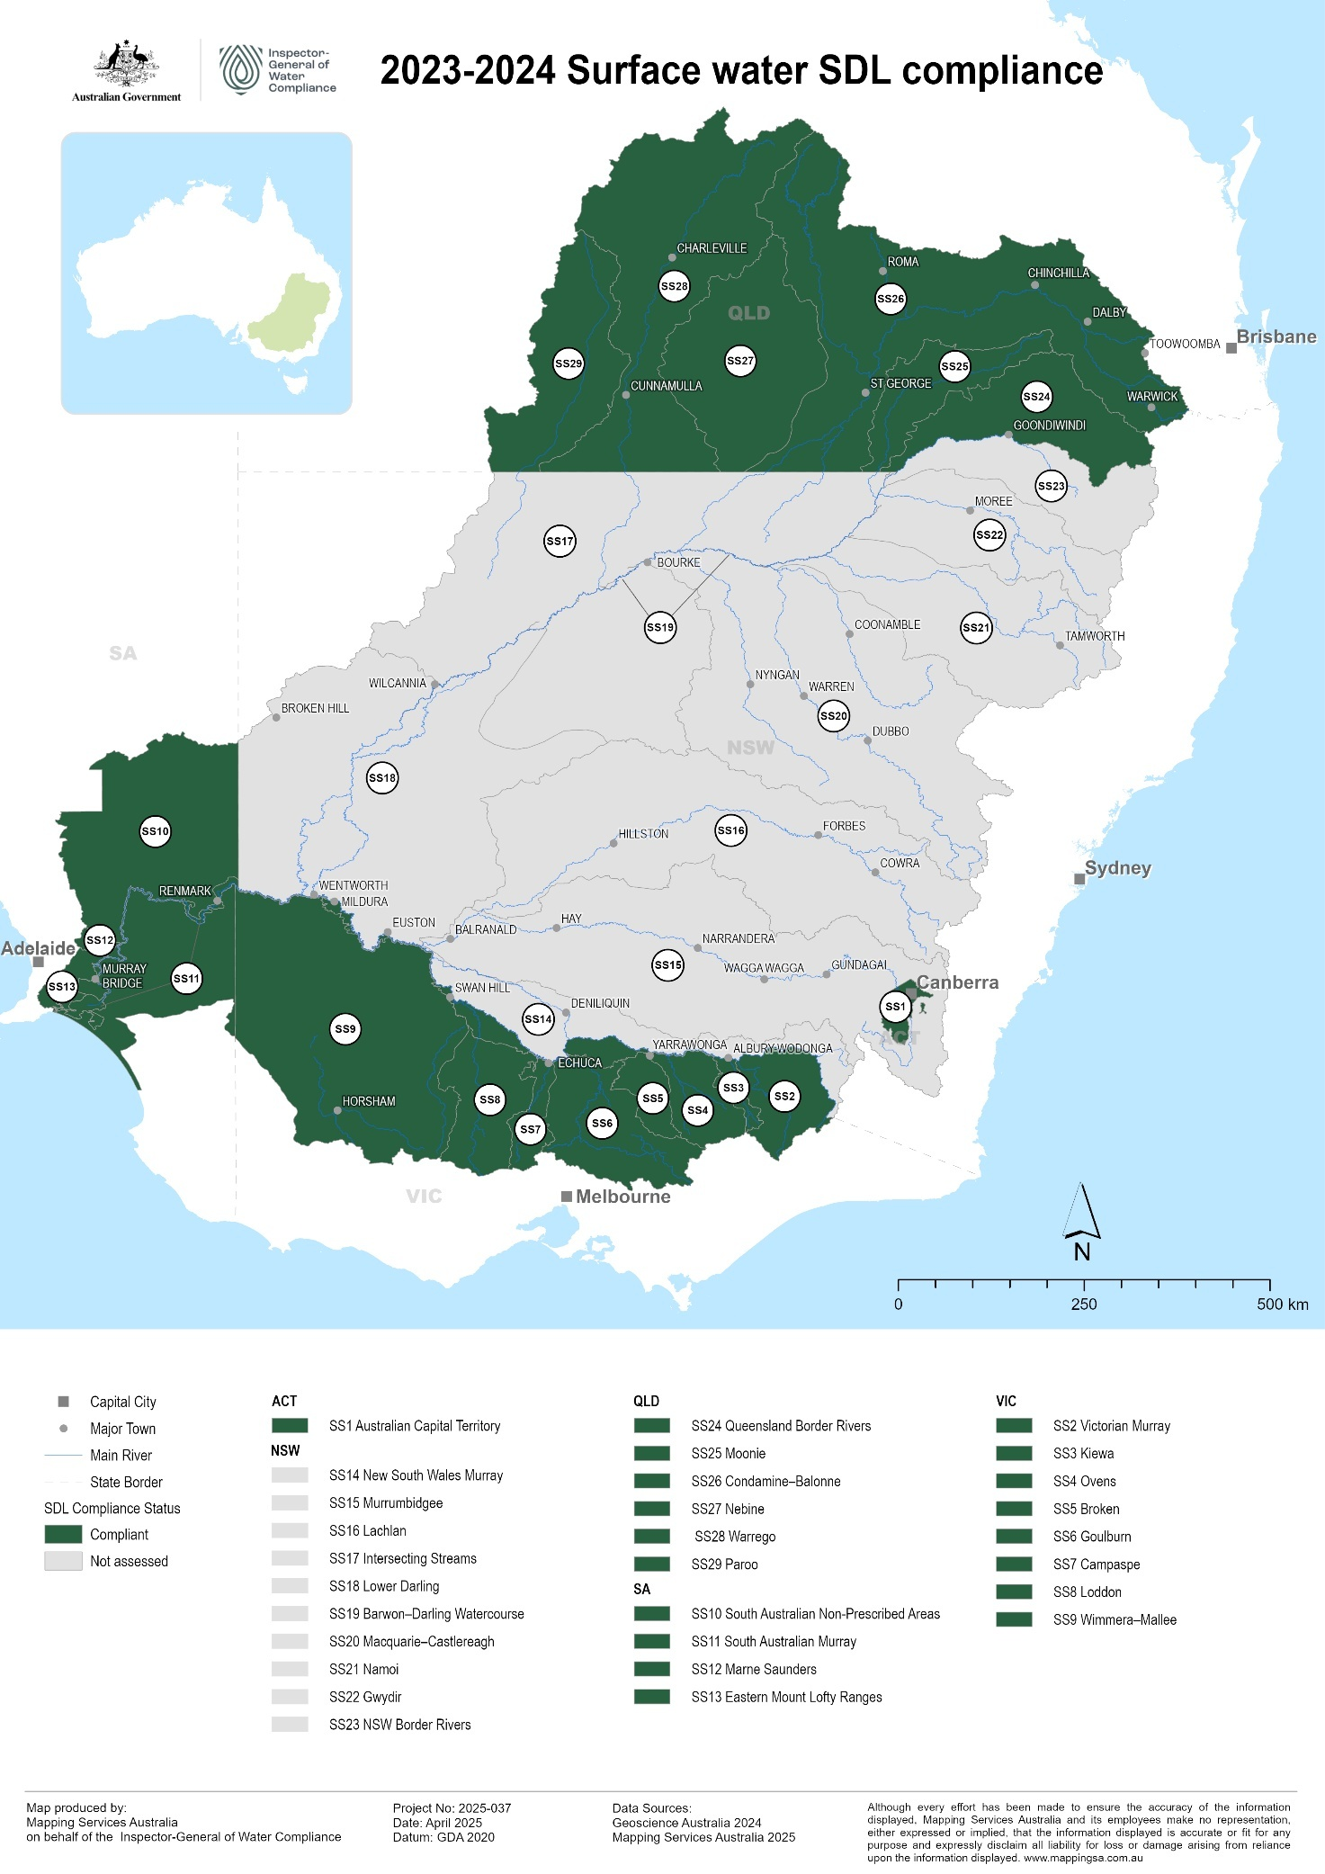

**Figure 1:** Compliance status of surface water SDL resource units across the MDB.

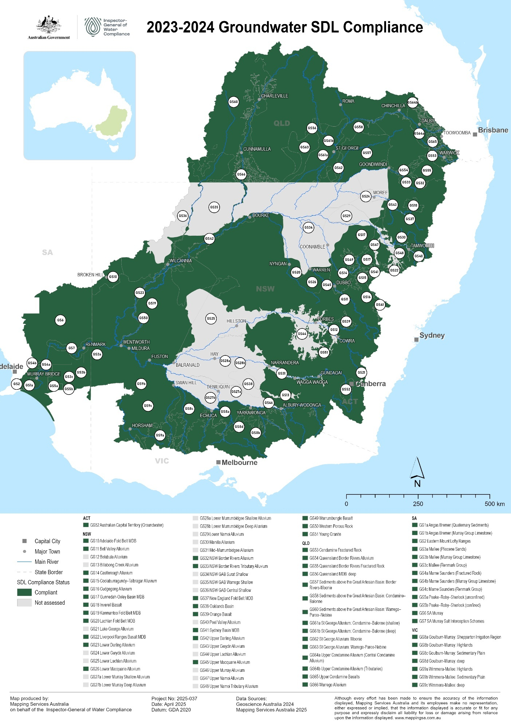

**Figure 2:**Compliance status of groundwater SDL resource units across the MDB.

Note: While all deeper SDL Resource Units within the NSW MDB Fractured Rock and Porous Rock water resource plan areas are assessed as compliant, some parts are not shown on the groundwater map due to being overlain by other groundwater units that cannot be assessed; together, these two plan areas cover the entire NSW portion of the Basin.

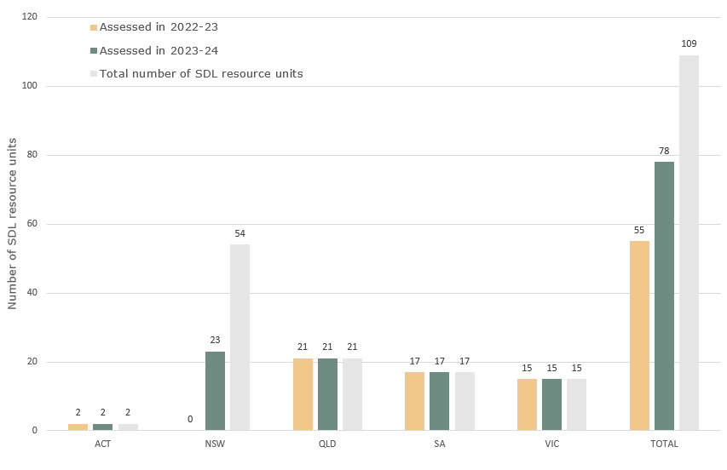

**Figure 3:** Number of SDL resource units (surface water and groundwater) assessed for compliance in 2022-2023 and 2023-2024, compared to the total number of resource units.

**Table 1**: List of water resource plans, date of accreditation and Compliance Assessment status

|  |  |  |  |  |  |  |  |
| --- | --- | --- | --- | --- | --- | --- | --- |
| **State** | **WRP area** | **Resource Type** | **Status** | **Accreditation Date** | **2022-23 assessed?**  **(Last Year)** | **2023-24 assessed?**  **(This Year)** | **2024-25 assessable?**  **(Next Year)** |
| ACT | Australian Capital Territory (groundwater) | Groundwater | Operational | 30-Jun-20 | Yes | Yes | Yes |
| NSW | Darling Alluvium | Groundwater | Operational | 28-Jun-23 | No | Yes | Yes |
| NSW | Gwydir Alluvium | Groundwater | Withdrawn | n/a | No | No | No |
| NSW | Lachlan Alluvium | Groundwater | Operational | 22-Aug-23 | No | No | Yes |
| NSW | Macquarie–Castlereagh Alluvium | Groundwater | Operational | 24-Dec-22 | No | Yes | Yes |
| NSW | Murray Alluvium | Groundwater | Operational | 22-Aug-23 | No | No | Yes |
| NSW | Murrumbidgee Alluvium | Groundwater | Operational | 09-Nov-23 | No | No | Yes |
| NSW | Namoi Alluvium | Groundwater | Withdrawn | n/a | No | No | No |
| NSW | NSW Border Rivers Alluvium | Groundwater | Operational | 24-Sep-22 | No | Yes | Yes |
| NSW | NSW Great Artesian Basin Shallow | Groundwater | Operational | 09-Dec-23 | No | No | Yes |
| NSW | NSW Murray–Darling Basin Fractured Rock | Groundwater | Operational | 22-Nov-22 | No | Yes | Yes |
| NSW | NSW Murray–Darling Basin Porous Rock | Groundwater | Operational | 24-Dec-22 | No | Yes | Yes |
| VIC | Goulburn–Murray | Groundwater | Operational | 13-Jun-20 | Yes | Yes | Yes |
| VIC | Wimmera–Mallee (groundwater) | Groundwater | Operational | 21-Sep-19 | Yes | Yes | Yes |

|  |  |  |  |  |  |  |  |
| --- | --- | --- | --- | --- | --- | --- | --- |
| **State** | **WRP area** | **Resource Type** | **Status** | **Accreditation Date** | **2022-23 assessed?**  **(Last Year)** | **2023-24 assessed?**  **(This Year)** | **2024-25 assessable?**  **(Next Year)** |
| QLD | Border Rivers Moonie | Groundwater & surface water | Operational | 24-Sep-19 | Yes | Yes | Yes |
| QLD | Condamine–Balonne | Groundwater & surface water | Operational | 21-Sep-19 | Yes | Yes | Yes |
| QLD | Warrego–Paroo–Nebine | Groundwater & surface water | Operational | 28-Jun-17 | Yes | Yes | Yes |
| SA | Eastern Mount Lofty Ranges | Groundwater & surface water | Operational | 16-Nov-19 | Yes | Yes | Yes |
| SA | Murray Region | Groundwater & surface water | Operational | 22-Aug-19 | Yes | Yes | Yes |
| ACT | Australian Capital Territory (surface water) | Surface water | Operational | 30-Jun-20 | Yes | Yes | Yes |
| NSW | Barwon–Darling Watercourse | Surface water | Operational | 19-Jun-24 | No | No | Yes |
| NSW | Gwydir | Surface water | Withdrawn | n/a | No | No | No |
| NSW | Intersecting streams | Surface water | Operational | 09-Nov-23 | No | No | Yes |
| NSW | Lachlan | Surface water | Operational | 18-May-24 | No | No | Yes |
| NSW | Macquarie–Castlereagh | Surface water | Operational | 19-Jun-24 | No | No | Yes |
| NSW | Murrumbidgee | Surface water | Operational | 29-Feb-24 | No | No | Yes |
| NSW | Namoi | Surface water | Withdrawn | n/a | No | No | No |
| NSW | NSW Border Rivers | Surface water | Operational | 02-May-24 | No | No | Yes |
| NSW | NSW Murray and Lower Darling | Surface water | Operational | 18-May-24 | No | No | Yes |
| SA | South Australian River Murray | Surface water | Operational | 16-Nov-19 | Yes | Yes | Yes |
| VIC | Northern Victoria | Surface water | Operational | 13-Jun-20 | Yes | Yes | Yes |
| VIC | Victorian Murray | Surface water | Operational | 13-Jun-20 | Yes | Yes | Yes |
| VIC | Wimmera–Mallee (surface water) | Surface water | Operational | 24-Sep-19 | Yes | Yes | Yes |

### Uncertainty in Modelled Actual Take

There is a reliance in the Murray–Darling Basin on modelled take for some aspects of SDL reporting. In particular, for floodplain harvesting and runoff (farm) dams. Sometimes this is necessary, and sometimes methods can mature over time.

There are risks around the uncertainties in the modelling used by Basin States to determine actual water take particularly for floodplain harvesting and runoff dams. Modelled estimates for floodplain harvesting, and runoff dams carry uncertainty. Limited transparency around modelled figures, particularly for floodplain harvesting makes it difficult to examine how these modelled figures are calculated and lowers confidence in their accuracy and consistency. This potential inaccuracy identified in Basin States reporting indicates a risk to the effective assessment of SDL compliance.

Accredited water resource plans allow for Basin State jurisdictions to quote multi-year average values for actual take, rather than estimates that have been tailored to the year in question. The use of outdated data and annual averages to inform the Registers of Take may underestimate or overestimate current water take for both floodplain harvesting and runoff dams and may not represent the actual volume of water take on ground.

The accredited water resource plans also allow for the Annual Permitted Take (APT) and the Annual Actual Take (AAT) to be the same number (ie APT = AAT) for these modelled components of AAT. As a result of the design, the reported AAT for SDL compliance can be equal to the APT from the same model, ensuring that a variance cannot occur under this framework. This renders Commonwealth SDL accounting and compliance as ineffective tools for managing these components of take under the Plan.

While some progress has been made in licensing and metering floodplain harvesting, the delayed incorporation of improved measurement data into SDL accounting and reporting has resulted in a disconnect between reported AAT and current on-ground practices. This gap undermines the reliability of SDL compliance assessments. It is important to note that inaccuracy can either under-represent take or alternatively over-represent take. Both are undesirable.

Although reforms were intended to enable measurement of actual take, implementation is occurring at a slow rate. At present, there is no defined pathway or timeline for transitioning floodplain harvesting from modelled to metered annual actual take. Addressing this issue is a matter of importance.

# Trends in SDL Compliance

The focus on SDL compliance trends analyses in this section of the report echoes the IGWC’s [Strategic Plan 2023-2026](https://www.igwc.gov.au/sites/default/files/2023-08/lgwc-strategic-plan-2023-2026.pdf), to achieve transparency in the management of water resources and to draw attention to community concerns about water use in the Basin.

Analysis is part of the IGWCs evidence-based tool kit to assess compliance systems and evaluate if the Plan outcomes are being delivered.

Moving forward, active compliance monitoring will remain a fundamental component of the SDL compliance assessment framework, ensuring continuous transparency, timely identification of compliance issues, and maintaining the highest standards of accountability throughout the process.

### Climatic context

Between 2020 and 2022, Australia experienced a three year (“triple – dip”) La Niña event, which brought higher than average rainfall to much of the Murray–Darling Basin, with intense rainfall contributing to widespread flooding in river systems. The Basin experienced its wettest October and Spring season on record in 2022.

Preceding the La Niña events, the South-East of Australia experienced an intense drought called the Tinderbox Drought from 2017 to 2019. This drought impacted stream flow and groundwater recharge across catchments, and water security for Basin communities. As a result, the La Niña recovery was still much slower to achieve needed aquifer and catchment recharge given the antecedent conditions from the extended Tinderbox drought period.

Throughout much of 2024, weather patterns across southern Australia were dominated by slow-moving high-pressure systems which resulted in persistent warm and dry conditions. This is presently resulting in below average streamflow across much of southern Australia. Long-range forecasts suggest that these conditions are likely to continue into the southern hemisphere winter.

In contrast, the northern Basin has experienced significant flooding on the Basin margins, with significantly increased flows expected along the western catchments.

SDL accounting commenced on 1 July 2019, and this report examines trends over the subsequent five years to 30 June 2024. Overall, most SDL resource units appear to be trending toward higher water balance credits. This likely reflects the relatively dry drought period, during which water take was reduced, followed by a three-year, wetter-than-average period contributing to the accumulation of credits in subsequent years.

### SDL Trends since implementation

The IGWC takes an active approach to compliance monitoring, with the aim of identifying SDL resource units that risk SDL non-compliance before it occurs; case studies of such are presented below. Data has been collected and analysed since 2019-2020, the period at which point SDL compliance was originally meant to be enforced. While several of these case studies are not subject to compliance assessment until the 2024-2025 water accounting year, and their water accounts will be subject to an initial one-off adjustment, they serve to illustrate how the IGWC utilises data and identifies risk. For interpretation of graphs presented in this section, please see Figures 4 and 5 of this report.

Water take under all water resource plans was examined for the entire 2023-2024 water accounting year even though 15 of the 33 WRPs were not accredited. This analysis was conducted using the interim Registers of Take data in the case of non-accredited water resource plans. Each year until the water resource plan is accredited, a new temporary water accounting method is agreed upon by the New South Wales Basin State agency and the Authority. The bilateral methods in 2023-2024 are retrospectively applied to previous years from 1 July 2019. The total effect is presented as a one-off adjustment to the cumulative balance (debit or credit) for each SDL resource unit, on the interim Registers of Take.

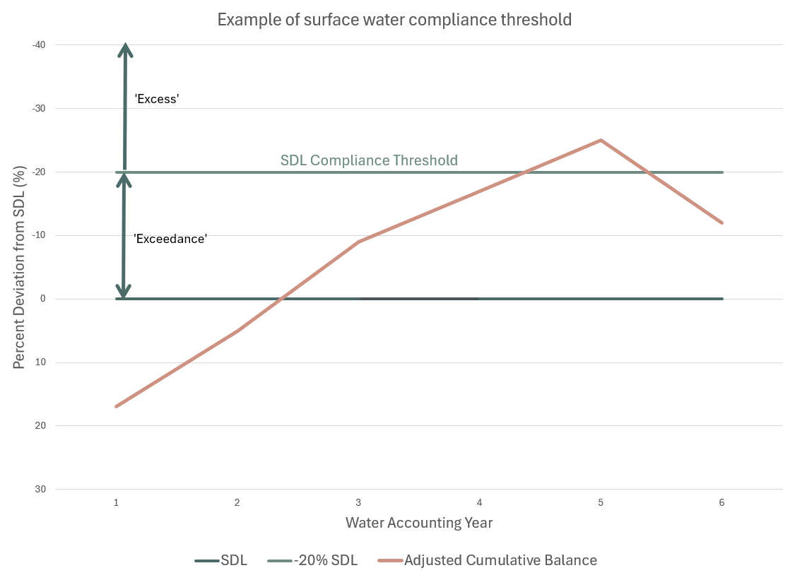

**Figure 4:** An example of the surface water compliance threshold and compliance monitoring. Data is presented as a percentage deviation from the SDL, with the y-axis inverted. The SDL Compliance Trigger plots above the zero line (-20% of the SDL) while the SDL plots as the x-axis. The Adjusted Cumulative Balance (ACB) is presented as a percentage of the SDL – if the ACB is a debit greater than 20%, it will plot above the Compliance Trigger. Normalising the data in this manner allows the scale of debits and credits to be comparable between different resource units with differing magnitudes of water take and minimises confusion due to SDL adjustments over time.

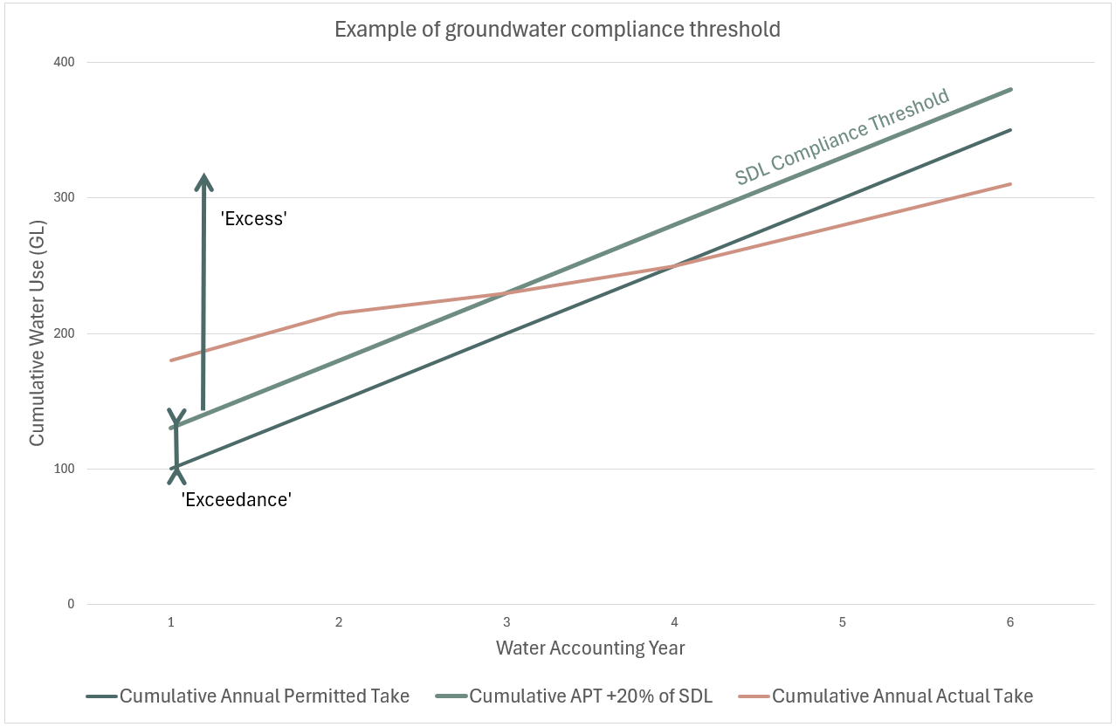

**Figure 5**: An example of the groundwater compliance threshold and compliance monitoring. Groundwater compliance assessment is based on the cumulative water take since the commencement of the 2019-2020 water accounting year. The SDL compliance threshold for a groundwater resource unit is the Cumulative Permitted Take plus 20% of the SDL. If the Cumulative Actual Take exceeds the SDL compliance threshold, the resource unit is deemed to be non-compliant. If the Cumulative Annual Actual Take exceeds the Cumulative Annual Permitted Take, but does not exceed the SDL compliance threshold, the resource unit is deemed to be in exceedance. Starting from 2029 water accounting year, the compliance assessment will shift to a rolling 10-year average approach.

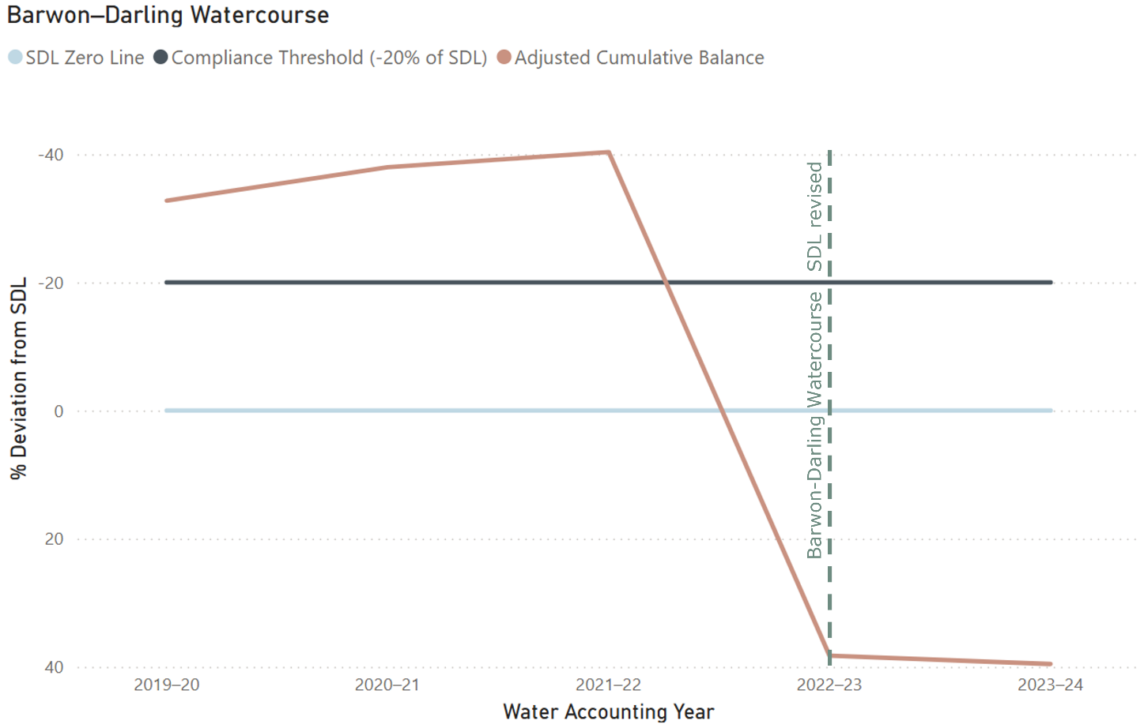

#### **Case Study 1: Barwon–Darling Watercourse**

Although not subject to SDL Compliance within this water year, the IGWC has been monitoring water use in the Barwon-Darling Watercourse. Since the introduction of the Basin Plan in 2012, the Annual Actual Take in the Barwon-Darling has fluctuated from year to year, but it has not shown a significant overall reduction (Figure 7).

The water operations within the Barwon-Darling watercourse yielded excessive SDL volumes within three consecutive water years—2019–2020, 2020–2021, and 2021–2022. In response the State submitted a reasonable excuse claim to the MDBA for the 2019-20 water year that the Barwon-Darling was operated in accordance with the submitted (but not yet accredited) water resource plan, along with the impact of incomplete water recovery in the watercourse. The MDBA assessed that the State did not operate in a manner fully consistent with the submitted (not yet accredited) water resource plan in the 2019–2020 water year, and therefore found this claim was invalid.

It is important to note that these exceedances and responses occurred outside of the legal framework of the Basin Plan, therefore it did not need to comply with the relevant Commonwealth water legislation. Also, during this time, the water resource plan itself, the accounting methods, as well as the underlying models were all constantly changing outside of the Basin Plan.

The operation of the Barwon-Darling yielded excessive SDL volumes until the BDL, and subsequently the SDL, was revised in 2022–2023 (Figure 6 and Figure 7).

The IGWC acknowledges that improving models is part of the Plan, however transparency and accountability are critical to maintaining public confidence in the integrity of the Plan.

The Barwon-Darling SDL resource unit will not be eligible for SDL compliance assessment until 2024-2025 SDL Compliance Statement. AAT in the Barwon-Darling may be subject to a one-off adjustment as a result of the recent accreditation of the water resource plan and its first full year of operation under the Basin Plan.

**Figure 6:** SDL Compliance analysis of the Barwon-Darling Watercourse. Please note, SDL Compliance for this area was not enforceable for this period.

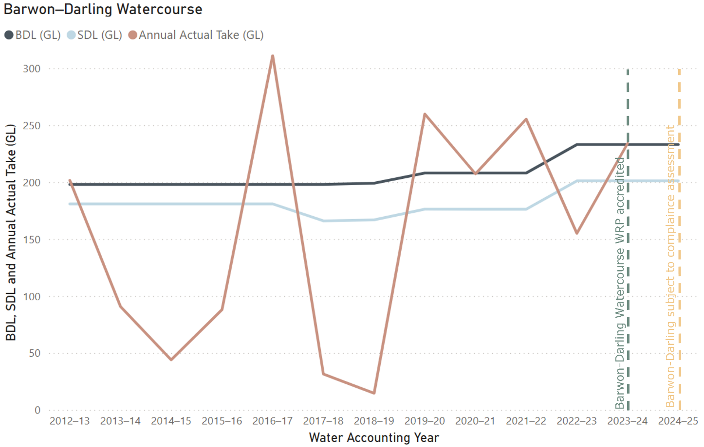

**Figure 7:** Changes over time to the SDL, BDL and the Annual Actual Take of the Barwon-Darling showing how current SDL and Actual Take are higher than the original BDL. Please note, SDL Compliance was not enforceable for this period.

#### **Case Study 2: Murrumbidgee**

Although the Murrumbidgee surface water WRP did not become operational until 29 February 2024 and will not be subject to SDL compliance assessment until the 2024–2025 water accounting year, the IGWC has identified it as an area of concern (Figure 8). This is due to the extended period during which it operated without an accredited water resource plan, as well as consistent SDL exceedances since 2020–2021, even if these remain below the compliance threshold. The Murrumbidgee has also been identified as an area of concern due to the high volume of water take within the SDL Resource Unit.

The initial upward trend in the adjusted cumulative balance (relative to the SDL compliance threshold), particularly between 2019–2020 and 2020–2021, may be partly attributed to the transition from a drought to wetter conditions during that period. Since 2021-2022 there has been a downward trend in the adjusted cumulative balance which may be a reflection of the La Niña conditions. The IGWC will continue closely monitoring the Murrumbidgee as it becomes eligible for SDL compliance in 2024-2025 and is subject to a one-off adjustment to account for the accredited accounting method being applied to water usage since 2019-2020.

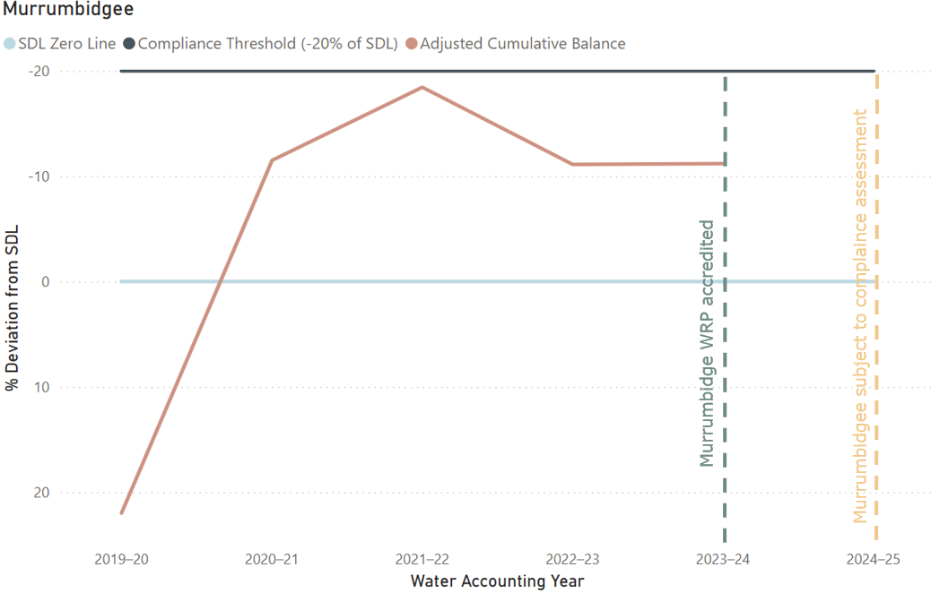

**Figure 8**: Analysis of SDL trends in the Murrumbidgee since 2019-2020. Please note the Murrumbidgee was not subject to SDL compliance during this period. SDL and compliance trigger shown to give context to adjusted cumulative balance.

#### **Case Study 3: Condamine-Balonne**

Another area closely examined by the IGWC was the Condamine-Balonne catchment in Queensland. The Condamine-Balonne surface water WRP has been operational since September 21, 2019, with SDL compliance enforceable since the 2020-2021 water year. Figure 9 shows the Condamine-Balone was trending towards exceedance of the SDL (although still well below the compliance threshold) at the tail end of the drought period before prevailing wet conditions contributed to move the adjusted cumulative balance away from the SDL. Although recent data indicates that the Condamine–Balonne is not currently approaching SDL non-compliance, the IGWC will continue to monitor the catchment closely due to the high volume of floodplain harvesting in the region and ongoing concerns about the accuracy of modelled floodplain harvesting actual take data (referred to as overland flow in Queensland).

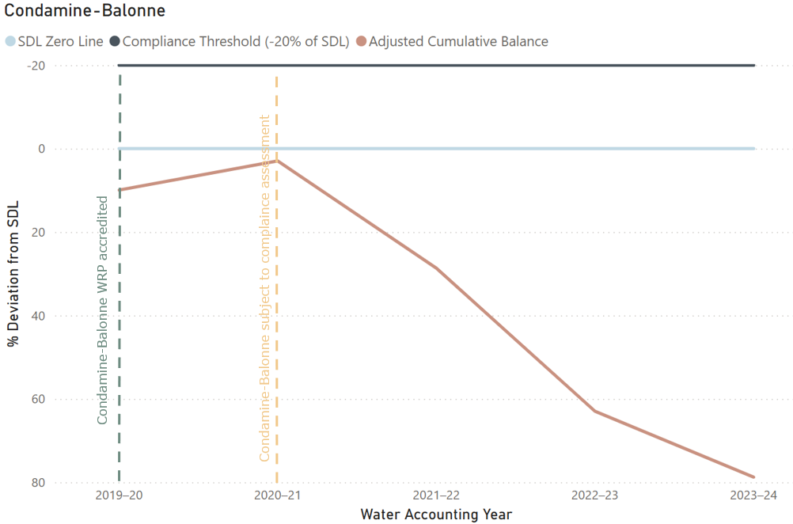

**Figure 9**: Analysis of SDL trends in the Condamine-Balonne since 2019-2020.

#### **Case Study 4: Upper Macquarie Alluvium**

As with surface water, all groundwater SDL resource units were found to be compliant with SDLs. The Upper Macquarie Alluvium is part of the Macquarie-Castlereagh Alluvium water resource plan which has been operational since 24 December 2022, meaning that 2023-2024 is the first water year that this area has been assessed for SDL compliance.

Figure 10 demonstrates initial periods in “excess” before moving below the compliance threshold. Although SDL compliance was not enforceable in the Upper Macquarie Alluvium at the time, a claim of reasonable excuse was provided by NSW to the MDBA. As this was prior to the establishment of the IGWC, the MDBA assessed this claim of reasonable excuse as valid, with NSW also providing ‘make good’ actions to ensure SDL non-compliance does not occur in the future. Make good actions included:

* Continuing to monitor groundwater take and assess whether there is any growth in use (in relation to ‘take from groundwater’)
* Announcing an available water determination if necessary, to reduce extraction back to the compliance trigger
* Undertaking a review of the variable permitted take method after five years, or earlier, if warranted.

Since exceeding the initial compliance trigger, cumulative actual take in the Upper Macquarie has fallen below the cumulative permitted take and trended away from SDL non-compliance. Nevertheless, the IGWC will continue to closely monitor the area to identify any early signs of potential SDL non-compliance.

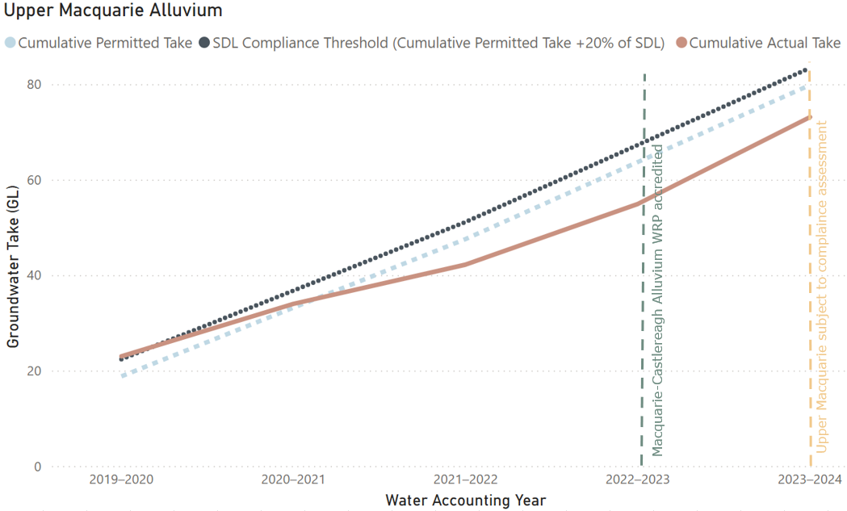

**Figure 10**: SDL compliance assessment of and trend analysis of groundwater use in the Upper Macquarie Alluvium.

### Water Use across the Basin

#### **Surface Water**

Surface water take across the Basin for the 2023–2024 water accounting year totalled 11,063.87 GL. The majority of this, approximately 59%, occurred in NSW. As previously discussed, none of NSWs surface water take can currently be assessed for SDL compliance, as no surface water WRPs in the state were accredited prior to 1 July 2023.

The inability to enforce surface water SDL compliance in NSW is particularly concerning given the scale of extraction across the Basin State. Within NSW, nearly 33% of total surface water take occurred in the Murrumbidgee SDL resource unit, with an additional 21% taken in the NSW Murray and Lower Darling. These two SDL units alone represent more than half of NSW’s surface water use yet remain outside the scope of this SDL compliance assessment due to the late accreditation of water resource plans (Figure 11).

The delayed accreditation of water resource plans in NSW, six years after the original deadline for water resource plan accreditation and full SDL compliance came into effect, significantly limits transparency and undermines confidence in the enforcement of SDLs. While several NSW water resource plans were accredited during 2023–2024 and will be included in the 2024–2025 compliance assessments, NSW remains the only Basin State with no surface water SDL resource units currently subject to formal compliance assessment for 2023-2024.

Elsewhere in the Basin where surface water SDL compliance is enforceable, Victoria accounted for 22% of total surface water take in the Basin. Within Victoria, 52% of the state’s surface water take occurred in the Victorian Murray, and 45% in Northern Victoria.

Queensland makes up 12.3% of the total Basin surface water take, with the Condamine–Balonne alone representing almost 61% of Queensland’s share. South Australia accounted for 6.2%, with 94% of that taken in the SA River Murray. The Australian Capital Territory made up a small portion, taking 0.24% of the Basin’s surface water total.

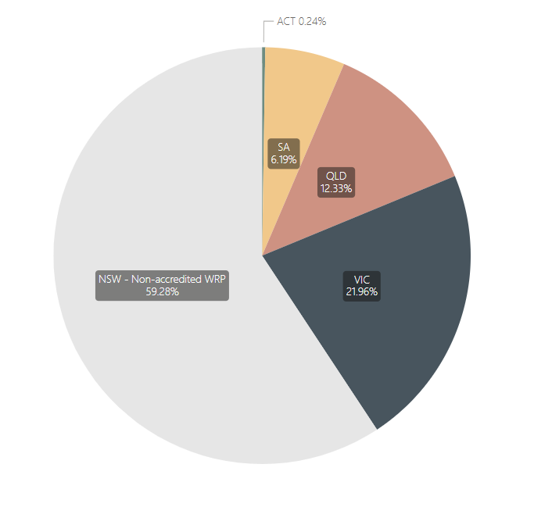

**Figure 11:** Proportion of Annual Actual Take (surface water) for the Basin by State. For the 2023-2024 water accounting year, none of NSW surface water SDL compliance can be assessed as none of the water resource plans were accredited for the entire period.

#### **Groundwater**

Groundwater take in the Basin for the 2023–2024 water year totalled 1,232 GL, with the majority (approximately 71%) extracted in NSW. However, 51.6% of the Basin’s total groundwater take cannot be assessed for SDL compliance (Figure 12), as six of NSW’s groundwater water resource plans were not accredited before 1 July 2023.

The delayed accreditation of water resource plans include some of the largest groundwater-consuming SDL resource units in the Basin, such as the Murrumbidgee Alluvium (accounting for 25% of NSW’s groundwater take) and the Lachlan Alluvium (15%). The Namoi Alluvium represents 21% of NSW’s groundwater take and is yet to be resubmitted by NSW for accreditation. These areas represent substantial groundwater use, yet they remain outside the current SDL compliance framework due to delays in water resource plan accreditation. As a result, a significant proportion of Basin groundwater take, particularly in NSW, cannot yet be formally assessed for compliance, weakening overall accountability in the Basin State.

Outside NSW, Queensland accounts for 14% of the Basin’s total groundwater take, with the Condamine–Balonne region making up 87% of that amount. Victoria’s share is 9.4%, with the Goulburn–Murray system responsible for 93% of the state’s groundwater extraction. South Australia accounts for 5.1% of total groundwater take, 81% of which comes from the SA Murray Region.

Although progress has been made, with 23 new groundwater SDL resource units in NSW being assessed for the first time in the 2023–2024 water year, the absence of fully accredited water resource plans for major groundwater systems continues to hinder the complete implementation of SDL compliance across the Basin. Until all water resource plans are accredited, and SDL compliance is enforceable, the Plan’s groundwater sustainability objectives remain only partially realised. This challenge is likely to persist in NSW, where water resource plans in both the Namoi and Gwydir regions remain unaccredited for both surface and groundwater and remains an area of concern for the IGWC.

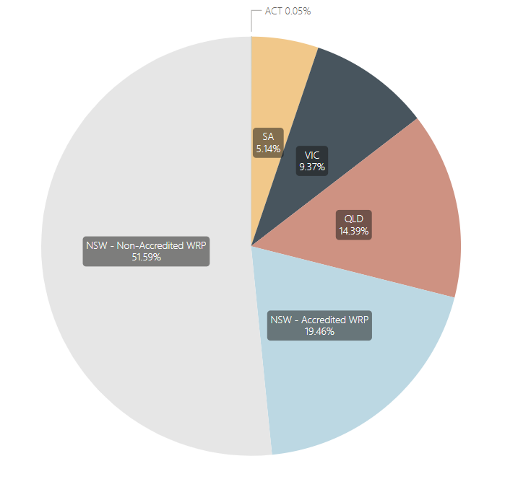

**Figure 12:** Proportion of Annual Actual Take (groundwater) by State. For the 2023-2024 water accounting year, the majority of NSW groundwater SDL compliance cannot be assessed as several water resource plans were not accredited for the entire period.

# Understanding SDL Compliance

### Sustainable Diversion Limits

The Plan establishes SDLs as the maximum long-term average volume of water that can be taken from the Basin’s water resources for consumptive use, while ensuring enough water remains to support ecosystems, environmental health, and cultural values. SDLs are a critical component of the Plan, introduced to ensure that water use across the Basin is environmentally sustainable. In effect, SDLs limit the amount of water that can be taken from rivers and aquifers by water users, primarily irrigation for agricultural crops.

Basin States are broken down into discrete geographic areas called SDL Resource Units, with each having its own set SDL. There are SDL Resource Units for both surface water and groundwater based on natural catchment and hydrogeological boundaries – 29 surface water and 80 groundwater SDL resource units. These resource units are shown in the Figures 1 and 2 of this report. However, SDL compliance can only be assessed for a given resource unit once an accredited WRP has been in operation for the entire water year.

Calculation of SDLs is based off the Baseline Diversion Limit (BDL) and the recovery target. The BDL is the historic long-term annual volume of water that was being used in the Basin prior to the implementation of the Plan. The reduction target is the amount of water that the Plan aims to recover for the environment by reducing the amount of water used for irrigation and other purposes. The SDL is approximately equivalent to the BDL less the recovery target volume.

### Water Resource Plans

Water resource plans outline how SDLs are to be achieved in specific areas of the Murray–Darling Basin and provide the framework for managing and implementing SDLs. Without an accredited water resource plan, SDL compliance cannot be enforced which undermines the purpose of thePlan.

All Basin States have operational water resource plans for both surface water and groundwater resource units for the 2023-2024 year, except for NSW which has no surface water WRPs and only 5 of 11 groundwater water resource plans accredited for the entirety of 2023-2024.

As of the release of this report, 29 of the 33 water resource plans are operational across the Murray–Darling Basin. The four water resource plans yet to be accredited are all in NSW, which currently has 16 out of 20 water resource plans accredited and operational.

All other Basin States had accredited and operating water resource plans on 1 July 2020 for the 2020–2021 water year and were able to provide information for the Registers of Take, as required by the Plan, and were subject to SDL compliance since that water year.

As of July 2025, there remains unaccredited water resource plans in the Namoi and Gwydir catchments, meaning the IGWC cannot fully assess NSW SDL compliance until the 2026-2027 water year at the earliest. In 2023–2024, the Namoi and Gwydir catchments extracted 1,093.2 GL of surface water and 217.3 GL of groundwater from Basin water resources, a significant volume that remains outside the scope of SDL compliance. The ongoing absence of accredited water resource plans in these catchments is a matter of concern for the Inspector–General. The continued absence of accredited water resource plans in the Namoi and Gwydir represents an unfair playing field across the Basin.

A list of water resource plans, when they were accredited, and which water accounting year SDL compliance can commence is presented in Table 1.

### IGWC’s role in SDL Compliance

One of the main functions of the IGWC is enforcing compliance with theAct and the Plan.

Under section 71 of the Act, Basin States are required to submit annual water take data to the MDBA, including a self-assessment of compliance with their SDLs. The water take data includes volumes taken under various entitlements, contextual information, and any permitted adjustments.

The MDBA performs quality assurance and reconciliation of this data under its SDL Accounting and Reporting Framework, and publishes the results in the Registers of Take, ensuring data is complete, consistent, and suitable for use in regulatory assessments. The MDBA provides the IGWC with the Basin States’ data as the primary input into formal SDL compliance assessments. The Registers of Take report is published by the MDBA concurrently with the SDL compliance decision issued by the IGWC.

The IGWC is responsible for determining and enforcing SDL compliance and through assessing SDL data under its SDL Compliance Framework. The IGWC receives the validated data from the MDBA and undertakes an independent assessment against SDL limits set in the Plan. The IGWC's annual SDL Compliance Statement is a formal regulatory document which confirms whether Basin States have met their SDL obligations.

The SDL Compliance Advisory Panel

The IGWC has established the SDL Compliance Advisory Panel (the Panel) to provide advice and assurance on SDL compliance. The Panel is established under Section 215T of the Act.

The role of the Panel will not be to make assessment decisions on SDL compliance, but to provide current knowledge, critical thinking and analysis to provide the IGWC with increased confidence in the information available to support and inform their statutory role related to SDL compliance assessment.

The Panel’s main responsibility is to advise the IGWC in carrying out their functions under the Act, by providing guidance, assistance and expertise in fields including water management and water accountancy. The following advice and outcomes will be expected from the Panel:

* Provide assurance of transparency and consistency in the assessment of SDL compliance and claims of reasonable excuse
* Offer recommendations to the IGWC regarding the form and content of the annual SDL compliance statement
* Offer independent advice regarding potential SDL compliance breaches, including assisting in assessing claims of reasonable excuse and providing recommendations
* Evaluate action plans and associated reporting, offering recommendations as appropriate
* Provide advice in the development or review of action plan guidelines
* Identify mechanisms for SDL accounting and compliance where accredited WRPs are absent, offering guidance where needed.

The Inspector–General has appointed Tony Slatyer as Chair of the Panel. Mr Slatyer brings extensive experience in water policy and governance, currently serving as Policy Adviser to the United Nations Water Expert Group on Water and Climate Change. From 2017 to 2024, he was Special Adviser on Water to the Australian Department of Foreign Affairs and Trade (DFAT), and adviser to the World Meteorological Organisation (WMO) on water policy and strategy (2022–2024). Prior to these roles, Mr Slatyer was a senior executive in the Australian Public Service, including with national water responsibilities. His experience and knowledge brings proven strategic insight that will directly benefit the Panel.

The Panel will be available to provide expertise and advice for the 2024-2025 SDL Compliance Statement.

### Calculation of the Cumulative Balance for SDL Compliance

The cumulative balance is key to ensuring that long-term actual water take is equal to or less than the SDL and allows for variability in the actual take and permitted take. The cumulative balance is the running total of annual differences between the permitted water take and actual water take for each SDL resource unit. It is calculated using water take data submitted by Basin States, with each year’s water balance credit or debit added to the previous total.

A negative cumulative balance (debit) indicates potential overuse, while a positive cumulative balance (credit) indicates actual take is under the permitted take. The adjusted cumulative balance modifies this total to account for factors such as the one-off adjustment or the acquisition or disposal of Held Environmental Water (HEW) and separate adjustments for incomplete recovery (AEIR) based on amount of water recovered towards the ‘Bridging the Gap’ targets.

For surface water SDL resource units, the registers open with a cumulative balance of zero in the year of their commencement (the start of the first water year after accreditation of the water resource plan) followed by the one-off adjustments (as discussed below) where water resource plans did not commence by 1 July 2019.

In contrast to surface water SDL resource units, for groundwater SDL resource units, the cumulative actual permitted takes begin from 1 July 2019, regardless of whether a water resource plan for the resource unit was accredited prior to 1 July 2019 or not.

As required by the Plan, the IGWC uses the adjusted cumulative balance to assess SDL compliance for surface water.

The Registers of Take are prepared by the MDBA annually for each SDL resource unit in line with the Plan requirements, using the best available data to calculate cumulative water take balances. The final cumulative balance in a given water accounting year becomes the opening balance for the following year.

Under the MDBA’s [SDL Accounting and Reporting Framework (2025)](https://www.mdba.gov.au/sites/default/files/publications/sustainable-diversion-limit-sdl-accounting-and-reporting-framework-2025.pdf), if better data becomes available after the Registers of Take are finalised, the MDBA may recalculate the opening balance in the following year to ensure accuracy. Changes to the opening cumulative balance of a new water year may occur for two reasons:

* the legislated one-off adjustment (described below); and
* recalculations due to revised metering data, updated climate or streamflow inputs, or re-accreditation of improved water take methods.

Such updates to the Registers of Take aim to ensure the ongoing accuracy of long-term SDL compliance without altering historical registers. The MDBA manages this process in collaboration with Basin States and documents any changes in the Registers of Take.

### One-off adjustment

Under the Planwater resource plans were to be accredited, and associatedSDLs due to come in to effect, for the 2019-2020 water year, commencing 1 July 2019. Due to the majority of the Basin States, except Queensland with Warrego-Paroo-Nebine water resource plan, failing to meet this deadline for water resource plan accreditation, full Basin Plan arrangements regarding SDLs did not come into effect on this date.

To address the delay in water resource plan accreditation and the resulting postponement of full SDL implementation, an amendment to the Act in 2023, known as the *Restoring our Rivers Act*,introduced a ‘one-off adjustment’ to cumulative balances for surface water SDL resource units. This adjustment retrospectively applies the cumulative balance credits and/or debits from 2019-2020 until the year the water resource plans came into operation. The IGWC supported this change to ensure all states had the same starting date and IGWC holds the ongoing role to potentially audit calculations taken by the Authority. This is the first water year that SDL compliance outcomes of the ‘one-off adjustment’ have been made available for assessment by the IGWC.

Figures for the one-off adjustment in each SDL Resource Unit can be found in the surface water SDL Accounts in Table 2.

### Baseline Diversion Limits and changes to SDL over time

BDLs are a foundational element in calculating SDLs under the Plan. It represents the estimated level of water use in the Basin prior to the Plan’s implementation. Over time, BDL estimates have been altered through changes to hydrological modelling in multiple resource units. Though the description of BDLs for surface water are fixed in the Plan, estimates may be updated. A change in the BDL necessarily results in a change in the SDL for a surface water SDL resource unit. Groundwater BDLs and SDLs are largely fixed in the Plan and can only be changed through an amendment.

Between 2012 and 2019, the MDBA and Basin States conducted trial SDL accounting alongside existing compliance measures. These trials were undertaken to develop and test new water accounting arrangements, identify areas for improvement, and support a smooth transition to full SDL implementation. As a result of these trials, surface water BDLs and SDLs were revised in some resource units.

In addition to changes stemming from BDL refinements, SDLs may also be amended through updates or the reallocation of shared reduction amounts in the Plan, as exemplified by the MDBA’s [Northern Basin Review (2016)](https://www.mdba.gov.au/sites/default/files/publications/Northern-basin-review.pdf).

For example, modifications to the BDL, and by extension the SDL, are evident in the Barwon-Darling Watercourse resource unit. When the Plan was published in 2012, the BDL for the Barwon-Darling was set at 197.6 GL, and the SDL at 180.9 GL. Since then, the BDL has increased to 233.2 GL and the SDL has risen to 201.2 GL, now exceeding the original BDL (Figure 7). This means that the Plan now legislates for more water take in the Barwon-Darling than the original estimated pre-Basin Plan level of take. The re-estimation of the BDL includes watercourse take as well as all forms of floodplain harvesting. Stakeholder sensitivity to these revised estimates is high due to the contentious nature of floodplain harvesting and the implications this may have on connectivity of the northern Basin.

### Sustainable Diversion Limits and the 2026 Basin Plan Review

As part of the upcoming 2026 Basin Plan review, one key area of focus will be SDLs, and assessing their effectiveness on environmental, cultural, social and economic outcomes across the Basin.

As outlined in the [Early Insights paper](https://www.mdba.gov.au/water-management/basin-plan-review/early-insights-paper) the MDBA will evaluate the effectiveness of SDLs in supporting desired environmental outcomes of the Plan over two timeframes: a) the next ten years until the next scheduled review; and b) out to 2050.

The evaluation will consider measures for promotion of environmental outcomes, and conduct environmental, social and economic analyses before proposing or recommending any responses. It will consider what action is needed now and what types of additional monitoring is required for vulnerable and high-risk areas.

# Assessment Process

### Sources of compliance data

The SDL compliance assessment is informed by water accounts and reports provided by the Basin States and the MDBA, as outlined in the SDL Compliance Framework, and may include the following data sources:

* **Basin State Reports/Water Accounts,** asrequired by Section 71 of the Act. The Section 71 reports contain detailed water accounts, including water taken and managed during the water accounting year, and each Basin State’s assessment of compliance and actions taken to meet SDLs.
* **Registers of Take** as prepared by the MDBA, which includes SDL resource units managed under an accredited water resource plan.
* **Previous years SDL compliance assessments** are also taken into account.
* **Other information** provided to the IGWC, or obtained publicly, for the purposes of undertaking a compliance assessment.
* **Bilateral discussions** and any additional information provided by the MDBA and Basin States.

This Compliance Statement report, released in conjunction with the MDBA’s “SDL Accounts - Registers of Take” report, considers the section 71 water data in the SDL Accounts and indicates the impact of water taken through cumulative balances (credits or debits) for each SDL resource unit. The section 71 data for 2023-2024 SDL Accounts report was provided progressively to the IGWC Compliance Monitoring team by the MDBA with first versions of section 71 data received in November 2024, although final data was not officially provided to the Inspector–General until 4 June 2025. The surface water and groundwater SDL Accounts are provided in Tables 2 and 3, respectively.

Basin States source the section 71 data from several different resources including water licensing systems, direct water take measurement including meters, water resource monitoring gauging stations, hydrological models, and other methods as necessary.

Water account data is submitted by the Basin States as required under section 71 of the Act and is the primary source of data for determining compliance and for observing longer-term trends. This information is due four months after the end of the water accounting year (i.e., 30 June), meaning submission is due on 31 October annually, although Basin States can seek an extension from the MDBA.

When submitting the section 71 data, Basin States provide a declaration of accuracy of the data. The MDBA then undertakes a quality assurance check on the data and collates the information onto the Registers of Take. Where a water resource plan is not accredited, the Registers of Take report presents the section 71 data as interim Registers of Take.

The IGWC has recently undertaken analysis to monitor compliance trends over time, informed by Section 71 data. This enables the IGWC to observe longer-term trends for individual SDL resource units and provide early warning in areas which may be trending towards the compliance trigger.

### Timely provision of SDL data

Under current legislative arrangements, Basin States are to submit water take data to the MDBA as outlined in section 71 of the Act; the data provided under this section of the Act is referred to as ‘section 71 data’. Basin States have four months from the end of the water year to submit water take data to the MDBA (by 31 October).

However, it has become common practice for Basin States to seek deadline extensions for the provision of section 71 data, with the finalised data not being received by the IGWC for up to nine months after the end of the water year. It is within the legislative remit of the MDBA to grant such extensions, as section 71 (2) of the Act states ‘*The Authority may, in writing, extend the period within which the report must be given to the Authority*’.

To allow timely and consistent SDL compliance reporting, it is essential that section 71 data is provided to the IGWC with sufficient time to analyse, review and disseminate outcomes. Delays in receiving section 71 data reduces the time available for independent review and assurance.

The willingness of the MDBA to grant extensions to Basin States for the provision of section 71 data and its flow on impact to assessment of SDL compliance across the Basin is a concern to the Inspector–General. IGWC has raised this concern with the MDBA regarding the continual late provision of section 71 data and the resulting impact on the assessment of SDL Compliance.

In voicing these concerns, the IGWC expects future extensions granted to Basin States can be considered an exception with justification rather than a standard practice and that the issues with timeliness of data provision will be addressed through the upcoming review of the Plan.

What is meant by compliant or non-compliant?

The term ‘excess’ has a specific meaning in the Plan. Once there is an excess, certain obligations and actions are triggered under the Plan.

For surface water SDL resource units, for a given water accounting year, the actual annual water take is subtracted from the permitted annual take to generate either a debit (where actual take was more than the permitted take) or a credit (where actual take was less than the permitted take). These debits and credits generate a **cumulative balance** over time.

The **surface water SDL compliance threshold** for an SDL resource unit is a cumulative balance in debit and equal to or greater than 20% of the SDL.

If the cumulative balance is below the SDL compliance threshold, the resource unit is considered to be **compliant**. If the cumulative balance exceeds the compliance threshold, the resource unit is deemed to be **non-compliant.**

If the cumulative balance is in debit but is below the SDL compliance threshold (20% of the SDL), the resource unit is in **exceedance**, though it is still considered to be **compliant**. This term serves as a warning that an excess, and therefore potential non-compliance, may occur.

An example of excess, exceedance and compliance for surface water SDL resource units is shown in Figure 4.

The **groundwater SDL compliance threshold**, for water accounting years up to the 2028, is the cumulative permitted take since 2019 plus 20% of the resource units SDL. If the cumulative actual take is below the threshold, the resource unit is considered compliant.

If the cumulative actual take over the same period exceeds this threshold, the resource unit is deemed **non-compliant**.

If the cumulative actual take exceeds the cumulative permitted take but is below the compliance threshold, the resource unit is in **exceedance**, though it is considered to be **compliant**.

An example of excess, exceedance and compliance for groundwater SDL resource units is shown in Figure 5.

Starting from the 2028-2029 water accounting year, the compliance assessment will shift to a 10-year rolling average approach. At this time, a groundwater SDL resource unit will be considered non-compliant if its *average* annual actual take during this period exceeds the *average* annual permitted take.

The SDL Assessment Process is outlined in detail in the IGWC’s SDL Compliance Framework ([Sustainable Diversion Limit Compliance Framework](https://www.igwc.gov.au/sites/default/files/2023-10/sdl-compliance-framework.pdf)).

### Actions that can be taken when non-compliance is found

If the IGWC assesses that a Basin State is non-compliant in a particular SDL resource unit, the IGWC will work with that Basin State to understand how it will be ensured that the non-compliance does not occur again. This will involve the Basin State proposing an ‘action plan’ that outlines the steps it will take to bring the SDL resource unit back into compliance. The IGWC will review this action plan and make a public statement regarding the facts of the non-compliance with the Basin States response.

If the IGWC’s compliance assessment indicates non-compliance, the IGWC will provide the responsible Basin State with an opportunity to respond to the assessment before it is finalised.

The IGWC may also choose to undertake an audit or investigation of the Basin State’s data and actions.

A singular occurrence of SDL non-compliance is not in itself a direct contravention of the Act, the Plan or a water resource plan. However, acting inconsistently with the Plan or a water resource plan is a contravention of the Act.

If the IGWC has evidence of a contravention of the Act, the IGWC may take appropriate enforcement action (Water Act Part 8). Enforcement action may include:

* Requesting a person (including a Basin State agency) to provide an enforceable undertaking that the person will take specified action to prevent the contravention; or
* Applying to the court for a declaration that there has been a contravention, and/or an injunction to prevent the contravention.

### Reasonable Excuse

In the event of SDL non-compliance, a Basin State can claim for a reasonable excuse if it followed an accredited water resource plan for the SDL resource unit, or it can demonstrate that other circumstances leading to the excess were beyond the Basin States control.

The Basin State must provide the IGWC and MDBA a ‘reasonable excuse’ report explaining the reasons for the SDL excess. The IGWC assesses reasonable excuse reports from Basin States.

A ‘reasonable excuse’ for the excess arises as the result of:

* the operation of the water resource plan for the SDL resource unit; or
* circumstances beyond the Basin State’s control i.e. where, for reasons beyond the Basin State’s control, the Commonwealth has not achieved the water recovery target that it has set for itself in relation to the SDL resource unit.

If the IGWC is satisfied that the Basin State has a reasonable excuse as claimed, the State is considered **compliant with reasonable excuse**.

If no acceptable excuse is provided, the breach is treated as non-compliance, requiring the State to submit a compliance report outlining the actions it will take to return to compliance.

In either case, compliance with excuse or non-compliance, the State is required to prepare an **Action Plan** which must be approved by the IGWC. The Action Plan indicates the steps that will be taken to address the cause of excess and reduce the cumulative balance to zero or less.

### Potential impact of delays in buybacks on SDL compliance

Outstanding water recovery presents a significant constraint to the IGWC’s ability to assess SDL compliance comprehensively and to ensure the effective implementation of SDLs. Incomplete water recovery may constitute a reasonable excuse for SDL non-compliance. This presents a problem, as it limits the enforceability of SDL obligations and reduces accountability for water use, particularly in areas with longstanding water recovery shortfalls. Where the excuse relates to incomplete recovery by the Commonwealth, Basin State reports must include evidence demonstrating that the recovery shortfall was beyond the State’s control.

The original ‘Bridging the Gap’ [water recovery](https://www.mdba.gov.au/water-use/water-environment/water-recovery/progress-water-recovery) target for surface water was set at 2,750 GL/year. Following amendments to the Plan, this target was revised to 2,075 GL/year, contingent upon the implementation of various measures designed to achieve equivalent environmental outcomes with less water.

Recovery data indicates that while some SDL resource units have exceeded their individual targets, others have yet to meet them in full. As of 31 March 2025, a total of 2,068.9 GL/year of surface water has been recovered towards the revised target, leaving a shortfall of 6.7 GL/year. To successfully complete the overall ‘Bridging the Gap’ target, it is essential that all SDL resource units and zones achieve their respective recovery targets in full.

Delays in water recovery must be addressed as a matter of urgency to uphold the integrity of SDL compliance assessments and effective implementation of the Plan. Until water recovery targets are fully met, the MDBA adjusts the Register of Take annually to reflect the shortfall in recovery. This is done by crediting the cumulative balance for the SDL resource unit with the annualised volume of incomplete recovery. As a result, these resource units are effectively permitted to divert water at volumes that may exceed sustainable limits. This practice raises a significant compliance concern, as it lowers the compliance trigger and allows ongoing consumptive use at levels inconsistent with the Plan’s environmental sustainability objectives.

# Accounts

### Surface Water Accounts

**Table 2:** Surface water Register of Take for SDL Resource Units subject to SDL compliance in 2023-2024

| **State** | **SDL resource unit** | **SDL resource unit code** | **SDL** | **Annual Permitted Take (GL)** | **Annual Actual Take (GL)** | **Annual Balance (GL)** | **Cumulative Balance, Start of year (GL)** | **Cumulative Balance, End of Year (GL)** | **HEW Adjust-ments (GL)** | **One off adjustment (GL)** | **Adjusted Cumulative Balance, End of year (GL)** | **Compliance Trigger   (GL)** | **Was the trigger exceeded? (Yes/No)** |
| --- | --- | --- | --- | --- | --- | --- | --- | --- | --- | --- | --- | --- | --- |
| **ACT** | Australian Capital Territory (surface water) | SS1 | 53.4 | 50.4 | 26.9 | 23.5 | 43.7 | 67.2 | 2.3 | 25.5 | 95.0 | -10.7 | No |
| **QLD** | Queensland Border Rivers | SS24 | 363.6 | 320.7 | 348.4 | -27.7 | 581.1 | 553.4 | 0.0 | 3.1 | 556.5 | -72.7 | No |
| **QLD** | Moonie | SS25 | 89.9 | 127.5 | 88.6 | 38.9 | 185.5 | 224.4 | 0.0 | 28.2 | 252.6 | -18.0 | No |
| **QLD** | Condamine-Balonne | SS26 | 919.0 | 847.3 | 831.3 | 16.1 | 578.6 | 594.7 | 16.1 | 113.2 | 724.0 | -183.8 | No |
| **QLD** | Nebine | SS27 | 17.1 | 18.9 | 14.2 | 4.6 | 18.2 | 22.8 | 0.0 | 0.0 | 22.8 | -3.4 | No |
| **QLD** | Warrego | SS28 | 55.5 | 73.2 | 41.0 | 32.2 | 104.0 | 136.3 | 0.0 | 0.0 | 136.3 | -11.1 | No |
| **QLD** | Paroo | SS29 | 11.8 | 41.2 | 41.1 | 0.1 | 0.3 | 0.4 | 0.0 | 0.0 | 0.4 | -2.4 | No |
| **VIC** | Victorian Murray | SS2 | 1316.5 | 1498.7 | 1250.3 | 248.4 | 553.7 | 802.1 | 26.0 | 319.1 | 1147.2 | -263.3 | No |
| **VIC** | Kiewa | SS3 | 27.8 | 28.3 | 23.2 | 5.1 | 15.9 | 21.0 | 0.0 | 6.6 | 27.5 | -5.6 | No |
| **VIC** | Ovens | SS4 | 85.9 | 91.7 | 77.2 | 14.6 | 37.0 | 51.6 | -0.1 | 21.2 | 72.7 | -17.2 | No |
| **VIC** | Broken | SS5 | 49.0 | 44.5 | 43.0 | 1.4 | 4.6 | 6.1 | 0.0 | 4.0 | 10.0 | -9.8 | No |
| **VIC** | Goulburn | SS6 | 1278.4 | 1196.0 | 824.0 | 372.0 | 1141.2 | 1513.2 | 9.0 | 325.8 | 1848.0 | -255.7 | No |
| **VIC** | Campaspe | SS7 | 111.8 | 95.8 | 75.1 | 20.6 | 60.2 | 80.9 | 0.8 | 22.5 | 104.2 | -22.4 | No |
| **VIC** | Loddon | SS8 | 127.9 | 128.7 | 88.3 | 40.4 | 71.6 | 112.0 | 0.0 | 54.6 | 166.6 | -25.6 | No |
| **VIC** | Wimmera-Mallee (surface water) | SS9 | 76.1 | 77.6 | 47.9 | 29.8 | 78.9 | 108.7 | 0.0 | 26.7 | 135.4 | -15.2 | No |
| **VIC** | Goulburn-Broken-Campaspe-Loddon^ |  | 1567.1 | 1465.0 | 1030.5 | 434.5 | 1277.8 | 1712.3 | 9.8 | 406.8 | 2128.9 | -313.4 | No |
| **VIC** | Victorian Murray-Kiewa-Ovens* |  | 1430.1 | 1618.8 | 1350.7 | 268.1 | 606.6 | 874.7 | 26.0 | 346.9 | 1247.5 | -286.0 | No |
| **SA** | South Australian Non-Prescribed Areas | SS10 | 55.2 | 55.2 | 23.3 | 31.9 | 95.6 | 127.4 | 0.0 | 31.9 | 159.3 | -11.0 | No |
| **SA** | South Australian Murray | SS11 | 542.3 | 712.7 | 643.2 | 69.5 | 30.9 | 100.4 | -13.6 | 29.1 | 115.8 | -108.5 | No |
| **SA** | Marne-Saunders | SS12 | 3.0 | 2.9 | 2.0 | 0.9 | 3.0 | 3.9 | 0.0 | 0.5 | 4.3 | -0.6 | No |
| **SA** | Eastern Mount Lofty Ranges | SS13 | 28.3 | 26.7 | 15.8 | 10.9 | 40.9 | 51.8 | 0.0 | 11.0 | 62.8 | -5.7 | No |

### Groundwater Accounts

**Table 3:** Groundwater Register of Take for SDL Resource Units subject to SDL compliance in 2023-2024

| State | SDL resource unit | SDL resource unit code | SDL (GL) | Annual Permitted Take (GL) | Annual Actual Take (GL) | Cumulative Permitted Take (PT) from previous year (GL) | Cumulative Actual Take from previous year (GL) | Annual Adjustments for the previous year's Annual Expression of Incomplete Recovery (AEIR) (GL) | Cumulative Adjustments for the previous year's Annual Expression of Incomplete Recovery (AEIR) (GL) | Cumulative Permitted Take at end of current year (GL) | Cumulative Actual Take at end of current year (GL) | | | Compliance Trigger (GL) | Was the trigger exceeded? (Yes/No) | |
| --- | --- | --- | --- | --- | --- | --- | --- | --- | --- | --- | --- | --- | --- | --- | --- | --- |
| ACT | Australian Capital Territory (groundwater) | GS52 | 3.2 | 3.2 | 0.6 | 12.6 | 1.7 | 0.0 | 0.0 | 15.8 | | 2.4 | 16.4 | | | No |
| NSW | Adelaide Fold Belt MDB | GS10 | 6.9 | 6.9 | 2.7 | 27.6 | 10.3 | 0.0 | 0.0 | 34.5 | | 13.0 | 35.9 | | | No |
| NSW | Bell Valley Alluvium | GS11 | 3.3 | 3.3 | 1.2 | 13.2 | 1.3 | 0.0 | 0.0 | 16.5 | | 2.5 | 17.1 | | | No |
| NSW | Castlereagh Alluvium | GS14 | 0.6 | 0.6 | 0.1 | 2.5 | 0.3 | 0.0 | 0.0 | 3.1 | | 0.4 | 3.2 | | | No |
| NSW | Coolaburragundy–Talbragar Alluvium | GS15 | 3.5 | 3.5 | 2.8 | 13.9 | 6.0 | 0.0 | 0.0 | 17.4 | | 8.8 | 18.0 | | | No |
| NSW | Cudgegong Alluvium | GS16 | 2.5 | 2.5 | 1.8 | 9.5 | 5.6 | 0.0 | 0.0 | 12.0 | | 7.4 | 12.5 | | | No |
| NSW | Gunnedah-Oxley Basin MDB | GS17 | 127.5 | 127.5 | 15.7 | 510.0 | 51.6 | 0.0 | 0.0 | 637.5 | | 67.3 | 663.0 | | | No |
| NSW | Inverell Basalt | GS18 | 4.2 | 4.2 | 1.4 | 16.6 | 5.8 | 0.0 | 0.0 | 20.8 | | 7.1 | 21.6 | | | No |
| NSW | Kanmantoo Fold Belt MDB | GS19 | 18.7 | 18.7 | 8.3 | 74.8 | 33.2 | 0.0 | 0.0 | 93.5 | | 41.5 | 97.2 | | | No |
| NSW | Lachlan Fold Belt MDB | GS20 | 259.0 | 259.0 | 86.4 | 1036.0 | 330.6 | 0.0 | 0.0 | 1295.0 | | 416.9 | 1346.8 | | | No |
| NSW | Liverpool Ranges Basalt MDB | GS22 | 2.2 | 2.2 | 1.9 | 8.6 | 7.7 | 0.0 | 0.0 | 10.8 | | 9.6 | 11.2 | | | No |
| NSW | Lower Darling Alluvium | GS23 | 2.2 | 2.2 | 0.8 | 8.9 | 3.1 | 0.0 | 0.0 | 11.2 | | 3.9 | 11.6 | | | No |
| NSW | Lower Macquarie Alluvium | GS26 | 52.7 | 52.7 | 30.2 | 210.9 | 89.1 | 0.0 | 0.0 | 263.6 | | 119.3 | 274.1 | | | No |
| NSW | NSW Border Rivers Alluvium | GS32 | 8.4 | 8.4 | 5.2 | 33.6 | 20.4 | 0.0 | 0.0 | 42.0 | | 25.6 | 43.7 | | | No |
| NSW | NSW Border Rivers Tributary Alluvium | GS33 | 0.4 | 0.4 | 0.2 | 1.6 | 0.6 | 0.0 | 0.0 | 2.1 | | 0.8 | 2.1 | | | No |
| NSW | New England Fold Belt MDB | GS37 | 55.1 | 55.1 | 22.0 | 220.4 | 84.1 | 0.0 | 0.0 | 275.5 | | 106.2 | 286.5 | | | No |
| NSW | Oaklands Basin | GS38 | 2.5 | 2.5 | 0.0 | 10.0 | 0.0 | 0.0 | 0.0 | 12.5 | | 0.0 | 13.0 | | | No |
| NSW | Orange Basalt | GS39 | 10.7 | 10.7 | 1.3 | 42.8 | 5.7 | 0.0 | 0.0 | 53.5 | | 7.0 | 55.6 | | | No |
| NSW | Sydney Basin MDB | GS41 | 19.1 | 19.1 | 2.3 | 76.4 | 8.9 | 0.0 | 0.0 | 95.5 | | 11.2 | 99.3 | | | No |
| NSW | Upper Darling Alluvium | GS42 | 6.6 | 6.6 | 2.8 | 26.4 | 13.0 | 0.0 | 0.0 | 33.0 | | 15.8 | 34.3 | | | No |
| NSW | Macquarie-Castlereagh Alluvium | GS45 | 17.9 | 16.1 | 18.2 | 63.7 | 54.9 | 0.0 | 0.0 | 79.8 | | 73.1 | 83.4 | | | No |
| NSW | Warrumbungle Basalt | GS49 | 0.6 | 0.6 | 0.6 | 2.2 | 2.2 | 0.0 | 0.0 | 2.8 | | 2.8 | 2.9 | | | No |
| NSW | Western Porous Rock | GS50 | 226.0 | 226.0 | 32.0 | 904.0 | 130.1 | 0.0 | 0.0 | 1130.0 | | 162.0 | 1175.2 | | | No |
| NSW | Young Granite | GS51 | 7.1 | 7.1 | 2.0 | 28.4 | 6.8 | 0.0 | 0.0 | 35.6 | | 8.8 | 37.0 | | | No |
| QLD | Condamine Fractured Rock | GS53 | 1.5 | 1.5 | 0.7 | 5.9 | 2.7 | 0.0 | 0.0 | 7.4 | | 3.4 | 7.7 | | | No |
| QLD | Queensland Border Rivers Alluvium | GS54 | 14.0 | 14.0 | 11.5 | 56.0 | 43.2 | 0.0 | 0.0 | 70.0 | | 54.7 | 72.8 | | | No |
| QLD | Queensland Border Rivers Fractured Rock | GS55 | 10.5 | 10.5 | 9.0 | 42.0 | 36.1 | 0.0 | 0.0 | 52.5 | | 45.1 | 54.6 | | | No |
| QLD | Queensland MDB: deep | GS56 | 100.0 | 100.0 | 0.0 | 400.0 | 0.0 | 0.0 | 0.0 | 500.0 | | 0.0 | 520.0 | | | No |
| QLD | Sediments above the Great Artesian Basin: Border Rivers-Moonie | GS57 | 46.9 | 46.9 | 0.5 | 187.6 | 2.1 | 0.0 | 0.0 | 234.5 | | 2.6 | 243.9 | | | No |
| QLD | Sediments above the Great Artesian Basin: Condamine–Balonne | GS58 | 18.1 | 18.1 | 0.5 | 72.4 | 1.8 | 0.0 | 0.0 | 90.5 | | 2.3 | 94.1 | | | No |
| QLD | Sediments above the Great Artesian Basin: Warrego–Paroo–Nebine | GS60 | 99.2 | 0.7 | 0.7 | 2.9 | 2.9 | 0.0 | 0.0 | 3.7 | | 3.7 | 23.5 | | | No |
| QLD | St George Alluvium: Condamine–Balonne (shallow) | GS61a | 27.7 | 27.7 | 0.3 | 110.8 | 1.6 | 0.0 | 0.0 | 138.5 | | 1.9 | 144.0 | | | No |
| QLD | St George Alluvium: Condamine–Balonne (deep) | GS61b | 12.6 | 12.6 | 11.7 | 50.4 | 46.6 | 0.0 | 0.0 | 63.0 | | 58.3 | 65.5 | | | No |
| QLD | St George Alluvium: Moonie | GS62 | 0.7 | 0.7 | 0.0 | 2.8 | 0.1 | 0.0 | 0.0 | 3.5 | | 0.1 | 3.6 | | | No |
| QLD | St George Alluvium: Warrego–Paroo–Nebine | GS63 | 24.6 | 0.1 | 0.1 | 0.3 | 0.3 | 0.0 | 0.0 | 0.4 | | 0.4 | 5.3 | | | No |
| QLD | Upper Condamine Alluvium (Central Condamine Alluvium) | GS64a | 46.0 | 46.0 | 40.0 | 184.0 | 145.5 | 0.2 | 1.4 | 230.0 | | 185.4 | 240.6 | | | No |
| QLD | Upper Condamine Alluvium (Tributaries) | GS64b | 40.5 | 40.5 | 33.8 | 162.0 | 110.4 | 3.0 | 11.8 | 202.5 | | 144.1 | 222.4 | | | No |
| QLD | Upper Condamine Basalts | GS65 | 79.0 | 79.0 | 67.6 | 316.0 | 213.5 | 0.0 | 0.0 | 395.0 | | 281.2 | 410.8 | | | No |
| QLD | Warrego Alluvium | GS66 | 10.2 | 0.8 | 0.8 | 3.1 | 3.1 | 0.0 | 0.0 | 3.8 | | 3.8 | 5.9 | | | No |
| SA | Angas Bremer (Quaternary Sediments) | GS1a | 1.1 | 0.3 | 0.0 | 1.0 | 0.0 | 0.0 | 0.0 | 1.3 | | 0.0 | 1.5 | | | No |
| SA | Angas Bremer (Murray Group Limestone) | GS1b | 6.6 | 6.6 | 0.8 | 26.3 | 4.3 | 0.0 | 0.0 | 32.9 | | 5.0 | 34.2 | | | No |
| SA | Eastern Mount Lofty Ranges | GS2 | 38.5 | 38.5 | 9.5 | 154.0 | 39.9 | 0.0 | 0.0 | 192.5 | | 49.4 | 200.2 | | | No |
| SA | Mallee (Pliocene Sands) | GS3a | 41.4 | 41.4 | 0.0 | 165.6 | 0.0 | 0.0 | 0.0 | 207.0 | | 0.0 | 215.3 | | | No |
| SA | Mallee (Murray Group Limestone) | GS3b | 63.6 | 63.6 | 38.0 | 254.4 | 136.5 | 0.0 | 0.0 | 318.0 | | 174.5 | 330.7 | | | No |
| SA | Mallee (Renmark Group) | GS3c | 2.0 | 2.0 | 0.0 | 8.0 | 0.0 | 0.0 | 0.0 | 10.0 | | 0.0 | 10.4 | | | No |
| SA | Marne Saunders (Fractured Rock) | GS4a | 2.1 | 2.1 | 0.5 | 8.4 | 1.8 | 0.0 | 0.0 | 10.5 | | 2.3 | 10.9 | | | No |
| SA | Marne Saunders (Murray Group Limestone) | GS4b | 2.4 | 2.3 | 1.3 | 9.4 | 4.8 | 0.0 | 0.0 | 11.7 | | 6.1 | 12.2 | | | No |
| SA | Marne Saunders (Renmark Group) | GS4c | 0.5 | 0.5 | 0.0 | 2.0 | 0.0 | 0.0 | 0.0 | 2.5 | | 0.0 | 2.6 | | | No |
| SA | Peake–Roby–Sherlock (unconfined) | GS5a | 3.4 | 3.4 | 0.2 | 13.6 | 0.8 | 0.0 | 0.0 | 17.1 | | 1.0 | 17.7 | | | No |
| SA | Peake–Roby–Sherlock (confined) | GS5b | 2.6 | 2.6 | 1.0 | 10.3 | 3.7 | 0.0 | 0.0 | 12.9 | | 4.7 | 13.4 | | | No |
| SA | SA Murray | GS6 | 64.8 | 64.8 | 1.8 | 259.2 | 7.2 | 0.0 | 0.0 | 324.0 | | 9.0 | 337.0 | | | No |
| SA | SA Murray Salt Interception Schemes | GS7 | 28.6 | 28.6 | 10.3 | 114.4 | 51.2 | 0.0 | 0.0 | 143.0 | | 61.5 | 148.7 | | | No |
| VIC | Goulburn-Murray: Shepparton Irrigation Region | GS8a | 244.1 | 244.1 | 13.4 | 976.4 | 258.0 | 0.0 | 0.0 | 1220.5 | | 271.4 | 1269.3 | | | No |
| VIC | Goulburn-Murray: Highlands | GS8b | 68.7 | 68.7 | 13.1 | 274.8 | 55.6 | 0.0 | 0.0 | 343.5 | | 68.7 | 357.2 | | | No |
| VIC | Goulburn-Murray: Sedimentary Plain | GS8c | 223.0 | 223.0 | 78.9 | 892.0 | 354.5 | 0.0 | 0.0 | 1115.0 | | 433.4 | 1159.6 | | | No |
| VIC | Goulburn-Murray: deep | GS8d | 20.0 | 20.0 | 1.6 | 80.0 | 4.7 | 0.0 | 0.0 | 100.0 | | 6.3 | 104.0 | | | No |
| VIC | Wimmera-Mallee: Highlands | GS9a | 2.8 | 2.8 | 0.6 | 11.0 | 3.8 | 0.0 | 0.0 | 13.8 | | 4.4 | 14.3 | | | No |
| VIC | Wimmera-Mallee: Sedimentary Plain | GS9b | 186.9 | 186.9 | 7.6 | 747.6 | 28.7 | 0.0 | 0.0 | 934.5 | | 36.2 | 971.9 | | | No |
| VIC | Wimmera-Mallee: deep | GS9c | 20.0 | 20.0 | 0.3 | 80.0 | 1.1 | 0.0 | 0.0 | 100.0 | | 1.4 | 104.0 | | | No |

# Glossary

**Act**

*Water Act 2007* (Commonwealth)

**Annual Actual Take (AAT)**

Defined under section 6.10 of the *Basin Plan*. For a water accounting period, the annual actual take is the sum of quantity of water actually taken by each form of take for consumptive use from the SDL resource unit. It excludes water traded out, though includes water use from water traded in. Sometimes referred to as Annual Total Take.

**Annual Permitted Take (APT)**

Defined under section 6.10 of the *Basin Plan*. For a water accounting period, the annual permitted take is the sum of the maximum quantity of water permitted to be taken by each form of take for consumptive use from the SDL resource unit, determined in accordance with the relevant water resource plan.

**Baseline Diversion Limit**

The historic long-term average annual amount of water that could be, or was being, used in the Basin prior to the Basin Plan (June 2009). It established a baseline from which to determine the reductions required to diversions to ‘bridge the gap’ to the SDL.

**Basin Plan**

*Basin Plan 2012* (Commonwealth)

**Basin State**

Basin State is defined in the Water Act and means New South Wales, Victoria, Queensland, South Australia, and the Australian Capital Territory. Basin States have obligations relating to SDL compliance reporting and action plans under s 71 of the Water Act and Chapter 6 of the Basin Plan.

**Cumulative balance/Adjusted cumulative balance**

For surface water SDL resource units, each year the actual take is subtracted from the permitted take to generate a debit (where actual take is more than permitted take) or a credit (where actual take is less than permitted take). Over time, these debits and credits generate a **cumulative balance**. The **surface water SDL compliance threshold** is when the cumulative balance for an SDL resource unit is a debit equal to or greater than 20% of the SDL. The adjusted cumulative balance includes adjustments made through Held Environmental Water (HEW) disposal or acquisition, and adjustments for under-recovery.

**Exceedance**

The term ‘exceedance’ refers to circumstances where the Registers of Take record actual take that exceeds permitted take (cumulatively) but has not reached the SDL compliance threshold of 'excess'.

**Excess**

The term ‘excess’ has a specific meaning in the Basin Plan:

For **surface water** SDL resource units, an excess occurs when the **cumulative balance** on the relevant Register is a debit amount equal to or greater than 20% of the SDL.

For **groundwater** SDL resource units, in any accounting period up to 2028, an excess occurs when the sum of actual take for all years since 2019 is greater than the sum of permitted take for those years, plus 20% of the SDL. For accounting periods after 2028, an excess occurs if the average annual actual take over the previous 10 years exceeds the average annual permitted take over that period.

**Incomplete water recovery**

The water recovery targets are for the purpose of 'bridging the gap' and recover water for the environment. Any unrecovered water (incomplete water recovery) remains in the consumptive entitlements and may be available and used as annual actual take (AAT). Therefore, the Registers of Take are adjusted to credit the surface water cumulative balance and added to the compliance trigger for groundwater, to not affect the States compliance with the SDLs due to incomplete water recovery.

**Sustainable Diversion Limit (SDL)**

The maximum long-term annual average quantities of water that can be taken, on a sustainable basis, from the Basin water resources. (Footnote: Water Act s 22(1))

The long-term average annual take of water than can be taken for consumptive use while leaving sufficient water for the environment, as set by the Basin Plan. Each of the 109 SDL surface water and groundwater resource units across the Basin has an SDL calculated for it.

**SDL compliance threshold**

The point at which the Register for an SDL resource unit records an ‘excess’ (see definition of excess above). Once the SDL compliance threshold is reached, certain obligations and actions under the Water Act and Basin Plan are triggered.

**Take**

See also Annual Actual Take and Annual Permitted Take.

The Basin Plan defines ‘take’... can include water use by both consumptive and environmental purposes, and includes water taken from regulated rivers, water courses, floodplain harvesting, commercial plantations, groundwater and under basic rights.

The Basin Plan specifies that the MDBA’s Registers of Take refers only to water taken for consumptive purposes.

**Unregulated Entitlement**

An entitlement or claim to water is considered to be unregulated when the holder of a water entitlement or a claim to water cannot order the release or delivery of water. The holder must abstract or otherwise exercise their entitlement or claim subject to that water being available in the watercourse. For unregulated entitlements, only actual diversions resulting from the exercise of the claim are reported in the water accounting statements, not the claim itself. An unregulated entitlement may exist on a regulated river, where it gives access to unregulated flows.

**Water Act**

*Water Act 2007 (Commonwealth)* referred to as ‘the Act’ in this document.

**Water Amendment (Restoring Our Rivers Act) (2023)**

Amends the Water Act 2007 and Basin Plan 2012 to: expand the type of projects that can deliver the Basin Plan target of 450 gigalitres (GL) of additional environmental water; repeal the statutory 1,500 GL cap on Commonwealth water purchases; enable funds from the Water for the Environment Special Account to be used to enhance environmental outcomes in the Basin; provide additional time for Basin States to deliver Sustainable Diversion Limit (SDL) Adjustment Mechanism projects; enable the Inspector–General of Water Compliance to determine SDL compliance and require action plans; provide for a roadmap for the delivery of constraints relaxation projects across the Southern Basin; delay the review of the Act from 2024 until 2027; and implement recommendations of the Water market reform: final roadmap report in relation to water markets and water management in the Basin. Also amends the Water Act 2007 to make technical amendments in relation to First Ministers’ Council; and makes consequential amendments to the Water Act 2007 and Competition and Consumer Act 2010.

**Water Resource Plan**

A water resource plan is a plan accredited or adopted under the Water Act. It sets out the rules for how water is used at a local or catchment level, including limits on how much water can be taken from the system, how much water will be made available to the environment, and how water quality standards can be met. Basin States also operate various water plans made under their own legislation (e.g. NSW water sharing plans or South Australian water allocation plans). While there is significant overlap in content, these are State instruments and not the same as water resource plans