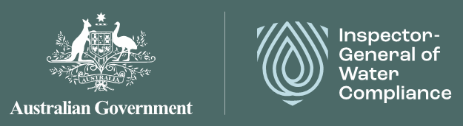

# Annual Report 2024–25

© Commonwealth of Australia 2025

### Ownership of intellectual property rights

Unless otherwise noted, copyright (and any other intellectual property rights) in this publication is owned by the Commonwealth of Australia (referred to as the Commonwealth).

### Creative Commons licence

All material in this publication is licensed under a Creative Commons Attribution 4.0 International Licence, except for content supplied by third parties, logos and the Commonwealth Coat of Arms.

Inquiries about the licence and any use of this document should be emailed to copyright@dcceew.gov.au.

CC-BY licence.

### Cataloguing data

This publication (and any material sourced from it) should be attributed as: Inspector-General of Water Compliance 2023, *Annual Report 2024-25,* the Australian Government, Canberra, August 2025. CC BY 4.0.

This publication is available at <https://www.igwc.gov.au/what-we-do/annual-reports>

Inspector–General of Water Compliance  
GPO Box 3090 Canberra ACT 2601

### Disclaimer

The Australian Government represented by the Inspector–General of Water Compliance, has exercised due care and skill in preparing and compiling the information and data in this publication. Notwithstanding, the Inspector–General of Water Compliance, the Australian Government's employees disclaim all liability, including liability for negligence and for any loss, damage, injury, expense or cost incurred by any person as a result of accessing, using or relying on any of the information or data in this publication to the maximum extent permitted by law.

### Acknowledgement of the Traditional Owners of the Murray–Darling Basin

We pay our respects to the Traditional Owners and their Nations of the Murray-Darling Basin. We acknowledge their deep cultural, social, environmental, spiritual and economic connection to their lands and waters.

Aboriginal people should be aware that this publication may contain images, names or quotations of deceased persons.

### Accessibility

The document and information are available in accessible formats. On some occasions the highly technical nature of the document means that we cannot make some sections fully accessible. If you encounter accessibility problems or the document is in a format that you cannot access, please contact us at [contact@igwc.gov.au](mailto:contact@igwc.gov.au).

# 2024-25 at a glance

* **289** stakeholder engagements
* **988** obligations, functions, powers or commitments in the Water Act, Basin Plan and intergovernmental agreements are overseen or enforced by the Inspector-General
* **47%** growth rate in FTE
* **5** NSW water resource plans are accredited, operational, and are eligible for SDL compliance assessment
* **109** sustainable diversion limits (SDLs) (80 groundwater and 29 surface water) confirmed for compliance
* **200+** documents and reports identified as part of the environmental outcomes stocktake
* **82%** water licence holders believe it's important to have an independent Basin-wide government body overseeing water rules and regulations

# Foreword by the Inspector-General

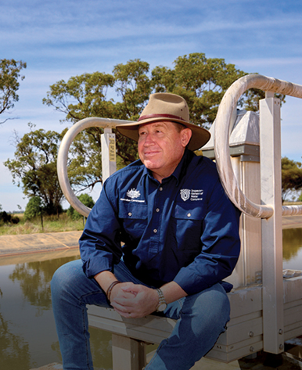

**It is an honour and privilege to undertake the functions of the Inspector–General of Water Compliance (Inspector–General) under the *Water Act 2007 (Cth)* (the Water Act). It is also an honour to have recently been reappointed as the Inspector–General by the Governor-General of Australia, the Hon. Sam Mostyn AC, for a second 4-year term commencing in August 2025.**

The Murray-Darling Basin (the Basin) covers over one million square kilometres or about 14% of the Australian continent, and covers 5 different state and territory jurisdictions. The Basin is home to about 2.2 million people, is estimated to have $69 billion of water rights, generates about $24 billion of agricultural produce and $8 billion in tourism each year, and has over 100 nationally important environmental sites[1]. The Basin is clearly unique and nationally significant – important to the whole Australian community, economy, and environment.

The landscape, the people who live and visit, and the environment are all dependent on the water resources of the Basin. It is my role as the Inspector-General to monitor and provide independent oversight of Commonwealth, state and territory agency management of the Basin water resources under *the Basin Plan 2012* (the Basin Plan) and the Water Act.

I undertake my activities of inquiry, audit, investigation, enforcement and community engagement with a genuine commitment to always act with integrity, accountability, and transparency. In this way, the role of the Inspector-General provides independent, evidence-based and trusted assessment of compliance and performance of water management agencies in delivering the Basin Plan. Critically, it ensures these assessments are visible and in a form that can be readily understood by government agencies at all levels, water users and community.

I am supported by an exceptionally skilled and hard-working team in my office, on whom I rely for the community engagement, fact finding and analysis upon which I base my findings and recommendations. I wish to thank each and every staff member for their dedication to our Strategic Plan and Annual Work Plan throughout 2024-25.

It is with enormous pride that I present the Inspector-General's Annual Report 2024-25, being my fourth annual report since the establishment of the independent Inspector-General role in 2021. This report outlines the extensive activities of me and my team in 2024-25 throughout the Basin, and explains why each activity is important, what the result of the work has been, and outlines the next steps I will take. I am proud of the report as it demonstrates the enormous volume of work that my office undertakes, and the value we provide in holding Basin agencies to account for delivery of the Basin Plan.

This reporting year has been characterised by 2 key features. Firstly, in addition to continuing to monitor compliance across the Basin, I have focused on assessing the effective implementation of the Basin Plan so its intended environmental outcomes are met. Secondly, I have scaled up my office, enabled by a budget enhancement of $28.6 million for the Inspector-General over 4 years to 2027-28.

### Monitoring

I am now undertaking monitoring of Basin State performance under the Basin Plan on an ongoing annual basis, focused on compliance performance reporting, sustainable diversion limit (SDL) compliance assessment, and Basin States' progression in comprehensive metering, and measurement of licensed water take across the Basin.

My inaugural Compliance Performance Report 2022-23 was published in December 2024, which, for the first time in one document, provides visibility of some of the Basin States' compliance approaches and activities using common metrics. I have also been monitoring compliance of the Basin States and Territories each water year with SDLs and published the third SDL Compliance Statement 2022-23 in July 2024. I will be publishing the third Metering Report Card in the next few months. I will also shortly publish a review of progress against the Compliance Compact.

Collectively, this monitoring work demonstrates a strong commitment by Basin States to improved water compliance but shows there is more to be done. More to be done to measure compliance outcomes and demonstrate that regulatory activities are driving higher water user compliance rates across the Basin. More to be done to finalise and accredit all 33 water resource plans so that there are comprehensive state agency commitments across the entire Basin. And more to be done to accelerate metering and measurement programs to meet Compliance Compact commitments and ensure water resources can be properly measured and accounted for. Collectively, these reports are also showing more needs to be done in the design of the Water Act and Basin Plan to ensure accountability for delivery of commitments, and that evaluation and oversight functions are appropriately allocated.

I will continue to closely monitor progress on these outstanding matters in coming years, and seek to ensure that a focus on these outstanding commitments is maintained and strengthened through the 2026 Basin Plan and 2027 Water Act reviews.

### Environmental outcomes

In addition to ongoing monitoring, my 2024-25 workplan focused on environmental outcomes. This work responds directly to genuine, direct and ongoing community feedback about the need to understand the Basin Plan outcomes, and to provide an evidence base to help inform the 2026 Basin Plan review.

I have recently published a stocktake of monitoring and evaluation of environmental outcomes reporting across the Basin. While this stocktake shows a high commitment to and compliance with reporting obligations by Commonwealth and Basin State agencies, it does not link management outputs to environmental outcomes. I encourage the Murray-Darling Basin Authority (MDBA) to bring together its recent evaluation report and my findings on environmental outcomes as key inputs into the Basin Plan review in 2026.

I am also nearing the completion of an audit into the sustainable use and management of groundwater resources in the Macquarie-Castlereagh water resource plan area, and another audit into the planning for environmental watering in the New South Wales Intersecting Streams and Victorian Murray. Together, these audits will provide insights into the management of water resources that support significant environmental assets in the Basin. It will provide useful information for the upcoming 2026 Basin Plan review and 2027 Water Act review. These audit reports are expected to be completed in the next few months.

I commenced an inquiry into the Northern Basin Toolkit (the Toolkit) on 30 October 2024, which is ongoing. The Toolkit is a set of measures aimed at maximising environmental outcomes in the northern Basin. This is my first inquiry as Inspector-General.

### Scaling up the office of the Inspector–General of Water Compliance

The role of the Inspector-General will have existed for 4 years in August 2025. During this time, I have set up a team to support me in performing my statutory functions under the Water Act. This set up phase included recruiting a small team, establishing governance arrangements, and developing and implementing procedures as well as delivering the Inspector-General's functions under the Water Act.

The Inspector-General was also subject to an independent review in 2023, known as the Harris Review. This review was a government election commitment to assess the Inspector-General's performance after their first 12 months of operation, and strengthen their powers if necessary. The Harris Review highlighted a potential conflict of interest in the governance arrangement of the Inspector-General, particularly in relation to the structural location of my team within the Commonwealth Department of Climate Change, Energy, the Environment and Water (Commonwealth DCCEEW), a department over which I have certain oversight responsibilities under the Water Act. In response to the Harris Review, and enabled by additional funding for the next 4 years, I have taken actions to scale up the organisation and respond to the Harris Review recommendations within my control, including the creation of a separate Legal Services Branch, expanding the senior executive supporting me, and establishing capacity to undertake the Inspector-General's inquiry functions under the Water Act.

While I am now well-resourced to step up my monitoring and oversight of Commonwealth and Basin State agency implementation of the Basin Plan, I will continue to seek action through the Basin Plan and Water Act reviews, as well as the review of the Inspector-General, on the outstanding Harris Review recommendations. Specifically, strengthening the independence of the Inspector-General as a Commonwealth integrity agency, improving Basin Plan governance and accountability which is relevant to my role, and enhancing the monitoring and oversight tools available to me.

It is this independence and clarity that ensures the Inspector-General will continue to be a trusted oversight body within the Basin.



**The Hon. Troy Grant**

Inspector-General of Water Compliance

# Contents

Annual Report 1

2024-25 at a glance 4

Foreword by the Inspector-General 5

Contents 10

01 Introduction 12

About the Inspector-General 12

02 Compliance activities 22

Stocktake of environmental outcomes 22

Ongoing audits 25

Review of audit recommendations: controls supporting Basin Plan compliance 28

Compliance and enforcement for data accuracy on trade application forms 30

Monitoring compliance with water resource plans 31

Assessing compliance with sustainable diversion limits 34

Investigation statistics for 2024-25 38

03 Oversight activities 42

Compliance performance reporting 42

Metering Report Card 43

Ongoing inquiry into the Northern Basin Toolkit 44

04 Engagement activities 46

Community sentiment 46

Stakeholder engagement 48

Agency collaboration 50

05 Governance and operational progress 52

Modern Regulator Improvement Tool 52

Statement of Expectations and Statement of Intent 55

Implementation of the 2024 independent review of the Inspector-General 57

Reappointment 59

06 Work Plan 2024-25 60

07 Looking forward 62

2025-26 Review of the role of the Inspector-General 62

Review of the Basin Plan 62

Review of the Water Act 63

Annual Work Plan 2025-26 64

Endnotes 65

# 01 Introduction

**The Inspector-General of Water Compliance (the Inspector-General) reports on the activities undertaken in the previous financial year by preparing an annual report in accordance with section 215Y of the *Water Act 2007 (Cth)* (the Water Act). This report fulfils that legislative requirement.**

The Inspector-General's financial statements and other information required by the *Public Governance, Performance and Accountability Act 2013* *(Cth)* are reported each year in the annual report of the Commonwealth Department of Climate Change, Energy, the Environment and Water (Commonwealth DCCEEW).

## About the Inspector-General

The Inspector-General is an **independent statutory office holder appointed on a four-year term under the Water Act and is an integrity agency** for the purposes of the *National Anti-Corruption Commission Act 2022* with oversight, monitoring and enforcement functions and powers in relation to the Water Act and the *Basin Plan 2012* (the Basin Plan). This provides independent oversight of the performance of function and exercise of powers by the Commonwealth and [2]performance of Basin States against certain obligations under the Water Act, Basin Plan, water resource plans and specified intergovernmental agreements.

The Commonwealth Water Minister is the Minister responsible for the Inspector-General of Water Compliance.

Like other statutory officers, the Inspector-General is accountable to the Commonwealth Parliament. The Inspector-General also engages directly with the Australian community in relation to the management of the Murray-Darling Basin (the Basin) water resources.

### What the Inspector-General does

The Inspector-General's functions under section 215C Water Act broadly entail:

* Monitoring and overseeing the performance of certain functions and exercise of certain powers by agencies of the Commonwealth under the Water Act and the Basin Plan.
* Monitoring and overseeing relevant Commonwealth, and Basin State government agencies' performance in the management of Basin water resources.
* Enforcing compliance with certain Commonwealth laws that regulate the management of Basin water resources and the provision of water markets information.
* Engaging with the Australian community on the management of Basin water resources.

**Figure 1** – Organisational Structure of the Inspector-General of Water Compliance

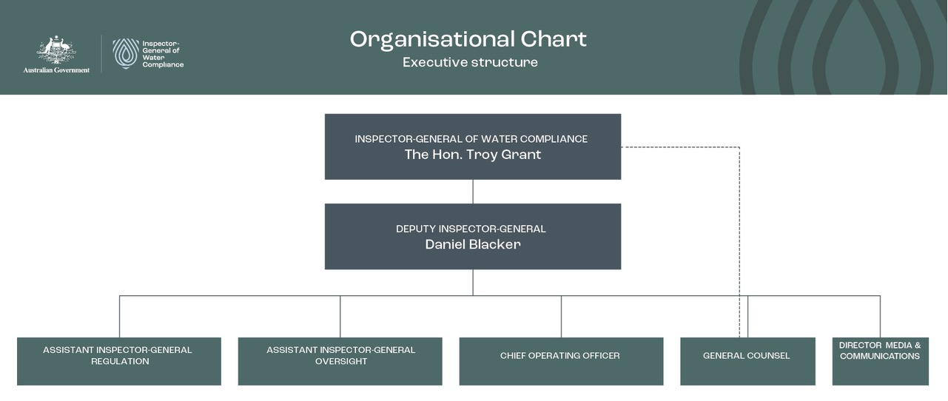

<description>

Diagram titled "Organisational Chart, Executive structure". The chart contains text boxes joined by lines in a hierarchical structure. Each box is listed below, starting from the top.

1. INSPECTOR-GENERAL OF WATER COMPLIANCE, The Hon. Troy Grant: Links downward to 2, and has a dotted link downward to 6.
2. DEPUTY INSPECTOR-GENERAL, Daniel Blacker: Links downward to each box from 3 to 7.
3. ASSISTANT INSPECTOR-GENERAL REGULATION
4. ASSISTANT INSPECTOR GENERAL OVERSIGHT
5. CHIEF OPERATING OFFICER
6. GENERAL COUNSEL
7. DIRECTOR MEDIA & COMMUNICATIONS

</description>

### Independence

The Inspector-General is established as an independent, statutory officer under the Water Act. The independent role is important to supporting community confidence in the management of Basin water resources, by ensuring there is objective, impartial and evidence-based oversight of the performance of the Commonwealth and Basin States in complying with certain obligations for the management of the Basin water resources under the Water Act and the Basin Plan. Independence is fundamental to the Inspector-General's role and the role of officers assisting the Inspector-General under the Water Act. Important elements of this independence include:

* **Statutory independence:** the Inspector-General separately determines workplans, priorities and exercise of powers under the Water Act, and can only be directed by the Minister in limited circumstances specified in section 215D Water Act.
* **Access to resources:** the Inspector-General has a dedicated budget and staffing allocated to support the role from within the Commonwealth DCCEEW.

The Inspector-General takes a risk and evidence-based approach to planning and undertaking its monitoring, oversight and enforcement functions under the Water Act, in accordance with its published Regulatory Policy and principle 2 of government's Regulator Performance expectations set out in Resource Management Guide 128 (RMG128). Refer to the Inspector-General's website for more about the Regulatory Policy.

**The Inspector-General strives to be open and transparent.**

The Inspector-General is committed to being transparent and open in undertaking the functions of the Inspector-General set out by section 215C Water Act through:

* regular engagement with the community
* public reporting, including this Annual Report
* publishing an Annual Work Plan
* accountability to the Australian Parliament and the Commonwealth Water Minister.

### Values

At all times, the Inspector-General and their staff act within the Australian Public Service (APS) Code of Conduct and values, in addition to the values they seek to embed into the fabric of Basin water management. The core values of the Inspector-General are integrity, accountability and transparency (Figure 2).

**Figure 2** – The Inspector-General's values

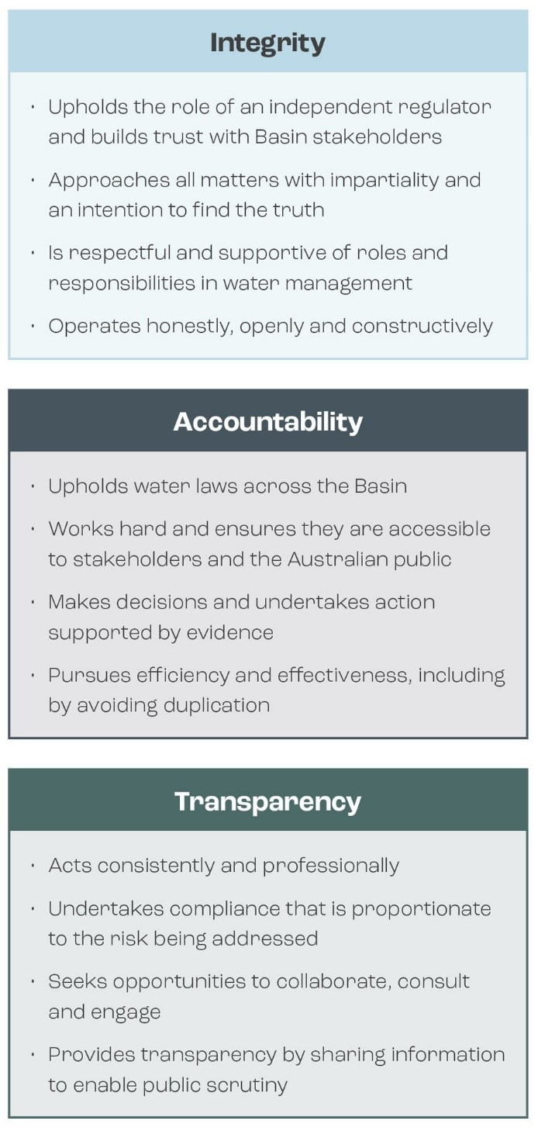

<description>

Three boxes describing Integrity, Accountability and Transparency. Each is transcribed below.

#### Integrity

* Upholds the role of an independent regulator and builds trust with Basin stakeholders
* Approaches all matters with impartiality and an intention to find the truth
* Is respectful and supportive of roles and responsibilities in water management
* Operates honestly, openly and constructively

#### Accountability

* Upholds water laws across the Basin
* Works hard and ensures they are accessible to stakeholders and the Australian public
* Makes decisions and undertakes action supported by evidence
* Pursues efficiency and effectiveness, including by avoiding duplication

#### Transparency

* Acts consistently and professionally
* Undertakes compliance that is proportionate to the risk being addressed
* Seeks opportunities to collaborate, consult and engage
* Provides transparency by sharing information to enable public scrutiny

</description>

### Strategic outcomes

The Inspector-General's vision is that water management and use within the Basin is lawful, transparent, and accountable, and the Australian public is confident in the integrity of Basin Plan delivery.

#### Strategic objectives

The Inspector-General has 4 strategic objectives that will contribute to realising this vision, namely: ensure it's lawful; ensure it's visible; make it better; do it better. More detail on each of these strategic objectives is at Figure 3. Symbols throughout this report refer to the relevant strategic objectives. For example, the shield symbol signals outcomes linked to the strategic objective 1, ensure it is lawful*.*

**Figure 3** – Strategic objectives of the Inspector-General 2023–26

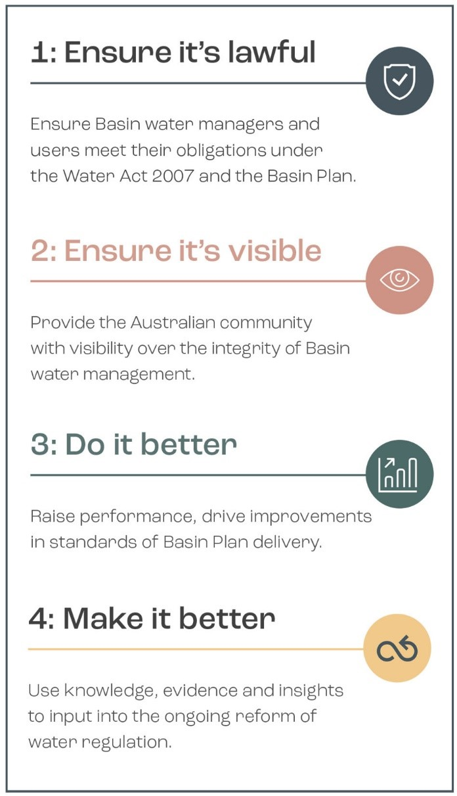

<description>

List of four strategic objectives. Each item is transcribed below.

#### 1: Ensure it's lawful

Ensure Basin water managers and users meet their obligations under the Water Act 2007 and the Basin Plan.

#### 2: Ensure it's visible

Provide the Australian community with visibility over the integrity of Basin water management.

#### 3: Do it better

Raise performance, drive improvements in standards of Basin Plan delivery.

#### 4: Make it better

Use knowledge, evidence and insights to input into the ongoing reform of water regulation.

</description>

#### Work plan priorities

The Inspector-General must prepare and publish an Annual Work Plan setting out key outcomes and priorities for the financial year, in accordance with section 215E Water Act. The 2024-25 Annual Work Plan identified 2 priorities:

|  |  |
| --- | --- |
| Plant leaf icon. | 1. Environmental outcomes |
| **Icon of document with tick.** | 2. Inquiry into the Northern-Basin Toolkit |

Further information is at [www.igwc.gov/au/what-we-do/annual-work-plans](http://www.igwc.gov/au/what-we-do/annual-work-plans)

### Roles and responsibilities of other agencies

Basin State governments are responsible for monitoring and enforcing compliance with the State water laws in their jurisdictions and for determining the allocations between different types of water use within a sustainable diversion limit (SDL) for each water source.

Several Australian Government entities have responsibilities relating to Basin Plan implementation that fall within the Inspector-General's remit of oversight. They include:

* the Murray–Darling Basin Authority (MDBA)
* the Commonwealth DCCEEW
* the Commonwealth Environmental Water Holder (CEWH).

Figure 4 shows some of the different roles of the Inspector-General, the MDBA and Basin State agencies in managing the Basin's water resources.

**Figure 4** – Roles and responsibilities in Basin water management and oversight

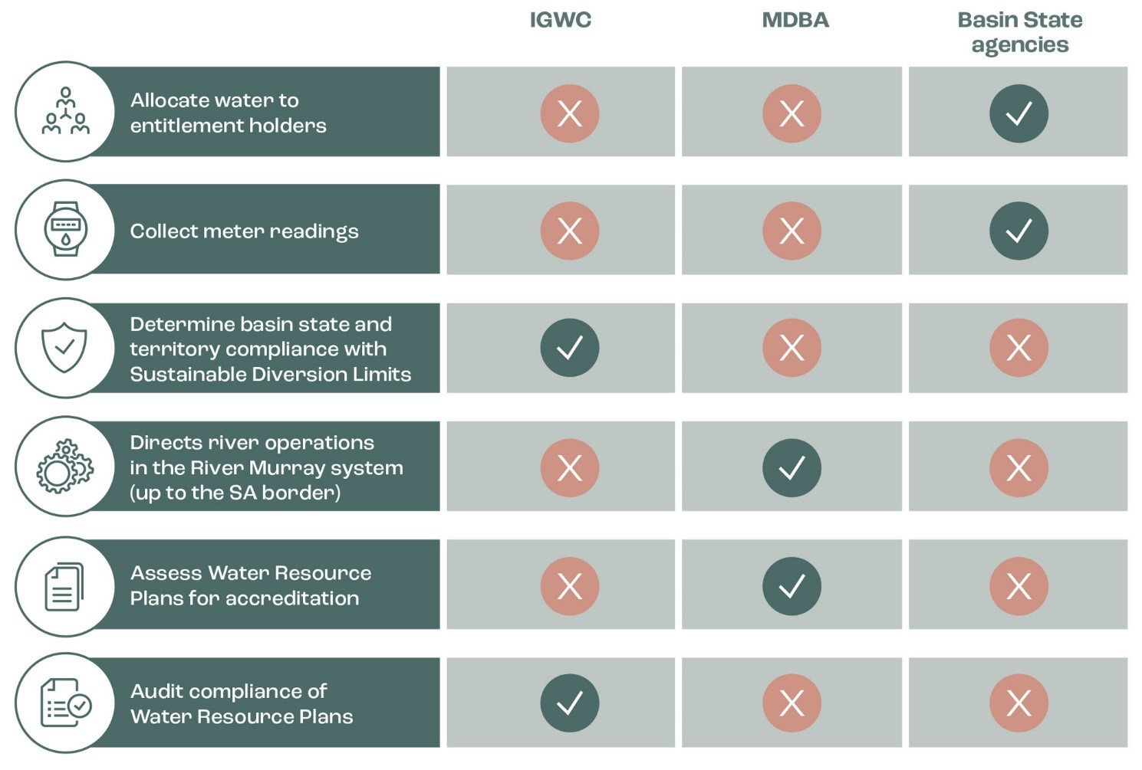

<description>

Table showing roles and responsibilities for three agencies.

|  | **IGWC** | **MDBA** | **Basin State agencies** |
| --- | --- | --- | --- |
| Allocate water to entitlement holders | ❌ | ❌ | ✓ |
| Collect meter readings | ❌ | ❌ | ✓ |
| Determine basin state and territory compliance with Sustainable Diversion Limits | ✓ | ❌ | ❌ |
| Directs river operations in the River Murray system (up to the SA border) | ❌ | ✓ | ❌ |
| Assess Water Resource Plans for accreditation | ❌ | ✓ | ❌ |
| Audit compliance of Water Resource Plans | ✓ | ❌ | ❌ |

</description>

# 02 Compliance activities

## Stocktake of environmental outcomes

 

The stocktake of environmental outcomes monitoring and evaluation reporting was published in June 2025. It is a list of publicly available reports from Commonwealth and Basin State agencies that address the monitoring and evaluation requirements and obligations related to environmental outcomes, including for environmental water.

The full report is available on the Inspector-General's [website](https://www.igwc.gov.au/publications/reviews-reports) at [www.igwc.gov.au/what-we-do/reviews-and-reports](http://www.igwc.gov.au/what-we-do/reviews-and-reports)

### Why this work is important

During the passage of the *Water Amendment (Restoring Our Rivers) Act 2023* (Restoring Our Rivers Act) in late 2023, the Inspector-General heard concerns from stakeholders relating to environmental outcomes throughout the Basin. As the 2026 review of the Basin Plan draws nearer, there is a growing shift in public attention from implementation to evaluating the Basin Plan's effectiveness in achieving environmental outcomes. The Inspector-General has therefore undertaken a stocktake of publicly available Basin Plan environmental outcomes evaluation and reporting which provided evidence that there is a legislated framework in place and that the Basin State agencies understand their role for monitoring and evaluation of environmental outcomes from Basin water management and are discharging these obligations.

### Key facts

* The scope of the stocktake focuses on monitoring and evaluation reporting related to Basin Plan environmental outcomes.
* The stocktake does not assess whether reporting obligations have been met, nor does it asses their content.
* Documents and reports were collected from 7 Basin State and Commonwealth agencies.
* Over 200 documents and reports were identified.

### Insights

In undertaking the stocktake, the Inspector-General identified several key insights, all of which highlight the complexity of the reporting requirements and their impact on managing the Basin's water resources:

|  | Insight | Impact |
| --- | --- | --- |
| ❌ | It is very difficult to navigate and understand how the large number of publicly available reports are interconnected. These reports then reference numerous technical reports and data, usually at a catchment scale, which may not always be publicly available. | This may present challenges in determining the key evidence used to inform Basin-scale evaluation. |
| ✓ | The stocktake of reports shows that the legislated framework in place for monitoring and evaluation reporting is clear and has been implemented. | The public can have confidence that agencies are fulfilling their responsibilities to monitor and evaluate environmental outcomes. |
| ✓ | It is clear within the legislated framework that Basin State and Commonwealth agencies have well defined roles and responsibilities. Under this framework, the MDBA reports on Basin-wide outcomes, including water usage and environmental health, while the CEWH reports on the use and outcomes of Commonwealth environmental water. Basin State agencies are responsible for reporting on their water resource plans, compliance with sustainable diversion limits, and local environmental outcomes. | The clearly legislated roles and responsibilities ensure that agencies can be held to account for meeting their reporting obligations. |
| ✓ | There is evidence that agencies are carrying out their roles and responsibilities to produce monitoring and evaluation reports and are committed to providing timely information about water management. | There are monitoring and evaluation reports available to support informed decision-making and improved management of water resources in response to changing conditions. |
| ❌ | The management of the Murray-Darling Basin requires detailed reporting across complex themes – environmental, social and economic, each of which have multiple indicators. This complexity is compounded by the involvement of multiple agencies and differing approaches to reporting, and reporting at different geographical scales – such as catchments, water resource plan areas, and Basin-wide. | This may contribute to difficulties in synthesising information in a way that meaningfully reflects Basin-wide trends or progress towards achieving environmental outcomes |
| ❌ | Reports are publicly available via agency websites. However, the information is often deeply embedded within multiple layers of menus and subpages. | The community has access to monitoring and evaluation information. However, it is difficult for individuals to locate necessary information efficiently. |

### Next steps

The Inspector-General will continue to monitor publication of these reports as part of their ongoing activities and use the report contents to inform the focus of ongoing compliance and performance monitoring.

## Ongoing audits

 

The Inspector-General commenced 2 audits during 2024-25 focused on environmental outcomes during the reporting year. These 2 audits are:

* **Macquarie-Castlereagh audit** – the sustainable use and management of groundwater resources in the Macquarie-Castlereagh water resource plan area
* **NSW Intersecting Streams and Victorian Murray audit** – implementation of rules and commitments made in the Intersecting Streams and Victorian Murray water resource plans when planning for environmental watering.

|  |
| --- |
| **What are water resource plans?**  Water resource plans are required under section 54 of the Water Act and are a key part of delivering the Basin Plan. The water resource plans make commitments by relevant Basin States about how they will manage water resources in each water source. This includes compliance with SDLs and trade rules; water quality objectives and salinity management; measurement and monitoring; protection of environmental water; consideration of First Nations values and uses; and arrangements for extreme weather events.  **Who's involved in water resource plans?**  **Prepared by:** Basin State governments  **Assessed by:** Murray–Darling Basin Authority  **Accredited by:** Commonwealth Minister for Water  **Monitored by:** Inspector-General of Water Compliance |

### Why this work is important

#### Macquarie-Castlereagh audit

This groundwater area has a significant hydrologic connection to surface water, and rules in the water resource plan are critical to the protection of over 20 groundwater dependent woodland forests and wetlands.

This audit allows the Inspector-General to provide visibility to the Australian community on the use and management of groundwater resources in the Macquarie-Castlereagh Alluvium water resource plan area and improve public confidence in how implementation of the Basin Plan is being monitored.

#### Intersecting Streams and Victoria Murray audit

Both these water resource plan areas contain significant wetlands where environmental water is crucial to the habitat of plants and animals and is important for conserving biological diversity.

This audit will provide visibility on how environmental watering is planned in water resource plan areas which contain significant wetlands and improve public confidence that there is appropriate oversight of environmental watering and its contribution to environmental objectives.

### Key facts

#### Macquarie-Castlereagh audit

The audit will determine whether rules are being implemented to ensure that the productive base of groundwater and environmental watering requirements are not being compromised.

This audit is focussing on the rules and commitments made in the Macquarie-Castlereagh Alluvium water resource plan for addressing water resource plan requirements in the following sections of the Basin Plan:

* section 10.18 Priority environmental assets dependent on groundwater
* section 10.19 Groundwater and surface water connections
* section 10.20 Productive base of groundwater

The audit commenced in March 2025.

#### Intersecting Streams and Victoria Murray audit

The audit will determine whether New South Wales and Victoria are implementing rules and commitments made in the New South Wales Intersecting Streams and Victorian Murray water resource plans when planning for environmental watering.

This audit will focus on rules and commitments made in the New South Wales Intersecting Streams and Victorian Murray water resource plans for addressing water resource plan requirements in the following sections of the Basin Plan:

section 10.26 Planning for Environmental Watering

section 10.27 Enabling environmental watering between connected water resources

section 10.28 No net reduction in the protection of planned environmental water

The audit commenced in March 2025.

### Next steps

Both audits were commenced in the reporting period and will be completed in the first half of 2025-26.

## Review of audit recommendations: controls supporting Basin Plan compliance



In 2023–24, the Inspector-General undertook an audit titled *Controls supporting compliance with Basin Plan Requirements – Department of Climate Change, Energy, the Environment and Water.* This audit was published in September 2024 on the Inspector-General's website.

The audit assessed the controls in place within the Commonwealth DCCEEW to ensure that employees with prior knowledge of the upcoming *Bridging the Gap* announcement did not engage in certain water trading activities before the information became public. These controls relate to sections 12.51 and 12.52 of the Basin Plan.

The audit made 8 recommendations in total to the Water Group within Commonwealth DCCEEW and the CEWH. During 2024-25, the Inspector-General conducted a review of these audit recommendations.

### Why this work is important

Public confidence in water management, including Commonwealth involvement in water trading, relies on ensuring integrity in Commonwealth processes and practice for water trading.

### Key facts

In early 2025, following the Inspector-General's audit, Commonwealth DCCEEW conducted a review of the controls supporting compliance with Basin Plan trading rules. The Inspector-General confirmed that all evidence demonstrating the implementation of recommendations was made available and shared during the review process.

### Findings

Overall, it has been confirmed that the recommendations have been either fully implemented or are actively being implemented by relevant Commonwealth agencies.

Eight recommendations were made in total to both Commonwealth DCCEEW (6 recommendations) and the CEWH (2 recommendations) related to strengthening processes to manage conflicts of interest, protect sensitive information, keep policies up to date and legally compliant, and ensure staff are trained properly.

All 6 recommendations have now been implemented by Commonwealth DCCEEW, and the CEWH has commenced implementation of their 2 recommendations as part of a broader probity framework being developed.

### Next steps

The Inspector-General has made no further recommendations regarding internal Commonwealth controls for staff water trading. The responsibility now lies with the auditees to complete the implementation of improvements arising from the audit recommendations.

## Compliance and enforcement for data accuracy on trade application forms



On 1 July 2024, new requirements in the Water Act commenced that require buyers, sellers and water brokers to report all information on a trade application form accurately and comprehensively. These changes are part of the Commonwealth Government's response to the Australian Competition and Consumer Commission's (ACCC's) 2021 *Water Markets Inquiry.* The Inspector-General is responsible for enforcing the rules for accuracy and completeness of trade application forms.

### Why this work is important

Accurate and complete water markets information is an essential requirement for an efficient and effective water trading market as it informs and supports water market participants' decision-making.

### Key facts

The 2023 Trade Price Reporting investigation report undertaken by the Inspector–General highlighted deficiencies with the price reporting requirements in the Basin Plan. This report, along with the observations from the ACCC's water markets inquiry and the Commonwealth Government's response, led to the new requirements as part of the recent water market reforms.

The new requirements on buyers, sellers and water brokers to report information on a trade form accurately and comprehensively help to ensure that the information available to the water market under the Water Market Data Standard is correct.

### Activities undertaken by the Inspector-General

The Inspector-General has incorporated the new requirements into their compliance monitoring program and is examining water market data to identify individual trades which may be non-compliant.

A set of Frequently Asked Questions has been published on the Inspector–General's to help people understand the requirements. These are available at [www.igwc.gov.au/get-involved/are-you-compliant](http://www.igwc.gov.au/get-involved/are-you-compliant).

### Next steps

The Inspector-General's work on ensuring compliance with water trade data forms is ongoing, and will expand once access to improved water market information is available through the Water Market Data Standard.

It is expected that the Water Market Data Standard will commence on 1 July 2026. Water Market information will be collected by the Bureau of Meteorology (the Bureau) from several sources including Basin States, irrigation infrastructure operators and water brokers. Some of this information will be publicly reported by the Bureau, but all information will be available to the ACCC and the Inspector-General for enforcement purposes.

## Monitoring compliance with water resource plans

  

### Why this work is important

Water resource plans are an integral part of implementing the Basin Plan. In particular, the water resource plans outline Basin State commitments in each water source across the Basin for compliance against SDLs, management of water quality objectives and salinity, protection of environmental water, how First Nations values and water uses are considered, how water management outcomes will be evaluated and reported, and arrangements for extreme weather events. Basin State governments are responsible for implementing water resource plans in accordance with the Basin Plan.

### Key facts

* The Inspector–General monitors water resource plans, which are accredited by the Commonwealth Minister for Water based on the assessment and advice from the MDBA.
* All water resource plans in the Australian Capital Territory, Queensland, South Australia and Victoria are accredited and in operation.
* In New South Wales, 16 water resource plans were accredited as at the end of 2023-24. An additional 4 water resource plans remain unaccredited. These 4 water resource plans are in the Gwydir and Namoi water sources.
* Water resource plans must be operational for a full 12 months before the MDBA will include water take numbers in the Registers of Take. The Register of Take informs the Inspector–General's SDL compliance assessment.
* The Inspector–General's Water Resource Plan Compliance and Enforcement Framework outlines our compliance powers in relation to water resource plans and sets out how the implementation of water resource plans is being monitored by the Inspector–General to provide transparency and build community confidence. The framework was developed during 2024-25 and published in July 2025.

### Findings

For the first time, 5 New South Wales (NSW) groundwater water resource plan areas were assessed for compliance as part of the Inspector–General's SDL Compliance Statement for 2023-24. These areas were:

* NSW Border Rivers Alluvium
* NSW Murray-Darling Basin Fractured Rock
* NSW Murray-Darling Basin Porous Rock
* Macquarie-Castlereagh Alluvium
* Darling Alluvium

A further 11 water resource plans were accredited in New South Wales during 2023-24, and will be included in future SDL assessments, once they have been operational for 12 months.

For more information on the SDL Compliance Statement, refer to below section.

### Next steps

The Inspector-General is now developing fit-for-purpose water resource plan reporting guidelines in consultation with the MDBA and Basin States. Purposeful, streamlined and consistent reporting will support the provision of data and information necessary to enable ongoing monitoring of, and response to, non-compliance risks of water resource plans.

As the Inspector-General's compliance audit and other compliance powers are not enlivened until 12 months after water resource plans are accredited, the Inspector-General continues to closely monitor the progress of New South Wales water resource plan accreditation in the Gwydir and Namoi areas.

## Assessing compliance with sustainable diversion limits



|  |
| --- |
| **What are Sustainable Diversion Limits (SDLs)?**   * SDLs are the long-term average annual volumes of water that can be taken from a water resource for consumptive use. * SDLs effectively limit the amount of water that can be taken from rivers and aquifers for agriculture, industry, town water supply and water users.   **Why are SDLs important?**   * SDLs promote the sustainable use of water, to ensure that there is enough water in river systems for all uses. * They account for the consumptive use of water, which is water used by Basin communities, towns, and industries. * SDLs are essential to the implementation of the Basin Plan, as they provide for *'the establishment and enforcement of environmentally sustainable limits on the volume of surface water and ground water that may be taken from Basin water resources',* ensuring that enough water remains in river systems to support healthy waterways and ecosystems. |

### Why this work is important

SDLs are a key element of the Basin Plan to:

* limit the level of water taken and used for consumptive purposes
* ensure that sustainable levels of water are available for water-dependent environments

### Key facts

* The Inspector–General is responsible for monitoring Basin State governments' compliance with SDLs.
* An SDL is the collective limit for all forms of consumptive water taken within an SDL water resource unit.
* Under the Basin Plan, SDLs are set for 109 water resource units: 29 surface water resource units and 80 groundwater resource units.
* There are currently 78 SDL resource units that are within accredited water resource plan areas and therefore able to be assessed for compliance (19 surface water and 59 groundwater) in 2023-24.
* Each year the Inspector–General assesses eligible SDL compliance by Basin States and makes a public statement of compliance.

### Findings

The Inspector-General's SDL Compliance Assessment 2023-24 was undertaken during 2024-25 and was published in August 2025.

The SDL compliance assessment for the 2023–24 water year used information from the MDBA Registers of Take report on surface water and groundwater SDL resource units.

In 2023–24, all 78 eligible resource units complied with SDLs. Therefore, the Basin States were not required to provide reports of a reasonable excuse and or action plans under the Basin Plan.

For the first time, 5 New South Wales groundwater water resource plan areas were assessed for compliance. However, the Inspector–General assessed no surface water SDL resource units in New South Wales for compliance, as no water resource plans were operating in New South Wales for the entirety of 2023–24 water year.

Figure 5 shows 2023-24 surface water SDL compliance, and figure 6 shows 2023-24 groundwater SDL compliance.

**Figure 5** – 2023-24 surface water SDL compliance

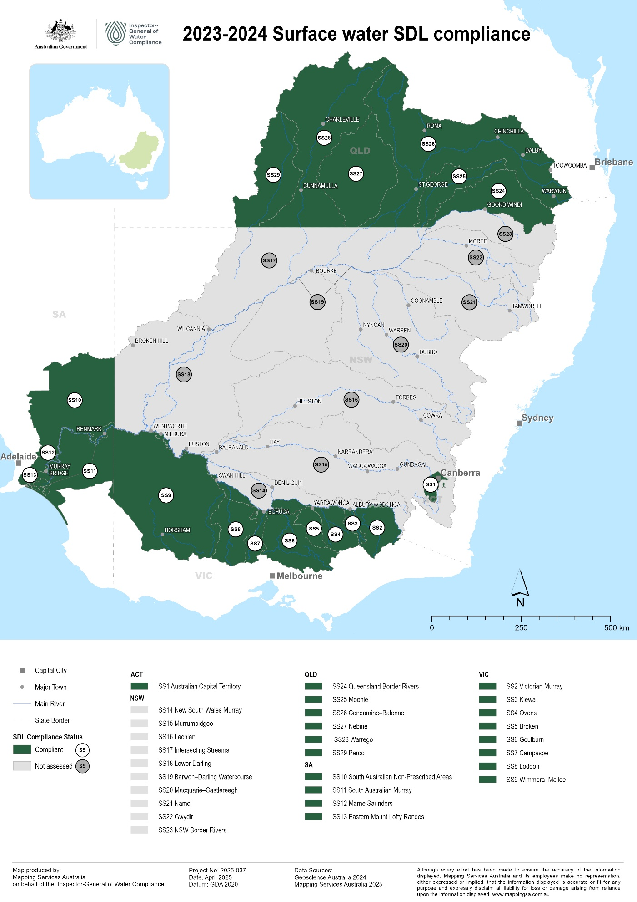

**Figure 6** – 2023-24 groundwater SDL compliance

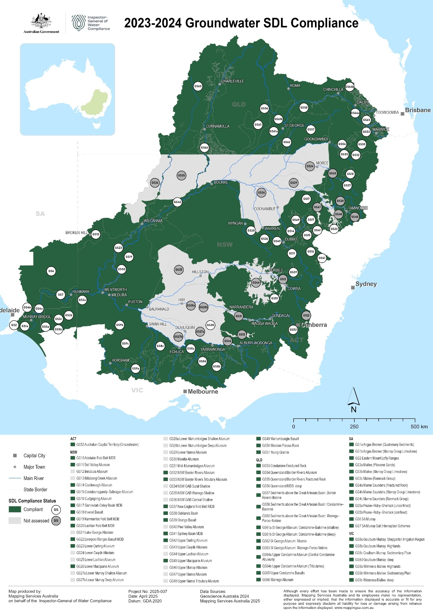

Note: While all deeper SDL Resource Units within the NSW Murray-Darling Basin Fractured Rock and Porous Rock water resource plan areas are assessed as compliant, some parts are not shown on the groundwater map due to being overlain by other groundwater units that cannot be assessed; together, these two plan areas cover the entire NSW portion of the Basin.

### Next steps

The Inspector-General is establishing an expert panel to provide guidance, assistance and expertise to the Inspector-General in matters relating to SDL Compliance, assessment of claims of reasonable excuse and the form and content of SDL compliance statements.

## Investigation statistics for 2024-25

 

The Inspector-General conducts investigations where there is information about possible non-compliance with water management obligations under Part 2 and 10AA of the Water Act, the Basin Plan and water resource plans as they apply to agencies of a Basin State and/or the Commonwealth, operating authorities, infrastructure operators, or the holder of a water access right.

In 2024–25, the Inspector-General identified potential cases for investigation through stakeholder allegations, intelligence gathering, and the compliance risk registers maintained by monitoring teams. The Inspector-General adopts a risk-based enforcement approach, guided by our Regulatory Policy, which considers factors such as the seriousness, impact, and culpability of any alleged breach.

During the reporting period, the Inspector-General received several new matters, primarily relating to potential breaches of the Basin Plan's water trading rules. Five cases were closed in 2024-25. Several instances of minor non-compliance were detected, particularly concerning the publication of trade rules by Irrigation Infrastructure Operators (IIOs). Importantly, these matters were resolved without formal enforcement action, rather compliance was achieved through dialogue and collaboration.

Figure 7 below shows the number of investigations per jurisdiction, and their status, for 2024-25. Figure 8 summarises processing times of investigations by the Inspector–General's team.

In line with their commitment to transparency, the Inspector–General periodically updates information regarding investigations on their website, including the category of investigations by state.

**Figure 7** – Number of investigations by state and status

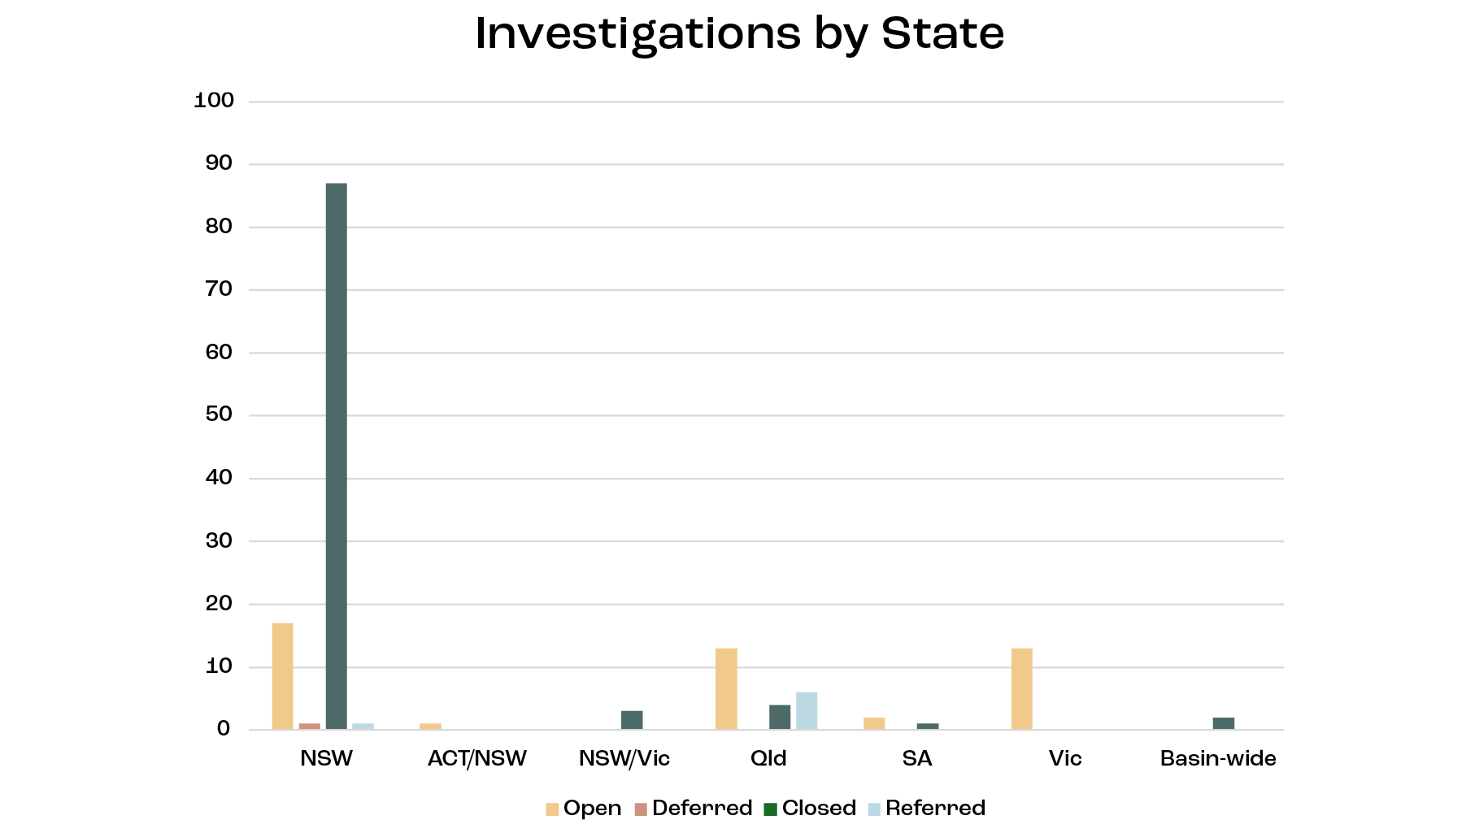

<description>

Bar graph titled "Investigations by State". Approximate values are provided below.

|  | Open | Deferred | Closed | Referred |
| --- | --- | --- | --- | --- |
| NSW | 17 | 1 | 88 | 2 |
| ACT/NSW | 1 | 0 | 0 | 0 |
| NSW/Vic | 0 | 0 | 3 | 0 |
| Qld | 13 | 0 | 4 | 6 |
| SA | 3 | 0 | 2 | 0 |
| Vic | 13 | 0 | 0 | 0 |
| Basin-wide | 0 | 0 | 3 | 0 |

</description>

**Figure 8** – Timeframes to complete investigations

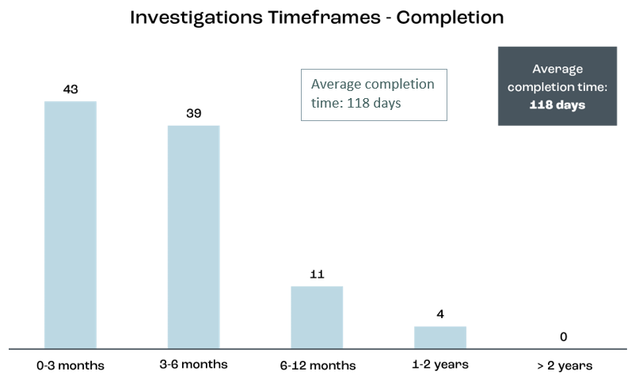

<description>

Bar chart titled "Investigation Timeframes - Completion". Values are listed below.

* 0-3 months: 43
* 3-6 months: 39
* 6-12 months: 11
* 1-2 years: 4
* > 2 years: 0

A text box reads "Average completion time: 118 days".

</description>

# 03 Oversight activities

## Compliance performance reporting

 

The first Compliance Performance Report was published in December 2023. This report contained information on selected common compliance activity metrics agreed by Basin compliance regulators.

In 2024-25, the Inspector–General continued to work with Basin compliance regulators to expand this reporting to include more performance indicators and outcomes where possible. The Inspector–General intends to publish the next Compliance Performance Report in late 2025.

### Why this work is important

Reporting on the performance of the compliance activities of Basin States aims to improve the community's confidence that regulators are effectively and fairly managing water resources. It enhances transparency by highlighting what compliance activities have been undertaken and what outcome or impact these activities are having for Basin water management. This informs stakeholders, and helps the Inspector–General to identify effective practices and areas for improvement or further assessment.

### Key facts

The inaugural compliance performance report (2022-23) highlighted the need for greater consistency and transparency in compliance performance reporting and the importance of ongoing collaboration among jurisdictions to develop Basin-wide measures of compliance effectiveness and the outcomes of this compliance activity.

### Next steps

The Inspector–General is working collaboratively with all Basin State water compliance agencies through the Regulatory Leaders Forum to continually improve this compliance performance reporting.

## Metering Report Card

 

### Why this work is important

The measurement of water take is fundamental to the management of Basin water resources, including water accounting, making allocation decisions, and undertaking compliance and enforcement to ensure that all water users and the environment get their fair share of available water. The Compliance Compact requires Basin States to meter all licensed water take by June 2025.

The Inspector–General publishes a Murray–Darling Basin Metering Report Card each year to ensure transparency about the Basin States' progress against this commitment. The annual Metering Report Card provides transparency about the volume of take that is metered, the accuracy of measurement of licensed take across the Basin, and the timeliness of meter readings. The Metering Report Card also addresses the measurement of floodplain harvesting, ensuring transparency to the community about measurement of this form of water take in the Basin.

### Findings

The fourth annual Metering Report Card, for 2023-24, was compiled during 2024-25 and is scheduled to be published in early 2025-26.

Over the 2023-24 period, notable developments in metering across the Basin included a review by the New South Wales government of its metering framework, the commencement of meter telemetry installation in Queensland, and the roll out of AS4747 compliant meters and grandfathering of existing meters in the Australian Capital Territory.

Meter coverage across the Basin States was generally consistent with the previous Metering Report Card from 2022-23, with the Australian Capital Territory, South Australia and Victoria all continuing to have the vast majority of licensed take monitored with meters. Metering accuracy improved across all states with progress in the installation of AS4747 meters and grandfathered meters during 2023-24.

#### Compliance Compact

The Basin States committed in the Compliance Compact to have metering frameworks in place to ensure non-urban meters comply with the Australian Standard (AS4747) or have suitable exemptions or grandfathering arrangements by June 2025. Based on data and information received by the Inspector-General from the Basin States under the Metering Report Card, most Basin States are progressing to meet this deadline. New South Wales has acknowledged that its metering framework is behind schedule and is prioritising meter installations in the Basin over other parts of the state, and adopting a more risk-based metering framework.

### Next steps

Once published, the Metering Report Card for 2023-24 will be available at [www.igwc.gov.au/what-we-do/reviews-and-reports](http://www.igwc.gov.au/what-we-do/reviews-and-reports).

## Ongoing inquiry into the Northern Basin Toolkit

  

Under part 10AB of the Water Act, the Inspector–General has the power to conduct inquiries into the performance of functions and exercise of powers of Basin State government agencies in relation to the Water Act, the *Water Regulations 2008* (the Water Regulations), the Basin Plan, water resource plans and the implementation of commitments relevant to specified intergovernmental agreements.

In October 2024, the Inspector–General announced an inquiry into the Northern Basin Toolkit (the Toolkit).

### Why this work is important

The Toolkit is an important package of policy initiatives and infrastructure projects aimed at improving water management and environmental outcomes in the northern Basin, with up to $180 million in federal funding committed to its implementation.

The original deadline for the Toolkit measures was 30 June 2024. However, in August 2023, the relevant Commonwealth, Queensland and New South Wales government Ministers agreed to extend the deadline to 31 December 2026.

### Activities undertaken by the Inspector-General

The terms of reference for the inquiry cover aspects of the Toolkit program such as design, governance, implementation, expenditure, effectiveness and outcomes. More information about the inquiry, including the terms of reference, are available at [www.inquiry.igwc.gov.au](http://www.inquiry.igwc.gov.au).

As part of the Inspector–General's commitment to engage with the community, members of the inquiry team have conducted on-site visits throughout the northern Basin and met with interested stakeholders in affected communities. The inquiry also received a number of formal submissions from both government and non-government stakeholders.

### Next steps

It is expected that an Inquiry report will be provided to the Minister by late 2025.

# 04 Engagement activities

## Community sentiment



The Inspector-General has conducted an Annual Community Sentiment Survey for the past 3 years for research, data gathering (sentiment tracking) and analysis reasons. The surveys are distributed in 2 alternate formats:

* a longer, more research-intensive format, used in 2022 and 2024
* a more targeted, smaller sample scope format, used in 2023.

### Why this work is important

The research gives the Inspector-General an understanding of the levels of trust and confidence in water management across the Basin and informs the Inspector–General's Annual Work Plan. The Community Sentiment Survey also provides individual states and territory with community sentiment insights relevant to their jurisdictions.

### Key facts

The primary objective of the surveys is to understand and track the level of community trust and confidence in Basin water compliance and management.

Both qualitative and quantitative methodologies are used to gather data.

In 2024, 1,068 people participated in the survey, including both Basin community members and water licence holders. An increase in refusal to participate was reported among water licence holders. This was in part due to 'over consultation' and 'consultation-fatigue'.

* Key areas of the survey include:
* knowledge of the Murray–Darling Basin
* sentiment towards the Basin Plan
* understanding of compliance and enforcement practices.

### Findings

**Key findings from the 2024 survey are:**

* Knowledge of the Murray-Darling Basin and Basin Plan remains low. Notably, **25%** of water licence holders (WLHs) surveyed didn't know they live in the Basin. Among general community members, **72%** did not know they live in the Basin.
* The importance of water compliance and enforcement has increased among community members, from **48%** indicating high importance in 2023, to **57%** in 2024.
* Perceptions of the Basin Plan among WLHs had become more polarised, with both those supportive and not supportive of the Basin Plan rising in the 2024 data. In 2023, **35%** of WLH respondents were not supportive of the Basin Plan, and **27%** were supportive. In 2024, these numbers increased to **40%** not supportive, and **43%** supportive. Only **18%** remained neutral in 2024 (down significantly from 38% the previous year).
* The importance of having an independent Basin-wide government body overseeing water rules and regulations remains high for the community, surveying at **82%.**

**The top 3 concerns of WLHs are:**

1. distribution/allocation of water across different states
2. perceptions of mismanagement of water
3. floods, drought and climate change.

## Stakeholder engagement



### Inspector-General

The Inspector-General has a function under section 215C (c)(1)(d) of the Water Act to engage with the Australian community in relation to the management of Basin water resources.

In 2024–25 the Inspector–General and his engagement staff attended 289 stakeholder engagements. These included:

* Speaking directly with farmers and community members including First Nations and community groups, peak industry bodies, and local councils, as well as private companies and infrastructure operators
* Meeting with state and Commonwealth agencies and ministers with responsibilities for Basin water management.

### Field days

Attending field days across the Basin enables the Inspector–General to interact directly with Basin water users and the community, gathering intelligence to inform the Inspector–General's work plans, and providing information about the Inspector–General's role in a form that can be understood by the community. In 2024-25, representatives of the Inspector–General attended:

* Mallee Machinery Field Days (Vic)
* AgQuip Field Days (NSW)
* Riverlands Field Days (SA)
* Henty machinery Field Days (NSW)
* FarmFest Field Days (Qld)

At field days, the Inspector–General invited community members to participate in anonymous surveys to gauge sentiment and awareness of the Basin and Basin Plan. Staff were able to gather information on the Basin issues that resonate most with the community and identify gaps in awareness of the Basin, the Basin Plan and the Inspector–General. These surveys were conducted in addition to the annual Community Sentiment Survey. The top 3 areas of concern from these field day surveys were:

* sustainability of water supply and usage (for business, community or the environment)
* environmental impacts, including blue-green algae, blackwater, erosion, invasive species, other impacts on flora or fauna
* water quality and/or pollution.

To find out more about the importance of field days to the work of the Inspector-General, watch the 2024 Field Day Wrap up video on our YouTube channel: <https://www.youtube.com/watch?v=l_ZK6qPZE10>.

### Field officers

The Inspector-General has established a network of field officers across the Basin. Part of their job is to listen to and hear from community members about matters relating to Basin water management. The Inspector-General uses this feedback to inform the agency's work priorities and track emerging trends.

### Social media

The Inspector-General is using social media effectively to present relevant and timely information in a form that enables the community to better understand Basin water management and compliance.

These social media platforms include YouTube, LinkedIn, Instagram, podcast platforms and our website, [www.igwc.gov.au](http://www.igwc.gov.au). The platforms reached increased audiences from July 2024 to June 2025, as evidenced by:

* a 31% increase in new unique users/visitors on the website
* 207 new followers on LinkedIn
* over 1,000 downloads of the *Water's Edge* podcast
* significant growth of over 43% in YouTube views.

## Agency collaboration

### Regulatory Leaders Forum

The Regulatory Leaders Forum (RLF) was established in 2021 by the Inspector–General to provide a mechanism through which Basin state regulators and the Inspector–General can:

* share knowledge, insights and lessons
* work collaboratively to build community confidence in water management
* actively cooperate to increase transparency in compliance and enforcement work across the Basin, and
* improve the effectiveness of compliance activities.

In 2024-25, the RLF met 3 times, where members were able to share ideas and information about the following topics:

* Water metering and measurement
* Floodplain harvesting
* Strengthening water laws in various Basin jurisdictions
* Modern Regulator Improvement Tool (MRIT)
* Reviewing the Compliance Compact commitments

### Australasian Environmental Law Enforcement and Regulators neTwork (AELERT)

The Inspector-General is an active participant of AELERT, and has been since 2021. AELERT is comprised of more than 250 member agencies from internationally recognised and respected regulators. The Inspector–General is an active participant in the AELERT Water Compliance Community of Practice (CoP) and co-chaired this CoP in 2024-25.

### Shared water knowledge for informed compliance

Since 2023, the Inspector-General has held discussions with universities, research institutions and consultants across Adelaide, Brisbane, Canberra, Melbourne, Armidale, Albury and Toowoomba to support the development of a register of research papers, data sources, water management plans, and legislation. These engagements help to ensure access to reliable and current information to guide workplans and compliance decisions.

# 05 Governance and operational progress

## Modern Regulator Improvement Tool



The Modern Regulator Improvement Tool (MRIT) was developed by the AELERT to assist regulatory agencies in objectively assessing and improving their organisation's regulatory maturity. It is a qualitative self-assessment tool with a 6-point maturity scale across 12 attributes of regulatory best practice.

### Why this work is important

Regular performance evaluation drives regulatory improvement, excellence and accountability. The Inspector–General conducts MRIT self-assessments as part of its commitment to continuous improvement.

The Inspector-General publishes MRIT results to be transparent, and to give the community confidence that there is a maturing agency capable of assessing compliance with the Water Act, the Basin Plan, water resource plans and intergovernmental agreements.

### Key facts

The Inspector-General completed their first MRIT self-assessment in January 2024 and their second in early 2025. These assessments show the progress that the Inspector–General is making against the baseline ratings of the first assessment (Figure 9). The Inspector-General is a relatively new organisation and will continue to use the tool to guide continuous improvement.

The Inspector-General's self-assessment is validated by an external, independent assurance review. Findings of the review are published alongside the results of the self-assessment each year, with the most recent results published in June 2025. These documents are available on the Inspector–General's [website](https://www.igwc.gov.au/publications/reviews-reports) at [www.igwc.gov.au/what-we-do/reviews-and-reports](http://www.igwc.gov.au/what-we-do/reviews-and-reports).

### Findings

In 2025, the Inspector–General's maturity progressed in 4 of the 12 MRIT attributes from its baseline assessment in 2024 (marked with a grey dot in Figure 9), and is assessed as 'well-established' in 3 attributes.

**Figure 9** – MRIT ratings progression from 2024 to 2025

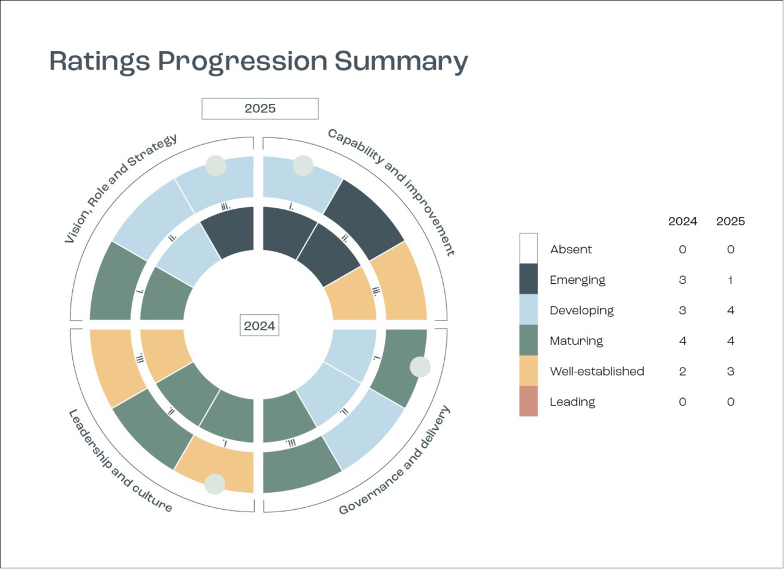

<description>

Diagram titled "Ratings Progression Summary".

On the left are two pie charts, one nested within the other. The data is listed below. Some slices are marked with a circle, which is indicated by a * symbol below.

* Capability and Improvement:
  + 2024
    1. Emerging
    2. Emerging
    3. Well-established
  + 2025
    1. Developing *
    2. Emerging
    3. Well-established
* Governance and delivery:
  + 2024
    1. Developing
    2. Developing
    3. Maturing
  + 2025
    1. Maturing *
    2. Developing
    3. Maturing
* Leadership and culture:
  + 2024
    1. Maturing
    2. Maturing
    3. Well-established
  + 2025
    1. Well-established *
    2. Maturing
    3. Well-established
* Vision, Role and Strategy:
  + 2024
    1. Maturing
    2. Developing
    3. Emerging
  + 2025
    1. Maturing
    2. Developing
    3. Developing *

On the right is a table of totals:

|  | **2024** | **2025** |
| --- | --- | --- |
| Absent | 0 | 0 |
| Emerging | 3 | 1 |
| Developing | 3 | 4 |
| Maturing | 4 | 4 |
| Well-established | 2 | 3 |
| Leading | 0 | 0 |

</description>

### Next steps

The Inspector-General will review updates made to the MRIT by AELERT in late 2024 and apply them to the next self-assessment in early 2026.

## Statement of Expectations and Statement of Intent



As part of the RMG128 related to regulator performance, the Commonwealth Government agreed that Ministers would issue Statements of Expectations to provide clear expectations for each statutory authority, including the policies and priorities it is expected to observe in conducting its operations. The Government also requires statutory agencies to respond through Statements of Intent.

### Why this work is important

Ministerial Statements of Expectations and Statements of Intent ensure clarity, transparency and alignment of government policy and activities by statutory authorities, whilst enabling the statutory authorities to independently make operational decisions.

### Key facts

The then Commonwealth Water Minister issued a Statement of Expectations for the Inspector–General on 11 September 2024. The Statement of Expectations is available on our website. In response, the Inspector–General's Statement of Intent was published on 11 June 2025.

**The Statement of Expectations:**

* Reflects the Inspector–General's unique regulatory responsibilities, role as an integrity agency, and expectations to ensure accountability for the management of Basin water resources
* Sets out how the Inspector–General is expected to contribute to regulatory stewardship, through a whole-of-system approach to regulation, in the context of complex water institution arrangements and where the Inspector–General oversees other water agencies
* Sets expectations for how the Inspector–General will engage with the Minister and the Minister will provide an appropriate enabling environment for the Inspector–General.
* Requires the Inspector–General to remove or minimise conflicts of interest in conducting their functions

**The Inspector–General's Statement of Intent:**

* Recognises the importance of removing or minimising conflicts of interest and maintaining the independence of the Inspector–General
* Highlights the values, vision and strategy of the Inspector–General, and their correspondence to those of the Commonwealth public sector
* Acknowledges their status as a Commonwealth integrity agency, and their commitment to the public sector integrity system
* Describes how the Inspector–General will develop and maintain relationships with stakeholders and other regulators in the Basin
* Summarises the Inspector–General's principles-based approach to regulatory practice and commitment to continuous improvement.

## Implementation of the 2024 independent review of the Inspector-General

On 14 September 2023, the Australian Government announced a review of the Inspector-General Water Compliance (referred to as the Harris Review). This was part of its election commitment to strengthen water compliance in the Basin.

### Why this work is important

The review provided an opportunity to reflect on the powers, structure and governance arrangements for the Inspector–General after several years of practical experience.

### Key Facts

**The terms of reference covered:**

* whether the Inspector–General has the powers needed to carry out their functions
* whether the structure and governance of the Inspector–General is appropriate, given the scope of their powers in relation to Commonwealth and Basin State governments.

### Recommendations

On 30 January 2024, the Australian Government received the final report of the Harris Review. The report found:

* The roles and responsibilities of the Inspector–General are generally well supported and valued by stakeholders.
* The governance structure of the Inspector–General has flaws that need to be managed to:
  1. maintain the Inspector–General's independence
  2. manage conflicts of interest
  3. ensure the Inspector-General has access to relevant and adequate expertise.
* The role of the Inspector–General compared to those of other regulators and agencies with responsibilities for water management in the Basin needs to be clarified.
* The Inspector–General needs collaborative relationships with those they oversight as their powers generally cannot require policy or program change to address a failure or poor behaviour exposed through the Inspector–General's oversight role.
* The Inspector–General's powers are broadly appropriate, but some minor reforms may be useful to give them more flexibility and increase public confidence about Basin water management.

In its response to the final report, the government agreed or agreed in principle to 8 of the 11 recommendations. It implemented several of these recommendations as part of the 2024-25 Budget – a budget that provided the Inspector-General with an additional $28.6 million over 4 consecutive years. The government noted several remaining recommendations and will consider them further through upcoming statutory reviews.

### Activities undertaken by the Inspector–General

Several actions have been taken by the Inspector–General in response to the findings of this review, using the increased funding made available in 2024-25. These include:

* Establishment of a fit-for-purpose executive structure within the Inspector-General's team
* Creating a legal services branch to provide independent legal advice to the Inspector-General
* Creating a dedicated inquiry team for the Inspector-General, enabling capacity to use all powers assigned to the Inspector–General under the Water Act
* Increasing staffing resources from 38.8 FTE to 58.8 FTE to undertake the Inspector–General's priorities and objectives.

## Reappointment

On 6 March 2025, the Governor-General of Australia, the Hon. Sam Mostyn AC, reappointed the Hon. Troy Grant for a second and final tenure as the Inspector-General Water Compliance (2 terms being the maximum allowed), until 4 August 2029. As this second term begins, the work undertaken by the Inspector–General and office supporting them is committed to oversighting the Water Act, Basin Plan, Water Resource Plans and Inter-governmental Agreements to:

|  |  |
| --- | --- |
| Icon of shield with a tick. | Ensure it's lawful. |
| Eye icon. | Ensure it's visible. |
| Icon of bar chart with increasing trend. | Do it better. |
| Icon of an arrow in an infinity-shaped loop. | Make it better. |

# 06 Work Plan 2024-25

The Inspector-General published a 2024-25 workplan in accordance with section 215E Water Act.

The Inspector–General also reviewed the Annual Work Plan in November 2024 in accordance with section 215F Water Act. A revised 2024-25 Annual Work Plan was published in February 2025 in accordance with section 215G Water Act.

### Why this work is important

The Annual Work Plan sets out activities to be undertaken to progress towards the Inspector–General vision and outcomes set out in the published Strategic Plan 2023-26.

Publishing an Annual Work Plan ensures visibility of the Inspector–General's work, and puts oversighted agencies on notice about what matters the Inspector–General will focus on over the next financial year. The review of the workplan enables the Inspector–General to adjust the work plan as needed to respond to any changed circumstances throughout a year.

### Key facts

**The Inspector–General had 2 priorities for 2024-25, shown in Table 1.**

**Table 1:** Work plan priorities and strategic plan outcomes, 2024-25

| **Work Plan Priority** | **Strategic Outcome** |
| --- | --- |
| 1. Environmental Outcomes  Plant leaf icon. | 2 Ensure it's visible  3 Do it better  Eye icon. Icon of bar chart with increasing trend. |
| 2. Inquiry into the Northern Basin Toolkit  Icon of document with a tick. | 2 Ensure it's visible  3 Do it better  Eye icon. Icon of bar chart with increasing trend. |

### Outcomes

The Inspector-General described 6 activities in the 2024-25 Annual Work Plan to support the 2 identified priorities. The Inspector-General pivoted in 2024-25 to respond to the Harris Review findings and securing additional budget, establishing an independent legal services branch, and expanding the executive and inquiry capacity. Because of this changed focus in 2024-25, 4 of the 2024-25 Annual Work Plan activities will continue into 2025-26. The Inspector–General remains committed to delivering on these remaining activities, including the Northern Basin Toolkit Inquiry, two environmental audits, the establishment of an SDL Advisory Panel through the appointment of panel members and finalising water resource plan reporting guidelines.

# 07 Looking forward

## 2025-26 Review of the role of the Inspector-General



The Water Act requires a review of the role of the Inspector–General in the 2025-26 financial year. This will be coordinated through the Commonwealth DCCEEW.

The Inspector–General will actively engage with the 2025-26 review, through the provision of practical insights and experiences, to ensure this review is fully informed and the issues identified in the Harris Review addressed. The Inspector–General also recognises the potential contribution of the 2025-26 review to strengthening the integrity of water management in the Basin by reviewing whether functions and regulatory tools available to the Inspector–General enable appropriate oversight and enforcement to hold Commonwealth and Basin State agencies to account for certain obligations under the Water Act, Basin Plan, water resource plans and intergovernmental agreements.

The 2025-26 review of the Inspector–General, combined with the MDBA's 2026 Basin Plan review and the upcoming 2027 statutory review of the Water Act provide an opportunity to ensure that the Commonwealth water laws are able to support effective and transparent Basin water management.

## Review of the Basin Plan

Under the Water Act, the MDBA is required to review the Basin Plan in 2026. The MDBA has started work on this review, which includes engagement with relevant stakeholders, such as the Inspector–General.

The Inspector–General will constructively engage with the MDBA through the Basin Plan review. The Inspector–General has key insights on Basin Plan implementation which have been obtained through 4 years of experience and evidence gathering about Basin Plan implementation and progress. These insights will be valuable to the MDBA's Basin Plan review, and consideration by government of any recommendations for reforms to the Basin Plan.

## Review of the Water Act

There is also a requirement in the Water Act for the Act to be reviewed before the end of 2027. This review must look into the operation of the Water Act and whether it has delivered the objectives of the legislation.

The Water Act review may be informed by a number of other reviews and processes that are being conducted over the next 2 years, such as:

* The 2025-26 review of the Inspector–General of Water Compliance
* An independent review of the Water for the Environment Special Account
* The MDBA's Basin Plan Review
* The MDBA's recalculation of SDLs at the end of 2026 (sometimes referred to as the sustainable diversion limit adjustment mechanism or SDLAM)
* The Productivity Commission's 2027 inquiry into national water reforms.

The Commonwealth DCCEEW, as the relevant policy agency, will ultimately be responsible for integrating the outcomes of these processes into comprehensive policy and coherent reform proposals for government consideration, potentially as part of the Water Act review.

As with the Basin Plan review, the Inspector-General will support the Water Act review by providing insights from practical experience as a regulator monitoring compliance with the Water Act. The Inspector-General also expects that the evidence base found in the Inspector-General's investigation, monitoring, audit and inquiry findings and reports over the past 4 years will inform the review of the Water Act, including examination of water governance and institutional arrangements to raise transparency and accountability for delivery of Basin water management.

## Annual Work Plan 2025-26

The deadline for the implementation of multiple components of the Basin Plan was extended to the end of 2026 via the Restoring Our Rivers Act. With this new deadline approaching, the Inspector–General has identified one priority for the Annual Work Plan 2025-26:

**Priority:** Holding responsible Commonwealth agencies and Basin States accountable on Basin Plan implementation

The Inspector-General is responsible for overseeing Commonwealth and Basin State water management agencies' performance in relation to the Basin Plan*.* This includes oversight of the implementation of commitments in intergovernmental agreements that support the delivery of the Basin Plan and water resource plans.

# Endnotes

1. Murray-Darling Basin Authority (2021) ‘About the Murray–Darling Basin’, Murray-Darling Basin Authority annual report 2020–21: Part 1 – Overview, Australian Government.
2. The Basin States are the Australian Capital Territory, New South Wales, Queensland, South Australia and Victoria.