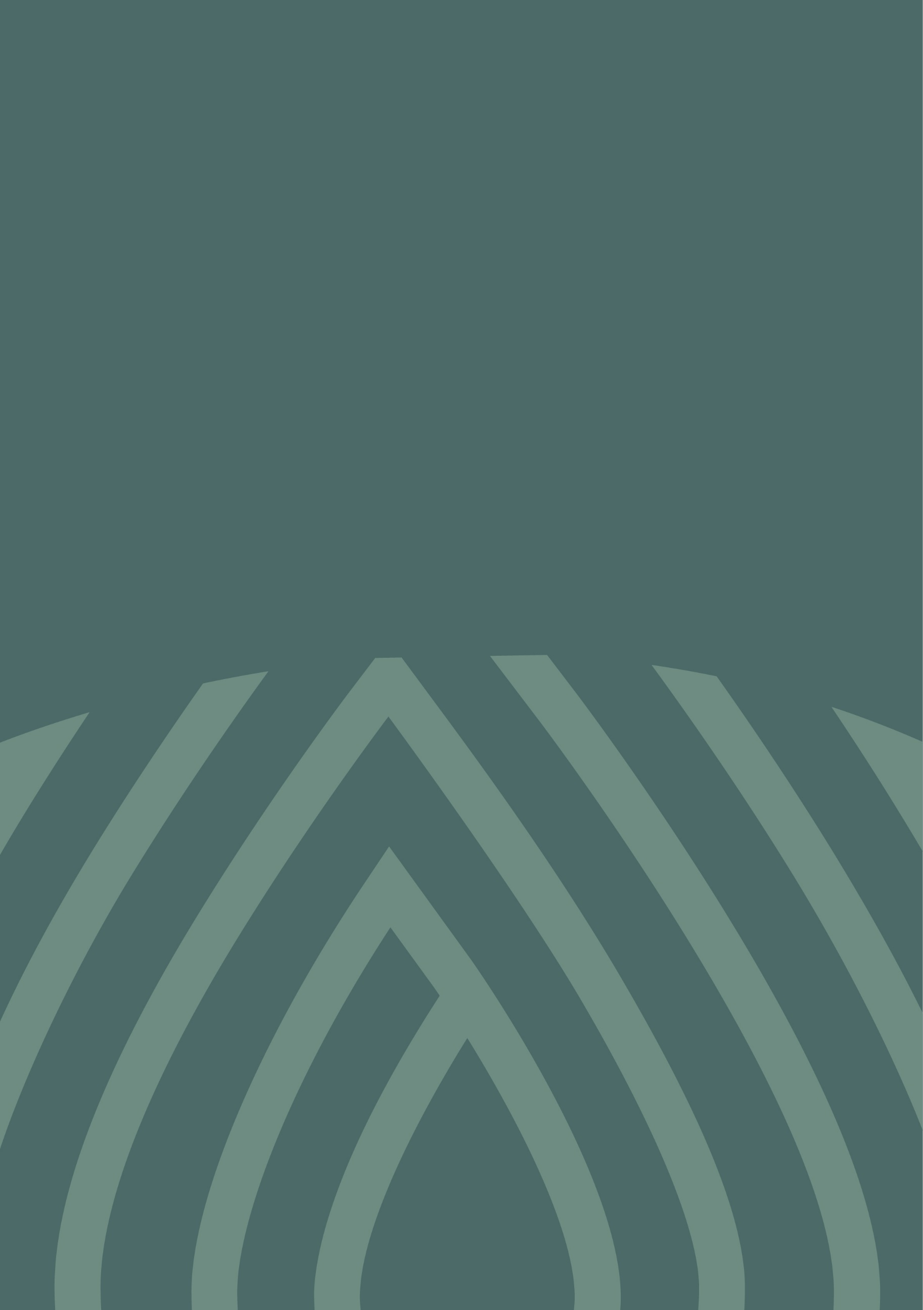
Murray–Darling Basin community perceptions research 2024–25
  - Understanding the Audience

Water licence holders
Results among water license holders were broadly consistent with those seen previously. Confidence in compliance and enforcement remains steady, while perceived performance on the Inspector-General is down slightly.
A water licence holder from Renmark is quoted, “Farmers are increasingly more careful because we know the value of water”.

Demographics

Type of water user
48% used water for non-dairy livestock, 33% for annual or seasonal crops, 23% for permanent crops, and 8% for dairy. 3% used water for tourism, 2% for industrial processes and manufacturing, and 5% used water for other purposes.

Water Licence Types
32% of water licence types were ground water/other only, 57% of water licence types were surface water only, and 11% were both ground and surface water. Surface water licence types for surface water licence holders were: high security, 33%; general security, 43%; and stock/domestic, 39%. 7% responded as ‘other’ or unsure.

Where they live
42% lived in Victoria, 36% in New South Wales, 15% in South Australia, 8% in Queensland, and less than 1% in the Australian Capital Territory.

Defining characteristics
100% of water licence holders either hold or manage a water licence, or purchase water for large-scale commercial purposes.

Heard of the Basin?
2024, 2023 and 2022 comparisons for the proportion of water licence holders who had heard of the Murray–Darling Basin:
- 91% of water licence holders responded 'yes, and know what it is,' in 2024, compared to 91% in 2023 and 89% in 2022.
- 8% responded 'yes, but not the details,' in 2024, compared to 9% in 2023 and 11% in 2022.
- 1% responded 'no' when asked if they had heard of the Basin in 2024, compared to 1% in 2023 and less than 1% in 2022.
Overall, 75% of water licence holders were aware that they live in the Murray–Darling Basin.

Top perceptions: Water licence holders tended to agree that…
- 86% agreed that it is important to know that water coming out of the Basin is measured.
- 83% agreed that having effective enforcement of water rules and regulations is important for maintaining healthy waterways.
- 82% agreed that it is important to have an independent Basin-wide government body overseeing water rules and regulations.
- 82% agreed that people should be punished for not following water rules and regulations.

IGWC
Awareness KPI, Confidence and Trust KPI, and Performance KPI scores among water licence holders were calculated for 2022, 2023 and 2024. Index scores are out of a potential range of 0 to 100.
- For Awareness, the KPI was 41 in 2024, compared to a score of 41 in 2023, and 36 in 2022. Note that an estimated value was used for water licence holders’ 2024 awareness KPI – more information about this is available in the project overview and research methodology.
- For Confidence and Trust, the KPI was 44 in 2024, compared to a score of 47 in 2023, 45 in 2022.
- For Performance, the KPI was 38 in 2024, compared to 44 in 2023, and 40 in 2022. A downward arrow can be seen beside the KPI score for 2024, indicating a statistically significant decrease compared to 2023 at a 90% confidence level. An upward arrow can be seen beside the KPI score for 2023, indicating a statistically significant increase compared to 2022 at a 90% confidence level.
47% of respondents either agreed or strongly agreed that they wanted to know more about water rules, regulations and enforcement in the Basin.
68% gave a rating of 8 to 10 out of 10 when asked if they felt that compliance and enforcement was important for them.
Base sizes for the data above:
- The water licence holders base sizes in 2024 were n=122 to 203, in 2023 was n=214, and in 2022 was n=200.

Basin community
Basin community respondents tended to have relatively low levels of understanding about the Basin and varying levels of interest and engagement with waterways and water management. Compared to 2023, findings relating to the Basin community remained broadly consistent.
A younger community member in Tamworth is quoted, “I don’t know how they police [water usage]… I don’t think it’s spoken about clearly to a regular person.”

Demographics

Gender
49% of Basin community respondents were male and 51% were female. Less than 1% provided another gender or preferred not to say.

Age
27% of Basin community respondents were between 18 to 34 years of age, 31% were between 35 to 54 years of age, and 42% were 55 years or older.

Where they live
37% lived in New South Wales, 28% lived in Victoria, 18% lived in the Australian Capital Territory, 11% lived in Queensland, and 6% lived in South Australia.
26% lived in the Northern Basin while 74% lived in the Southern Basin.
57% lived in a metropolitan area, a regional centre or a large rural town, while 43% lived in a smaller rural town or remote community.

Heard of the Basin?
2024, 2023 and 2022 comparisons for the proportion of Basin community who have heard of the Murray–Darling Basin:
- 59% of Basin community responded 'yes, and know what it is,' in 2024, compared to 60% in 2023, and 61% in 2024.
- 35% responded 'yes, but not the details,' in 2024, compared to 35% in 2023, and 34% in 2022.
- 6% of Basin community in 2024 responded 'no' when asked if they had heard of the Basin, compared to 5% in 2023 and 5% in 2022.
Overall, 28% of the Basin community were aware that they live in the Murray–Darling Basin.

Top perceptions: Basin community tended to agree that…
- 80% agreed that having effective enforcement of water rules and regulations is important for maintaining healthy waterways.
- 78% agreed that people should be punished for not following water rules and regulations.
- 76% agreed that it is important to have an independent Basin-wide government body overseeing water rules and regulations.
- 75% agreed that the whole community benefits when the water rules and regulations are followed.

IGWC
Awareness KPI, Confidence and Trust KPI, and Performance KPI scores of community advocates were calculated for 2022, 2023 and 2024. Index scores are out of a potential range of 0 to 100.
- For Awareness, the KPI was 15 in 2024, compared to a score of 16 in 2023 and 15 in 2022.
- For Confidence and Trust, the KPI was 39 in 2024, compared to a score of 39 in 2023 and 36 in 2022. An upward arrow can be seen beside the KPI score for 2023, indicating a significant increase from the previous year at a 90% confidence level.
- For Performance, the KPI was 34 in 2024, compared to a score of 35 in 2023 and 31 in 2022. An upward arrow can be seen beside the KPI score for 2023, indicating a significant increase from the previous year at a 90% confidence level.
48% of respondents either agreed or strongly agreed that they want to know more about water rules, regulations and enforcement in the Basin.
57% gave a rating of 8 to 10 out of 10 when asked if they felt that compliance and enforcement was important for them.
Base sizes for the data above:
- The community base size in 2024 was n=865, in 2023 was n=800, and in 2022 was n=817

First Nations Community
First Nations community respondents tended to feel more negatively about water management than the overall Basin community. They were more likely to indicate concerns about compliance, and more likely to actively seek information on the topic.
A First Nations community member in Broken Hill is quoted, “I want to know it’s being managed and that those doing the wrong thing are being told off and shamed.”

Demographics

Gender
48% of First Nations community respondents were male, while 51% were female and 1% provided another gender or preferred not to say.

Age
42% of First Nations community respondents were between 18 to 34 years of age, 33% were between 35 to 54 years, and 25% were 55 years or older.

Where they live
68% lived in New South Wales, 18% lived in Victoria, 8% lived in South Australia, 5% lived in the Australian Capital Territory, and 2% lived in Queensland.
52% lived in the Northern Basin while 48% lived in the Southern Basin.
25% lived in a metropolitan area, a regional centre or a large rural town, while 75% lived in a smaller rural town or remote community.

Heard of the Basin?
Proportion of First Nations community respondents who have heard of the Murray–Darling Basin.
- 57% of First Nations community respondents responded 'yes, and know what it is'.
- 33% responded 'yes, but not the details'.
- 11% responded 'no' when asked if they had heard of the Basin.
Overall, 31% of the First Nations community in the Basin were aware that they live in the Murray–Darling Basin.

Top perceptions: First Nations community tended to agree that…
- 79% agreed that people should be punished for not following water rules and regulations.
- 74% agreed that having effective enforcement of water rules and regulations is important for maintaining healthy waterways.
- 73% agreed that the whole community benefits when the water rules and regulations are followed.
- 71% agreed that knowing that water rules and regulations are being enforced would reassure them.

IGWC
Awareness KPI, Confidence and Trust KPI, and Performance KPI scores of First Nations community respondents were calculated for 2024. Index scores are out of a potential range of 0 to 100.
- For Awareness, the KPI was 17.
- For Confidence and Trust, the KPI was 39.
- For Performance, the KPI was 40.
55% of First Nations community respondents either agreed or strongly agreed that they would want to know more about water rules, regulations and enforcement in the Basin.
52% gave a rating of 8 to 10 out of 10 when asked if they felt that compliance and enforcement was important for them.
Base sizes for the data above:
- The First Nations community base size in 2024 was n=82.

